MAGNETISM
1. 1995 Q15 P1
Give a reason why attraction in magnesium is not regarded as a reliable
method of testing for polarity. (1 mark)
2. 1996 Q2 P2
(a) Given a bar magnet, an iron bar and a string

i) Describe a simple experiment to distinguish between the magnet and
the iron bar (4 marks)
ii) State with reasons the observation that would be made in the experiment.
(4 marks)
(b) In an experiment to magnetize two substances P and Q using electric
current, two curves(graphs) were obtained as shown in figure 1
Using the information in Fig 1, explain the difference between the
substances P and Q with references to the domain theory (6 marks)

3. 1997 Q14 P1
Distinguish between soft and hard magnetic materials (1 mark)

4. 1997 Q16 P1
Figure 7 shows an incomplete circuit of an electromagnet. Complete the
circuit between X and Y drawing the windings on the two arms of the core
such that A and B are both North poles when switch S is closed. Indicate
the direction of the current on the windings drawn.
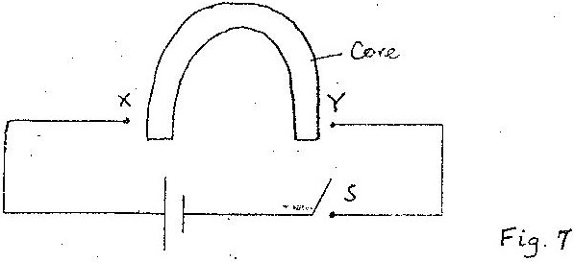

5. 1997 Q5a, b P2
(a) State two factors that affect the strength of an electromagnet.

(b) In the set up in figure 5, the suspended metre rule is in equilibrium balanced
by the magnet and the weight shown. The iron core is fixed to the bench.
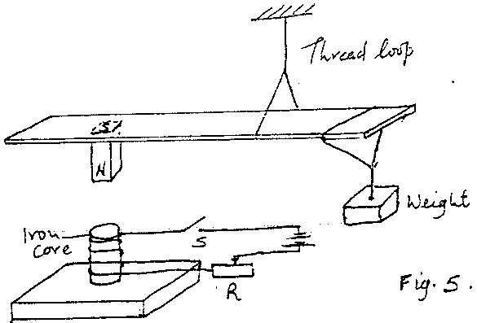

- State and explain the effect on metre rule when the switch S is closed
- What would be the effect of reversing the battery terminals
- Suggest how the set up in figure 5 can be adapted to measure the
current flowing in the current circuit.

6. 1998 Q14 P1
Explain how hammering demagnetizes a magnet

7. 1999 Q12 P1
How can it be shown that the strength of a magnet is concentrated at the poles?

8. 2000 Q12 P1
Fig. 7 shows how magnets are stored in pairs with keepers at the ends
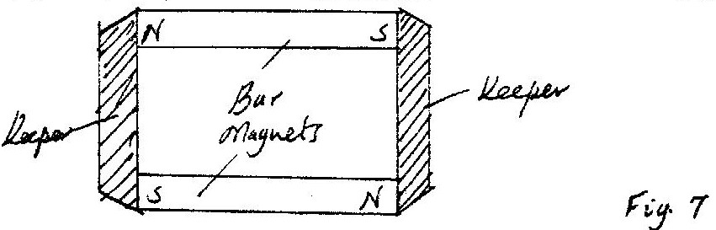

Explain how this method of storing helps in retaining magnetism longer.

9. 2001 Q11 P1
Fig 8 shows a soft-iron ring placed between the poles of a magnet. On the
same diagram sketch the magnetic field pattern.

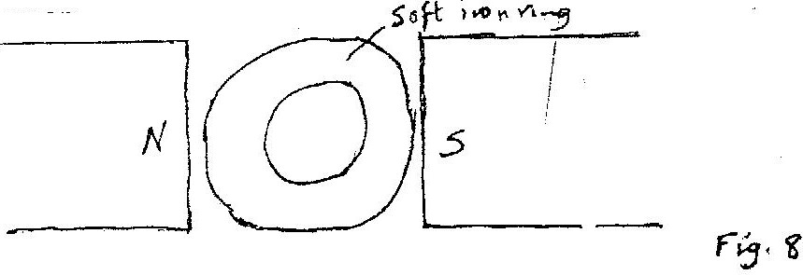

10. 2002 Q11 P1
Fig. 6 shows a soft iron placed between poles of two magnets.
Figure 6

Sketch the magnetic field pattern.

11. 2003 Q12 P1
Figure 8 shows a bar of soft iron placed near a magnet.
SOFT IRON
S N

Figure 8

On the same diagram, sketch the magnetic field pattern due to the set up

12. 2003 Q13 P1
Give a reason why the core of the electromagnet of an electric bell is
made of soft iron and not steel.

13. 2004 Q11 P1
Figure 7 shows the poles of two magnets close together.
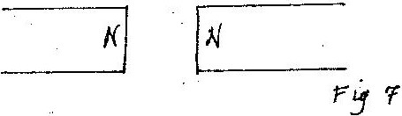

Sketch the magnetic field pattern in the space between the poles. (1 marks)

14. 2004 Q37P1
In the set up Fig 17 the metal rod is made up of steel and iron pieces
joined end. Your are provided with two iron nails.

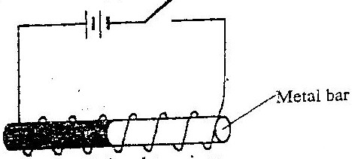

Explain how you would use two nails provided to determine
which side is iron (2marks)

15. 2006 Q1 P2
Figure 1 shows two bar magnets placed with the south poles close together

In figure 1 sketch the magnetic field pattern between the two south poles (1 mark)

16. 2007 Q3 P2
Figure 2 shows a horse –shoe magnet whose poles are labelled and two
other magnets near it. Iron nails are attracted to the lower ends of the
magnets as shown.
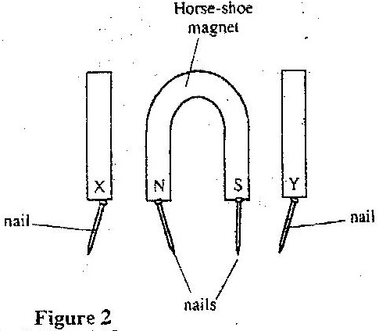

Identify the poles marked X and Y (1 mark)

17. 2008 Q4 P2
An un-magnetized steel rod is clamped facing North-South direction
and then hammered repeatedly for some time. When tested, it is found
to be magnetized. Explain this observation. (2 marks)
18. 2010 Q2 P2
Figure 2(a), shows a magnetic compass placed under a horizontal wire XY

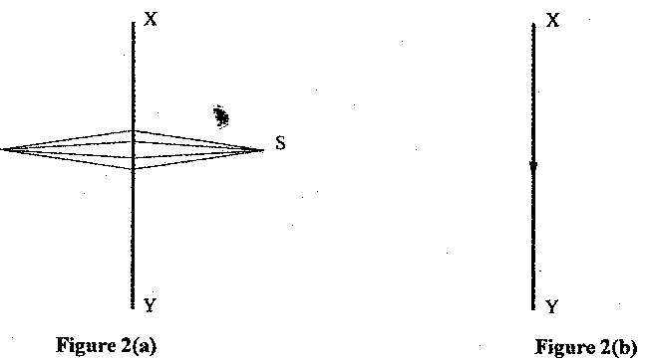
A large current is passed from X to Y. Draw the final position of the magnetic
compass needle in figure
19. 2011 Q6 P2
One method of producing a weak magnet is to hold a steel rod in the
North South direction and then hammer it continuously for some time.
Using the domain theory of magnetism explain how this method works.
(2 marks)
20. 2013 Q3 P2
State the reason why the magnetic field strength of a magnet is greatest
at the poles. (1mark)

21. 2014 Q7 P2
Figure 4 shows the magnetic field pattern around two bar magnets
placed side by side.

Indicate on the diagram the poles of each magnet. (1 mark)

22. 2015 Q4 P2
Figure 2 shows a soft iron bar AB placed in a coil near a freely
suspended magnet.
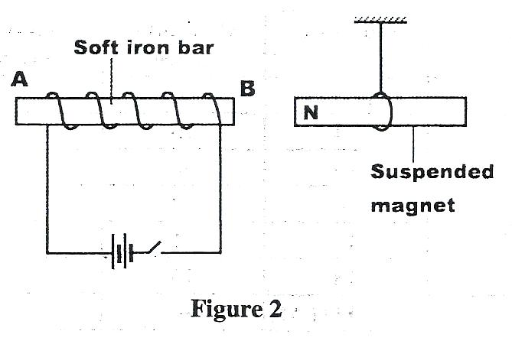
Explain the observation made when the switch is closed. (2 marks)

MEASUREMENT II

- 1995 Q1 P1
Name the instrument that would be most suitable for measuring the
thickest of one sheet of this question paper. (1 mark)

- 1995 Q1 P1
State the assumption made when calculating the size of a molecule in
the thin oil film experiment (1mark)

- 1995 Q1 P1
The micrometer screw gauge represented by figure 1 has thimble scale
of 50 Divisions (1mark)

4. 1997 Q6 P1
The number of molecules in 18cm³ of a liquid is 6 x 10²³. Assuming that
the diameter of the molecules is equivalent to the side of a cube having
the same volume as the molecule. Determine the diameter of the molecule.

5. 1999 Q1 P1
What is the reading on the vernier callipers shown in figure 1? (1mark)

6. 2001 Q3(a) P1
You are provided with the following: a large shallow tray water lycopodium powder some olive oil
either a piece of thin wire with a kink and a millimeter scale or a
burette a metre rule.
Describe an experiment to estimate the diameter of a molecule of the olive oil.
(7 marks)

7. 2002 Q1 P1
Fig one shows a micrometer crew gauge being used to measure the
diameter of a metal rod. The thimble scale has 50 divisions
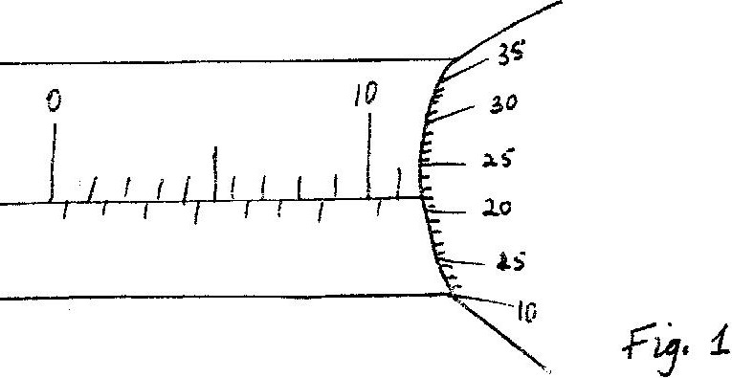

What is the reading shown?

8. 2004 Q1 P1
Figure 1 shows a micrometer screw gauge being used to measure the
diameter of a ball bearing.
A magnified portion of the scale is shown.
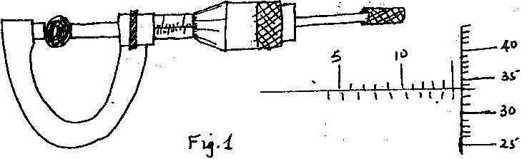

Record the diameter of the ball bearing (1mark)

9. 2004 Q2(b) P1
Fig 3 shows part of an experimental set up for estimating the diameter
of an oil molecule.

i) Describe how the oil patch is formed

ii) In an experiment the diameter a, of the patch was measured to
be 200mm for an oil drop of radius 0.25mm. Determine the
diameter of the molecule of the oil.

10. 2005 Q27 P1
The melting point of oxygen is given as -273⁰C. Covert this temperature
to Kelvin (K) (1 mark)

11. 2006 Q14 (b) &(c) P1
(b) In an experiment to estimate the diameter of an oil molecule, an oil
drop of diameter 0.05 cm spreads over a circular patch whose diameter
is 20 cm
Determine
(i) The volume of the oil drop (2 marks)
(ii) The area of the patch covered by the oil (2 marks)
(iii) The diameter of the oil molecule (3 marks)

(c) State
(i) Any assumption made in (b) (iii) above (1 mark)
(ii) Two possible sources of errors in this experiment (2 marks)

12. 2007 Q1 P1
Figure 1 shows a metal cube of mass 1.75g placed between the jaws
of a micrometer screw gauge. The magnified portion of the scale is also
shown. The reading on the gauge when the jaws were fully closed
without the cube was 0.012 cm. Use this information and the figure
to answer questions 12 and 13
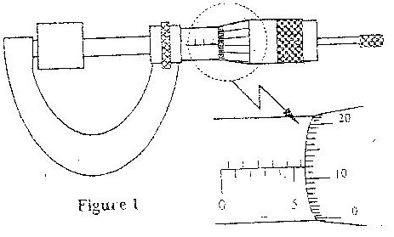

What is the length of the cube? (1 mark)

13. 2007 Q2 P1
Determine the density of the metal cube giving your answer correct to
three significant figures. (3 marks)

14. 2010 Q1 P1
Figure 1 shows a vernier caliper being used to measure the internal
diameter of a tube.

Record the diameter of the tube (1 mark)

15. 2010 Q2 P1
A stop watch started 0.50s after the started the start button was pressed.
The time recorded using the stopwatch for a ball bearing failing through a liquid was 2.53s. Determine the time of fail.

16. 2010 Q9 P1
When a drop of oleic acid of known volume is dropped on the surface of
water in a large trough, it spreads out to form a large circular patch. State
one assumption made when the size of the molecule of oleic acid is
estimated by determining the area of the patch. (1 mark)

17. 2012 Q6 P1
State two environmental hazards that may occur when oil spills over
a large surface area of the sea. (2marks)

18. 2013 Q1 P1
Figure 1 shows part of the main scale and vernier scale of a vernier calipers.

Record the reading indicated. (1 mark)
19. 2014 Q2 P1
Figure 1 shows a magnified scale of a micrometer screw gauge.
Record the reading indicated. (1 mark)

20. 2014 Q6 P1
An oil drop of volume V m³ introduced on the surface of water spreads
to form a patch whose area is A m². Derive an expression or obtaining
the diameter, d of a molecule of oil. (2 marks)

21. 2015 Q 1 P1
Figure 1 shows part of the main scale of a vernier Calipers.
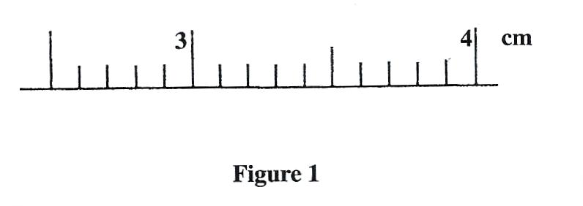
Insert the vernier scale to the main scale, to show a reading of 3.14 cm (1 mark)

TURNING EFFECT OF A FORCE
1. 1995 Q17 P1
The diagram in figure 5 shows a beam negligible weight balanced by
constant forces P and Q.
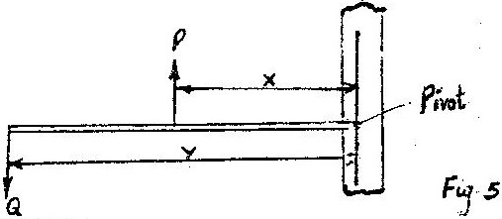

Derive the relationship between x and y (2 marks)

2. 1996 Q14 P1

Figure 5 shows a wheel W pivoted at its centre, O and held stationary by a
string and a spring. The tension in the strings is T and the force on the
springs is F.

Use this information to answer 2 and 3
State how the magnitudes of T and F compare. Give reasons for your answer
(3 marks)
3. 1996 Q15 P1
State what would happen to the wheel if the string snapped (1 mark)

4. 1996 Q30 P1
The moment of the weight of vertical door does not significantly affect
the moment of the force required to open the door. Give a reason for this (1 mark)

5. 1997 Q2 P1
Figure 2 shows a rigid body acted upon by a set of forces. The
magnitudes of the forces are as follow
F₁ = 3N₁, F₂ = 6N, F₃ = 3N, F₄ = 4 N₁, F₅ = 3N and F₆ = 3 N
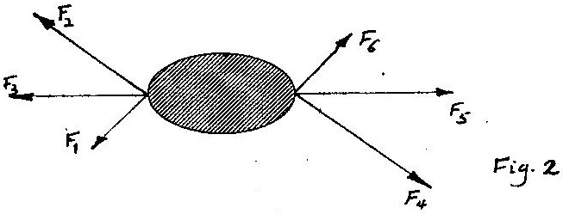

Identify the couple among these forces
6. 1999 Q2 P1
Figure 2 shows forces F₁ and F₂ acting on a meter rule such that it
is in equilibrium.
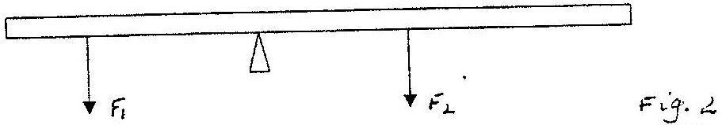

Mark on the figure a third force F3 acting on the rule such that it is in
equilibrium maintained.

7. 1999 Q14 P1
Determine the moment of the couple shown in figure 10. (2 marks)

8. 2000 Q5 P1
Fig. 3 shows a device for closing a steam outlet.
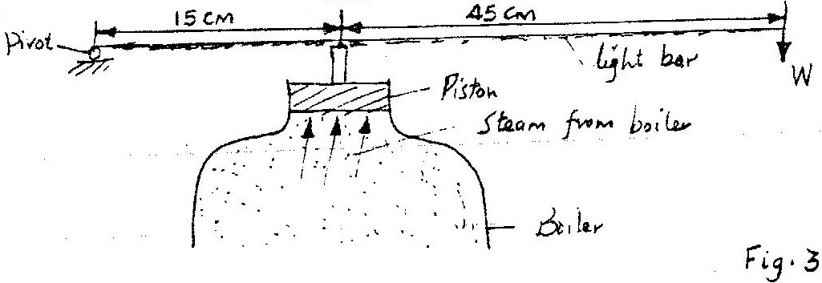

The area of the position is 4.0 x 10⁻⁴ m² and the pressure of the steam
in the boiler is 2.0 x 10⁵ Nm³. Determine the weight W that will just
hold the bar in the horizontal position shown.

9 . 2000 Q14 P1
In fig 9 the couple represented by forces F1 is acting on light uniform bar.
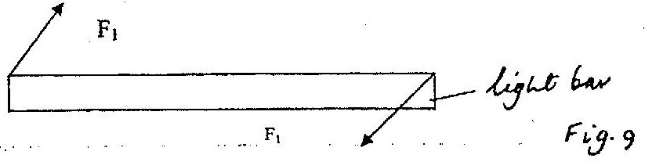

Sketch on the figure a couple represented by forces F₂ such that the bar is in equilibrium. And the forces F₂ have minimum magnitude.

11. 2001 Q12 P1
Fig. 9 shows a uniform light bar one meter in length in equilibrium under
the action of forces F₁ F₂ F₃ and F₄. All the forces are in the same plane.
Use the information on the figure to answer questions 11 and 12.
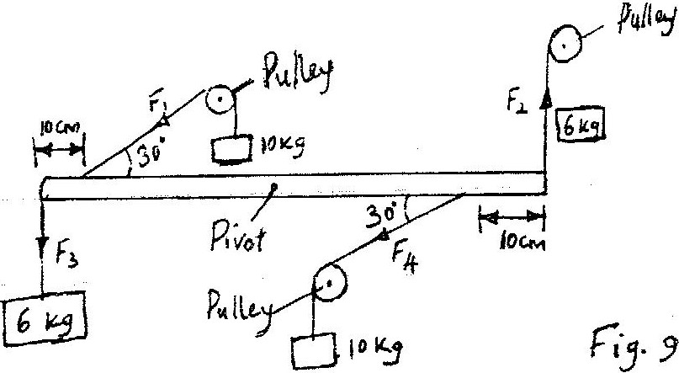

Name one set of forces on the figure that constitutes a couple.

12. 2001 Q13 P1
Determine the moment of the couple named in question 11.

14. 2003 Q14 P1
Figure 9 shows a uniform bar in equilibrium under the action of two forces.

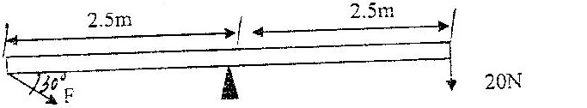

Determine the value of F (3 marks)

15. 2004 Q14 P1
The system in figure 9 is in equilibrium.
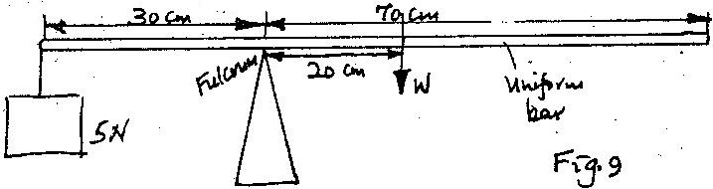

Determine the weight of the bar.

16. 2008 Q19 P1
a) State the principle of moments. (1 mark)

b) A uniform metal strip is 3.0cm wide, 0.6cm thick and 100cm long.
The density of the metal is 2.7 g/cm^{3.}
(i) Determine the weight of the strip. (3 marks)

The strip placed on a pivot and kept in equilibrium by forces as shown
in fig. 13

(ii) Determine the value of F and R (3 marks)

(iii) X is the distance from the end of the plank to the point of application
of force F. Force F is now applied at various points nearer to the pivot so
that x increases. Equilibrium is maintained all the time. On the axes
provided sketch the relation between force F and x.

F
x

(iv) Give a reason for the answer in (iii) above (1 mark)

17. 2010 Q6 P1
Figure 3 shows a uniform meter rule pivoted at 30cm mark. It is balanced
by weight of 2N suspended at the 5cm mark.

5cm 30cm

2N

Determine the weight of the metre rule.

18. 2011 Q11 P1
Figure 8 shows a uniform wooden block of mass 2kg and length 25cm
lying on a bench. It hangs over the edge of the bench by 10cm.Use the
figure to answer questions 19 and 20.

25 cm

Wooden block

10 cm
Bench

Indicate on the figure two forces acting on the wooden block. (1 mark)

19. 2011 Q12 P1
Determine the minimum force that can be applied on the wooden
block to make it turn about the edge of the bench. (2 marks)

20. 2013 Q2 P1
State one factor that affects the turning effect of a force on a body. (1 mark) (2 marks)
21. 2013 Q8 P1
Figure 4 shows a uniform meter rule of weight 1 N with two weights of
0.18 N and 0.12 N suspended from its ends.

Determine how far from the 0.18 N weight a pivot should be placed
in order to balance the meter rule. (3 marks)

22. 2014 Q8 P1
Figure 5 shows a uniform rod 4 m long and of mass 2 kg. It is pivoted
1m from one end and balanced horizontally by a string attached near
the other end.

Determine the position where a mass of 5 kg should be placed on the rod
so that the rod remains horizontal and the tension in the string is zero. (3 marks)

23. 2015 Q8 P1
Figure 4 shows a uniform metal rod balanced at it's centre by different forces.
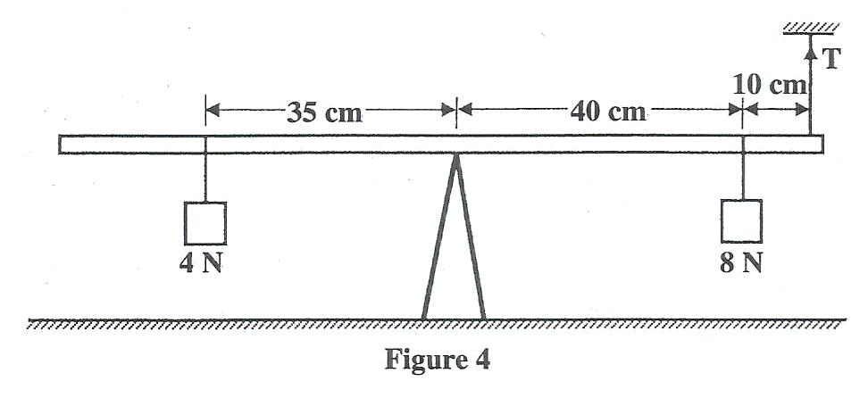
Determine the value of T. (3 marks)

EQUILIBRIUM AND CENTRE OF GRAVITY
- 1995 Q33 P1
What is meant by the centre of gravity of a body? (1 mark)

- 1996 Q3 P1
State two factors that should be controlled in manufacturing a cylindrical
container of uniform thickness, which should normally be in a standing position?
(2 marks)
- 1997 Q2b P2
In the set up in the figure 3, the metre rule is in equilibrium

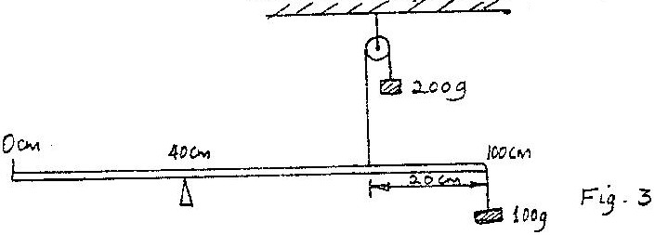

Given that the metre rule is uniform, determine its weight (2 marks)

- 1998 Q7 P1
State one advantage of fitting wide tyres on a vehicle that moves on earth roads.

- 1998 Q24 P1
John carried a uniform post of mass 20kg horizontally on his shoulder as
shown in fig 6. He placed the post on his shoulder such that the centre of
gravity of the pole is 1.0m behind him. He balanced the post by applying a
downward force F at a point 0.5m on the part of the post in front of him.
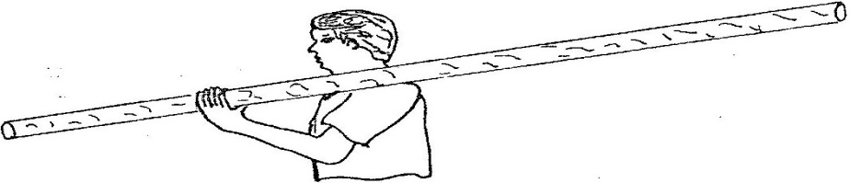

Determine the value of the force F. (3 marks)

- 1999 Q2 P1
Figure 2 shows forces F₁ and F₂ acting on a meter rule such that it is
in equilibrium.

Mark on the figure a third force F₃ acting on the rule such that it is in
equilibrium maintained. (1 mark)

- 1999 Q3 P1
State how the position of the centre of gravity of a body in stable
equilibrium changes to that in the rest position when the body is slightly
tilted and then released.
(1 mark)
- 2000 Q3 P1
Fig. 2 shows a beaker placed on a bench. of ice is placed in the beaker
as shown.
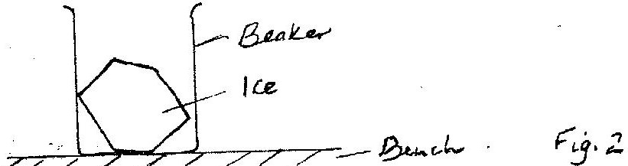

State and explain the change in the stability of the beaker when the
ice melts. (1 mark)

- 2001 Q3 P1
Fig 3 shows two identical hollow spheres. Spheres A is completely filled
with the liquid while B is partly filled with identical liquid.
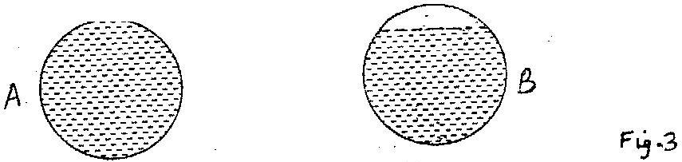

When the two spheres are rolled gently on a horizontal surface. It is observed
that the sphere B stops earlier that the sphere A. Explain this observation. (2 marks)

- 2002 Q2 P1
Fig. 2 represents a rock balanced at point O.G is the centre of gravity of
the rock. Use this information to answer questions 5 and 6.

Draw and label on the figure, the forces acting on the rock. (2 marks)

- 2002 Q3 P1
If the portion of the rock represented by the shaded part is chopped
off explain why the rock may topple to the right. (2 marks)

- 2002 Q12 P1
Fig. 7 shows a non – uniform log of mass 100kg balanced on the pivot
by a 2kg mass placed as shown.
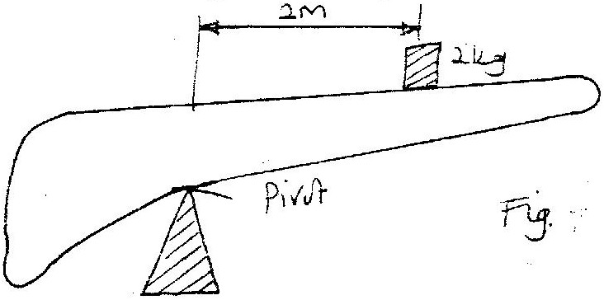

Determine the distance of the center of gravity of the log from the pivot. (3 marks)

- 2003 Q3 P1
Figure 3 shows two identical trolleys with loads A and B. The loads are
identical in shape and size.

Figure 3
Given that the density of A is greater than that of B, explain why the
trolley in figure 3(ii) is more suitable. (2 marks)

- 2004 Q3 P1
Fig 3 shows a rectangular block of wood with a hollow section (inside) at the
position shown.

The block is resting on a Horizontal bench

(i) State the effected on the stability of the block when the hollow
section is filled with water. (1 mark)

ii) Explain your answer in (i) above. (2 marks)

- 2004 Q14 P1
The system in figure 9 is in equilibrium.

Determine the weight if the bar. (1 mark)

- 2005 Q2 P1
Fig 2 shows a solid cylinder standing on a horizontal surface. The
cylinder is in stable equilibrium.
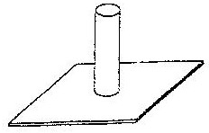

On the horizontal space provided, sketch the cylinder in neutral equilibrium. (1 mark)

- 2006 Q4 P1
Figure 3 shows a bimetallic strip with a wooden handle, suspended
horizontally using a thin thread.

Heat
Figure 3
Handle
Thread
Bi-metallic
strip

The strip is heated at the point shown. Explain why the system tips to
the right (1 mark)

- 2007 Q8 P1
Figure 5 shows a uniform bar of length 1.0 m pivoted near one end. The
bar is kept in equilibrium by a spring balance as shown.

Given that the reading of the spring balance is 0.6 N. Determine the weight
of the bar. (3 marks)

- 2008 Q10 P1
Fig. 5 shows a toy resting on top of a closed bottle. Use the information
on the figure to answer questions 10 and 11.

Mark on the diagram, point Q, the approximate centre of gravity
of the toy. (1 mark)

- 2008 Q11 P1
Giving a reason, name the state of equilibrium of the toy. (2 marks)

- 2008 Q14 P1
The system in Fig. 8 is in equilibrium
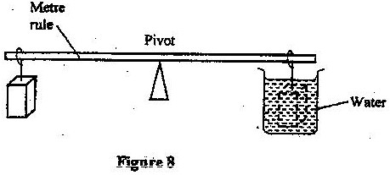

When the temperature of the water is raised the system is observed to
tilt to the right, state the reason for this observation. (2 marks)

- 2008 Q19 P1
a) State the principle of moments. (1mark)

b) A uniform metal strip is 3.0cm wide, 0.6cm thick d 100cm long. The
density of the metal is 2.7 g/cm^{3.}
(i) Determine the weight of the strip. (3marks)

The strip placed n a pivot and kept in equilibrium by forces as shown in fig. 13

FIGURE 13

(ii) Determine the value of F and R (3marks)

(iii) X is the distance from the end of the plank to the point of application
of force F. Force F is now applied at various points nearer to the pivot
so that x increases. Equilibrium is maintained all the time. On the axes
provided sketch the relation between force F and x.
F
x

(iv) Give a reason for the answer in (iii) above (1mark)

- 2009 Q9 P1
Figure 4 shows a uniform cardboard in the shape of a parallelogram

Locate the centre of gravity of the cardboard. (1 mark)

- 2010 Q6 P1
Figure 3 shows a uniform metre rule pivoted at 30cm mark. It is balanced
by weight of 2N suspeded at the 5cm mark.
5cm 30cm

2N

Determine the weight of the metre rule.

- 2010 Q14 P1
Figure 6 shows an athlete lifting weights while standing with the feet apart.

Explain why standing with the feet apart improves an athlete’s stability.
(1 mark)

- 2011 Q9 P1
Figure 1 shows a lorry moving on an inclined section of a straight road. At
the back is a chain hanging from a point on a horizontal axis through the
centre of gravity of a lorry.
State with a reason whether the lorry is stable or not stable. (1 mark)

- 2012 Q9 P1
State the reason why a steel sphere resting on a horizontal surface is
said to be neutral equilibrium. (1 mark)
- 2012 Q18(a) P1
(a) Figure 12 shows a set up used to determine the mass of a solid S.
The rod is pivoted at its centre of gravity C.

- State two measurements that need to be made to determine
the mass of solid S. (1mark)
- Write an expression to show how the measurements in (i) above
are used to obtain the mass of S. (2marks)

29. 2014 Q9 P1
Figure 6 shows two identical rods JK and LK connected with a hinge at K.

The position of the centre of gravity for the system is at P. The
arrangement is now adjusted so that J and L move equal distances
towards O. Sketch the new arrangement on the same diagram and
mark the new position of the centre of gravity. (2 marks)

REFLECTION AT CURVED SURFACES

1. 1994 Q1a P2
Draw a ray diagram to show what is meant by
(i) The principal focus and
(ii) The focal length of a concave mirror. (3 marks)

2. 1995 Q36 P1
Explain with the aid of a labelled ray diagram the wide field of view
of a convex mirror (2 marks)

3. 1995 Q3a P2
(a) An object O is placed in front of convex mirror as shown in figure 2

(i) Draw to scale a ray diagram to show the position of the image (5 marks)
(ii) Determine the magnification (3 marks)

4. 1996 Q22 P1
A lady holds a large concave of focal length 1 m 80 cm from her face, state
two characteristics of her image in the mirror (2 marks)

5. 1997 Q26 P1
Figure 9 shows two parallel rays incident on a concave mirror. F is the
focal point of the mirror.
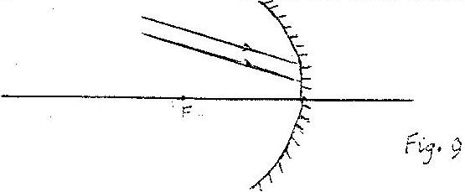

Sketch on the same diagram the path of the rays after striking the mirror

6. 1997 Q7 P2
a) Fig. 6 shows an object, 0.3cm high placed in front of a concave mirror. C
is the centre of curvature of the mirror. The diagram is drawn to scale:
(1cm: 2cm)
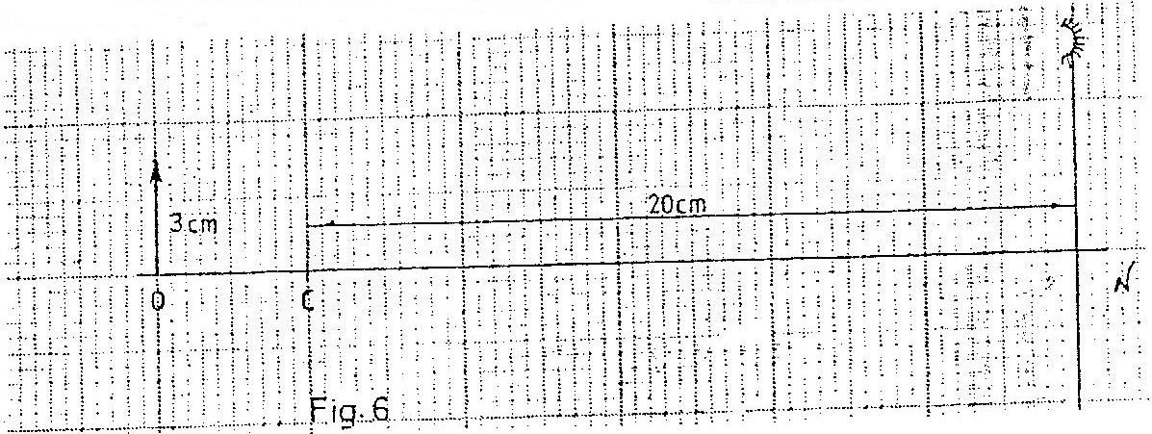

Draw a ray diagram, on figure 6, and determine the size of the image produced.

b) Table 3 shows the object distance y and the corresponding image
distance v, for an object placed in front of a concave mirror.

U(cm | 20 | 25 | 30 | 40 | 50 | 70
V(cm | 20 | 16.7 | 15 | 13.3 | 12.0 | 11.6
1/v(cm-1)
V(cm-1)

i) Complete the table and plot a graph of 1/v (y-axis) against 1/u (give
your answers to 3 decimal places). (7 marks)

ii) From the graph, determine the focal length of the mirror. (3 marks)

7. 2000 Q23 P1
Fig. 12 shows a ray of light incident on a convex mirror.

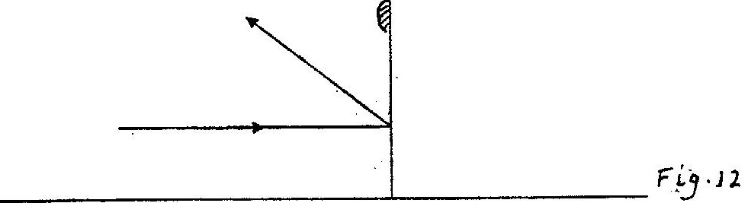

Using a suitable construction on the same diagram determine the
radius of curvature of the mirror. (3 marks)

8. 2000 Q1 P2
a) i) State one application of each of the following.
Convex mirror-
Parabolic mirror – (2 marks)

ii) Fig. 1, which is drawn to a scale of 1:5, represents an object O
and its image ‘I’ formed by a concave mirror.
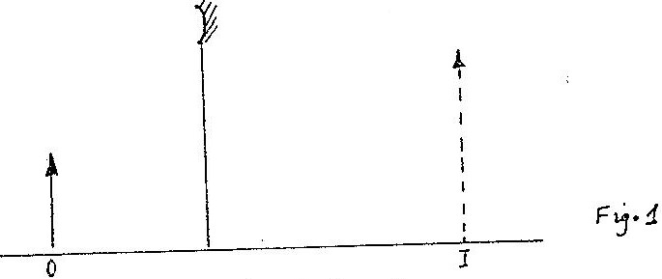

By drawing suitable rays, locate and mark on the figure the position
of the principal focus ‘F’ of the mirror. Determine the focal length f. (4 marks)

b) The graph in Fig. 2 shows the variation of magnification, M with
image distance, V for a concave mirror.

Determine:
- The object position when the image position is 45cm (4 marks)
- The focal length of the mirror. (1 mark)

9. 2001 Q20 P1
Fig. 13 shows a point object O placed in front of a concave mirror.
Draw appropriate rays to locate the image of the object.

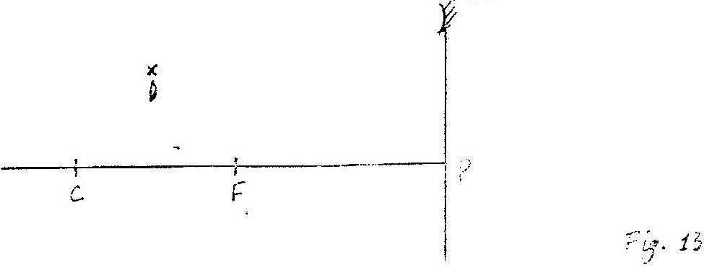

10. 2003 Q29 P1
Figure 16 (a) and (b) show a convex mirror and a plane mirror of
equal aperture.
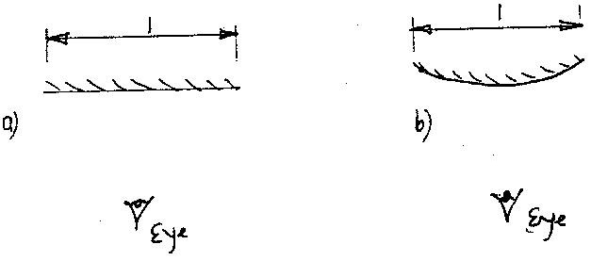

By sketching a pair of incident and reflected rays for each (a) and (b)
show how the convex mirror provides to the eye, a wider field of view
than the plane mirror.

11. 2004 Q23 P1
Figure 12 shows a parabolic surface with a source of light placed at
its focal point F

Draw rays to show reflection from the surface when rays from the
source strike the surface at points ABC and D.

12. 2005 Q22 P1
Fig. 12 shows a vertical object, O, placed in front of a convex mirror.

Fig 12
On the same diagram draw the appropriate rays and locate the image formed (3 marks)
13. 2006 Q18(a) P1
Figure 8 shows an object placed in front of a concave mirror of focal
length 10cm. C is the centre of curvature.

      - On the same figure draw a ray diagram showing the location
of the image (4 marks)
Use the ray diagram drawn in (i) above to determine the

      - Image distance (2 marks)
      - Magnification (2 marks)

14. 2007 Q4 P2
Figure 3 shows an object, O in front of a concave mirror and its image,
I formed after reflection.

(a) On the same diagram draw appropriate ray (s) to locate the principal
focus, F, of the mirror. (2 marks)

(b) Determine the focal length of the mirror (scale 1: 5) (1 mark)

15. 2010 Q5 P2
Figure 4, shows a bright electric lamp placed behind a screen which has
a hole covered with wire gauze. A concave mirror of focal length 25cm
is placed in front of the screen. The position of the mirror is adjusted
until a sharp image of the gauze is formed on the screen.

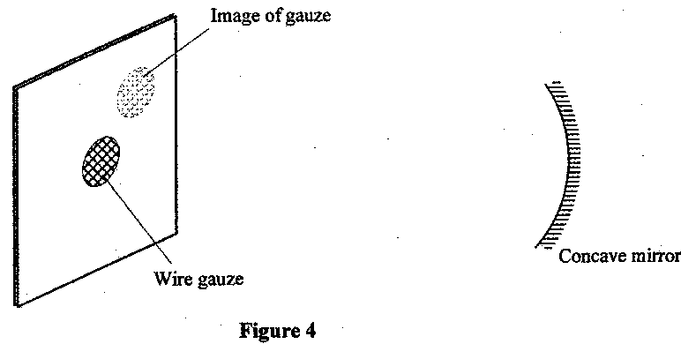

Determine the distance between the mirror and the screen. (1 mark)

16. 2012 Q17 P2
b) Figure 17 shows an object O placed in front of a converging mirror of
focal length 15 cm.

Draw on the figure a ray diagram to locate the image formed (3 marks)

c) State why parabolic reflectors are used in car headlights. (1 mark)

17. 2013 Q5 P2
Figure 2 shows the image of an object formed by reflection in a converging
mirror. C is the centre of curvature of the mirror.

Complete the diagram to show:
- How incident rays are reflected to form the image: (2marks)
- The object position (1mark)

18. 2014 Q5 P2
Figure 2 shows circular waves originating from the principal focus F
of a concave mirror and moving towards the mirror.

Complete the diagram to show the reflected waves. (1 mark)

19. 2015 Q5 P2
State the reason why a convex mirror is preferred over a plane mirror
for use as a driving mirror. (1 mark)

MAGNETIC EFFECT OF AN ELECTRIC CURRENT

1. 1995 Q14 P1
The force on a conductor carrying a current in a magnetic field can be varied
by changing, among others, the magnitude of the current and the magnetic
field strength. Name two other factors that can be changed to vary the force.
(2 marks)
2. 1996 Q13 P1

Figure 4 shows two parallel current conductors A and B placed close to each
other. The direction of the current is into the plane of the paper.
On the same figure;

- Sketch the magnetic field pattern (1 mark)
- Indicate the force F due to the current on each conductor (1 mark)

3. 1997 Q16 P1
Figure 7 shows an incomplete circuit of an electromagnet. Complete the
circuit between X and Y drawing the windings on the two arms of the core
such that A and B are both North poles when switch S is closed. Indicate
the direction of the current on the windings drawn. (1 mark)

4. 1997 Q5 (b) & (c) P2
(b) In the set up in figure 5, the suspended metre rule is in equilibrium balanced
by the magnet and the weight shown. The iron core is fixed to the bench.

  - State and explain the effect on metre rule when the switch S is closed (1 mark)

  - What would be the effect of reversing the battery terminals (1 mark)
  - Suggest how the set up in figure 5 can be adapted to measure
the current flowing in the current circuit. (1 mark)

5. 1998 Q1 P2
a) In an experiment to determine the strength of an electromagnet, the
weight of pins that can be supported by the electromagnet, was recorded
against the number of turns. The current was kept constant throughout
the experiment. Table 1 shows the data obtained.

Number of turns, n, | 0 | 4 | 8 | 12 | 16 | 20 | 24 | 28 | 32 | 36
Weight, of pins x10⁻³(N) | 0 | 4 | 14 | 30 | 58 | 108 | 198 | 264 | 296 | 300

Table 1
(i) Plot a graph of weigh, W (y-axis) against the number of turn’s n
(ii) Use the domain theory to explain the nature of the curve.
(iii) Sketch on the same axes, the curve that would be obtained using a
higher current.

b) Using a labeled diagram, explain the working of a simple relay.

6. 1999 Q13 P1
Figure 9 shows a wire carrying a current whose direction is into the paper.
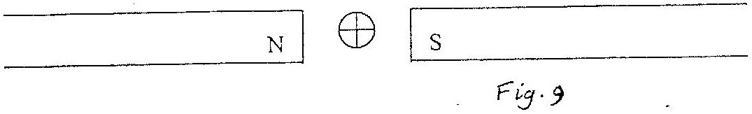

The wire is placed in a magnetic field.
Indicate on the figure the direction of the force acting on the wire. (1 mark)

7. 1999 Q33 P1
Figure 16 shows a wire XY at right angles to a magnetic field. XY is
part of circuit containing a galvanometer.
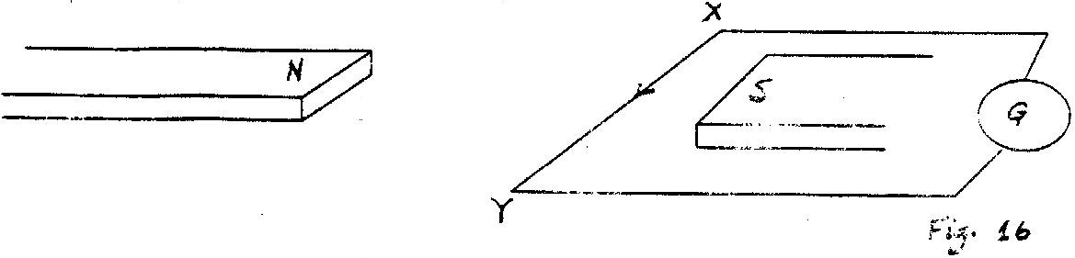

In which direction is XY is moved

8. 2000 Q13 P1
In fig 8 the arrow indicates the directions of the current in the conductor.
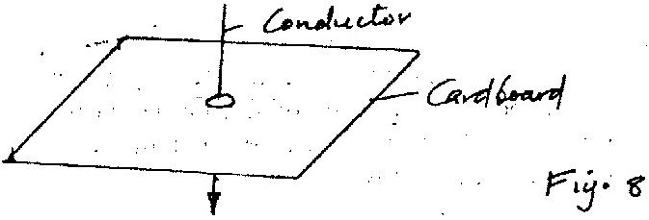

Sketch on the diagram the magnetic field pattern due to the current.

9. 2001 Q2a P2
a) Fig 1 (a) shows the circuit of a simple telephone receiver.When the
telephone is lifted, a steady current flows through the solenoids. When
a person speaks into the microphone on the other side, a varying current
flows. These two currents are shown in fig. 1(b).
i) State the reason why solenoids are wounds in opposite directions
around the soft-iron core pieces as shown. (1 mark)
ii) Explain how the speech current from the microphone is converted
into sound in the receiver. (4 marks)
iii) State and explain the effect of replacing the soft iron core pieces
with steel core pieces. (3 marks)

10. 2002 Q13 P1
Fig. 8 shows two parallel thick copper conductors connected to a D.C.
power supply. A rider made from a thin copper wire is placed on the conductors.
State and explain what is observed on the rider when the switch is closed. (3 marks)

11. 2002 Q33 P1
Fig.1 shows a wire XY placed in a magnetic field.
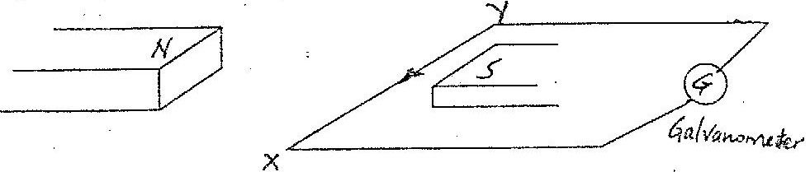

State the direction in which the wire must be moved for the current to
move in the direction shown.

12. 2004 Q12 P1
Figure 8 shows a current-carrying coil in a magnetic field.
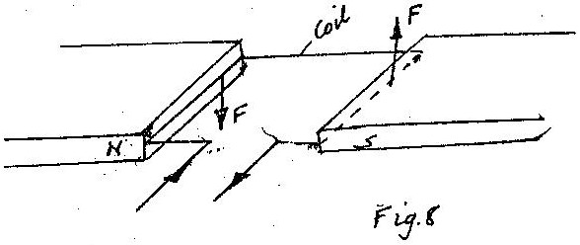

Use the information on the figure to answer question 12 and 13.
Mark on figure 8 the direction of the forces acting on the sides of
the coil labelled
(2 marks)
13. 2004 Q13 P1
State two ways of increasing the force on the coil. (2 marks)

14. 2005 Q12 P1
Fig 9 shows a current carrying coil in a magnetic field. The direction of
the current and the resulting force are shown. Study the figure and answer
questions 12 and 13.
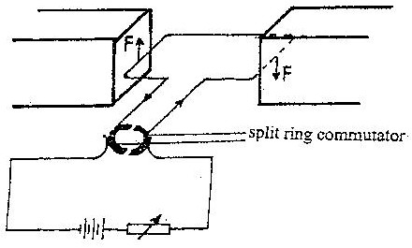

Fig 9

Label the poles of the magnets. (1mark)

15. 2005 Q13 P1
Explain the purpose of the split ring commutator in the principle
of the D.C motor shown in the diagram. (2marks)

16. 2005 Q37 P1
In the set up Fig 1 the metal rod is made up of steel and iron pieces
joined end. Your are provided with two iron nails.

Explain how you would use two nails provided to determine which
side is iron (2 marks)

17. 2006 Q6 P2
Figure 4 shows a solenoid carrying an electric current.
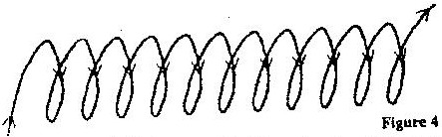

Sketch the magnetic field pattern inside and at the ends of the solenoid (1 mark)

18. 2008 Q6 P2
Figure 3 shows a flat spring made of iron clamped horizontally on the
bench over a solenoid.

When the switch is closed, the spring vibrates. Explain this observation. (3 marks)

19. 2009 Q5 P2
An electromagnet is made by winding insulated copper wire on an iron
core. State two changes that could be made to increase the strength
of the electromagnet (2 marks)

20. 2010 Q3 P2
Figure 2(a), shows a magnetic compass placed under a horizontal wire XY

A large current is passed from X to Y. Draw the final position of the
magnetic compass needle in figure (1 mark)

21. 2010 Q3 P2
Figure 3, shows a diagram of a current-carrying wire wound on a
U-shaped soft iron

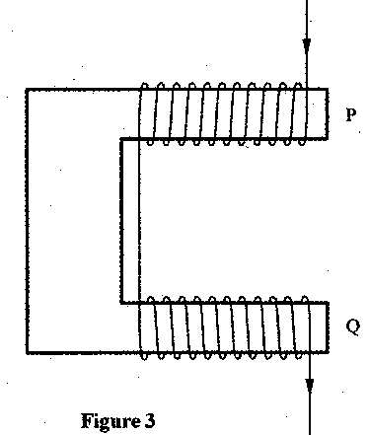

Draw the magnetic field pattern around P and Q. (2 marks)

22. 2010 Q11 P2
Figure 1, shows a horizontal conductor in a magnetic field parallel to
the plane of the paper.

conductor

State the direction in which the wire may be moved so that the induced
current is in the direction shown by the arrow.

23. 2011 Q7 P2
Figure 5, shows a motor connected to amagnetic switch called arelay
operated by ordinary switch S1. Use the infoemation in the figure to
answer question 23 and 24

Explain how the relay switches on the motor when S₁ is closed. (3 marks)

24. 2011 Q8 P2
State with a reason the effect on the motor, if the iron core is replaced
with a steel Core and switch S₁ is put on and then off. (2 marks)

25. 2012 Q7 P2
Figure 7, shows two similar coils P and Q around the end L and M of a
piece of soft iron. A steady current passes through the coils.
State the polarity of the resulting magnet at end L (1 mark)

26. 2012 Q11 P2
Figure 10, shows the cross section of a conductor held between two
magnets and carrying a current out of the paper
Indicate with an arrow on the diagram the direction in which the
conductor will move when it is released. (1 mark)

27. 2012 Q11a P2
(a) Figure 14 shows an E shaped steel block being magnetized by a
current through two coils in series.
On the figure, indicate
- The north and south poles of the resulting magnet (1mark)
- The complete magnetic field pattern between the poles (1mark)

28. 2013 Q19 P2
- Figure 15 shows the permanent magnet made in part (a) above.

A coil wound loosely on the middle limb is connected in series with a low
voltage a.c. and a switch. State and explain the observation made on the
coil when the switch is closed (2 marks)

(b) In a simple cell, the zinc plate gets negatively charged and the copper
plate gets Positively charged.

- Name the electrolyte in the cell (1mark)

- Explain how:
- Zinc gets negatively charged. (1 mark)
- Copper gets positively charged (1 mark)

- State what constitutes the current when a wire is used to connect
the zinc plate and the copper plate externally. (1mark)

29. 2014 Q5 P2
Figure 3 shows a nail on which a wire is to be wound to make an electromagnet.
By drawing, show how the wire should be wound around the nail so that end
A becomes a north pole and end B a south pole. (1 mark)

30. 2014 Q14 P2
Figures 6 show a simple electric bell circuit.
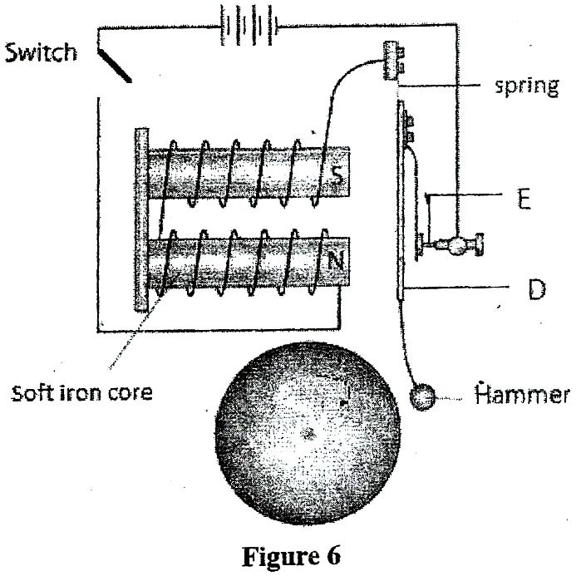
- Name the parts labeled:
- D (1 mark)
- E (1 mark)

- When the switch is closed, the hammer hits the gong repeatedly.
Explain why:
i) The hammer hits the gong. (2 marks)
ii) The hammer hits the gong repeatedly. (3 marks)

(b) An electric bulb is rated 60W, 240 V. Determine:
(i) The current that flows through it when it is connected to a
240 V supply (3 marks)
(ii)The resistance of the bulb. (3 marks)

31. 2015 Q6 P2
State two ways in which the strength of an electromagnet can be increased. (2 marks)

HOOKES’ LAW
1. 1994 Q3a P2
State Hooke's law (1 mark)

2. 1999 Q11 P1
A wire fixed at one end extends by 4mm when a load of 20N is suspended
from the other end. Determine the load that would cause an extension
of 1.5 mm on the wire (assume elastic limit is not exceeded)

3. 2002 Q10 P1
Fig. 5 shows a wire A and a spring B made of the same material. The
thickness of the wire is the same in the both cases. Masses are added
on each at the same intervals and the extension noted each time.

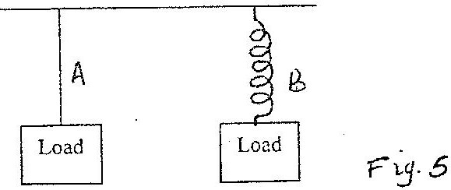

On the same axes provided, sketch the graphs of extension against
load for each. (hookes’ law is obeyed.)
Extension
Load

4. 2003 Q2 P1
Two identical spring balances R and S each weighing 0.5N are arranged
as shown in Figure 2.

What is the reading on balance R?

5. 2005 Q5 P2
(a) State Hooke’s law (1 mark)
(b) One of a piece of a rubber was fixed to a rigid support and the
other end pulled with a force of varying magnitude. The graph
in fig 6 shows the relationship between the force (N) and the
extension (cm)

Using the graph, determine
(i) The stretching force at the elastic limit
(ii) The tensile stress in the rubber at an extension of 5cm if the
cross-section of the rubber is 0.25cm²

(iii) The tensile in the rubber at an extension of 5 cm if the original
length was 2m (3 marks)

(c) In Fig 7. girders AB, BC, CD, ED, EB and BD were joined to make the rigid
structure shown. The load W hangs from the structure as shown.

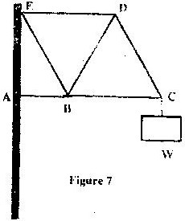

Which of the girders can be replaced with strings without affecting the structure?
(2 marks)
6. 2006 Q5 P1
The spiral springs shown in figure 4 are identical. Each spring has a spring
constant k = 300N/m

Determine the total extensions caused by the 90N weight. (Ignore the
weight of the spring and connecting roots) (3 marks)

7. 2006 Q15 P1
(a) You are provided with two wires of same material and same thickness.
Describe how you would make two spiral springs of different springs
constants (assume that other apparatus to make springs are available). (2 marks)

(b) In an experiment, two identical springs are attached end to end. One
end of the combined springs is fixed to a rigid support such that the
spring hangs vertically. Masses are then hang from the lower end.

The graph in figure 1 shows the relation between the force (weight)
and the extension for the combined springs.

From the graph determine

(i) The elastic limit for the combined springs (1 mark)
(ii) The springs constant of the combined spring and hence for
each spring (4 marks)

(iii) The work done in stretching the combined spring from 15 mm to32 mm
(3 marks)
8. 2008 Q13 P1
The graphs in Fig. 7 represent the relations between extension e and
mass m added on two springs x and y.

Given that the two springs are made of same materials, give a reason
why the graphs are different. (1 mark)
9. 2009 Q10 P1
The three springs shown in the figure are identical and have negligible
weight. The extension produced on the system of springs is 20cm.

Determine the constant of each spring. (2 marks)

10. 2010 Q13 P1
State the SI unit of a spring constant (NB in words) (1 mark)

- 2011 Q3 P1
Figure 2 shows a spring balance. Its spring constant is 125Nm. The
scale spreads a distance of 20cm

determine the maximum weight that can be measured using the spring. (3marks)

- 2012 Q10 P1
Table 1 shows the result of an experiment carried out to study the
properties of a spring.
Table 1

Force (N) | 0 | 10 | 20 | 30 | 40
Extension (cm) | 0 | 2 | 4 | 6 | 8

State with a reason whether the experiment was done within the elastic
limit of the spring. (2 marks)

- 2013 Q4 P1
An object of weight 20 N attached at the end of a spring causes an extension
of 0.5 cm on the spring.

(a) Determine the spring constant of the spring. (2 marks)
(b) Determine the weight of an object that would cause an extension of
0.86 cm when attached at the end of the same spring. (1 mark)

14. 2014 Q10 P1
A light spiral spring extends by 4mm when loaded with a weight W. The
spring is connected in series with an identical spring. The combination is
loaded with the weight W. Determine the extension of the combination. (2 marks)

WAVES I
1. 1996 Q5a, c P2
(a) (i) What is the difference between longitudinal and transverse waves? (1 mark)
(ii) State two distinctions between the way sound waves and
electromagnetic waves are transmitted (2 marks)

- In an experiment to observe interference of light waves a double
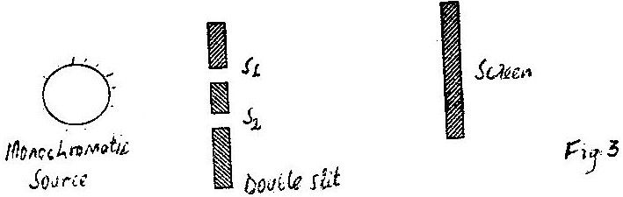
slit is placed close to the source. See figure 3

(i) State the function of the double slit (1 mark)
(ii) Describe what is observed on the screen (2 marks)

(iii) State what is observed on the screen when
i). The slit separation S₁S₂ is reduced (1 mark)
ii). White light source is used in place of monochromatic source (1 mark)

2. 1997 Q21 P1
Calculate the wavelength of the KBC FM radio wave transmitted at a
frequency of 95.6 Mega Hertz. (2 marks)

3. 1997 Q(a), (b) & (c) P1
a) i. Distinguish between transverse and longitudinal waves (1 mark)
ii. Give one example of a transverse and one example of longitudinal. (1 mark)

b) Figure 6 shows the displacement of a particle in a progressive wave
incident on a boundary between deep and shallow regions.
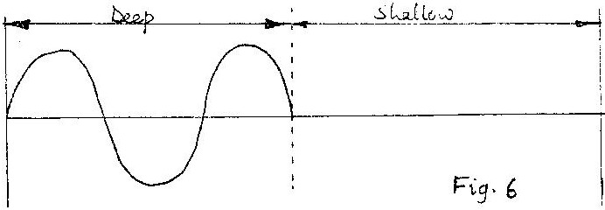

- Complete the diagram to show what is observed after boundary.
(assume no loss of energy) (1 mark)
- Explain the observation in (i) above. (3 marks)

(c) Water waves are observed as they pass a fixed point at a rate of
30 crests per minute. A particular wave crest takes 2s to travel
between two fixed points 6m apart. Determine for the wave:
(a) The frequency (1mark)
(b) Wavelength (3 marks)

4. 1999 Q18 P1
Two tuning forks of frequencies 256Hz and 258 Hz are sounded simultaneously
and then placed close to each other, calculate the beat frequency.

5. 1999 Q1a P2
a) Distinguish between longitudinal and transverse waves (1 mark)

b) Figure 2 represents a displacement – time graph for a wave.
Displacement time

i) Determined the frequency of the wave. (4 marks)
ii) Sketch on the same axes, the displacement – time graph of a wave
of the same frequency but 180º out of phase and with a smaller amplitude.
(2 marks)
6. 2000 Q17 P1
Give one example of a longitudinal wave. (1 mark)

7. 2002 Q23 P1
Fig. 12 shows water waves incident on an aperture AB.
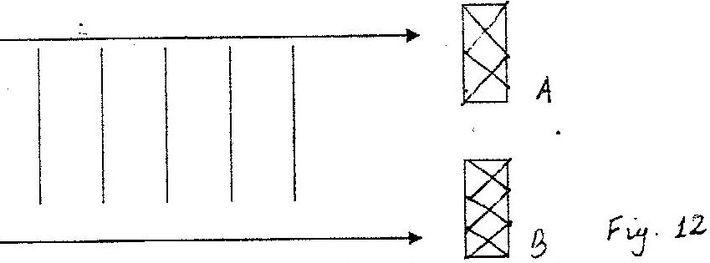

On the same diagram, sketch the waves after going through the aperture.

8. 2002 Q24 P1
The audible frequency range for a certain person is 30 Hz and 16,500 Hz.
Determine the largest wavelength of sound in air the person can detect.
(Speed of sound in air = 330m/s) (3 marks)

9. 2003 Q4 P2
a) Figure 3 shows a transverse wave travelling along x-axis.

(i) Determine the:
I Wavelength of the wave
II Amplitude of the wave.

(ii) If the time taken by the wave to move from 0 to A is 0.09 seconds,
determine the:
I Frequency of the wave.
II Speed of the wave

10. 2004 Q19 P1
State the difference between mechanical and electromagnetic waves.

11. 2005 Q16 P1
Fig 10 represents a transverse wave of frequency 5 Hz traveling in the
x direction.
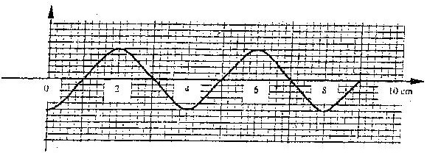

Determine the speed of the wave. (3marks)

12. 2005 Q28 P1
Fig 15 shows an arrow which indicates the direction of travel of a wave
in a medium. P is a particle of the medium that is in path of the wave.

In the space provided sketch diagram to show how the particles P moves
when the wave is
(i) A transverse wave
(ii) A longitudinal wave. (1mark)

13. 2006 Q5 P2
A long coil is attached to a vibrating blade as shown in figure 3

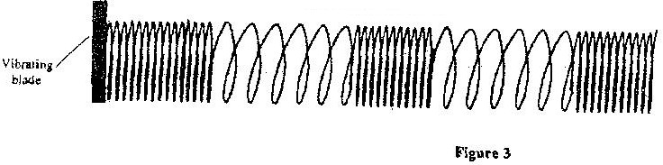

State the type of mechanical wave generated by the set - up and mark alongside
the coil, the length corresponding to the wavelength, λ of the wave. (2 marks)

14. 2007 Q5 P2
Figure 4. shows the displacement – time graph for a certain wave
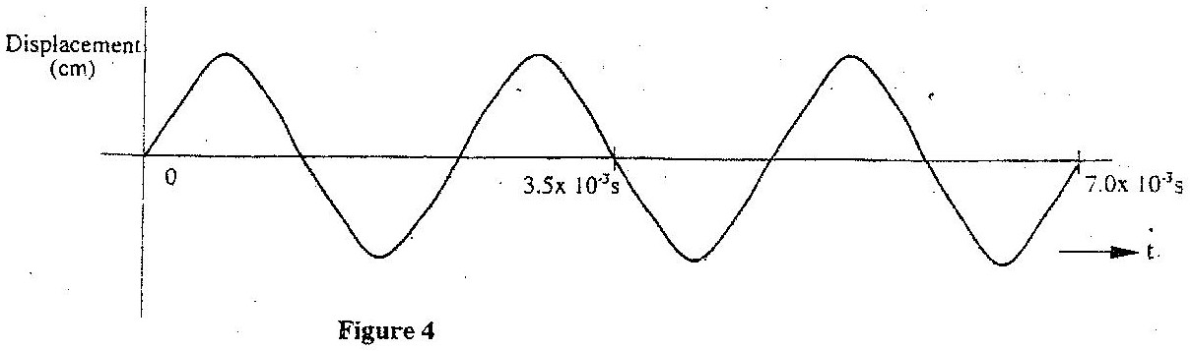

Determine the frequency of the wave (3 marks)

15. 2008 Q7 P2
Figure 4 shows a hack-saw blade clamped horizontally on a bench
and the free end is made to vibrate about the rest position.
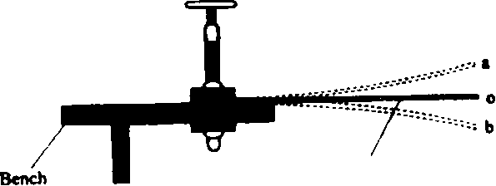
Hacksaw blade

The movement o a 0 b 0 a 0 b
takes 0.7 seconds.

Determine the frequency of vibration of the blade. (2 marks)

16. 2009 Q6 P2
Figure 2 shows how the displacement varies with time for a certain wave.

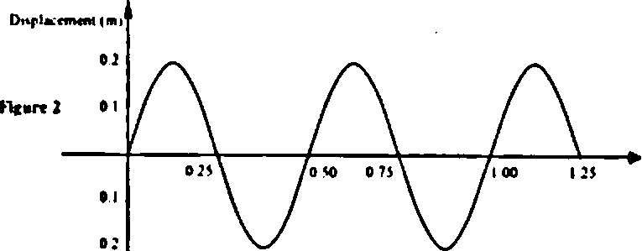

Determine the frequency of the wave (3 marks)

17. 2010 Q7 P2
Figure 5, shows how the displacement of a point varies with time as a
wave passes it.
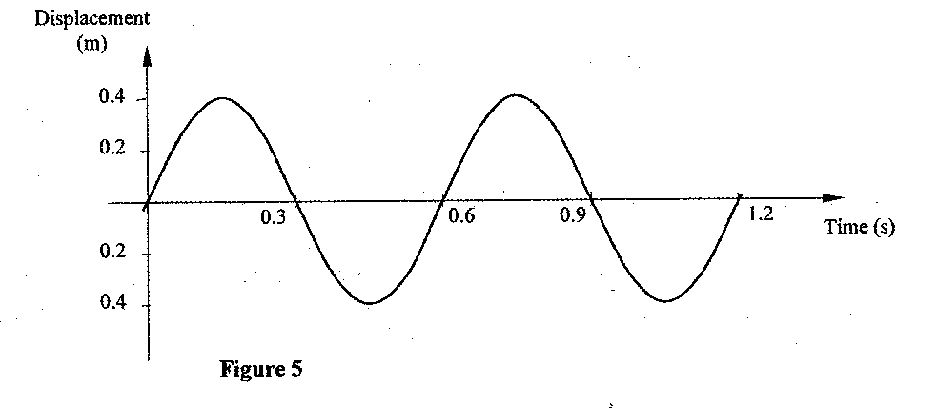
On the same diagram, draw a wave which passes the point with half
the amplitude and twice the frequency of the one shown. (2 marks)

18. 2010 Q13 P2
The wavelength of a radio wave is 1km. Determine its frequency. (Take
the speed of light as 3.0 x 10⁸ ms⁻¹) (2 marks)

19. 2011 Q9 P2
Figure 6 shows standing waves on a string. It is drawn to scale of 1:5

Indicate on the diagram the wavelength of the standing wave (2 marks)

20. 2011 Q9 P2
a) Figure 12, shows a displacement –time graph for a progressive wave.
Displacement (cm)
time(s)

- State the amplitude of the wave (1mark)
- Determine the frequency of the wave (4marks)
- Given that the velocity of the wave is 20^{ms-1} , determine its wavelength (3marks)

21. 2015 Q7 P2
State two differences between electromagnetic waves and mechanical waves.
(2 marks)

SOUND
1. 1995 Q31 P1
State a characteristic of sound, which is determined by overtone (1 mark)

2. 1996 Q10 P1
The pitch of the note produced by a wire depends on the tension in
the wire. State the other factor that affects the pitch (1 mark)

3. 1996 Q18 P1
What characteristic of sound is applied in turning pianos? (1 mark)

4. 1996 Q28 P1
An observer A is in a moving vehicle with a siren on while an observer
B is stationary on the side of the road. State the difference between the
sound heard by A and B as the vehicle approaches B at a high constant
speed (2 marks)

5. 1996 Q5b P2
A mineworker stands between two vertical cliffs 400m from the nearest
cliff. The cliffs are X distance apart. Every time he strikes the rock once, he
hears two echoes, the first one after 2.5 s, while the second follows 2s later.
From this information; calculation:
(i) The speed of the sound in air (2 marks)
(ii) The value of X (3 marks)

6. 1997 Q17 P1
An observer watching a fireworks display sees the light from an
explosion and hears the sound 2 seconds later. How far was the
explosion from the observer? (3 marks)

7. 1997 Q32 P1
Two turning forks are sounded together. What is the condition for
the beats to be heard?

8. 1998 Q28 P1
What determines the quality of a musical note?

9. 1998 Q2(a) P2
You are provided with two straight open tubes each about 1m long, a
sound source, a sound detector and a reflecting surface. With the aid
of a labeled diagram, describe an experiment to show that the angle of
incidents is equal to reflection for sound waves. (5 marks)

10. 1999 Q18 P1
Two tuning forks of frequencies 256Hz and 258 Hz are sounded simultaneously
and then placed close to each other, calculate the beat frequency.

11. 2000 Q21 P1
A wire is stretched between two fixed points such that when it is plucked,
it produces sound. Explain why the pitch of the sound produced may
become lower when the temperature of the surrounding rises.

12. 2002 Q17 P1
Name two factors other than tension, which determine the frequency of
sound form stretched wire at room temperature.

13. 2002 Q24 P1
The audible frequency range for a certain person is 30 Hz and 16,500 Hz.
Determine the largest wavelength of sound in air the person can detect.
(Speed of sound in air = 330m/s)

14. 2003 Q21 P1
A girl standing 600m away from a cliff bangs two pieces of wood together
and hears and echo 3.5 seconds later. Determine the speed of sound in
air at that place.
(3 marks)
15. 2005 Q17 P1
An electronic siren producing sound continuously at a certain frequency
is dropped from the top to a deep hole. State and explain what is observed
about the pitch of the sound reaching the observer at the top. (3 marks)

16. 2004 Q6 P2
a) You are provided with two identical tuning forks and some plasticine.
Describe how you would demonstrate beats in sound.

b) Fig 8 shows a set up that was used in an experiment to determine the
speed of sound air
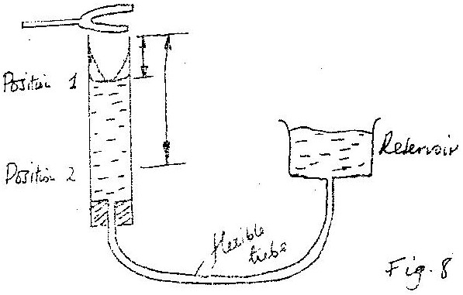

Turning forks of different frequencies were sounded near the mouth
of the open tube and by lowering the reservoir, the list two resonant
lengthsL₁ L₂ were ensured for each frequency.

Table 1 shows the results obtained.

Frequency, f (H_{Z}) | 256 | 288 | 341 | 427 | 480 | 512
L₁(cm) | 30,8 | 27.2 | 22.8 | 17.9 | 15.8 | 14.7
L₂(cm) | 95.5 | 84.5 | 71.2 | 56.6 | 50.2 | 46.9
¹/_{f} (HZ⁻¹)
L₂ – l_{1(m)}

(i) Complete the table. On the grid provided, plot the graph of l₂– l₁ (y-axis)
against ¹/_{f}
(ii) From the graph determine the speed V of sound in air given that
1₂-1₁ = v/2r. Therefore V= 2f(1₂ – 1₁)
(iii) Explain how resonance is attained in this set up.

17. 2006 Q8 P2
S soldier standing some distance from a wall, blows a whistle and hears
its echo 1 seconds later. How far is the wall from the soldier?
(speed of sound in air is 330ms⁻¹) (3 marks)

18. 2008 Q15 P2
a) State one factor that affects the speed of sound in a solid. (1 mark)

b) An observer stands half-way between two vertical cliffs that are L metres
apart. He moves directly towards one cliff and after a distance x=10cm
from the centre, he strikes a gong and measures the time interval, t, between
the echoes heard from the two cliffs. He moves a further 10m and again
strikes the gong and measure the time interval between the echoes. The
process is repeated several times.

The graph in Figure 8 shows the relation between the time interval, t and
the distance, x from the centre.

Distance x (cm)
Time t (s)

- From the graph, determine the value of x for which the time
- interval was 0.55. (1 mark)
(ii) Given that t= ⁴/_{v} x where v is the speed of sound in air, determine
the value of v from the graph. (3 marks)

(iii) If the maximum time measured by the observer was t=4.7s,
determine the distance L between the cliffs. (3 marks)

(c) A search boat uses a signal of frequency 6.0 x 10⁴ H_{z} to detect a sunken
ship directly below. Two reflected signals are received; one after 0.1
seconds from sunken boat and the other after 0.14 seconds from the
sea bed. If the sea bed is 98 m below the boat, determine:-

(i) The speed of the signal in water. (3 marks)
You may use the value of v from (ii) above.
(ii) The depth of the sunken ship below the boat (2 marks)

19. 2009 Q12 P2
A boy standing in front of a cliff blows a whistle and hears the
echo after 0.6s determine the speed of the sound (3 marks)

20. 2014 Q17b P2
Figure 10 shows sound waves in air produced by a vibrating tuning fork.
R is an air molecule on the path of the waves.
Oscillation

(i) Using a line, indicate on the diagram a distance d equal to one
wavelength of the wave. (1 mark)

(ii)In the spaces provided, show with an arrow the direction of motion of the
air molecule R as the waves pass. (1 mark)

(iii)Explain the reason for the answer in (ii) (2 marks)

21. 2015 Q9 P2
A ship in an ocean sends out an ultra sound whose echo is received after
3 seconds. If the wavelength of the ultra sound in water is 7.5 cm, and the
frequency of the transmitter is 20 kHz, determine the depth of the ocean. (3 marks)
FLUID FLOW
1. 1996 Q24 P1
Figure 7 represents a tube through which a liquid is flowing in the flowing
in the diagram shown by the arrow

Show on the diagram the relative positions of the levels of the liquid in
section marked x, y and z (2 marks)

2. 1996 Q24 P1
State how the pressure in a moving fluid varies with the speed of the fluid (1 mark)

3. 1997 Q18 P1
Water flows in a horizontal smooth pipe. State the changes that would
be observed in the nature of the flow if the speed of the water is steadily
increased from low to a high value (2 marks)

4. 1998 Q30 P1
Fig 9 shows a Bunsen burner.
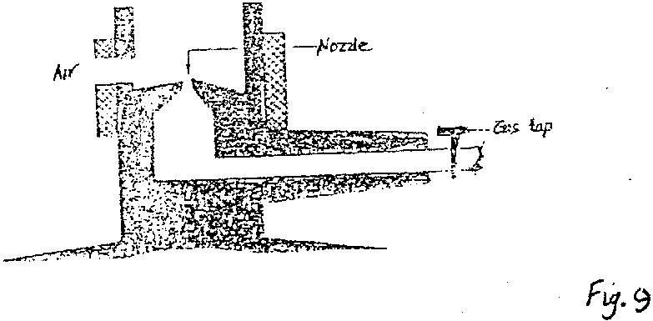

Use Bernoulli’s principle to explain how air is drawn into the burner,
when, the gas tap is opened. (3marks)

5. 1999 Q25 P1
Figure 13 shows a section of a pipe PQ. A constant pressure difference
maintains a streamline flow of a liquid in the pipe.
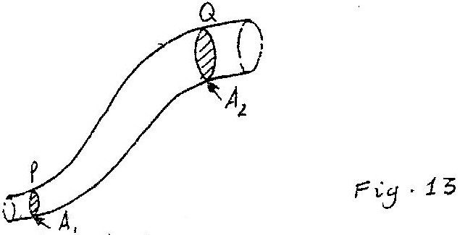

If the cross-sectional area A₁ at P is less than A₂ at Q, state how the
liquid velocity. V₂ at Q compares with velocity V₁ at P. (1 mark)

6. 2000 Q25 P1
A student holds a sheet of paper at one end so that it hangs in the
position A shown in fig. 14

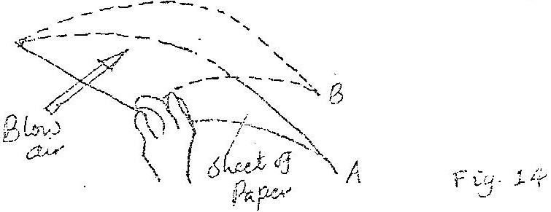

Explain why the paper rises to the position B when the student
blows air in the direction shown by the arrow. (2 marks)

7. 2001 Q23 P1
Fig. 16 shows a non – viscous fluid flowing through a pipe a long which
vertical tubes A, B and C have been fitted.

Complete the diagram by indicating the possible levels of the fluid in
tubes B and C. (1 mark)

8. 2003 Q36 P1
Figure 19 shows a pith ball placed in a flask. When a jet of air is blown over
the mouth of the flask as shown, the pith ball is observed to rise from
the bottom

Explain this observation

9. 2005 Q26 P1
State Bernoulli’s principle. (1 mark)

10. 2006 Q11 P1
A pipe of radius 6 mm is connected to another pipe of radius 9 mm. If
water flows in the wider pipe at the speed of 2 ms⁻¹, what is the speed
in the narrower pipe? (3 marks)

11. 2007 Q3 P1
Figure 2 shows a tube of varying cross sectional area

Arrange the speed V₁V₂V₃ and V₄ in decreasing order starting with
the highest (1 mark)

12. 2008 Q12 P1
Fig. 6 shows a sheet of paper rolled into a tube.

When a fast stream of air is blown into the tube as shown in the
diagram the paper tube collapses. Explain the observation. (2 marks)

13. 2009 Q11 P1
Figure 6 shows two inflated balloons hanging vertically on light threads

When a stream of air is blown in the space between the balloons, they are
observed to move towards each other. Explain this observation. (1 mark)

14. 2010 Q7 P1
Figure 4 shows a horizontal tube with two vertical tubes x and y. water
flows through the horizontal tube from right to left. The water level in
tube x is higher than water in tube y.

Explain this observation. (2 marks)

15. 2012 Q14 P1
Figure 7 shows part of a petrol engine, in which air flowing under
atmospheric pressure passes into a constriction, where it mixes with
petrol. The mixture then flows into a combustion cylinder.

Explain what causes the petrol to move from the petrol chamber to the
air steam in the constriction when the piston is moved downwards.

16. 2012 Q14 P1
- An aeroplane is moving horizontally through still air at a uniform speed.
It is observed that when the speed of the plane is increased, its height
above the ground increases. State the reason for this observation. (1 mark)

(b) Figure 5 shows parts A, B and C of a glass tube.
State with a reason the part of the tube in which the pressure will be lowest
when air is blown through the tube from A towards C. (2 marks)

17. 2013 Q10 P1
Figure 5 shows a bunsen burner.
Explain how air is drawn into the burner when the gas tap is open. (3 marks)

18. 2014 Q11 PP1
Figure 7 shows an incompressible fluid flowing through a pipe, A₁ and A₂
are the cross sectional areas of the pipes in the larger section and smaller
section of the pipe respectively, while V1 and V2 are speeds of the fluid
at the two section of the pipe.
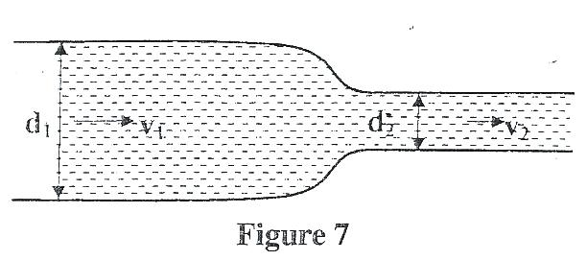
Derive an expression for the ratio of the speeds V₂/V₁ in terms of A1 and A2
(2 marks)

19. 2015 Q9 P1
Figure 5 shows air flowing through a pipe of different cross-sectional areas.
Two pipes A and B are dipped into water

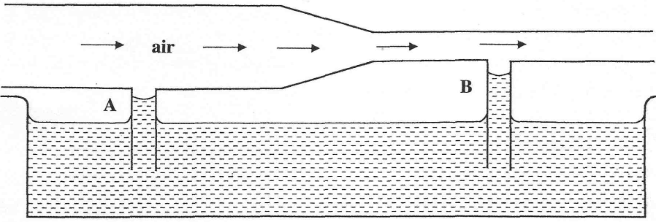
Figure 5
Explain the cause of the difference in the levels of water in the pipes A and B.

MAGNETISM
MARKING SCHEME
- 1995 Q15 P1
All ferromagnetic materials are attracted by magnets or any magnetic materials is
attracted

- 1996 Q2 P2
(a) (i) Each bar is suspended at a time using the string;
The suspended bar is allowed to rest;
Its orientation is observed and recorded;
This is repeated several times for confirmation
(ii) The bar magnet settles in the N – S specific direction, due to its
Interaction (l) with magnetic field of the earth (l)
The iron bar settles in any direction; (l) because it does not have
a magnetic field to the interact with that of the earth; (l)
(b) P and Q are magnetized to the same level, by applying two different (l)
current lp and lq such that lq > lp (l)
Thus Q requires greater magnetizing power, (l) since its domains are
more difficult to align; (l) P is easier to magnetize, since its (l)
domain are more easily aligned: (1 mark) (Total 14 marks)

- 1997 Q14 P1
Soft – easily magnetised and easily demagnetised
Hard – Neither easily magnetised nor easily demagnetised

- 1997 Q16 P1

340 x 2 = 680 anticlockwise windings

X Y

A B
- 1997 Q5a,b P2
a) Amount of current , No of coils / shape of core / X – core
b) i) End of coil facing up becomes a south pole and the metre rule
is pulled down / attraction occurs. Or Rule tips; core
magnetized; top of core becomes south pole; attracts magnet.
ii) Rule moves up (repelled by the core)
iii) The metre rule to have appointer attached to read zero when switch S is
open. Use rheostat to vary current to maximum and calibrate accordingly.

- 1998 Q14 P1
Domains/Dipoles initially organized are disorganized by mechanical forces.

- 1999 Q12 P1
-Dipping a magnet into a container with iron fillings, most of them will cling at
the poles ⇒
- Use of plotting compass to trace.
- 2000 Q12 P1
The keepers become magnetized thus neutralizing the pole; this reduces repulsion at the poles, thus helping in retention of magnetism

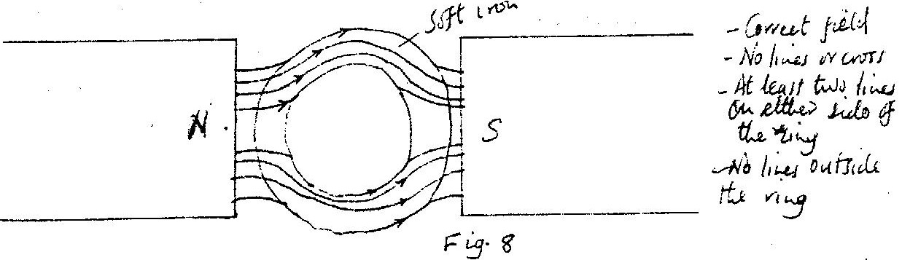
- 2001 Q11 P1

- 2002 Q11 P1
Neutral

X
N S

- 2002 Q11 P1
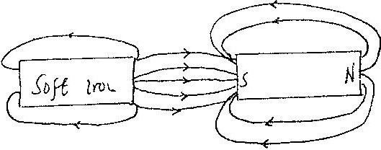

- 2003 Q13 P1
It does not retain magnetism / Iron is easily magnetized / demagnetized / Iron enhances / strengthens magnetism.

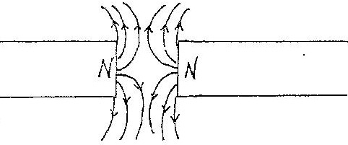
- 2004 Q11 P1

Check
-correct pattern - correct direction NB- at least 4 lines of forces must be shown

- 2005 Q37 P1
When the switch is closed and nails attracted.
When the switch is opened, the nail on the iron end drops first.

- 2006 Q1 P2
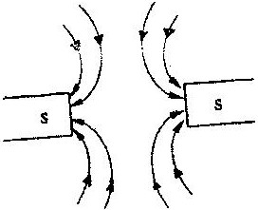

- 2007 Q3 P2
X is north (both correct)
Y is north

- 2008 Q4 P2
Hammering causes the domains or dipoles to vibrate when setting, some domains themselves in the N- S direction due to the earth’s magnetic field causing magnetism.

- 2010 Q2 P2

- 2011 Q6 P2
Hammering disarrange the dipoles as the earth’s magnetic field rearrange
the dipole to face same direction

- 2013 Q3 P2
the resultant attractive force is concentrated at the poles

21. 2014 Q7 P2
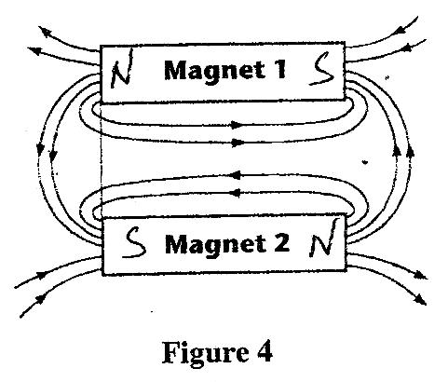
22. 2015 Q17 P2
Repulsion occurs that is, the suspended magnet moves away from the iron bar.
This is because the flow of current creates an electromagnet wit side B becoming North hence repelling the suspended magnet
MEASUREMENT II
MARKING SCHEME

- 1995 Q1 P1
Micrometer screw gauge

- 1995 Q1 P1
Oil spread until it is one molecule thick or film taken as a perfect circle or oil drop has been taken as perfect sphere/ cylinder/ uniform thickness

- 1995 Q1 P1
15.00 + 0.30 = 15. 30 mm; or 1.53 / 1.53 x 10²m

- 1997 Q6 P1
Volume of 1 molecule = 18cm³
6 x 10²³
Diameter of the molecule = 18cm³
6 x 10²³

3 18cm³
6 x 10²³ = 3.1 x 10⁻⁸ cm
OR
= 3.1 x 10⁻⁸m

- 1999 Q1 P1
Reading on the vernier calipers
0.5 + 0.01(5) 0.5 +0.05cm = 0.0055m/5.50mm.

- 2002 Q3(a) P1
Fill tray with water to the brim and level on bench; sprinkle lycopodium
powder on the water surface either pick an oil drop with kinked wire; and measure the volume of a drop; put one drop at centre of the tray let oil spread and measure maximum diameter d of the patch; hence reproducing speech.

- 2002 Q1 P1
11.72/11.72 cm/0.01172m

- 2004 Q1 P1
15.5 + 0.33 = 15.83mm/1.583cm

- 2004 Q2(b) P1
i) When oil drop is placed at the centre of tray, oil spreads on water until it
is one molecule thick producing patch (monolayer)

ii) Volume of drop=⁴/₃Ωr³ =Ωr²h(r = radius of drop)
Volume of patch =Ωr²h (h=Thickness of molecule)
⁴/₃ Ωr³=Ωr³/Ωr²h (equating)
H=⁴/₃Ωr³/Ωr²+2 = 4x(0.25)³/₃ x (100)² 2.1x10⁻⁶mm

Because oil does not necessary spread to a monolayer/ one molecule thick or
Big errors in radius of oil drop and patch or errors in measurement of
diameter/radius.

iii) Put oil in a burette and read level, let 100 drops fall and read new level, obtain
radius using ⁴/₃Πr³ = Volume
or
Obtain thin wire and make Kink; deep in oil and let drop form on kink use a milimetre scale to measure diameter of drop.

- 2005 Q27 P1
273+ -281.3 = 8.3K (accept – 8.15 was use.)

- 2006 Q14(b) & (c) P1
(b) (i) Volume = 4/3 π r³
= ⁴/₃ π x 0.025³
= 6.54 x 10⁻⁵ cm³

(ii) Area = π r²
= π x 10²
= 314 cm²
(iii) A x diameter of molecule = volume;
314 x d = 6.54 x 10⁻⁵
d = 2.1 x 10⁻⁷ cm
(c) (i) The oil is assumed to have spread to thickness of one molecule
(ii) Sources of errors:
- Getting the right oil
- Measuring drop diameter
- Measuring diameter of patch
- Getting drop of a right size

- 2007 Q1 P1
0.562 – 0.012 = 0.550cm  5.62 – 0.12 = 0.55 cm  5.5 mm | Or 5.62 – 0.12  5.5 | 1 mark

- 2007 Q2 P1
Density p= m/r
D = m/v = 1.75g formula - accept g/mm³
(0.550)³cm substitution
= 10.5g/cm³ answer - allow transfer of error
=10500kg/m³

- 2010 Q1 P1
1.62cm / 1.62

- 2010 Q2 P1
2.53 + 0.50 = 3.035 (working must be shown)

- 2010 Q2 P1
- Patch is one molecule thick or monolayer

- 2012 Q6 P1
- Oil film spreads over a large surface of the sea reducing inflow of air / oxygen needed by the aquatic life
- Causes death of aquatic animals and plants / suffocation reduces sunlight entering the sea.
- Beaches become dirty / causes pollution (of water)
- Poisons marine animals
- Contaminates sea water when taken in.

- 2013 Q1 P1
Main scale reading = 5.3, vernier scale reading = 2 x 0.01 = 0.02
Reading = 5.3 + 0.002 = 5.32cm

19. 2014 Q2 P1
Reading= 3.0+46X0.01=3.46mm

20. 2014 Q6 P1
Volume of drop = Volume of patch
V m³ = A m³x d
d = V m³
A m³
$=\frac{V}{A}$ m

21. 2015 Q1P1

TURNING EFFECT OF A FORCE
MARKING SCHEME

- 1995 Q17 P1
At equilibrium sum of clockwise moment = sum of anti – clockwise moments
Clockwise moments = P x X = QY
Px = Qy
- 1996 Q14 P1
T< F or F> T
Moments of T and F about are equal; but the perpendicular distance from
O to T perpendicular distance from O to F/ Resultant moment are zero

- 1996 Q15 P1
Turn anticlockwise about O, OR Oscillate about O

- 1996 Q30 P1
The weight of the door and the force are perpendicular to one another (1 mark)
- 1997 Q2 P1
F₁ and F₆

- 1999 Q2 P1
Third force F₃ acting on the ruler is either upwards or downwards.
No: My must be at the centre.
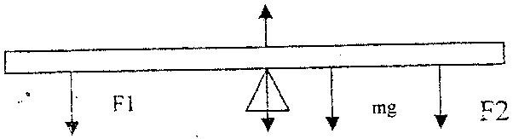

- 1999 Q14 P1
Moment of couple = Force x distance between forces.
=10 x 2 = 20Nm.

- 2000 Q5 P1
Since the system is in equilibrium let A be the area of piston and P the pressure
of steam
P x A x 15 = W (15 + 45)
2.0 x 10⁵ x 4 x 10⁴ x 15 = W x 60

W = 20N

- 2000 Q14 P1

Force F₂ at the ends perpendicular and turning to opposite to F₁

- 2001 Q12 P1
F₂ F₃ or F₁ and F₄

- 2001 Q13 P1
Moment of a couple = one force x distance between the two forces.
Distance between F₁ and F₄ = 0.8sin 30º.
Moment = 0.8sin 30º x 100 =10NM
Alternative (F₂ and F₃) Moment = f x 1M = 60N x1M = 60nM(or J)

- 2003 Q14 P1
Clock wise moments about pivot = Anticlockwise moments about pivot.
F x 2.5 Sin 30 = 2.5 x 20 F = 40N
Acc. F cos 60º = 20.
F = 20

- 2004 Q14 P1
Sum of clockwise moment=sum of anticlockwise moments
W x 20= 30 x 5
2w=15

- 2008 Q19 P1
(a) When an object is in equilibrium sum of anticlockwise moments about
any point is equal to the sum of clockwise moments about that point

(b) (i) V= 100 x 3 x 0.6 = 180cm³ W = Mg
M = VP OR = Pvg
180 x 2.7 = 486 g = 2.7 x 3 x 0.6 x 100 x 10
100
W = Mg
486 x 10 = 4.86N
1000
(ii) Taking moments about F pivot; 20F = 15 x 4.86
F = 15 x 4.86 = 3.645
20
Or
F = taking moments about W, 15R = 35F – (i)
F + W = F = R – 4.86 – (ii) substitute
F = R – 4. 86 ---- 1
F = 3.645N
OR
Taking moments about F = 20R = 4.86 x 35
R = 8.51 and F = R – W
F= 8.51- 4.86 = 3.645N

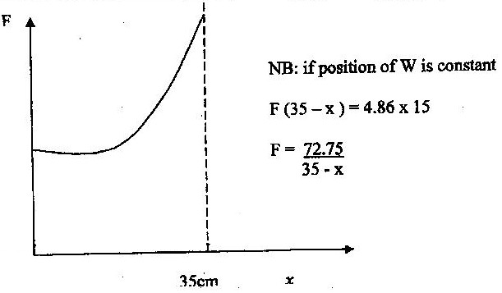

(iii)

(iv) As x increase/ anticlockwise moments reduces/ moments to the left
reduces/ distance between F and pivot reduces F has to increase to
maintain equilibrium

- 2010 Q6 P1
Clockwise moments = anticlockwise moments either
OR W₁d₁ = w2d2 / f1d1 = F2d2
W x 0.2 = 2 x 0.25
W = 2.5N

19. 2011 Q11 P1
25 cm
Reaction R

Wooden block

Bench
10 cm

Weight/w/mg Figure 8

20. 2011 Q12
Sum of clockwise moments = sum of anticlockwise moments
Or F₁D₁ = F₂D₂
20 x 2.5 = F x 10 or F x 15 = 20 x 2.5

F = 5N F = 3.33N (must be in 3 sig fig)

21. 2013 Q2 P1
- perpendicular distance from the point of action of the force
- magnitude of force

22. 2013 Q8 P1
Let the pivot be at point X, x cm from the 50 cm mark on the left hand side,
Clockwise moment = Anticlockwise moment
(x x 1) + 0.12(50 + x) = (50 - x)0.18
x = 2.307cm

23. 2014 Q8 P1

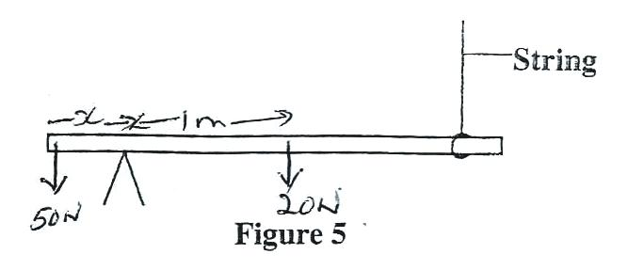

50N xx = 20N x 1 m Clockwise moment = Anticlockwise
x = 20Nm F₁d₁ – F₂d₂
50N 50x=20 NM

x= 0.4m x=0.4m
From pivot

24. 2015 Q8 P1
Clockwise moments = anticlockwise moment
0.4 x 8N = 0.35 X 4N + 0.5 x T
3.2 = 1.4 + 0.5T
0.5T = 3.2 – 1.4
$T=\frac{1.8}{0.5}=3.6N$

EQUILIBRIUM AND CENTRE OF GRAVITY
MARKING SCHEME
- 1995 Q33 P1
The point where the weight of the body acts

- 1996 Q3 P1
Length of container/ height
Width of the base/ base area/ diameter/ radius of the base/ thickness

- 1996 Q3 P1
10w + (10x60) = 2.0 x 40 ⇒ 10w + 6x = 80 w = ^{x}/₁₀ =2N

- 1998 Q7 P1
Low contact pressure between tyre and earth/no sinking

- 1998 Q24 P1
Principles of moment.
200 x1.5 R x 0.5, 0.5f=1x20x10or 0.5,R = 600. R = F +200 = 400N take
moments about O
F = 600 -200 = 400N
F = 400N

- 1999 Q2 P1
Third force F₃ acting on the ruler is either upwards or downwards.

No: My must be at the centre.

- 1999 Q3 P1
Centre of gravity rises when the body is tilted slightly and lowers when
released / returns to original position.

- 2000 Q3 P1
Beaker becomes more stable because the position of C.O.G is lowered on
melting or water is denser than ice.

- 2001 Q3 P1
Centre of gravity of A is at (geometric) centre while that of B is lower when rolled. Centre of gravity of A stays in one position while that of B tends to be raised resisting motion as it resists; thus slowing down B. OR B there is friction force between the surfaces which resists motion.

- 2002 Q2 P1
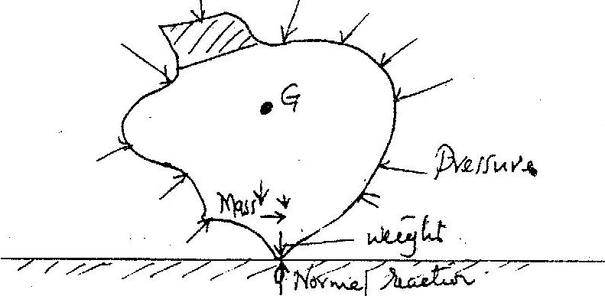

- 2002 Q3 P1
G moves / shifts to the right / C.O.M. moves/ shifts/ more weight or mass of the right/ weight will have a clockwise movement about O/causing greater moment of force towards right than left.

- 2002 Q12 P1
Sum of clockwise moment = sum of anticlockwise moments
100 x x = 2 x 2 x = 0.04

- 2003 Q3 P1
Low density / weight / mass lowers Cog Lower Cog increases stability.
Or higher mass / weight / density raises Cog. Higher Cog. reduces stability.

- 2004 Q3 P1
Stability reduced/Lower /less stable
-Upper section heavier/hollow section becomes heavy/more massive top
- Raising the c.og of the block.

- 2004 Q14 P1
Sum of clockwise moment = sum of anticlockwise moments
Wx20 = 30 x 5
2w =15
Higher, reducing the current.

- 2005 Q2 P1
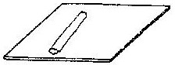

- 2006 Q4 P1
On heating, the bimetallic strip bends; This causes the position of the centre of
gravity of the section to the left to shift to the right causing imbalance and so tips to
the right

- 2007 Q10 P1
Taking moments and equating clockwise movements = anticlock movements
0.6 N x 7cm = mg N x 30cm;
W = mg = 1.4 N:

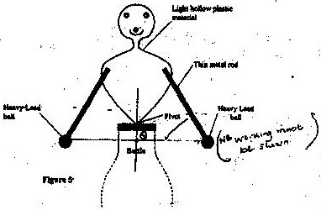
- 2008 Q10 P1

- 2008 Q11 P1
Stable equilibrium when it is tilted slightly Q rises/ c.o.g is raised when
released it turns to its original position

- 2008 Q14 P1
Heated water has lower density, hence lower up thrust

- 2008 Q19 P1
(a) When an object is in equilibrium sum of anticlockwise moments about
any point is equal to the sum of clockwise moments about that point

(b) (i) V= 100 x 3 x 0.6 = 180cm³ W = Mg
M = VP OR = Pvg
180 x 2.7 = 486 g = 2.7 x 3 x 0.6 x 100 x 10
100
W = Mg
486 x 10 = 4.86N
1000 = 4.86 N

(ii) Taking moments about F pivot; 20F = 15 x 4.86
F = 15 x 4.86 = 3.645
20
Or
F = taking moments about W, 15R = 35F – (i)
F + W = F = R – 4.86 – (ii) substitute
F = R – 4. 86 ---- 1
F = 3.645N
OR
Taking moments about F = 20R = 4.86 x 35
R = 8.51 and F = R – W
F= 8.51- 4.86 = 3.645N

(iii)

(iv) As x increase/ anticlockwise moments reduces/ moments to the left reduces/ distance between F and pivot reduces F has to increase to maintain equilibrium

- 2009 Q9 P1
Centre of gravity located at the intersection of diagonals

- 2010 Q6 P1
Clockwise moments = anticlockwise moments either
OR W1d1 = w2d2 / f1d1 = F2d2
W x 0.2 = 2 x 0.25
W = 2.5N

- 2010 Q14 P1
- Increases the base area or lowers the centre of gravity

- 2011 Q1 P1
Stable: The centre of gravity is within the base of the lorry.
- 2012 Q9 P1
The weight of its center of gravity (above the surface is) constant position of centre of gravity is constant.
Accept initials c.o.g
- 2012 Q18(a) P1
(a) (i)lengths BC and CD
(ii) 100 x BC = S x CD OR 1 x BC = 105 x CD
S = $\frac{100BC}{CD}$ S = $\frac{BC}{10CD}$ reject use of (g) / mass.
29. 2014 Q9 P1
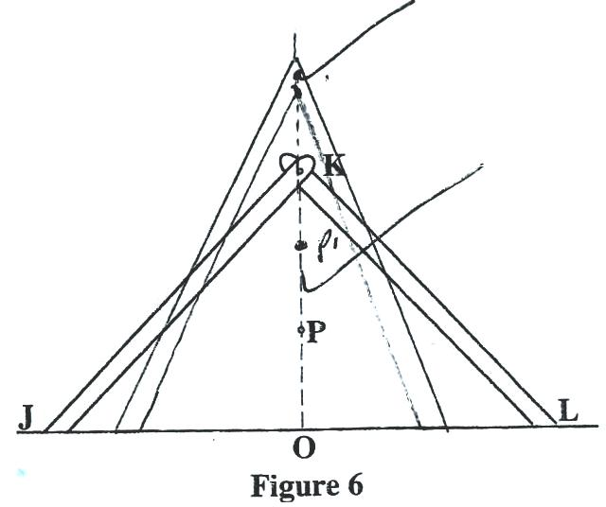

REFLECTION AT CURVED SURFACES
MARKING SCHEME
- 1995 Q36 P1
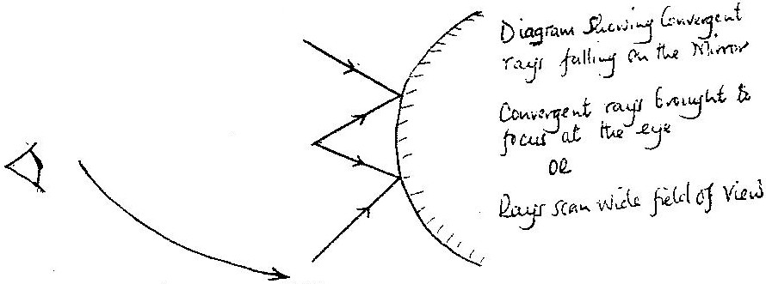

- 1995 Q3a P2

(ii) Magnification = V Isign = 1.1 OR 1.75
U Osign 1.6 2.5 = 0.7 ± 0.05

- 1996 Q22 P1
Magnifie
d, enlarged upright, virtual, image behind the mirror, negative distance

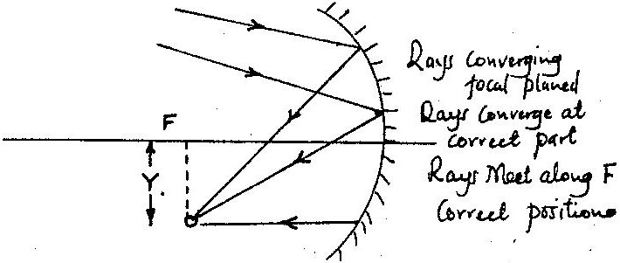
- 1997 Q26 P1

- 1998 Q7 P1
a) 2 complete rays, 2 with arrow at one end image (inverted real) (continuous tie)
locating F size 2.4 +0cm
b)
U (cm) | 20 | 25 | 30 | 40 | 50 | 70
V(cm) | 20 | 16.7 | 15 | 13.3 | 12.5 | 11.6
1  V(cm⁻¹) | 0.50 | 0.040 | 0.033 | 0.025 | 0.020 | 0.014
1  V(cm⁻¹) | 0.50 | 0.060 | 0.067 | 0.075 | 0.080 | 0.086
ii) ¹/_{f} = ¹/_{u} +¹/_{v} Intercept ^{1/}_{f}
0.1 = 1/f ... f = 10cm
- 2000 Q23 P1
Fig 12 shows a ray of light incident on a convex mirror
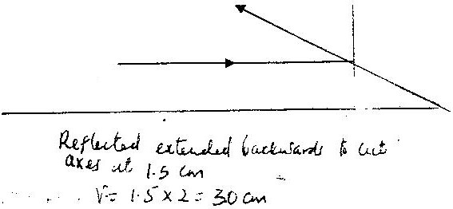

- 2000 Q1 P2
(a) (i) Convex mirror – driving mirror/ supermarkets mirrors
Parabolic mirror- solar heater reflector, reflector, torch reflector etc.
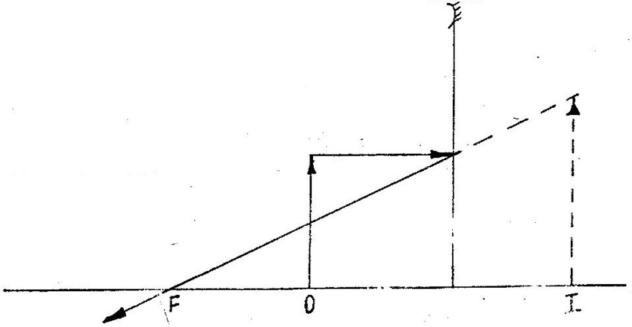
(ii)

(b) (i) V= 45 M = 3.5 ( from graph) m = v/u ⇒ 3.5 = 45/u
U = 12.9 cm ± 0.4

(ii) Choosing convenient value of ‘m’
M = I, V = 20 =u M= v/f-1 M = v/f -1/f= 1/45+ 1/12.9
1/f = 1/20 + 1/20 v= 45m = 3.5 m= 0 = f = v
f= 10cm f = 9.8 – 10.3 f= 10 cm f = -10cm

- 2001 Q20 P1
Object
I C F

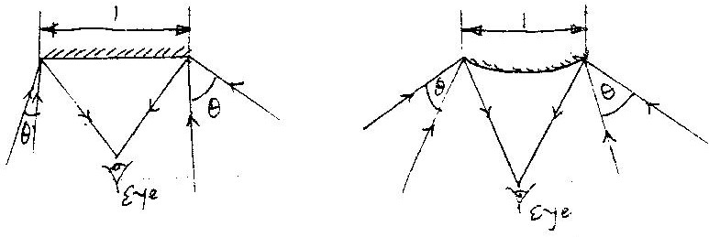
- 2003 Q29 P1

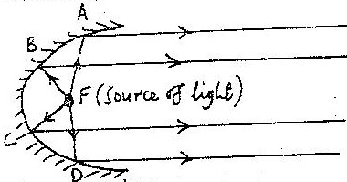
- 2004 Q23 P1

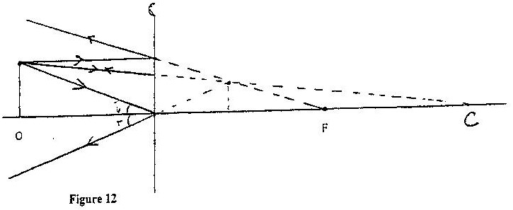
- 2005 Q22 P1
2 Rays: Each correct ray 1 mark
Image position 2.2 +0.1 cm from mirror.

- 2007 Q18(a) P1
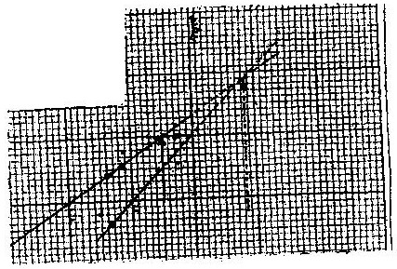
(a) (i)

(ii) Image at 10cm from mirror (using scale) (2 marks)
(iii) Magnification
Size of image ₌ 4.0 cm = 2
Size of object 2.0 cm
OR
Image distance ₌ 2.0 cm = 2
Object distance 1.0 cm

- 2007 Q4 P2
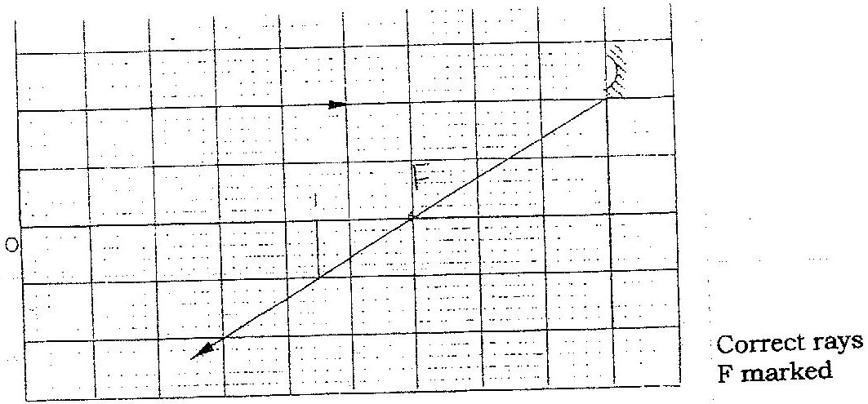

- 2010 Q5 P2

16. 2012 Q17 P2
(a) (i) The image diminishes (becomes smaller);
(ii) m = 1 $\frac{V}{u}$ = 1
V = u = 40cm

(iii) u = 25
m = 3.5 or m = 3.6
m = $\frac{V}{u}$ m = $\frac{V}{u}$
$\frac{V}{25}$ = 3.5 $\frac{V}{25}$ = 3.6

V = 87.5 v = 90cm
(b)
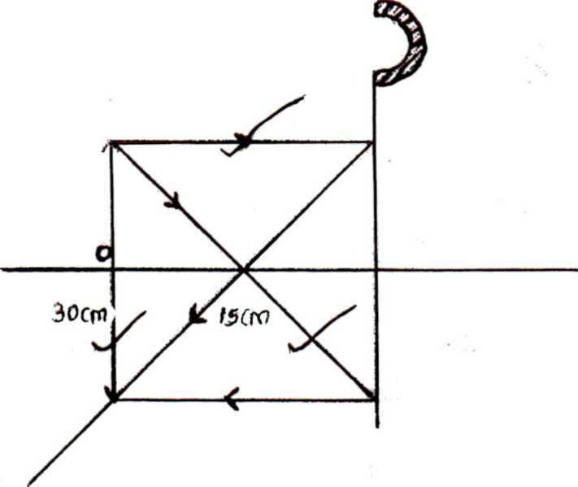

(c) A bulb/lamp placed at principal focus will give a wide parallel beam;

17. 2013 Q5 P2

18. 2014 Q3 P2
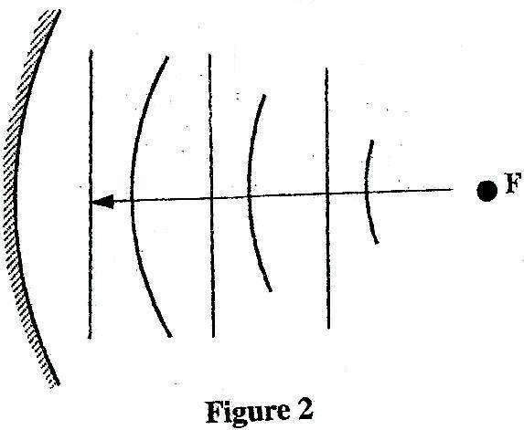
- Straight equally spaced lines
- Minimum of 3 straight lines
- Accept dotted lines

19. 2015Q5 P2
A convex mirror provides a wide field of view

MAGNETIC EFFECT OF AN ELECTRIC CURRENT
MARKING SCHEME

- 1995 Q14 P1
– Length of conductor in the field
- Angle between conductor and fields

- 1996 Q13 P1
- 1997 Q16 P1
d= speed x t; 340 x 2; 680m

- 1997 Q5(a) & (b) P2
a) Amount of current No of coils / shape of core / X – core
b) i) End of coil facing up becomes a south pole and the metre rule is pulled down / attraction occurs. Or Rule tips; core magnetized; top of core becomes south pole; attracts magnet.
ii) The metre rule to have appointer attached to read zero when switch S is open. Use rheostat to vary current to maximum and calibrate accordingly.

- 1998 Q1 P2
i) Scale, axes label, unit-plotting 8-10-2 5-7-1 Curve (smooth)

ii) As the number of turns is increased, alignment of domain with field increases. After 35-36
turns, all domains are aligned, so that magnet is saturated.

iii) Sketch – curve above 1 to some saturation, and from origin.
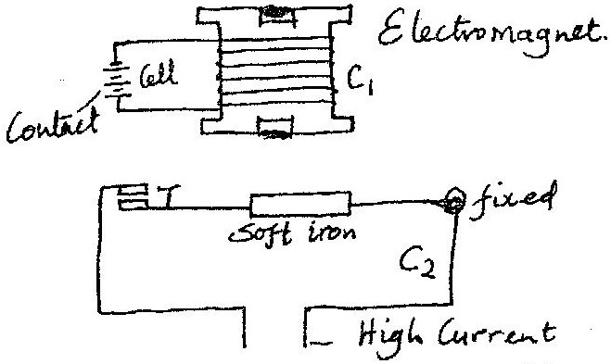

b) When switch is closed electromagnet attracts soft iron. This causes T
to close and so circuit 2 is put on.

- 1999 Q13 P1

- 1999 Q33 P1
Downwards into the paper.

- 2000 Q13 P1

9. 2001 Q11 P1

- 2001 Q2a P2
a i) So as to have opposite polarity on the poles.

ii) Since the current is varying with time; it causes the current in the solenoid to vary, with time causing the diaphragm to vibrate this vibration is at the frequency of speech; hence reproducing speech.

- No vibration/receiver does not work, steel core pieces would become
permanent magnet/so force of attraction would not be affected by variation
in speech current.

- 2002 Q13 P1
Rider moves into the rectangular magnet. Magnetic field due to the magnet and the one around the rider interact to produce a force toward the inside of the magnet on the rider

- 2002 Q33 P1
Downwards

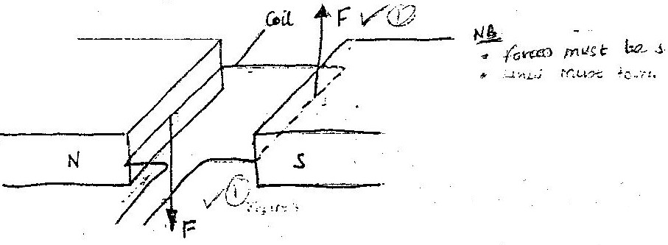
- 2004 Q12 P1

NB forces must be straight
Lines must touch a conduct

- 2004 Q13 P1
Increasing current/increasing no. of turns or length of coils/ increase strength of field same as moving magnet close to core & using U shaped winding coil on soft iron core/increasing the angle between conductor and the field. (give any 2 marks)

15. 2005 Q12 P1
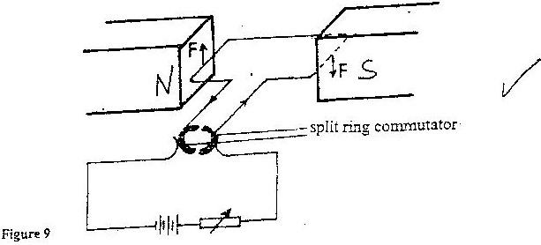

16. 2005 Q13 P1
to make the rotation continuous by changing the direction in the coil every half cycle/turn also accept changing direction of the current every half cycle/turn/maintaining the direction of current in field.

- 2005 Q37 P1
When the switch is closed and nails attracted.
When the switch is opened, the nail on the iron end drops first.

- 2006 Q2 P2
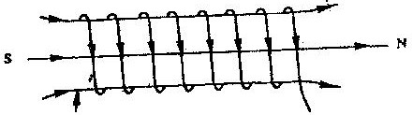

- 2008 Q6 P2
When the switch is closed, 1 flows the iron core in the solenoid is magnetized attracting the flat spring this causes a break in contact disconnecting current.
Magnetism is lost releasing the spring
- Process is repeated (make and break circuit)

- 2009 Q5 P2
Increase the magnitude of 1
Increase the number of turns per unit length
Use of U shaped iron core.

- 2010 Q10 P2

- 2010 Q3 P2

- 2010 Q11 P2
Motion out of paper /moves upwards√ 1
OR increases in p.d

- 2011 Q7 P2
When S is closed, current flows in the solenoid magnetizing the iron core, attracts the iron armature closing the contacts. This causes the current ti the motor circuit. The motor keeps running continuously.

- 2011 Q8 P2
Steel would remain permanently magnetized causing current in motor circuit remain
on when the switch is open.

26. 2012 Q7 P2
L – south pole

27. 2012 Q11 P1
28. 2013 Q19 P2
(a) (i) and (ii)
(b) The coil moves to and from since it experiences a varying force when placed a
magnetic field.
(i) dilute sulphuric acid
(ii) (I) Loss of electrons occurs in this plate i.e. oxidation. Zinc thus becomes a
negative terminal.
(II) Reduction takes place in this place hence becoming a positive plate.
(iii) The flow of electrons from zinc plate to copper plate.

29. 2014 Q5 P2
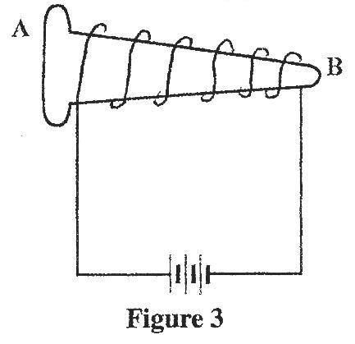
≥ 2 turns
Ignore direction of current i.e use windings
Look for contradiction of labeling the poles
By drawing, show how the wire should be wound around the nail so that end A becomes

30. 2014 Q14 P2
(a) (i) (I) soft iron armature
(II) contact screw

(ii) (I) When current flows the soft iron core becomes magnetised and attracts the soft iron armature and the hammer hits the gong.
(II) When the harmer hits the gong, contact is broken and current stops flowing.
The soft iron core becomes demagnetized, soft armature is released and the process is repeated.

(b)
1 = $P/V$
=${60}/{240}$
=0.25 A
ii)
${R =V}/I$ or R = $\frac{v^{2}}{p}$
${240}/{0.25}$ = $\frac{{\left(240\right)}^{2}}{60}$

= 960 $Ω$ = 960Ω

31. 2015 Q6 P2
Increasing the current
Increasing the number of turns making the coil
Using a soft iron

HOOKES’ LAW
MARKING SCHEME

- 1994 Q 3a P2
Extension is directly proportional to the extending force provided the
elastic limit is not exceeded.

- 1999 Q11 P1
4mm=20N
1.5 =? F = Ke
1.5x 20 K = F = 20 = 5 x 10³ N
4 e 4x 10⁻³
= 7.5 N F=5x 10³ x 1.5 x 10⁻³
=7.5N
- 2003 Q2 P1
30.0 + 0.5 = 30.5 (No mark if working not shown)
- 2005 Q5 P2
(a) Extension is directly proportional to the extending force provided the
elastic limit is not exceeded.
(b) (i) 3.2 N or 3.3 N
(ii) At 5 cm F = 1.45N
Stress = F/A = 1.45
0.25 x 10⁻⁴m²
= 5.8 x 10⁴ Pa
NB: can work with N/cm²
Accept 5.6 – 5.8) x 104 pa
(iii) Strain = Ext = 5 = 0.025
Original length 200

(c) ED and DC

- 2006 Q5 P1
Lower spring extend by 15 cm;
Upper springs extended by 10 cm;
Total = 15 + 10 = 25 cm (3 marks)

- 2006 Q15 P1
(a) Make diameter of springs different
- Make number of turns per unit length different
- Make lengths of springs different (any 2 x 1 = 2 marks)
- (i) 2.2 N ; 2.2 ± 0.1
- (ii) Spring constant = gradient
= 2.1
4.1 x 10⁻²
= 5/Nm⁻¹
For each spring k= 102 Nm⁻¹ (1 mark)
(iii) Work = Area under graph
= 0.75 + 1.65 x 1.7 x 10⁻²
2
= 2.04 x 10⁻² J (3 marks)
- 2008 Q13 P1
Diameter coils different/ wires have different thickness/ No. of turns per
unit length different/ length of spring different.
(x- Larger diameter than Y or in one coils are closer than in the other)

- 2009 Q10 P1
Parallel
F=2Ke
40 = 2x ke
E₁ = ⁴⁰/ _{2k} = ²⁰/_{k}

Single = f = Ke₂
20 = Ke₂
E₂ = 20/K
e_{T} = e₁ + e₂
20 = 20/K + 20/K
20K = 40
K = ⁴⁰/₂₀ = 2N/cm

- 2010 Q13 P1
- Newton per metre
- 2011 Q13 P1
F=ke=125 x0.2 = 25N

- 2012 Q10 P1
Yes/it is within the elastic limit; because the values of $\frac{F}{e}=constant$ / in all the
cases $\frac{F}{e}=5$ .
OR
- Extension is proportional to the force applied
- Spring constant remains the same
- It obeys Hooke’s law
- A graph of force against extension is straight line (through the origin)
- Conclusion from graph
- 2013 Q4 P1
- k = $\frac{F}{e}=\frac{20}{0.005}=$ 4000N/m
- F = ke
F= 400 x 0.086N = 34.4
14. 2014 Q10 P1

Extension = 4 mm + 4mm  = 8mm  F= ke  W= k(4) | k=$\frac{w}{4}$  e = $\frac{w}{4/8}$  8mm | 1=1 +1 =2  ks k k k  2 ks= k, k= $\frac{F}{4}$  F=4 x 2 ks  e=8mm

WAVES I
MARKING SCHEME

- 1995 Q19 P1
V = f λ sine V is constant reducing f to 1/3 ⇒ λ increases 3 fold

- 1995 Q25 P1
Polarization

- 1995 Q6 P2
(a) Progressive wave- Wave profile moves along with the speed of the wave
Stationary wave – wave profile appears static

Progressive wave – Phase of points adjacent to each other is different
Stationary wave – All points between successive node vibrate in phase

Progressive wave – Energy translation in the direction of the wave travels
Stationary wave- No translation of energy but energy oscilliate in the wave

(b) (i) A glass slide i.e. blackened with soot or paint lines are drawn close together using a razor blade or pin.
(ii) Path differences equals to an odd number of half wavelengths or completely out of phase ( 180⁰)
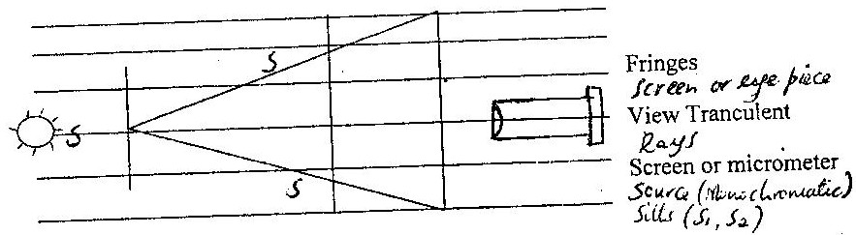

(iii) Photometer / photocell or thermometer with a bulb

- 1996 Q5a,c P2
(a) (i) Particles of the transmitting medium vibrate in the direction of the
wave for a longitudinal wave, but at right angles for a transverse
wave:
Sound requires medium but no medium required for electromagnetic wave; speed of sound lower than that of electromagnetic wave;

(c) (i) Double slit provides coherent sources;
(ii) Dark and bright fringes;
The central fringe is the brightest while the intensity of the other
fringes reduces away from the central fringe;

(iii) I. The separation of fringes increases
II. Central fringe is white; fringes on either side are colored;

- 1997 Q21 P1
6V

- 1997 Q7(a) & (b) P2
a (i) Transverse – particles in the wave perpendicular to the direction of the wave.
Longitudinal – particles move in the same direction as the wave.
b) i)
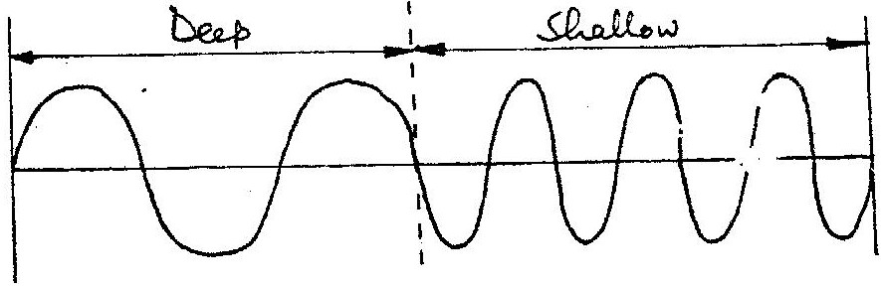

ii) Velocity decreases since the frequency remains the same. No loss of energy
therefore amplitude does not change.

- 1999 Q18 P1
Beat frequency f = f2 – f1 F = f2 – f1
= 258 – 256 256 – 258
= 2Hz =/-2/ = 2
- 1999 Q1(a) & (c) P2
(a) Longitudinal waves - direction of the disturbance while ½ .Transverse waves –
direction of propagation is perpendicular to that of the disturbances.

c i) T = (2.5 – 5) x 10 – 3
= 20 x 10 – 3s 10³
F = 1/T = 50 Hz. 1/20 x 10⁻³
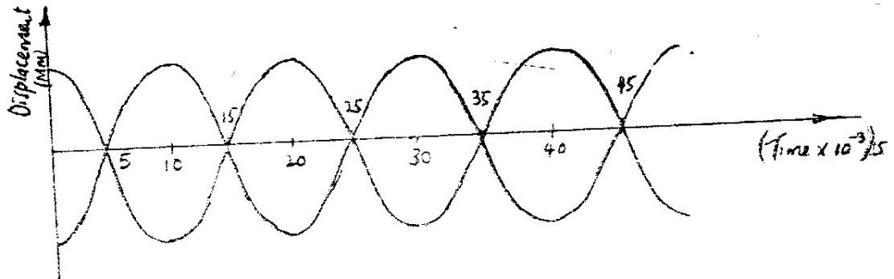
ii)

- 2000 Q17 P1
- Sound waves
- Shock waves (Tsunami)

- 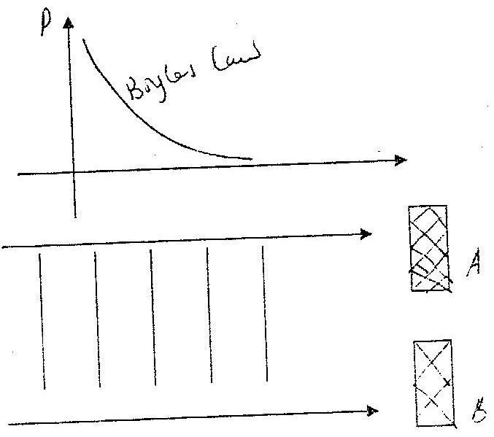 2002 Q23 P1

- 2002 Q24 P1
V = fλ
λ = v = ^{330/}₃₀ = 11m
F

- 2003 Q4 P2
a i) I 4cm; II A= 2cm;
ii) I 0 to A- 9cm containing 2 ¼ waves
time for 1 wave = 0.04 s
f=¹/₇; = ¹/_{0.04} f= 25Hz;
II V = f; 15 x 0.04 = 1 ms⁻¹

b i) to allow all radiations to penetrate;
(ii) On entry radiation ionizes argon gas
Avalanche of ions flows between terminal causing condition;
Pulse of current flows; Pulse registered as particle;
iii) Quenching the tube;

- 2004 Q19 P1
Electromagnetic Mechanical
-Can travel through vacuum - Cannot travel through a vacuum
-Travel at speed of light - Travel at varying speeds
-Are faster - are slower
- Does not necessarily
refuse a material media - Refuse a material media

- 2005 Q16 P1
=4cm or 0.04m from the graph
V = fλ= 5 x 0.04
= 0.2ms-1 or 20cm/s

- 2005 Q28 P1
(i) (ii)

- 2006 Q5 P2
- Longitudinal wave

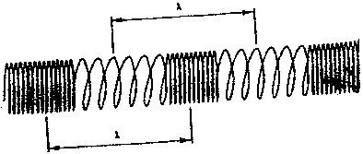
(ii) Length of the spring, from one point to a similar point of vibration

- 2008 Q7 P2
Movement equals 1.75 oscillations
T = ^{0.7}/ _{1.75}
= 0.4 sec
F = ^{I}/_{T}
= ¹/_{0.4} = 2.5 HZ.

- 2009 Q6 P2
f = 0.5sec
F= 1/T
=1/0.5
=2Hz

- 2010 Q7 P2

- 2015 Q7 P2

Electromagnetic waves | Mechanichal waves
- Do not require medium for propagation  - Caused by vibration of particles | - Require material for propagation  - Caused by wave amplitude and not frequency

SOUND
MARKING SCHEME

- 1995 Q31 P1
Quality / Timbre

- 1996 Q10 P1
Mass per unit length or (linear density/ thickness/ cross – sectional
area/ diameter, radius

- 1996 Q18 P1
Interferences ( accept beat)
- 1996 Q28 P1
A hears a constant frequency produced by the siren/ same roundness/ pitch B hears a frequency that increases as the vehicle approaches/ sound of increasing loudness/ higher sound (2 marks)
- 1996 Q5b P2
(b) (i) Speeds of sound;
2.5 x s = 400 x 2
S = 320 m/s;

(ii) 2( x – 400) = 2.5 + 2);
- = 1120m;
- 1997 Q17 P1
At low speeds the speed is streamline
At high speed the flow is turbulent

- 1997 Q32 P1
Small differences in frequencies

- 1998 Q28 P1
Overtones/harmonics

- 1998 Q2(a) P2
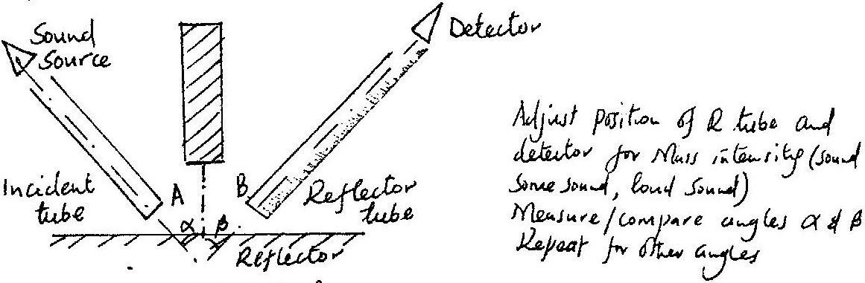

- 1999 Q18 P1
Beat frequency f = f2 – f1 F = f2 – f1
= 258 – 256 256 – 258
= 2Hz =/-2/ = 2
- 2000 Q21 P1
Wire expands becoming longer (reduces tension) this lowers frequency
hence pitch.

- 2002 Q17 P1
- Mass per unit length / linear density
- Length of wire
- 2002 Q24 P1
V =fλ
λ = v = ^{330/}₃₀ = 11m
F
- 2003 Q21 P1
Speed = distance / time speed = 600m/s
= 1200 1.75
3.5 =343 m/s
= 343 m/s (Range 342.8 - 343 m/s)
- 2005 Q17 P1
The pitch decreases as the siren falls
The higher the speed away from the observer, the lower the
frequency heard and so the lower the pitch hard.
- 2004 Q6 P2
a) One turning fork is loaded with a small amount of plasticine sounding together again one can produce detectable beats.
b) i) ¹/_{f} x10⁻³ (H₃⁻¹) 3.91 3.5 2.9 2.3 2.1 2..0
12-11 0.65 0.57 0.48 0.39 0.34 0.32
ii) Slope (Gradient) = ^{V}/₂ = (0.67-0.10)m/4.0-0.75)x 10⁻³H3⁻¹
V=340 ^{10m}/_{s}
iii) Sound waves entering tube is reflected at water surface forming
standing wares with incoming wares, when an antinode is at the
mouth loud sound is heard. By adjusting length of air column this can be achieved.
- 2006 Q8 P2
Distance moved by sound waves = 2x;
2x = speed x time
X = 330 x 1.8
2
= 297m (3 marks)
- 2008 Q15 P2
(a) Temperature
Density
- Graph
  - 46.5 m accept 46 m to 47 m
  - T = 4 x
V
V=4x or slope = 4
t v

= 0.51 ⁻¹
43

= V = 43 x ⁴/_{0.51} = 337 m/s
  - For max internal observer is at one end and so the distance = 2L
337 x 4.7 = 2L
L= 792 m

(c) (i) Distance moved by sound from sea bed = 98 x 2 m
V= 98 x 2
0.14 = 1400m/s

(ii) Distance = v x t
1400 x ^{0.10}/₂ = 70m
- 2009 Q12 P2
12.2d =2d +34 OR V =d/t
0.5 0.6 =17 x 2
0.1
d=17\0.2=85m =340m/s
speed =2x86
0.5
=340m\s
20. 2014 Q17b P2
(i) Oscillation
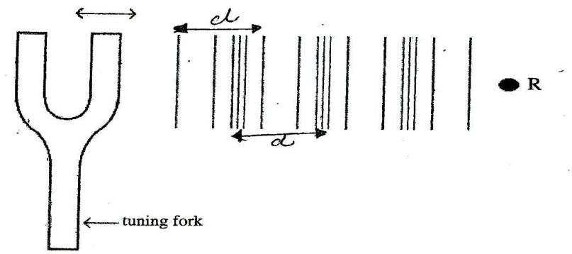
Two consecutive points in phase 5 spaces in between, 4 lines in between
(ii) 1mk
R

iii)
As longitudinal waves pass, molecules R moves along either side for a crest R moves away, the source / rarefaction towards the source / compression away from the source

21. 2015Q9 P2
V = f λ = 20000Hz x 0.075m = 1500
But V = $\frac{d}{t}=\frac{2d}{3}\left(echo\right)→2d=4500→d=2250m$

FLUID FLOW
MARKING SCHEME
- 1995 Q23 P1
(If x ≠z but both above y give 1 mk. Accept difference of 1.0 mark)

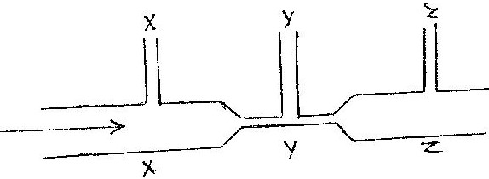

hX = hZ > hY

- 1996 Q24 P1
Pressure is inversely proportional to the speed OR speed increases as pressure decreases
- 1997 Q18 P1
At low speeds the speed is streamline
At high speed the flow is turbulent

- 1998 Q30 P1
Gas through the nozzle gains velocity. Hence its pressure reduces above the
nozzle. The higher atmospheric pressure pushes air into the gas stream

- 1999 Q25 P1
V₂ is smaller than V₁ V₁ is larger than V₂

- 2000 Q25 P1
The air above paper travels faster than below causing lower pressure above.
Excess pressure causes paper to be raised.

- 2001 Q23 P1

- 2003 Q36 P1
Fast air causes low / - reduced pressure at the top. So there is net force upwards
on pith ball / pressure difference pushes pith ball upwards.

- 2005 Q26 P1
1. At steady rate, the sum of pressure, the potential energy per unit
volume and kinetic energy per Unit volume in fluid in a constant.
2. Provided a finish is non-viscous, incompressible and its flow steamline
and increase in its velocity produces a corresponding decrease in
pressure
3. When the speed of a fluid increases, the pressure in the fluid decreases
and vice versa.

- 2006 Q11 P1
A₁V₁ = A₂V₂;
π x 6² x V₁ = π x 9² x 2;
= 4.5 ms⁻¹ (3 marks)

- 2007 Q3 P1
V₂V₄ V₁ V₃ (correct order) (1 mark)

- 2008 Q12 P1
This reduces air pressure inside the tube, pressure from outside is greater than inside/ hence pressure difference between inside and outside causes it to collapse.

- 2009 Q11 P1
Air between balloons is faster than that outside so there is pressure reduction between

- 2010 Q7 P1
Water flows faster in Y than X hence pressure is lower at Y than X
(i.e 1st mark - compare velocity)
2nd - compare pressure

- 2011 Q9 P1
Air speed/velocity at constriction is higher. This makes the pressure drop. The atmospheric pressure being higher, pushes the petrol to the constriction.

- 2012 Q14 P1
- Air above the plane moves faster than air below it (because of its shape)
creating a region of low pressure above the plane hence the plane experiences
a lift; due to the pressure difference. (1 mark)

- At B / narrowest part / smallest cross-section; because the cross sectional
area is smaller hence the air moves faster in that region.

- 2013 Q10 P1
When the gas tap is opened, gas flows at high speed creating a low pressure
regi :-i above the nozzle. The higher atmospheric pressure on the outside
pushes air in the gas burns

18. 2014 Q11 PP1

A₁V₁ = A₂V₂

= A₁ V₁
A₂
= A₂ V₂
A₂
= A₁
A₂
= V₂
V₁

19. 2015Q9 P1
The pressure above tube B is lower than that above tube B. This is caused
by high velocity of air above B compared to velocity above tube A

