INDICES

- 1989 Q4 P2
Simplify $\frac{{25}^{3/4}×{0.9}^{2}×2^{2}}{5^{5/2}×3^{3}}$
in the form ^{A}/_{B} where A and B are integers (2 marks)

- 1990 Q4 P2
Solve for x in
5^{2x-1} = 12^{x} (3 marks)

- 1991 Q 4 P2
Solve for x in
4^{x+1} = 32 (3 marks)

- 1993 Q8 P2
Solve for x in
9^{x} + 3^{2x} – 1 = 53 (3 marks)
- 1995 Q 5 P2
Find the value of x in the following equations:
49^{x + 1} + 7^{2x} = 350 (4 marks)

- 1996 Q 9 P2
Find the value of x which satisfies the equation (4 marks)
16 = 8^{4x-3}

- 1997 Q 7 P2
Find the value of m in the following equation
(¹/₂₇) ^{m} х (81)⁻¹ = 243 (3 marks)

- 1998 Q 10 P2
Given that P = 3^{y}, express the equation 3^{2y – 1} + 2 x 3^{y-1} = 1 terms of P. (1mark)
Hence or otherwise find the value of y in the equation
3^{2y – 1} + 2 x 3^{y-1} (3 marks)

- 1999 Q 4 P2
Simplify (2 marks)

- 2000 Q 12 P2
Find the value of x which satisfy the equation
5^{2x} – 6 x 5^{x} + 5 = 0 (4 marks)

- 2001 Q 2 P2
Solve for x in the equation 32^{(x-3)} ÷8 ^{(x+4)} = 64 ÷ 2^{x} (3 marks)

- 2002 Q 7 P2
Solve for x in the equation (3 marks)

- 2005 Q 1 P2
Find the value of y in the equation
(3 marks)

- 2008 Q 2 P1
Simplify
(3 marks)

- 2009 Q 5 P1
Without using logarithm tables or calculators, evaluate
(4 marks)

- 2010 Q 8 P1
Without using mathematical tables or a calculator, evaluate

(3 marks)

- 2012 Q5 P1
Given that 9^{2y} x 2^{x} =72, find the values of x and y (3 marks)

- 2014 Q6 P1

Simplify $\frac{{243}^{\frac{-2}{5}}×{125}^{\frac{2}{3}}}{9^{\frac{-3}{2}}}$ (3marks)

EVALUATION OF NUMERIC EXPRESSIONS
(Using Mathematical tables)

        - 1989 Q1 P1
Use logarithms to evaluate (4 marks)
$\sqrt[3]{\left(35.6 ×0.0613^{2}\right) }$

        - 1990 Q1 P2
Evaluate $\frac{1.34}{{\left(5.24\right)}^{0.8}×0.0029}$ (4 marks)

        - 1991 Q1 P2
Use mathematical tables to evaluate (3 marks)
$\sqrt{\left[\frac{2.935 ×0.0765}{32.74}\right]}$

        - 1992 Q1 P1
Use logarithms to evaluate $\sqrt[3]{\left[\frac{7.08}{76.8 ×7.034}\right]}$ (4 marks) $\sqrt[3]{\left[\frac{7.08}{76.8 ×7.034}\right]}$

        - 1993 Q2 P1
Use logarithms to evaluate $\frac{\sqrt{0.0645} }{0.0082}$$\sqrt[4]{\frac{4.562 ×0.038}{0.82}}$ (3 marks)

        - 1994 Q1 P1
Use logarithms to evaluate

$\sqrt[4]{\frac{4.562 ×0.038}{0.82}}$ (4 marks)

7. 1995 Q1 P2
Use logarithms to evaluate (4 marks)

8. 1996 Q1 P1
Use logarithms to evaluate (3 marks)

9. 1997 Q1 P1
Use logarithms to evaluate (4 marks)

10. 1998 Q1 P2
Use logarithms to evaluate (4 marks)

11. 1999 Q1 P2
Use logarithms to evaluate (4 marks)

12. 2000 Q11 P2
Use the logarithms to evaluate (4 marks)

13. 2001 Q1 P1
Find the reciprocal of 0.342. Hence evaluate:
(3 marks)

14. 2001 Q3 P1
Use logarithms to evaluate
(4 marks)

15. 2002 Q1 P2
Use logarithms to evaluate $\frac{{\left(0.0056\right)}^{1/2}}{1.38×27.42}$ (3 marks)

16. 2002 Q5 P1
Use reciprocal and square tables to evaluate, to 4 significant figures, the
expression: (3 marks)

17. 2003 Q1 P2
Use logarithm tables to evaluate (4 marks)

18. 2004 Q1 P2
Use logarithms to evaluate (4 marks)

19. 2004 Q8 P1
Use tables of reciprocals only to work out
(3 marks)

20. 2006 Q1 P2
In this question, show all the steps in your calculations, giving your
answers at each stage
Use logarithms, correct to 4 decimal places, to evaluate (4 marks)

21. 2007 Q1 P2
Using logarithm tables, evaluate (3 marks)

22. 2008 Q1 P2
In this question, show all the steps in your calculations, giving the answer at
each stage. Use logarithms correct to decimal places, to evaluate.

(3 marks)
23. 2011 Q1 P2
Use logarithms, correct to 4 decimal places, to evaluate
(4 marks)

24. 2012 Q2 P1
Find the reciprocal of 0.216 correct to 3decimal places, hence evaluate
$\frac{\sqrt[3]{0.512}}{0.216}$ (3 marks)
$\frac{\sqrt[3]{0.512}}{0.216}$

25. 2015 Q4 P1
Use logarithms, correct to 4 significant figures, to evaluate
$\sqrt{\frac{72.56 X 0.64}{{\left(1.845\right)}^{2}}}$ (4 marks)

EQUATIONS OF STRAIGHT LINES

      - 1989 Q23 P1
A rhombus PQRS is such that Q lies on the x axis. The coordinates of vertices
P and R are (2, 4) and (6, 2) respectively.
Determine
    - The coordinates of Q (4 marks)
    - The coordinates of S (4 marks)

      - 1992 Q9 P2
A perpendicular is drawn from a point (3, 5) to the line 2y + x = 3. Find the
equation of the perpendicular. (3 marks)

- 1995 Q 5 P1
A perpendicular to the line y - 4x + 3 = 0 passes through the point (-8, 5)
Determine its equation (2 marks)

- 1997 Q 24 P1
The co-ordinates of the points P and Q are (1, -2) and (4, 10) respectively.
A point T divides the line PQ in the ratio 2: 1

- Determine the coordinates of T (2 marks)

- (i) Find the gradient of a line perpendicular to PQ (2 marks)
(ii) Hence determine the equation of the line perpendicular PQ and
passing through T (2 marks)
(iii) If the line meets the y- axis at R, calculate the distance TR, to three
significant figures (2 marks)

- 1999 Q 7 P2
The equation of a line is
$-\frac{3}{5}x$ + 3y = 6
Find the:
(a) Gradient of the line (1 mark)
(b) Equation of a line passing through point (1, 2) and
perpendicular to the given line. (3 marks)

- 2000 Q 1 P2
Find equation of the perpendicular to the line x + 2y – 4 and passes
through point (2,1) (3 marks)

- 2001 Q 5 P1
A line L₁ passes though point (1, 2) and has a gradient of 5. Another line
L₂, is perpendicular to L₁ and meets it at a point where x = 4. Find the
equation for L₂ in the form of y = mx + c (4 marks)

- 2003 Q 4 P2
A straight line passes through points A (-3, 8) and B (3, -4).Find the
equation of the straight line through(3,4) and parallel to AB. Give the
answer in the form y – mx +c, and c are constants. (3 marks)

- 2004 Q 16 P1
P(5,-4)and Q (-1,-2) are points on a straight line. Find the equation of the
perpendicular bisector of PQ: giving the answer in the form y = mx+c.
(4 marks)

- 2005 Q 11 P1
On the diagram below, the line whose equation is 7y – 3x + 30 = 0 passes
through the points A and B. Point A on the x- axis while point B is
equidistant from x- and y – axes.
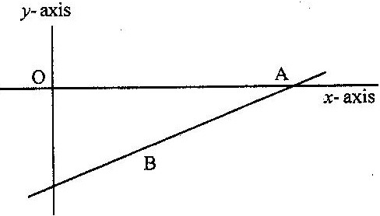

Calculate the co-ordinates of the points A and B (3 marks)

11. 2005 Q 12 P2
Two lines L₁ and L₂ intersect at a point P. L₁ passes through the points
(-4, 0) and (0, 6). Given that L₂ has the equation: y = 2x – 2, find, by
calculation, the coordinates of P. (3 marks)

- 2006 Q 9 P1
A line with gradient of -3 passes through the points (3. k) and (k.8). Find the
value of k and hence express the equation of the line in the form ax + by = c,
where a, b, and c are constants. (3 marks)

- 2007 Q 7 P2
Find the equation of a straight line which is equidistant from the
points (2, 3) and (6, 1), expressing it in the form ax + by = c where a, b
and c are constants (4 marks)

- 2008 Q 11 P1
Three vertices of a rhombus ABCD are; A(-4,-3), B(1,-1) and C(3,4)
are constants.
(2 marks)
a) Draw the rhombus on the grid provided below. (2 marks)
b) Find the equation of the line AD in the form y = mx + c, where and c
are constants. (2 marks)

- 2008 Q 15 P1
The equation of line L₁ is 2y-5x-8=0 and line L₂ passes through the points
(-5, 0) and (5,-4). Without drawing the lines L₁ and L₂ show that the
two lines are perpendicular to each other. (3 marks)

- 2009 Q 9 P1
A line which joins the points A (3,k) and B (-2,5) is parallel to another
line whose equation is 5y +2x = 10 .Find the value of k. (3 marks)

- 2009 Q 14 P1
The diagonals of a rhombus PQRS intersect at T. Given that P(2,2),Q(3,6)
and (-1,5):
(a) Draw the rhombus PQRS on the grid provided;
(b) State the coordinate of T. (2 marks)

- 2010 Q 3 P1
A straight line l passes through the point (3,-2) and is perpendicular to a line
whose equation is 2y – 4x =1. Find the equation of / in the form y= mx + c,
where m and c are constants. (3 marks)

- 2011 Q 12 P1
Three vertices of a parallelogram PQRS are P(-1, -2),Q(8,-5)and R(5,0).
- On the grid provided below draw the parallelogram PQRS (1 mark)
- Determine the length of the diagonal QS. (2 marks)
- 2012 Q13 P1
A line L passes through point (3, 1) and is perpendicular to the line
2y = 4x + 5.
Determine the equation of line L. (3 marks)

- 2013 Q12 P1
A straight line passes through points (-2, 1) and (6, 3).
Find:
- equation of the line in the form y = mx + c; (2 marks)
- the gradient of a line perpendicular to the line in (a) (1 mark)

- 2014 Q17 P1
A line L passes through (-2, 3) and (-1, 6) and is perpendicular to a line P
at (-1, 6).

- Find the equation of L (2marks)
- Find the equation of P in the form ax + by = c,where a, b and c
are constants. (2marks)
- Given that another line Q is parallel to L and passes through
point (1, 2) find the x and y intercepts of Q (3marks)
- Find the point of the intersection of lines P and Q (3marks)

- 2015 Q21 P1
(a) A straight line L, whose equation is 3y — 2x = —2 meets the x-axis at R.
Determine the co-ordinates of R. (2 marks)
(b) A second line L₂ is perpendicular to L₁ at R. Find the equation of L₂ in
the form y = mx + c, where m and c are constants. (3 marks)

(c) A third line L₃ passes through (—4,1) and is parallel to L₂ Find:
(i) the equation of L₃ in the form y = mx + c, where m and c are constants
(2 marks)
(ii) the co-ordinates of point S, at which L intersects L (3 marks)

TRANSFORMATIONS

REFLECTION, ROTATION, TRANSLATION, ENLARGMENT

      - 1989 Q22 P2
- O n the grid provided, draw a square (s) with vertices (6, 3), (7, 0) (9, 4)
and (10, 1).Draw also two straight lines AB and AC where the coordinates
of A, B and C are (1,-2), (3, 2) and (0, 1) respectively.

S′ is the image of S under reflection in the line AB and S′′ is the image of S′
under refection in the line AC. Draw S′ and S′′ (5 marks)

- Describe the transformation which maps S onto S′′ if the transformation is
- translation (1 mark)
- rotation (2 marks)

2. 1991 Q7 P2
The image of P (0, 2), under an enlargement with a scale factor 3 is P′ (4, 6).
Find the centre of enlargement (3 marks)

- 1991 Q15 P2
In the figure below A′B′ is the image of AB under rotation. Use geometrical
instruments to locate the centre of rotation for the figure (3 marks)
B

A

A′ B′

- 1992 Q3 P1
The points Aʹ (3, 2) and Bʹ (4,-1) are the images of A and B respectively under
a translation.
Given that he coordinates of A are (0, 1) find the coordinates of B.
(3 marks)

5. 1995 Q6 P2
A translation maps a point (1, 2) onto) (-1, 2). What would be the coordinates
of the object whose image is ( -3 , -3) under the same translation? (2 marks)

6. 1999 Q2 P1
A point (-5, 4) is mapped onto (-1, -1) by a translation. Find the image of
(-4, 5) under the same translation. (3 marks)

7. 1999 Q11 P2
In the figure below triangle ABO represents a part of a school badge. The badge
has as symmetry of order 4 about O. Complete the figures to show the badge. (3 marks)
A
B
O
C

8. 2000 Q9 P2
A triangle is formed by the coordinates A (2, 1) B (4,1) and C(1,6). It is rotated
clockwise through 90⁰ about the origin. Find the coordinates of this image.
(3 marks)
9. 2001 Q7 P2
A translation maps a point P (3, 2) onto P' (5,-4)
a) Determine the translation vector. (1 marks)

b) A point Q′ is the image of the point (2, 5) under the same translation.
Find the length of P′Q′, leaving the answer in surd form. (2 marks)

10. 2003 Q7 P2
In the figure below, triangle A ′B′ C′ is the image of triangle ABC under a
rotation, centre O.

By construction, find the label the centre O of the rotation. Hence, determine
the angle of the rotation. (3 marks)

11. 2005 Q4 P2
The diagram below is a part of a figure which has rotational symmetry of
order 4 about O.

(a) Complete the figure (1 mark)
(b) Draw all the lines of symmetry of the completed figure (2 marks)

12. 2006 Q18 P1
On the Cartesian plane below, triangle PQR has vertices P(2, 3), Q ( 1,2) and
R (4,1) while triangles P ″Q ″ R″ has vertices P″ (-2, 3), Q ″ ( -1,2) and R ″ ( -4, 1)

- Describe fully a single transformation which maps triangle PQR onto
triangle P ″Q ″ R″ (2 marks)
- On the same plane, draw triangle P′Q′R′, the image of triangle PQR, under
reflection in line y = -x (2 marks)
- Describe fully a single transformation which maps triangle P′Q′R′, onto
triangle P″ Q ″ R″ (2 marks)

- Draw triangle P ″′Q″′ R″′ such that it can be mapped onto triangle
PQR by a positive quarter turn about ( 0,0) (2 marks)
- State all pairs of triangle that are oppositely congruent (2 marks)

13. 2008 Q21 P1
The diagram below shows a triangle ABC with A (3, 4), B (1, 3) and C (2, 1).

a) Draw A ′B′C′ the image of ABC under a rotation of +90⁰ about (0, 0).
(2 marks)
b) Draw A″B″C ″ the image of A ′B′C ′under a reflection in the line y=x.
(2 marks)
c) Draw A″′B″′C″′ the image of ∆ A″B″C″ under a rotation of -90⁰ about
(0, 0) (2 marks)
d) Describe a single transformation that maps ABC onto A′″B′″C′″
(2 marks)
e) Write down the equations of the lines of symmetry of the quadrilateral
BB″A′′′A′ (2 marks)

14. 2010 Q22 P1
In the figure below, ABCD is a square .Points P, Q, R and S are the midpoints of
AB, BC, CD and DA respectively.

(a).Describe fully:
- a reflection that maps triangle QCE onto triangle SDE. (1 mark)
- an enlargement that maps triangle QCE onto triangle SAE.
(2 marks)
- a rotation that maps triangle QCE onto triangle SED. (3 marks)

(b).The triangle ERC is reflected on the line BD. The image of ERC
under the reflection is rotated clockwise through an angle of 90⁰ about P.

Determine the images of R and C:
- Under the reflection (2 marks)
- After two successive transformations (2 marks)

15. 2011 Q7 P2
The vertices of a triangle are A (1,2), B(3, 5) and C(4, 1).The coordinates of
C’ the image of C under a translation vector T, are (6, -2).
(a) Determine the translation vector T. (1 mark)
(b) Find the coordinates of A′ and Bʹ under translation vector T. (2 marks)

16. 2012 Q21 P1
The vertices of quadrilateral OPQR are O(0,0), P(2,0), Q(4,2) and R(0,3). The
vertices of its image under a rotation are O'(1, -1), P'(1, -3) Q'(3, -5) an R'(4, -1).

- (i) On the grid provided, draw OPQR and its image O'P'Q'R' (2 marks)
(ii) By construction, determine the centre and angle of rotation. (3 marks)

- On the same grid as (a) (i) above, draw O''P''Q''R'', the image of O'P'Q'R'
under a reflection in the line y = x (2 marks)
- From the quadrilaterals drawn, state the pairs that are:
- Directly congruent; (2 marks)
- Oppositely congruent (2 marks)
17. 2013 Q23 P1
(a) On the grid provided, draw the square whose verticals are A (6, -2),
B (7, -2), C (7, -1) and D (6, -1). (1 mark)

(b) On the same grid, draw:
(i) A BʹCʹDʹ, the image of ABCD, under an enlargement scale factor 3,
centre(9, -4); (3 marks)
(ii) AʹʹBʹʹCʹʹDʹʹ, the image of AʹBʹCʹDʹ, under a reflection in the line x = 0;
(2 marks)
(iii) AʹʹʹBʹʹʹCʹʹʹDʹʹʹ, the image of AʹʹBʹʹCʹʹDʹʹ under a rotation of + 90⁰
about (0,0)
(2 marks)
(c) Describe a single transformation that maps AʹBʹCʹDʹ onto AʹʹʹBʹʹʹCʹʹʹDʹʹʹ
(2 marks)

18. 2014 Q16 P1
Points A (-2, 2) and B (-3, 7) are mapped onto Aʹ (4, -10) and Bʹ (0, 10) by an
enlargement.
Find the scale factor of the enlargement. (3marks)

19. 2015 Q22 P1
On the grid below, an object T and its image T’ are drawn

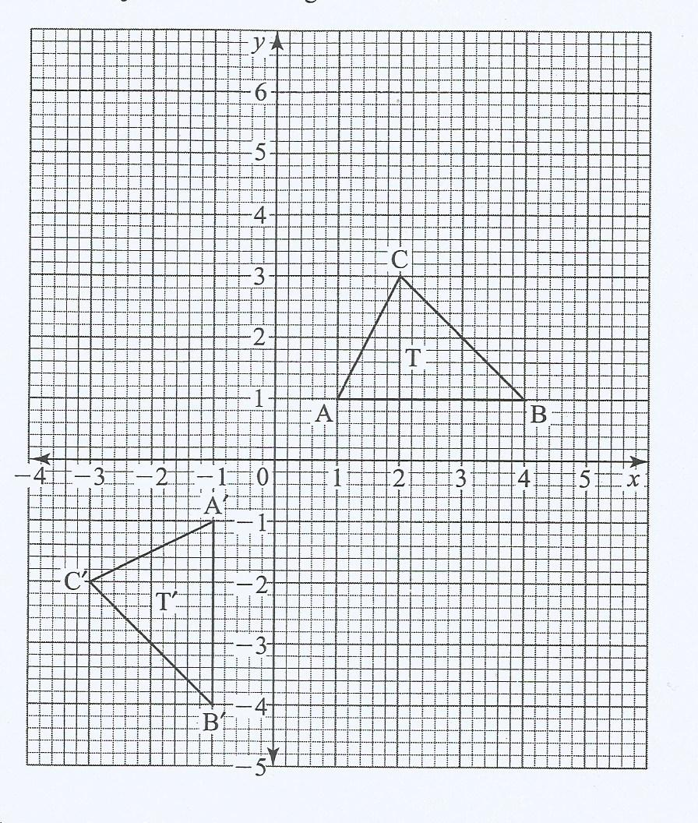

- Find the equation of the mirror lien that maps T onto Tʹ. (1 mark)

b i)Tʹ is mapped onto Tʺ by positive quarter turn about (0,0). Draw Tʺ (2 marks)

ii) Describe a single transformation that maps T onto Tʺ (2 marks)

c) Tʺ is mapped onto Tʺʹ by an enlargement, centre (2,0), scale factor -2 .
Draw Tʺʹ (2 marks)

d) Given that he area of Tʺʹ is 12cm², calculate the area of Tʺʹ . (3 marks)

SIMILARITY AND CONGRUENCY
      - 1989 Q15 P2
In the figure below, ABCD IS A cyclic quadrilateral and BC is parallel to AD.
Show that triangle ABX is congruent to triangle DXC. (4 marks)
      - 1990 Q7 P2
In the triangle ABC shown below DE is parallel to BC. If AE = 3cm and EC = 2cm,
determine the ratio of the triangle ADE to that of the triangle ABC. (2 marks)
      - 1991 Q6 P1
In the figure below AD // BC. AC and BD intersect at E. Given that AE: EC = 1:5
and BD =12 cm, calculate the length of DE. (3 marks)
A D

E

B
C
      - 1992 Q5 P1
In the figure above, triangle ABC is similar to triangle AED and BC // ED. Given
that the ratio AB: AE = 2:5, find the ratio of the area of triangle ABC to that of
the trapezium BCDE.
(3 marks)

      - 1992 Q21 P1
In the figure given below (not drawn to scale) DC is a tangent to the circle centre O.
AOBC is a straight line.
D

O
6cm

A C
B 4cm

- Show that ΔADC is similar to Δ DBC.
- Given that BC = 4cm AND DC = 6cm, calculate
  - the length of AB (3 marks)
  - the size of angle ACD (2 marks)

      - 1992 Q15 P2
In the figure below, the chord AB and CD intersect at E. Show that ΔAED is
similar to ΔBEC. (3 marks)
C A
E

B

D

      - 1993 Q16 P1
In the triangle ABC below AC=8cm, BC=5cm and angle BCA = 30⁰. Point D
divides BC in the ratio 1:4 and point E divides AC in the ratio 2:3. Find the area
of the quadrilateral ABDE (3 marks)

      - 1993 Q2 P2
A football tube in the form of a sphere is inflated so that its radius increases
in the ratio of 4:3. Find the ratio in which the volume is increased (2 marks)

      - 1994 Q9 P9
A container of height 30cm has a capacity of 1.5 litres. What is the height of
a similar container of capacity 3.0 m³? (3 marks)

10. 1995 Q7 P2
The ratio of the lengths of the corresponding sides of two similar rectangular
water tanks is 3:5. The volume of the smaller tank is 8.1 m³. Calculate the
volume of the larger tank. (3 marks)

11. 1996 Q10 P2
Pieces of soap are packed in a cuboid container measuring 36cm by 24cm by
18cm. Each piece of soap is similar to the container. If the linear scale factor
between the container and the soap is ¹/₆, find the volume of each piece of soap.
(2 marks)

12. 2002 Q15 P2
In the diagram below, ABCD is a trapezium with AB parallel to DC. The
diagonals AC and BD intersect at E.

a) Giving reasons show that triangle ABE is similar to triangle CDE. (2 marks)
b) Giving that AB = 3DC, find the ratio of DB to EB. (2 marks)

13. 2005 Q8 P2
The volumes of two similar solid cylinders are 4752 cm³ and 1408 cm³. If
the area of the curved surface of the smaller cylinder is 352 cm², find the
area of the curved surface of the larger cylinder. (4 marks)

14. 2008 Q9 P2
In the figure below, angles BAC and ADC are equal. Angle ACD is a right angle.
The ratio of the sides AC: BC = 4:3

Given that the area of triangle ABC is 24cm²,find the area of triangle ACD

(4 marks)

15. 2009 Q21 P1
A glass in the form of a frustum of a cone is represented by the diagram below.
The glass contains water to a height of 9 cm. The bottom of the glass is a circle of
radius 2 cm while the surface of the water is a circle of radius 6 cm.
(a) Calculate the volume of the water in the glass. (3 marks)

(b) When a special marble is submerged into the water in the glass, the water
level rises by 1 cm.
Calculate :
(i) the volume of the marble (4 marks)
(ii) the radius of the marble (3 marks)

16. 2011 Q 16 P1
A small cone of height 8 cm is cut off from a bigger cone to leave a frustum
of height 16cm. If the volume of the smaller cone is 160cm³, find the volume
of the frustum (3 marks)

17. 2013 Q24 P1
The figure below represents a cone of height 12 cm and base radius of 9 cm
from which a similar smaller cone is removed, leaving a conical hole of height 4 cm.

- Calculate:
- The base radius of the conical hole; (2 marks)
- The volume, in terms of π, of the smaller cone that was removed . (2 marks)

- (i) Determine the slant height of the original cone. (1 mark)

TRIGONOMETRY
1. 1989 Q4 P1
When the angle of elevation of the sun is 58⁰, a vertical pole casts a shadow
of length 5m on a horizontal ground. Find the height of the pole (2 marks)

2. 1990 Q12 P1
The angle of elevation of the top of a cliff from point P is 45⁰. From a point Q
which is 10m from P towards the foot of the cliff, the angle of elevation is 48⁰.
Calculate the height of the cliff. (4 marks)

3. 1990 Q12 P2
Towns A,B,C and D are such that A is 15km north of B,C is 8km east of B,D
is directly east of A and on a bearing 060⁰ from C. Find the distance between
towns A and d, giving your answer to two significant figures (3 marks)

4. 1994 Q23 P2
A flag 10m long is fixed on top of a tower. From a point on horizontal
ground, the angles of elevation of the top and bottom of the flag post are
40⁰ and 33⁰ respectively.
Calculate
      - The height of the tower (6 marks)
      - The shortest distance from the point on the ground to the top of
the flag post
(2 marks)
5. 1996 Q4 P1
A man walks directly from point A towards the foot of a tall building 240m away.
After covering 180m, he observes that the angle of the top of the building is 45⁰.
Determine the angle of elevation of the top of the building from A.
(3 marks)
6. 1997 Q5 P1
There are two signposts A and B on the edge of the road. A is 400 m to the west
of b. A tree is on a bearing of 060⁰ from A and a bearing of 330⁰ from B

Calculate the shortest distance of the tree from the edge of the road.
(3 marks)
7. 1998 Q6 P1
A point A is directly below a window. Another point B is 15 m from A
and at the same horizontal level. From B angle of elevation of the top of the
bottom of the window is 30⁰ and the angle of elevation of the top of the window
is 35⁰.
Calculate the vertical distance.
- From A to the top of the window (1 mark)
- From A to the bottom of the window (1 mark)
- From the bottom to top of the window (1 mark)

8. 1998 Q4 P2
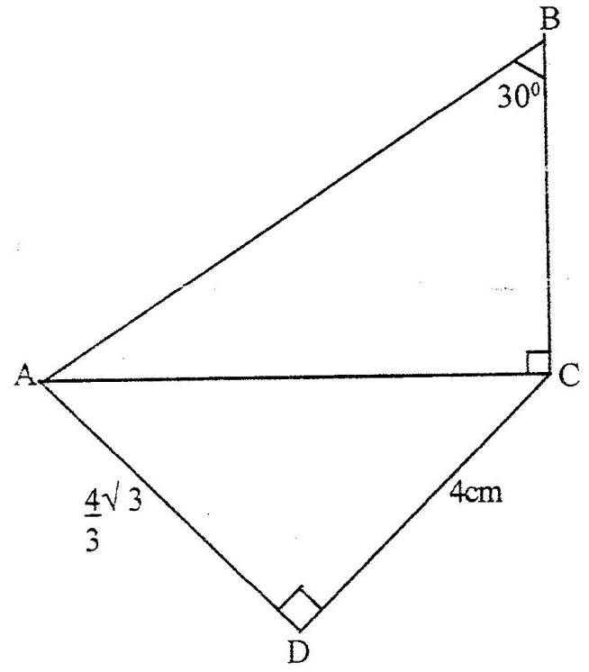
In the figure below ABC = 30⁰, < ACB = <ADC= 90⁰, AD = $\frac{4}{3}\sqrt{3}$ cm and DC = 4cm

Calculate the length of (a) AC (2 marks)
(b) BC (2 marks)

9. 2000 Q7 P1
Given that sin θ = ²/₃ and θ is an acute angle find:
- Tan θ giving your answer in surd form (2 marks)

10. 2001 Q20 P2
An electric pylon is 30m high. A point S on top of the pylon is vertically above
another point on the ground . Points A and B are on the same horizontal ground
as R. Point A is due south of the pylon and the angle of elevation of S from A is 26⁰.
Point B is due west of the pylon and the angle of elevation of S from B is 32⁰.

a) Distance from A and B (6 marks)
b) Bearing B from A (2 marks)

11. 2003 Q12 P1
Two straight paths are perpendicular to each other at point p. One path
meets a straight road at point A while the other meets the same road at B.
Given that PA is 50 metres while PB is 60 metres. Calculate the obtuse angle
made by path PB and the road. (3 marks)

12. 2005 Q7 P1
Given that sin (90 – x)⁰ = 0.8, where x is an acute angle, find without using
mathematical tables the value of tan x⁰. (2 marks)

13. 2006 Q11 P1
The diagram below represents a school gate with double shutters. The
shutters are such opened through an angle of 63⁰.
The edges of the gate, PQ and RS are each 1.8 m

Calculate the shortest distance QS, correct to 4 significant figures
(3 marks)

14. 2007 Q8 P1
Given that x is an acute angle and $\cos{x=\frac{2\sqrt{5}}{5}}$ cos x = , find without using
mathematical tables or a calculator, tan ( 90 – x)⁰. (2 marks)

15. 2007 Q15 P1
Points L and M are equidistant from another point K. The bearing of
L from K is 330⁰. The bearing of M from K is 220⁰.Calculate the bearing of M
from L (3 marks)

16. 2007 Q18 P1
In the diagram below PA represents an electricity post of height 9.6 m. QB and RC
represents two storey buildings of heights 15.4 m and 33.4 m respectively. The
angle of depression of A from B is 5.5⁰ While the angle of elevation of C from B is
30.5⁰ and BC = 35m.

(a) Calculate, to the nearest metre, the distance AB (2 marks)
(b) By scale drawing find,
(i) The distance AC in metres (5 marks)
(ii) ∠ BCA and hence determine the angle of depression of A from C (3 marks)

17. 2008 Q20 P1
The diagram below represents two vertical watch-towers AB and CD on a level
ground. P and Q are two points on a straight road BD. The height of the tower AB
is 20m road a BD is 200m.
A
20 M
B
P
Q
D
C

a) A car moves from B towards D. At point P, the angle of depression of the car
from point A is 11.3⁰. Calculate the distance BP to 4 significant figures. (2 marks)
b) If the car takes 5 seconds to move from P to Q at an average speed
of 36 km/h, calculate the angle of depression of Q from A to 2
decimal places (3 marks)

c) Given that QC=50.9m, calculate;
(i) The height of CD in meters to 2 decimal places; (2 marks)
(ii) The angle of elevation of A from C to the nearest degree. (3 marks)

18. 2009 Q12 P1
An electric pole is supported to stand vertically on a level ground by a tight wire.
The wire is pegged at a distance of 6 metres from the foot of the pole as shown.

wire

6 metres

The angle which the wire makes with the ground is three times the angle it
makes with the pole. Calculate the length of the wire to the nearest centimetre.
(3 marks)
19. 2010 Q13 P1
Given that 3θ⁰ is an acute angle and sin 3θ⁰,find the value of θ. (3 marks)

20. 2011 Q5 P1
Given that sin (x + 60)⁰ = cos (2x), find tan (x + 60)⁰ (3 marks)

21. 2012 Q10 P1
Given that tan $x^{0}=\frac{3}{7}$ , find the cos ${\left(90-x\right)}^{0}$ giving the answer to 4
Significant figures (2 marks)

22. 2015 Q5 P1
A piece of wire is bent into the shape of an isosceles triangle. The base angles
are each 48° and the perpendicular height to the base is 6 cm. Calculate,
correct to one decimal place, the length of the wire. (3 marks)

23. 2015 Q20 P1
In the figure below, AC = 12cm, AD =15 cm and B is point on AC,
<BAD= DB=30⁰.

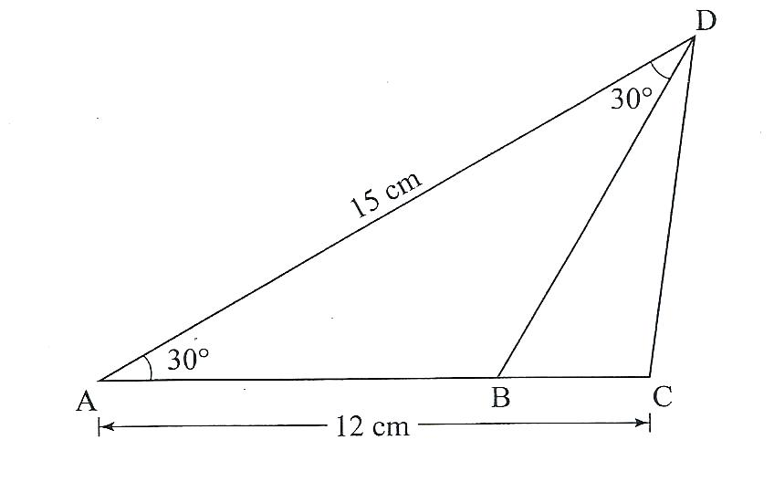

Calculate , correct to one decimal place
a) The length of CD: (3 marks)
b) The length of AB (3 marks)
c) The area of triangle BCD (2 marks)
d) The size of <BDC (2 marks)

24. 2015 Q15 P2
Solve the equation sin ( ½ x – 30⁰) = cos x for 0 < x < 90⁰. (2 marks)

MEASUREMENT
      - 1989 Q9 P1
The base of an open rectangular tank is 3.2m by 2.8m. Its height is 2.4m. It
contains water to a depth of 1.8m. Calculate the surface area inside the tank that is
not in contact with water. (2 marks)

      - 1989 Q16 P2
The solid shown in the figure below consists of a cylinder and a hemisphere of
equal diameters of 14cm. If the height of the solid is 22cm, find its volume.
(4 marks)

      - 1990 Q9 P1
The figure below shows a sector of a circle. If the area of the sector is 30.8cm²,
Calculate the length of the arc AB. (Take $π$to be ²²/₇) (3 marks)

      - 1990 Q11 P1
The figure below shows a vertical section of a hemispherical pot centre O.
The radius OA of the pot is 20cm. If the pot contains water to a depth of
8cm, calculate the diameter of the water surface. (3 marks)
O

20cm

B A

      - 1990 Q14 P1
The figure below shows an equilateral triangle ABC inscribed in a circle of
radius 6cm. Calculate the length of the side of the triangle. (2 marks)

A

B

C
      - 1990 Q13 P2
A metal bar 14cm long and 5cm in diameter is melted down and cast
into circular washers. Each washer has an external diameter of 4cm and
an internal diameter of 1¹/₂cm and is 0.3cm thick. Calculate the number
of complete washers obtained.
(Take $π$ ²²/₇) (4 marks)

      - 1991 Q12 P1
A cone of radius 20cm has a slant height of 52cm. A frustum is cut off from
this cone Such that its top is 10cm and its slant height is 26cm (see
diagram below).
Calculate the area of the curved surface of the frustum. (3 marks)

10cm

52cm

26cm

20cm

      - 1991 Q17 P2
The metal solid shown in the figure below is made up by joining a hemisphere
of radius 7cm to a cylinder of the same radius. The mass and density of the
solid are 40kg and 17.5gm per cm3, respectively. Calculate the height of the
cylindrical part of the solid. (8 marks)

9. 1992 Q4 P1
The two diagonals of a parallelogram are 20cm and 28.8cm. The acute angle
between them is 62⁰.Calculate the of the parallelogram. (3 marks)

- 1992 Q15 P1
In the figure below, ABCD is a square of side 4cm. BXD and BYD are arcs of
circles centres A and C respectively. Calculate the area of the shaded region.
(Take $π$ 3.14) (4 marks)

- 1992 Q17 P1
A room is to be constructed such that its external length and breadth are 7.5m
and 5.3m respectively. The thickness of the wall is 15cm, and its height is
3.3cm. A total space of 5m³ is to be left out in the walls for a door and
windows.
  - Calculate the volume of the material needed to construct the walls
without the door and the windows. (4 marks)

  - The block used in constructing the walls are 45 cm x 20cm x 15 cm.
0.225m³ of cement mixture is used to join the blocks. Calculate the
number of blocks needed to construct the room. (4 marks)

- 1992 Q22 P1
The diagram alongside shows a model of a cylindrical water tank. The total
surface area of the model is 0.4m² and the surface area of the actual tank is
14.4m².

  - If the height of the tank is 2.1m, find the height of the model. (4 marks)

ii) If the capacity of the model is 23.15litres, find the capacity of the tank to
the nearest litre. (4 marks)

- 1992 Q20 P2
A swimming pool 30m long is 1m deep at its shallow end 4m deep at its deep
end. The pool is 14m wide.

  - Find the volume of water, in cubic metres, when the pool is full. (4 marks)

  - A circular pipe of diameter 14cm is used to empty the swimming pool.
Water flows through pipe at a rate of 5m per sec.
Calculate the time it would take, to the nearest minute, to empty the pool.
(4 marks)
- 1993 Q7 P1
The figure alongside shows the cross-section of a metal bar of length
40mm.The ends are equal semi-circles.

Determine its mass if the density of the metal is 8.8 g/cm³ (Take $π$ = ²²/₇)
(4 marks)

- 1993 Q15 P1
A rostum is made by cutting off the upper part of a cone along a plane parallel
to the base at $\frac{2}{3}$ up the height. What fraction the volume of the cone does the
rostum represent?
(3 marks)

- 1993 Q3 P2
A plug is made up of a hemi-spherical cap of radius 4.2cm, and a cylinder of
diameter 3.5cm and height 5.0cm as shown in the diagram alongside.
Calculate the volume of the plug. (3 marks)

- 1993 Q9 P2
The cross-section of a head of a bolt is the form of a regular hexagon as
shown in the figure below. Determine the area of the cross-section (4 marks)

- 1993 Q10 P2
To fence one side of his farm, a farmer requires 25 posts placed 4m apart.
How many posts would he require if the posts were 3m apart? (2 marks)

- 1995 Q9 P2
A solid cone of height 12cm and radius 9cm is recast into a soli sphere.
Calculate the surface area of the sphere (4 marks)

20. 1995 Q 4 P2
Calculate volume of a prism whose length is 25cm and whose cross- section
is an equilateral triangles of 3 cm (3 marks)

21. 1995 Q 14 P2
Two containers, one cylindrical and one spherical, have the same volume.
The height of the cylindrical container is 50 cm and its radius is 11 cm.
Find the radius of the spherical container. (2 marks)

22. 1996 Q 7 P2
In the figure below BAD and CBD are right angled triangles.

Find the length of AB (4 marks)

- 1997 Q 6 P1
A cylinder of radius 14 cm contains water. A metal solid cone of base radius 7 cm
and height 18cm is submerged into the water. Find the change in height of the
water level in the cylinder. (4 marks)

- 1997 Q 16 P2
A metal bar is a hexagonal prism whose length is 30 cm. The cross – section is a
regular hexagon with each side of the length 6 cm.
Find
- the area of the hexagonal face (3 marks)
- the volume of the metal bar (2 marks)

- 1998 Q 11 P1
A cylindrical container of radius 15cm has some water in it. When a solid is
submerged into the water, the water level rises by 1.2 cm.
- Find, the volume of the water displaced by the solid leaving your
answer in terms of Л (2 marks)
- If the solid is a circular cone of height 9 cm, calculate the radius of
the cone to 2 decimal places. (2 marks)

- 1998 Q 21 P1
A cylindrical can has a hemisphere cap. The cylinder and the hemisphere
are of radius 3.5 cm. The cylindrical part is 20 cm tall. Take Л to be ²²/₇
Calculate
- the area of the circular base (2 marks)
- the area of the curved cylindrical surface (2 marks)
- the area of the curved hemisphere surface (2 marks)
- The total surface area. (2 marks)

- 1998 Q 11 P2
A balloon, in the form of a sphere of radius 2 cm, is blown up so that the volume
increase by 237.5%. Determine the new volume of balloon in terms of $π$ (2 marks)
- 1999 Q4 P1
An open right circular cone has a base radius of 5 cm and a perpendicular
height of 12 cm. (2 marks)

- 1999 Q 8 P1
A girl wanted to make a rectangular octagon of side 14cm. She made it from a
square piece of a card of size y cm by cutting off four isosceles triangles whose
equal sides were x cm each, as shown below.
- Write down an expression for the octagon in terms of x and y (1 mark)
- Find the value of x (1 mark)
- Find the area of the octagon (1 mark)

- 1999 Q 13 P1
An artisan has 63 kg of metal of density 7, 000kg/m³. He intends to use to make
a rectangular pipe with external dimensions 12 cm by 15 cm and internal
dimensions 10 cm by 12 cm.
Calculate the length of the pipe in metres (4 marks)

- 1999 Q 23 P1
The diagram below shows a cross- section of a bottle. The lower part ABC is
a hemisphere of radius 5.2 cm and the upper part is a frustrum of a cone.
The top radius of the frustrum is one third of the radius of the hemisphere.
The hemisphere part is completely filled water as shown in the diagram.
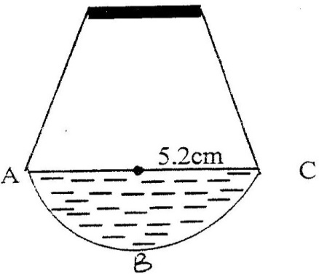

When the container is inverted, the water now completely fills only the
frustrum part.
- Determine the height of the frustrum part (5 marks)
- Find the surface area of the frustrum part of the bottle. (3 marks)

- 2000 Q 9 P1
The figure below shows an octagon obtained by cutting off four congruent
triangles from rectangle measuring 19.5 by 16.5 cm (3 marks)

Calculate the area of the octagon

- 2000 Q 20 P1
A solid made up of a conical frustrum and a hemisphere top as shown in
the figure below. The dimensions are as indicated in the figure.
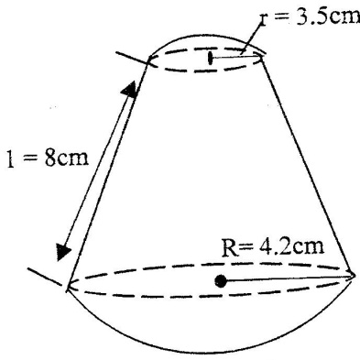

(a) Find the area of
(i) The circular base (1 mark)
(ii) The curved surface of the frustrum (3 marks)
(iii) The hemisphere surface (2 marks)

(b) A similar solid has a total area of 81.51 cm². Determine the radius of its base. (2 marks)

- 2000 Q 3 P2
Two sides of a triangle are 5 cm each and the angle between them is 120⁰.
Calculate the area of the triangle. (3 marks)

- 2000 Q 4 P2
A piece of wire P cm long is bent to form the shape shown in the figure below
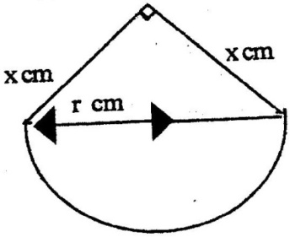

The figure consists of a semicircular arc of radius r cm and two perpendicular
sides of length x cm each. Express x in terms of P and r, (1 mark)
Hence show that the area A cm², of the figures is given by
A = ½ $π$ r² + $\frac{1}{8}$ (p - $π$r)² (2 marks)

- 2001 Q 2 P1
The figure below represents a kite ABCD, AB = AD = 15 cm. The diagonals BD
and AC intersect at O. AC = 30 cm and AO = 12 cm.
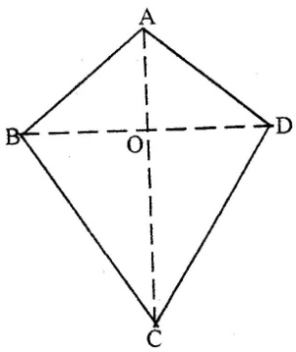

Find the area of the kite (3 marks)

- 2001 Q 4 P1
The diagram below represents a solid made up of a hemisphere mounted on
a cone. The radius of the cone and the radius of the hemisphere is each 6 cm and
the height of the cone is 9 cm.

Calculate the volume of the solid. Take $π$ as ²²/₇ (3 marks)

- 2001 Q 12 P2
The figure represents a pentagon prism of length 12cm. The cross – section is
a regular pentagon, centre O, whose dimensions are shown.
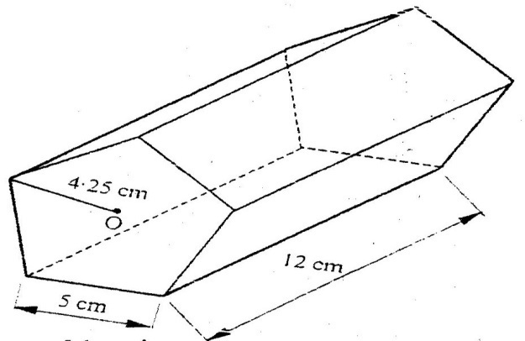

Find the total surface area of the prism. (4 marks)

- 2001 Q 23 P2
The diagram below represents a pillar made of cylindrical and regular
hexagonal parts. The diameter and height of the cylindrical part are 1.4m
and 1m respectively. The side of the regular hexagonal face is 0.4m and
height of hexagonal part is 4m.

a) Calculate the volume of the:
i) Cylindrical part (2 marks)
ii) Hexagonal part (3 marks)
b) An identical pillar is to be built but with a hollow centre cross – section
area of 0.25m². The density of the material to be used to make the pillar
is 2.4g/cm³.
Calculate the mass of the new pillar. (3 marks)

- 2002 Q 6 P1
The figure below is a polygon in which AB = CD = FA = 12cm BC = EF = 4cm and
BAF =- CDE = 120⁰. AD is a line of symmetry.

Find the area of the polygon. (4 marks)

- 2002 Q 11 P1
The internal and external diameters of a circular ring are 6cm and 8cm
respectively.
Find the volume of the ring if its thickness is 2 millimeters.
(3 marks)

- 2002 Q 3 P2
A triangular flower garden has an area of 28m². Two of its edges are 14 metres
and 8 metres. Find the angle between the two edges. (2 marks)

- 2003 Q 10 P1
The length of a solid prism is 10cm. Its cross section is an equilateral triangle
of side 6cm. Find the total surface area of the prism. (3 marks)

- 2003 Q 11 P1
A wire of length 21cm is bent to form the shape down in the figure below,
ABCD is a rectangle and AEB is an equilateral triangle. (2 marks)
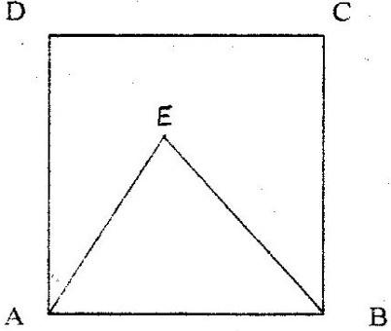

If the length of AD of the rectangle is 1$\frac{1}{2}$ times its width, calculate the
width of the rectangle.

- 2003 Q 13 P1
The length of a hollow cylindrical pipe is 6metres. Its external diameter is
11cm and has a thickness of 1cm. Calculate the volume in cm3 of the
material used to make the pipe. Take $π$ as 3.142. (3 marks)

- 2003 Q 17 P1
A rectangular tank whose internal dimensions are 1.7m by 1.4m by 2.2m is
three – quarters full of milk.

    - Calculate the volume of milk in the tank in cubic metres.

    - The milk is to be packed in small packets. Each packet is in the shape of a right
pyramid on an equilateral triangular base of side 16cm.
The height of each packet is 13.6cm. Full packets obtained are sold at
Sh.25 per packet.
Calculate
- The volume of milk in cubic centimetres, contained in each
packet to 2 significant figures (4 marks)
ii) The exact amount that will be realized from the sale of all the
packets of milk. (2 marks)

- 2003 Q 9 P2
The surface area of a solid hemisphere is radius r cm is 75$π$ cm². Find the
volume of the solid, leaving your answer in terms of $π$. (4 marks)

- 2004 Q 13 P1
The figure below represents a hexagon of side 5cm.
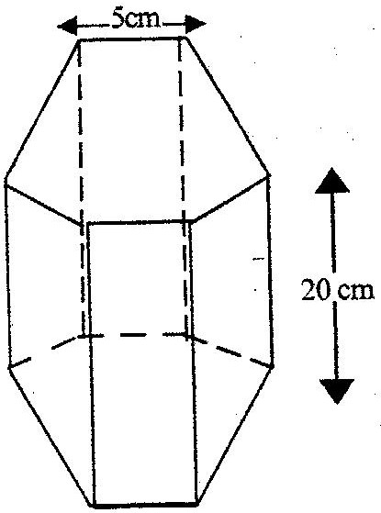

Find the volume of the prism. (4 marks)

- 2004 Q 19 P1
The figure below represents a model of a solid structure in the shape of a
frustum of a cone with hemispherical top. The diameter of the
hemispherical part is 70cm and is equal to the diameter of the top of the
frustum. The frustum has a base diameter of 28cm and slant height of 60cm.

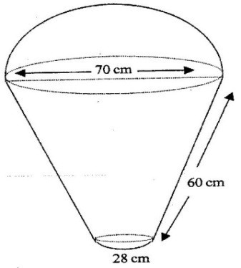

Calculate
a) The area of hemispherical surface. (2 marks)
b) The slant height of the cone from which the frustum was cut (2 marks)
c) The total surface area of the model. (4 marks)

50. 2005 Q 3 P1
The area of a rhombus is 60cm². Given that one of its diagonals is 15 cm long,
Calculate the perimeter of the rhombus (3 marks)

51. 2005 Q 12 P1
A cylindrical piece of wood of radius 4.2 cm and length 150 cm is cut length into
two equal pieces. Calculate the surface area of one piece
(Take $π$ as $\frac{22}{7}$ ) (4 marks)

52. 2005 Q 19 P1
The diagram below represents a rectangular swimming pool 25m long and
10m wide. The sides of the pool are vertical.
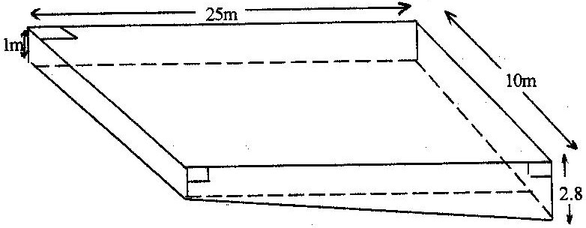

The floor of the pool slants uniformly such that the depth at the shallow
end is 1m at the deep end is 2.8 m.
- Calculate the volume of water required to completely fill the pool.
(3 marks)
- Water is allowed into the empty pool at a constant rate through an inlet pipe.
It takes 9 hours for the water to just cover the entire floor of the pool.
Calculate:
- The volume of the water that just covers the floor of the pool (2 marks)
- The time needed to completely fill the remaining of the pool. (3 marks)

53. 2006 Q 19 P1
The diagram below (not drawn to scale) represents the cross- section of a
solid prism of height 8.0 cm (3 marks)

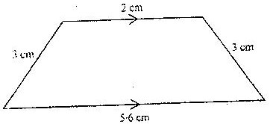

(a) Calculate the volume of the prism (3 marks)
(b) Given that the density of the prism is 5.75g/cm³, calculate its mass in
grams (2 marks)
(c) A second prism is similar to first one but is made of a different
materials. The volume of the second prism is 246.24cm³
(i) Calculate the area of the cross section of the second prism (3 marks)

(ii) Given that the ratio of the mass of the first to that of the second is
2: 5, find the density of the second prism (2 marks)

54. 2006 Q 23 P1
The figure below is a model representing a storage container. The model whose
total height is 15cm is made up of a conical top, a hemispherical bottom and the
middle part is cylindrical. The radius of the base of the cone and that of the
hemisphere are each 3cm. The height of the cylindrical part is 8cm.

(a) Calculate the external surface area of the model (4 marks)

(b) The actual storage container has a total height of 6 metres. The outside
of the actual storage container is to be painted. Calculate the amount
of paint required if an area of 20m² requires 0.75 litres of the paint (6 marks)

55. 2007 Q 7 P1
A square brass plate is 2 mm thick and has a mass of 1.05 kg. The density of
the brass is 8.4 g/cm³. Calculate the length of the plate in centimetres (3 marks)

56. 2007 Q 9 P1
A cylindrical solid of radius 5 cm and length 12 cm floats lengthwise in water
to a depth of 2.5 cm as shown in the figure below.

Calculate the area of the curved surface of the solid in contact with water,
correct to 4 significant figures (4 marks)

57. 2007 Q 22 P1
Two cylindrical containers are similar. The larger one has internal
cross- section area of 45cm² and can hold 0.945 litres of liquid when
full. The smaller container has internal cross- section area of 20cm²

  - Calculate the capacity of the smaller container (4 marks)
  - The larger container is filled with juice to a height of 13 cm. Juice is
then drawn from is and emptied into the smaller container until the
depths of the juice in both containers are equal.
Calculate the depths of juice in each container (2 marks)

  - On fifth of the juice in the larger container in part (b) above is further
drawn and emptied into the smaller container. Find the difference in
the depths of the juice in the two containers. (4 marks)

58. 2008 Q 4 P1
Mapesa travelled by train from Butere to Nairobi. The train left Butere on a
Sunday at 23 50 hours and travelled for 7 hours 15 minutes to reach Nakuru.
After a 45 minutes stop in Nakuru, the train took 5 hours 40 minutes to
reach Nairobi.
Find the time, in the 12 hours clock system and the day Mapesa arrived
in Nairobi. (2 marks)

59. 2008 Q 7 P1
A liquid spray of mass 384g is packed in a cylindrical container of internal
radius 3.2cm. Given that the density of the liquid is 0.6g/cm³, calculate to
2 decimal places the height of the liquid in the container. (3 marks)

60. 2008 Q 9 P1
A solid metal sphere of radius 4.2 cm was melted and the molten material
used to make a cube. Find to 3 significant figures the length of the side of
the cube.
(3 marks)
61. 2008 Q 13 P1
A rectangular and two circular cut-outs of metal sheet of negligible
thickness are used to make a closed cylinder. The rectangular cut-out has
a height of 18cm.
Each circular cut-out has a radius of 5.2cm. Calculate in terms of π, the
surface area of the cylinder (3 marks)

62. 2008 Q 22 P1
The diagram below represents a conical vessel which stands vertically.
The which stands vertically. The vessels contains water to a depth of
30cm. The radius of the surface in the vessel is 21cm. (Take π=$\frac{22}{7}$).

21cm

30cm

- Calculate the volume of the water in the vessels in cm³

b) When a metal sphere is completely submerged in the water, the level
of the water in the vessels rises by 6cm.
Calculate:
(i) The radius of the new water surface in the vessel; (2 marks)

(ii) The volume of the metal sphere in cm³ (3 marks)
(iii) The radius of the sphere. (3 marks)

63. 2009 Q 6 P1
The figure below represents a plot of land ABCD such that AB = 85 m,
BC= 75m, CD = 60m, DA=50m and angle ACB=90◦

Determine the area of the plot in hectares correct to two decimal places.
(4 marks)
64. 2009 Q 7 P1
A watch which loses a half minute every hour was set to reach the correct
time at 05 45h on Monday. Determine the time in the 12 hour system, the
watch will show on the watch will show on the following Friday at 1945h.
(3 marks)
65. 2010 Q 14 P1
A cylindrical solid whose radius and height are equal has a surface area of
154 cm². Calculate its diameter, correct to 2 decimal places. (Take π =3.142).
(3 marks)
66. 2010 Q 15 P1
The figure below shows two sectors in which CD and EF are arcs of
concentric circles ,centre O. Angle COD =2 radians and CE=DF= 5cm.

If the perimeter of the shape CDFE is 24 cm, calculate the length of OC.

67. 2010 Q 18 P1
A carpenter constructed a closed wooden box with internal
Measurements 1.5 metres long,0.8 metres wide and 0.4 metres high. The
wood used in constructing the box was 10 cm thick and had a density of 0.6
g/cm³.
a). Determine the:
- Volume in cm³,of the wood used in constructing the box (4 marks)
- Mass of the box in kilograms, correct to 1 decimal place. (2 marks)

b). Identical cylindrical tins of diameter 10 cm, height 20 cm with a mass
of 120 g each were packed in the box.
Calculate the:
- Maximum number of tins that were packed. (2 marks)
- Total mass of the box with the tins. (2 marks)

68. 2011 Q 2 P1
The diagonal of a rectangular garden measures 11¹/₄m while its width
measures 6$\frac{3}{4}$ m. Calculate the perimeter of the garden. (2 marks)

69. 2011 Q 7 P1
The external length, width and height of an open rectangular container are
41 cm, 21 cm and 15.5cm respectively. The thickness of the material
making the container is 5mm. If the container has 8 litres of water, calculate
the internal height above the water level. (4 marks)

70. 2011 Q 17 P1
A solid consists of a cone and a hemisphere. The common diameter of the
Cone and the hemisphere is 12cm and the slanting height of the cone is
10cm.
- Calculate correct to two decimal places;
      - The surface area of the solid; (3 marks)
      - The volume of the solid. (4 marks)

- If the density of the material used to make the solid is 1.3g/cm³, calculate
its mass in kilograms. (3 marks)
71. 2012 Q4 P1
In the parallelogram PQRS shown below, PQ=8cm and angle SPQ = 30⁰
S R

30⁰

P 8cm Q

If the area of the parallelogram is 24cm³, find its perimeter. (3 marks)

72. 2012 Q15 P1
The figure below represents a solid cone with a cylindrical hole drilled into
it. The radius of the cone is 10.5cm an its vertical height is 15cm.The hole
has a diameter of 7cm and depth of 8cm.

Calculate the volume of the solid. (3 marks)

73. 2012 Q18 P1
The figure below represents a solid cuboid ABCDEFGH with a rectangular
base.AC = 13cm, BC = 5cm and CH = 15cm.

- Determine the length of AB. (1 mark)

- Calculate the surface area of the cuboid (3 marks)

- Given that the density of the material used to make the cuboid is
7.6g/cm³, calculate its mass in kilograms. (4 marks)

- Determine the number of such cuboids that can fit exactly in a container
measuring 1.5m by 1.2m by 1m. (2 marks)

74. 2013 Q7 P1
Chelimo’s clock loses 15 seconds every hour. She sets the correct time on the
clock at 0700h on a Monday. Determine the time shown on the clock when
the correct time was 1900h on Wednesday the same week. (3 marks)

75. 2013 Q14 P1
A cylindrical pipe 2 ½ metres long has an internal diameter of 21 millimetres
and an external diameter of 35 millimetres. The density of the material that
makes the pipe is 1.25 g/cm³.
Calculate the mass of mass of the pipe in kilograms. (Take π =$\frac{22}{7}$). (4 marks)

76. 2013 Q15 P1
The figure below represents a pentagonal prism of length 12 cm.The
cross-section is a regular pentagon of side 5 cm.

12cm
5cm

Calculate the surface area of the prism correct to 4 significant figures. (4 marks)

77. 2014 Q3 P1
The mass of solid cone of radius 14cm and height 18cm is 4.62kg.
find its density in g/cm³ (3marks)
78. 2014 Q13 P1
The figure below shows a rectangular container of dimensions 40cm by 25cm
by 90cm. a cylindrical pipe of radius 7.5cm is fitted in the container as shown.

Water is poured into the container in the space outside the pipe such that the
water level is 80% the height of the container. Calculate the amount of the water,
in litres, in the container in 3 significant figures. (4marks)

79. 2014 Q14 P1
A minor arc of a circle subtends an angle of 1050 at the centre of the circle. If
the radius of the circle is 8.4cm, find the length of the major arc
(take $=\frac{22}{7}$ ) (3marks)

80. 2015 Q3 P1
The volume of a cube is 1728 cm³. Calculate, correct to 2 decimal places,
the length of the diagonal of a face of the cube. (3 marks)

81. 2015 Q23 P1
The figure below represents a conical flask. The flask consists of a cylindrical
part and a frustum of a cone. The diameter of the base is 10cm while that of the
neck is 2 cm. the vertical height of the flask is 12cm.
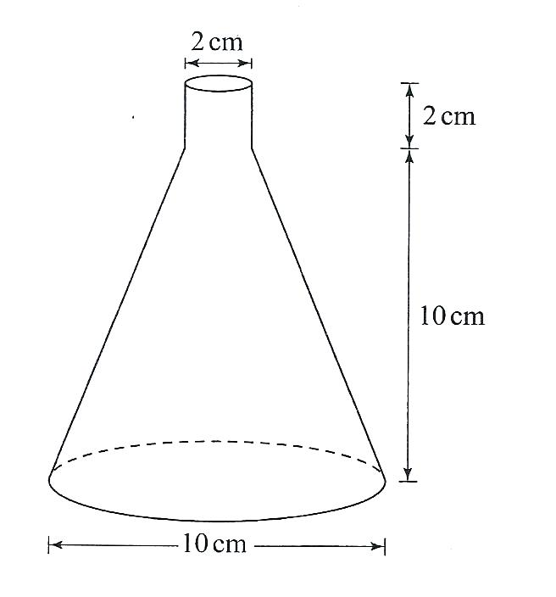

Calculate, correct to 1 decimal place
a) The slant height of the frustum part (2 marks)

b) The slant height of the smaller cone that was cut off to make the
frustum part (2 marks)
c) The external surface area of the flask. (Take $π=3.142$) (6 marks)

82. 2015 Q3 P2
An arc 11 cm long, subtends an angle of 70° at the centre of a circle. Calculate
the length, correct to one decimal place, of a chord that subtends an angle of 90°
at the centre of the same circle. (4 marks)

ALGEBRAIC EXPRESSIONS

- 1989 Q2 P1
Factorize completely a² – 15ab + 36b² (2 marks)

- 1990 Q3 P1
Simplify (3 marks)
$$\frac{\left(6a+b\right)\left(a+b\right)-7b\left(a+b\right)}{{2a}^{2}-{2b}^{2}}$$

- 1991 Q8 P2
Simplify $\frac{a}{2\left(a+b\right)}+\frac{b}{2\left(a-b\right)}$ $\frac{a}{2\left(a+b\right)}+\frac{b}{2\left(a-b\right)}$ (3 marks)

- 1992 Q6 P1
If the expression 25y² – 70y + d is a perfect square, where d is a constant,
find the value of d. (3 marks)

- 1993 Q1 P1
Factorize 2x² y² – 5xy - 12 (3 marks)

- 1993 Q14 P2
Simplify $\frac{x-2}{x+2}+\frac{2x+20}{x^{2}-4}$ $\frac{x-2}{x+2}+\frac{2x+20}{x^{2}-4}$ (4 marks)

- 1994 Q 2 P1
Simplify 28x² + 3x – 1 (2 marks)

- 1995 Q 2 P1
Simplify (3 marks)
÷

- 1995 Q 8 P2
Simplify completely

- 1996 Q 2 P1
Factorize completely
3x² – 2xy – y² (2 marks)

- 1997 Q 2 P1
Find the greatest common factor of x³y² and 4xy⁴. Hence factorize
completely the expression x³ y² – 4xy⁴ (3 marks)

12 1998 Q 2 P1
Factorize a² – b²
Hence find the exact value of 2557² - 2547² (2 marks)

- 1999 Q 1b P1
Simplify the expression
5a – 4b = 2 [a- (2b + c)] (2 marks)

- 1999 Q 15 P1
By substituting y for (2-a) or otherwise simplify the expression
(x + 2 –a)² + (2 – a-x)² – 2(x- 2 + a) (x + 2 – a). (3 marks)
Give your answer in terms of a and as a product of two squares.

- 1999 Q 22 P1
If x² + y² = 29 and x + y = 3
- Determine the values of
- x² + 2xy + y² (1 mark)
- 2xy (1 mark)
- x² – 2xy + y² (1 mark)
- x – y
- Find the value of x and y (3 marks)

- 2000 Q 2 P1
Simplify the expression $\frac{{3a}^{2}+4ab+b}{{4a}^{2}+3ab-b^{2}}$ (3 marks)

- 2001 Q 6 P1
Simplify the expression
- 2002 Q 2 P1
Simplify: (x + 2y)² – (x- 2y)² (3 marks)

- 2002 Q 11 P2
Simply the expression
- 2003 Q2 P1
Simplify the expression ${\left(a+\frac{1}{b}\right)}^{2}-{\left(a-\frac{1}{b}\right)}^{2}$ (3 marks)

- 2004 Q 3 P1
Simplify the expression $\frac{{2a}^{2}- 3ab-{2b}^{2} }{{4a}^{2}-b^{2}}$

- 2005 Q 4 P1
Simplify the expression $\frac{{9t}^{2}- {25a}^{2}}{{6t}^{2}+19at+15a^{2}}$ (3 marks)

- 2006 Q 3 P1
Simplify $\frac{p^{2}+2pq+q^{2}}{p^{3}-{pq}^{2}+p^{2}q-q^{3}}$ (4 marks)

- 2007 Q 3 P1
Expand the expression
( x² – y²) ( x² + y²) ( x⁴ – y⁴) (2 marks)

- 2007 Q 6 P1
Simplify the expression $\frac{{15a}^{2}b-{10ab}^{2}}{{3a}^{2}-5ab+{2b}^{2}}$ (3 marks)

- 2008 Q 3 P1
Simplify the expression (3 marks)

- 2009 Q 8 P1
Simplify the expression (3 marks)

- 2010 Q 12 P1
Simplify the expression $\frac{x^{2}+x-4xy-4x}{\left(x+1\right) \left(4{xy}^{2}-xy\right)}$ (3 marks)

- 2011 Q 6 P1
Simplify the expression: $\frac{4x-{9x}^{3}}{{3x}^{2}-4x-4}$ (3 marks)

- 2011 Q 8 P1
Factorise
2x²y² – 5xy – 12 (2 marks)

- 2012 Q3 P1
Expand and simplify the expression
(2x² – 3y³)² + 12x²y³ (2 marks)

- 2013 Q4 P1
Simplify the expression:
$\frac{16m^{2}-9n^{2}}{4m^{2}mn-3n^{2}}$ (3 marks)

- 2014 Q8 P1
Expand and simplify (x + 2y)² – (2y – 3)² (2marks)

- 2015 Q12 P1
Given that a = 3 , b = 5 and c = - ½ evaluate $\frac{4{ a^{2} +2b-4c}^{ }}{\frac{1}{4}\left(b^{2}-3a\right)}$ (3 marks)

LINEAR INEQUALITIES

      - 1999 Q 2 P2
Find the range of x if 2 ≤ 3 – x < 5 (2 marks)

      - 2000 Q 6 P2
Find all the integral value of x which satisfy the inequalities
2 (2-x) < 4x -9 < x + 11 (3 marks)

      - 2001 Q 16 P2
The diagram below shows the graph of:
y = $\frac{3}{10}$x – $\frac{3}{2}$ , 5x + 6y= 30 and x= 2

By shading the unwanted region, determine and label the region R that satisfies
the three inequalities. y ≥ $\frac{3}{10}$x – $\frac{3}{2}$ , 5x + 6y ≥ 30 and x ≥ 2 (4 marks)

4. 2002 Q 8 P1
Solve the following inequalities and represent the solutions on a single number line:
3 – 2x < 5
4 – 3x ≥ -8 (3 marks)

5. 2003 Q 12 P2
A mixed school can accommodate a maximum of 440 students. The number
of girls must be at least 120 while the number of boys must exceed 150.
Taking x to represent the number of boys and y the number of girls, write
down all the inequalities representing the information above. (3 marks)

6. 2004 Q 15 P2
Form the three inequalities that satisfy the given region R.

- 2006 Q 5 P1
Solve the inequality 3 – 2x ∠ x ≤ $\frac{2x+5}{3}$ and show the solution on the number
line (4 marks)

- 2010 Q 5 P1
The sum of three consecutive odd integers is greater than 219.Determine the
first three such integers. (3 marks)

- 2011 Q 4 P2
        - Solve the inequalities 2x -5> -11 and 3 + 2x ≤13, giving the answer as a
combined inequality. (3 marks)
        - List the integral values of x that satisfy the combined inequality in (a) above
(1 mark)
- 2013 Q16 P1
Given the inequalities x – 5 ≤ 3 x – 8 < 2 x – 3.
- Solve the inequalities; (2 marks)
- Represent the solution on a number line. (1 mark)

- 2014 Q12 P1
Solve 4 ≤ 3x – 2 ˂ 9 + x hence list the integral value that satisfies the inequality.
(3marks)

LINEAR MOTION
            - 1989 Q21 P1
Two towns T and S are 300km apart. Two buses A and B started from T at the same
time travelling towards S. Bus B, travelling at an average speed of 10kmh⁻¹ greater
than that of A reached S 1¹/₄ hours earlier.

  - Find the average speed of A (6 marks)
  - How far was A from T when B reached S (2 marks)

            - 1991 Q5 P1
Mwangi and Otieno live 40km apart. Mwangi starts from his home at 7.30 am and
cycles towards Otieno’s house at 16km/h. Otieno starts from his home at 8.00am
and cycles at 8km/h towards Mwangi. At what time do they meet?
(4 marks)
3. 1992 Q14 P1
A vehicle moves at an initial speed of 20m/s with a constant acceleration of 2m/s²
for five seconds before brakes are applied. If the car comes to rest under constant
deceleration in 4 seconds, determine the total distance travelled during the 9 seconds
(3 marks)

      - 1992 Q2 P2
A minibus covered a distance of 180km at an average speed of 90km/hr. It travelled
at a sped of 80km/hr for ²/₃ of its journey. At what speed did it travel the remaining
part of the journey (3 marks)

      - 1993 Q9 P1
In a race, Ogot, running at a constant speed of 8m/s, is 5m ahead of Ondiek maintains
a constant speed of 10m/s, how far does Ondiek run before catching up with Ogot?
(3 marks)
6. 1995 Q16 P1
A bus takes 195 minutes to travel a distance of (2x + 30) km at an average speed
of ( x – 20) km/h
Calculate the actual distance traveled. Give your answers in kilometres.
(3 marks)
7. 1996 Q16 P16
Two lorries A and B ferry goods between two towns which are 3120 km apart.
Lorry A travelled at 5 km/h faster than lorry B and B takes 4 hours more than
lorry A to cover the distance.
Calculate the speed of lorry B (5 marks)

8. 1997 Q14 P1
Two towns P and Q are 400 km apart. A bus left P for Q. It stopped at Q for one
hour and then started the return journey to P. One hour after the departure of the
bus from P, a trailer also heading for Q left P. The trailer met the returning bus ¾
of the way from P to Q. They met t hours after the departure of the bus from P.

- Express the average speed of the trailer in terms of t (1 mark)

- Find the ration of the speed of the bus so that of the trailer. (2 marks)

9. 1997 Q15 P2
The athletes in an 800 metres race take 104 seconds and 108 seconds respectively
to complete the race. Assuming each athlete is running at a constant speed.
Calculate the distance between them when the faster athlete is at the finishing line. (2 marks)

10. 1998 Q16 P1
A and B are towns 360 km apart. An express bus departs form A at 8 am and
maintains an average speed of 90 km/h between A and B. Another bus starts
from B also at 8 am and moves towards A making four stops at four equally
spaced points between B and A. Each stop is of duration 5 minutes and the
average speed between any two spots is 60 km/h.
Calculate distance between the two buses at 10 am. (3 marks)
11. 1999 Q9 P2
Two towns A and B are 220km apart. A bus left town A at 11. 00am and travelled
towards B at 60 km/h. At the same time, a matatu left town B for town A and
travelled at 80 km/h. The matatu stopped for a total of 45 minutes on the way
before meeting the bus.
Calculate the distance covered by the bus before meeting the matatu.
(3 marks)
12. 2000 Q2 P2
A passenger noticed that she had forgotten her bag in a bus 12 minutes after
the bus had left. To catch up with the bus, she immediately took a taxi which
travelled at 95 km/h.
The bus maintained an average speed of 75 km/h. Determine
a) The distance covered by the bus in 12 minutes (1 mark)
b) The distance covered by the taxi to catch up with the bus (2 marks)

13. 2001 Q15 P1
A town N is 340 km due west of town G and town K is due west of town N. A helicopter
Zebra left G for K at 9.00 am. Another helicopter Buffalo left N for K at 11.00 am.
Helicopter Buffalo travelled at an average speed of 20 km/ h faster than Zebra.
If both helicopters reached K at 12.30 pm find the speed of helicopter Buffalo.
(3 marks)
14. 2003 Q6 P2
A train moving at an average speed of 72km/h takes 15 seconds to completely
cross a bridge that is 80 metres long.
a) Express 72km/h in metres per second (1 mark)
b) Find the length of the train in metres (2 marks)

15. 2004 Q4 P2
Two trains T₁ and T₂ travelling in the opposite directions, on parallel tracks are just
beginning to pass one another. Train T₁ is 72 m long and travelling at 108 km/h. T₂
is 78 m long and is travelling at 72 km/h.
Find the time, in seconds, the two trains take to completely pass one another

16. 2005 Q17 P1
The distance between towns M and N is 280 km. A car and a lorry travel from M to
N. The average speed of the lorry is 20 km/h less than that of the car. The lorry
takes 1 h 10 min more than the car to travel from M and N.

- If the speed of the lorry is x km/h, find x (5 marks)
- The lorry left town M at 8: 15 a.m. The car left town M and overtook
the lorry at 12.15 p.m . Calculate the time the car left town M.
(3 marks)

17. 2006 Q20 P1
A bus left Mombasa and travelled towards Nairobi at an average speed of
60km/hr. after 2¹/₂ hours; a car left Mombasa and travelled along the same road
at an average speed of 100km/ hr. If the distance between Mombasa and Nairobi
is 500km, Determine

(a) (i) The distance of the bus from Nairobi when the car took off
(2 marks)
(ii) The distance the car travelled to catch up with the bus (4 marks)

(b) Immediately the car caught up with the bus, the car stopped for 25 minutes.
Find the new average speed at which the car travelled in order to reach
Nairobi at the same time as the bus. (4 marks)

18. 2007 Q16 P1
A rally car travelled for 2 hours 40 minutes at an average speed of 120km/h.
The car consumes an average of 1 litre of fuel for every 4 kilometres.
A litre of the fuel costs Kshs 59
Calculate the amount of money spent on fuel (3 marks)

19. 2008 Q21 P2
Two policemen were together at a road junction. Each had a walkie talkie. The
maximum distance at which one could communicate with the other was 2.5 km.
One of the policemen walked due East at 3.2 km/h while the other walked due North
at 2.4 km/h the policeman who headed East travelled for x km while the one who
headed North travelled for y km before they were unable to communicate.

(a) Draw a sketch to represent the relative positions of the policemen.
(1 mark)
(b) (i) From the information above form two simultaneous equations in
x and y. (2 marks)

20. 2009 Q4 P1
A bus travelling at an average speed of 63km/h left a station at 8.15 a.m.
A car later left the same station at 9.00 a.m. and caught up with the bus at
10.45 a.m. Find the average speed of the car. (3 marks)

21. 2009 Q22 P1
The diagram below shows the time graph for a train travelling between two
stations. The train starts from rest and accelerates uniformly for 150 seconds.
It then travels at a constant speed for 300 seconds and finally decelerates
uniformly for 200 seconds.
Given that the distance between the two stations is 10 450m, calculate the:
- maximum speed , in Km/h the train attained (3 marks)
- acceleration (2 marks)
- distance the train travelling during the last 100 seconds (2 marks)
- time the train takes to travel the first half of the journey (3 marks)

22. 2010 Q4 P1
A bus left a petrol station at 9.20 a.m and y travelled at an average speed of
75 km/h to a town N. At 9.40 a.m a taxi travelling at an average speed of
95 mk/h, left the same petrol station and followed the route of the bus.

Determine the distance, from the petrol station, covered by the taxi at
the time it caught up with the bus. (3 marks)

23. 2011 Q3 P1
A motorist took 2 hours to travel from one town to another town and
1 hour 40 minutes to travel back. Calculate the percentage change in the
speed of the motorist. (3 marks)

24. 2011 Q18 P1
Makau made a journey of 700 km partly by train and partly by bus. He started
his journey at 8.00 am. By train which traveled at 50km/h. After alighting from
the train, he took a lunch break of 30 minutes. He then continued his journey by
bus which traveled at 75km/h. The whole journey took 11¹/₄ hours.

a) Determine
(i) the distance travelled by bus (4 marks)
(ii) the time Makau started traveling by bus (3 marks)

b) The bus developed a puncture after traveling 187¹/₂ km. It took 15
minutes to replace the wheel.
Find the time taken to complete the remaining part of the journey
(3 marks)
25. 2012 Q7 P1
Koech left home to a shopping centre 12km away, running at 8km/h.
Fifteen minutes later, Mutua left the same home an cycled to the shopping
centre at 20km/h.Calculate the distance to the shopping centre at which
Mutua caught up with Koech. (3 marks)

- 2012 Q13 P2
The graph below shows the relationship between distance s metres and time
t seconds in the interval 0$≤$ t $≤$ 6
Use the graph to determine:
- The average rate of change of distance between t=3 seconds and t-6 seconds (2 marks)
- The gradient at t-3 secs (2 marks)

- 2013 Q20 P1
Two towns, A and B are 80km apart. Juma started cycling from town A to
town B at 10.00 am at an average speed of 40 km/h. Mutuku started his
journey from town B to town A at 10.30 am and travelled by car at an
average speed of 60 km/h.

- Calculate:
- The distance from town A when Juma and Mutuku met; (5 marks)
- The time of the day when the two met. (2 marks)

- Kamau started cycling from town A to town B at 10.21 am. He met
Mutuku at the same time as Juma did. Determine Kamau’s
average speed. (3 marks)

- 2014 Q19 P1
The figure below represents a speed time graph for a cheetah which
covered 825m in 40 seconds.

- State the speed of the cheetah when recording of its motion started (1 mark)
- Calculate the maximum speed attained by the cheetah (3marks)
- Calculate the acceleration of the cheetah in:
- The first 10 seconds (2marks)
- The last 20 seconds (1mark)
- Calculate the average speed of the cheetah in first 20 seconds (3marks)

- 2015 Q16 P1
Musa cycled from his home to a school 6km away in 20 minutes. He
stopped at the school for 5 minutes before taking a motorbike to a town
40km away. The motorbike travelled at 75km/h. On the grid provided,
draw a distance-time graph to represent Musa's journey. (3 marks)

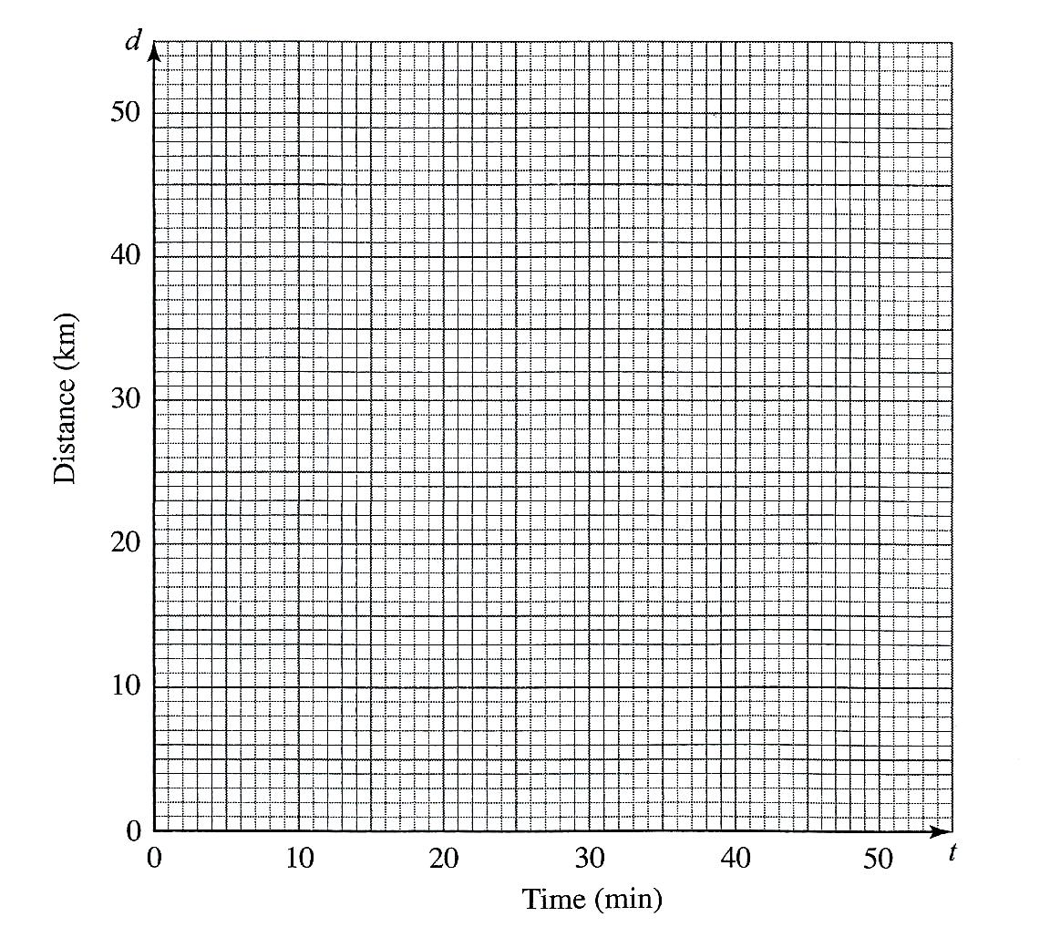

- 2015 Q18 P2
Mute cycled to raise funds for a charitable organisation. On the first day, he
cycled 40 km. For the first 10 days, he cycled 3 km less on each subsequent day.
Thereafter, he cycled 2km less on each subsequent day.

a) calculate
i)the distance cycled on the 10th day (2 marks)
ii)The distance cycled on the 16th day (3 marks)

b) If Mute raised kshs 200 per km, calculate the amount of money collected (5 marks)

STATISTICS I
      - 1990 Q2 P2
The shoe sizes for 40 pupils in a class were recorded as shown in the table below

Shoe size | 4 | 5 | 6 | 7 | 8 | 9
Number of pupils | 1 | 4 | 18 | 14 | 2 | 1

Determine the mean shoe size in the class (2 marks)

      - 1991 Q6 P2
The height in centimeters of 60 children attending a clinic were recorded as follows:

Height (cm) | 33-35 | 36-38 | 39-41 | 42-44 | 45-47 | 48-50 | 51-53 | 54-56
No. of children | 1 | 3 | 14 | 15 | 16 | 8 | 2 | 1

Calculate the median height (3 marks)

      - 1993 Q4 P1
The mean age of 15 boys in a class is 19 years. On a day when one of the boys
was absent, the rest gave their ages as follows:

20, 22, 16, 18, 17, 21, 18, 20, 17, 18, 19, 20, 19, 21.

Find the age of the absent boy (3 marks)

      - 1995 Q3 P1
Every week the number of absentees in a school was recorded. This was done
for 39 weeks these observations were tabulated as shown below

Number of absentees | 0.3 | 4 -7 | 8 -11 | 12 - 15 | 16 - 19 | 20 - 23
(Number of weeks) | 6 | 9 | 8 | 11 | 3 | 2

Estimate the median absentee rate per week in the school (2 marks)

      - 1997 Q8 P1
The following enrolment figures for twenty primary schools were collected.

934 | 923 | 936 | 931 | 924 | 933 | 933 | 937 | 926 | 923
934 | 931 | 929 | 934 | 927 | 927 | 932 | 934 | 927 | 940

- Determine the mode (1 mark)
- The differences from an assumed mean were obtained and rearranged as follows.

-2 | -2 | -1 | 1 | 2 | 2 | 2 | 4 | 6 | 6
7 | 8 | 8 | 9 | 9 | 9 | 9 | 11 | 12 | 15

  - Determine the assumed mean. (1 mark)
  - Use the assumed mean in (b)(i) to find the mean enrolment.
(2 marks)

6. 1998 Q12 P1
Six weeks after planting the height of bean plants were measured correct to the
nearest centimetre. The frequency distribution is given in the table below.

Height (x) | 0 ≤ x ≤ 4 | 4 ≤ x ≤ 8 | 8≤ x ≤ 12 | 12 ≤ x ≤ 16 | 16 ≤ x ≤ 20
Frequency | 3 | 8 | 19 | 14 | 6
Cumulative Frequency

- Enter the cumulative frequency values in the above table (1 mark)
- Estimate the median height of the plants (2 marks)

7. 1999 Q13 P2
The number of people who attended an agricultural show in one day was
510 men, 1080 women and some children. When the information was represented
on a pie chart, the combined angle for the men and children was 2160. Find
the angle representing the children. (3 marks)

8. 1999 Q19 P2
Patients who attend a clinic in one week were grouped by age as shown
in the table below:

Age x years | 0 ≤ x < 5 | 5 ≤ x < 15 | 15≤ x 25 | 25≤ x < 45 | 45 ≤ x < 75
No. of patients | 14 | 41 | 59 | 70 | 15
    - Estimate the mean age (4 marks)
    - On the grid provided draw a histogram to represent the distribution

1 cm to represent 5 unit on the horizon axis
2 cm to represent 5 units on the vertical axis (4 marks)

9. 2000 Q4 P1
The table below shows heights of 50 students
Height (cm) | Frequency
140 – 144 | 3
145 – 149 | 15
150- 154 | 19
155- 159 | 11
160-164 | 2

- State the modal class (1 mark)
- Calculate the median height (2 marks)

10. 2000 Q16 P2
The frequency distribution table below shows the weekly salary (K£) paid to
workers in a factory

Salary (K£) | 50 ≤ x < 100 | 100≤ x <150 | 150≤ x < 25 | 250 ≤ x <350 | 350≤ x <500
No. of workers | 13 | 16 | 38 | 24 | 9

On the grid provided draw a histogram to respect the information shown above

11. 2003 Q3 P2
The table below shows the number of goals scored by a football team in 20 matches

Goals scored | 0 | 1 | 2 | 3 | 4 | 5
Number of matches | 5 | 6 | 4 | 3 | 1 | 1
Find:
a) The mode (1 mark)
b) The mean number of goals (2 marks)

12. 2006 Q15 P1
The histogram below represents the distribution of marks obtained in a test.

The bar marked A has a height of 3.2 units and a width of 5 units. The bar
marked B has a height of 1.2 units and a width of 10 units

If the frequency of the class represented by bar B is 6, determine the frequency
of the class represented by bar A.

13. 2007 Q19 P1
A frequency distribution of marks obtained by 120 candidates is to be
represented in a histogram. The table below shows the grouped marks.
Frequencies for all the groups and also the area and height of the rectangle
for the group 30 – 60 marks.

Marks | 0-10 | 10-30 | 30-60 | 60-70 | 70-100
Frequency | 12 | 40 | 36 | 8 | 24
Area of rectangle |  |  | 180
Height of rectangle |  |  | 6

(a) (i) Complete the table (4 marks)
(ii) On the grid provided below, draw the histogram (2 marks)

(b) (i) State the group in which the median mark lies (1 mark)

(ii) A vertical line drawn through the median mark divides the total area of the
histogram into two equal parts
Using this information or otherwise, estimate the median mark (3marks)

14. 2009 Q16 P1
The following data was obtained for the masses of certain animals.

Mass (x kg) | Frequency
1.5 ≤ x < 5.5  5.5 ≤ x 7.5  7.5 ≤ x < 13.5  13.5 ≤ x < 15.5 | 16  20  18  14

Complete the histogram on the grid provided below: (3 marks)

15. 2009 Q18 P1
The marks scored by a group of pupils in a mathematics test were as recorded in
the table below.
Marks | Frequency
0-9  10-19  20-29  30-39  40-49  50-59  60-69  70-79  80-89  90-99 | 1  2  4  7  10  16  20  6  3  1

(a) (i) State the modal class (1 mark)
(ii) Determine the class in which the median mark lies (2 marks)

(b) Using an assumed mean of 54.4 calculate the mean mark. (7 marks)

16. 2010 Q16 P1
The histogram below represents the distribution of heights a of seedlings
of a certain plant.

The shaded area in the histogram represents 20 seedlings. Calculate
the percentage number of seedlings with heights of at least 23 cm but less
than 27 cm. (3 marks)

17. 2010 Q23 P1
The frequency distribution table below represents the number of kilograms
of meat sold in a butchery.

Mass in Kg | 1 - 5 | 6 - 10 | 11 - 15 | 16 - 20 | 21 - 25 | 26 - 30 | 31 – 35
Frequency | 2 | 3 | 6 | 8 | 3 | 2 | 1

- State the modal frequency (1 mark)
- Calculate the mean mass. (5 marks)

18. 2011 Q10 P1
The masses of people during a clinic session were recorded as shown in the
table below.

Mass (kg) | 40-44 | 45-49 | 50-54 | 55-59 | 60-64 | 65-69 | 70-74
No. of people | 1 | 2 | 12 | 10 | 2 | 2 | 1

Calculate the mean mass. (3 marks)

19. 2011 Q24 P1
The frequency table shows the daily wages paid to casual workers by a
certain company.

Wages in Sh. | 100-150 | 150-200 | 200-300 | 300-400 | 400-600
No. Of workers | 160 | 120 | 380 | 240 | 100

- Draw a histogram to represent the above information. (5 marks)
- (i) State the class in which the median wage lies (1 mark)
(ii) Draw a vertical line, in the histogram showing where the median lies
(1 mark)
- Using the histogram, determine the number of workers who earn sh.
450 or less per day. (3 marks)

- 2012 Q17 P1
The table below shows the height, measured to the nearest cm, of 101
pawpaw trees.

Height in cm. | 20-24 | 25-29 | 30-34 | 35-39 | 40-44 | 45-49 | 50-54 | 55-59
Frequency | 2 | 15 | 18 | 25 | 30 | 6 | 3 | 2

- State the modal class. (1 mark)
- Calculate to 2 decimal places:
- The mean height; (4 marks)
- The differences between the median height and the mean height
(5 marks)
- 2012 Q8 P2
The masses in kilograms of 20 bags of maize were;
90,94,96,98,99,102,105,91,102,99,105,94,99,90,94,99,98,96,102 and 105

Using an assumed mean of 96kg, calculate the mean mass, per bag, of the maize

(3 marks)
- 2013 Q2 P1
The production of milk, in litres, of 14 cows on a certain day was recorded as
follows
22, 26, 15, 19, 20, 16, 27, 15, 19, 22, 21, 20, 22 and 28.

- The mode; (1 mark)
- The median. (2 marks)

- 2014 Q18 P1
The lengths, in cm, of pencils used by pupils in a standard one class on a
certain day were recorded as follows.

3 | 7 | 9 | 9 | 20 | 14 | 10 | 6 | 8 | 13
14 | 3 | 27 | 13 | 8 | 12 | 5 | 15 | 14 | 15
7 | 12 | 11 | 6 | 10 | 19 | 9 | 14 | 6 | 9
10 | 16 | 16 | 13 | 9 | 12 | 11 | 7 | 10 | 11

- Using a class width of 3, and starting with the shortest length of the pencils,
make a frequency distribution table for the data.
- Calculate:
- The mean length of the pencils (3marks)
- The percentage of pencils that were longer than 8cm but shorter
than 15cm.
(2marks)
- On the grid provided, draw a frequency polygon for the data (3marks)

- 2014 Q5 P2
The table below shows the frequency distribution of marks scored by
students in a test.

Marks | Frequency
1-10 | 2
11-20 | 4
21-30 | 11
31-40 | 5
41-50 | 3

Determine the median mark correct to 2 s.f. (2marks)

- 2015 Q10 P1
The marks scored by a group of students in a test were recorded as shown
in the table below
Marks | 30-34 | 35-39 | 40-44 | 45-49 | 50-54 | 55-59 | 60-64
No. Of students | 3 | 6 | 5 | 12 | 8 | 9 | 7

On the grid provided, and on the same axes, represent the above data using
a) a histogram; (3 marks)
b) a frequency polygon (1 mark)

VECTORS (I)
- 1989 Q11 P2
In the figure below, AB = p, AC = q, AD = $\frac{3}{5}$ AC and CE = $\frac{2}{3}$ CB
C

D
E

A B
Express DE in terms of p and q (3 marks)

- 1990 Q8 P2
In a triangle ABC, D is the midpoint of AB and E is appoint on BC such that
BE = $\frac{2}{3}$ BC. If AD = P and AC = Q, express EC in terms of p and q. (2 marks)

- 1990 Q10 P2
A point T divides a line AB internally in the ratio 5: 2. Given that A is
(-4, 10) And B is (10, 3) find the coordinates of T. (4 marks)

- 1991 Q6 P1
In the diagram below OABC is a parallelogram.

C T

M

O A
AB is produced to T such that BT : AB = 1:2. M is the midpoint of AC. Given
that OA = a and OC = c. Express MT in term of a and c. (3 marks)

- 1992 Q24 P1
OABC is a trapezium such that the coordinates of O, A, B and C are (0,0),(2,-1),
(4, 3) and (0, y).
- Find the value of y (2 marks)
- M is a midpoint of AB and N is a midpoint of OM. Show that A, N and C
are collinear. (6 marks)
6. 1993 Q21 P1
OABC is a trapezium in which OA = a, OC = c and CB = 3a. CB is produced to
such that CB : BD = 3: 1. E is a point on AB such that AB = 2AE. Show that O,
E and d are collinear.
(8 marks)

7. 1993 Q16 P2
In the figure below CA = b CB = a, AX = XY and AY = YB.
C

b a

A X Y B
Express CX in terms of a and b (3 marks)

8. 1994 Q10 P2
In the figure below OC = 3 CA and OD = 3DB. By taking OA = a, OB = b, show
that CD // AB. (3 marks)
O

C D

A B

9. 1994 Q15 P2
In the figure below ABCD is a parallelogram. AOC and BOD are diagonals
of the parallelogram. Show that the diagonals of the parallelogram bisect
each other. Give reasons. (3 marks)
A B

D C

- 1995 Q 18 P1
The figure below is a right pyramid with a rectangular base ABCD and VO
as the height. The vectors AD= a, AB = b and DV = c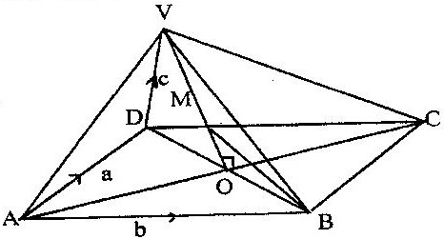

  - Express
(i) AV in terms of a and c (1 mark)
(ii) BV in terms of a, b and c (2 marks)

(b) M is point on OV such that OM: MV = 3:4, Express BM in terms of
a, b and c . Simplify your answer as far as possible (5 marks)

- 1997 Q12 P2
In the figure below, OA =3i + 4j and OB = 8i – j. C is a point on AB such that
AC:CB = 3:2, and D is a point such that OB//CD and 2OB=CD

Determine the vector DA in terms of i and j. (4 marks)

- 1997 Q 11 P2
ABC is a triangle and P is on AB such that P divides AB internally in the
ratio 4:3. Q is a point on AC such that PQ is parallel to BC. If AC = 14 cm

  - State the ratio AQ:QC (1 mark)
  - Calculate the length of QC (1 mark)

- 1998 Q 9 P2
In the figure, KLMN is a trapezium in which KL is parallel to NM and KL = 3 NM
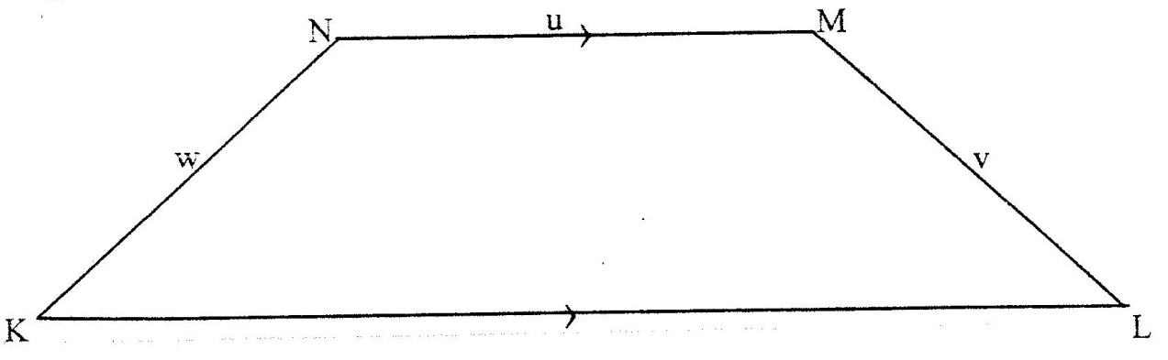

Given that KN = w, NM = u and ML = v. Show that 2 u = v+ w (2 marks)

- 1999 Q 21 P1
In triangle OAB, $\vec{OA}$ = a $\vec{OB}$ = b and P lies on AB such that AP: BP = 3:5
- Find the terms of a and b the vectors
  - $\vec{AB}$ (1 mark)
  - $\vec{AP}$ (1 mark)
  - $\vec{BP}$ (1 mark)
  - $\vec{OP}$O (2 marks)
- Point Q is on OP such AQ =$-\frac{5}{8}a+\frac{9}{40}b$ .
Find the ratio OQ: QP (3 marks)

- 2002 Q 10 P2
The coordinates of points O,P,Q and R are (0,0) , (3,4) , (11,6) and (8,2)
respectively. A point T is such that vectors OT, QP and QR satisfy the vector
equation. OT = QP + ½ QR .Find the coordinates of T. (3 marks)

16. 2004 Q 21 P1
a) If A, B and C are the points (2,-4),(4,0)and (1,6) respectively, use the
vector method to find the co-ordinates of point D given that ABCD is a
parallelogram.
  - The position vectors of points P and Q are p and q respectively is another
point with position vector r = $\frac{3}{2}$q - $\frac{1}{2}$ p. Express in terms of p and q.
i) PR
ii) RQ hence show that P, Q and R are collinear.
iii) Determine the ratio PQ: QR.
17. 2005 Q 18 P1
The points P, Q, R and S have position vectors 2p, 3p, r and 3r respectively,
relative to an origin O. A point T divides PS internally in the ratio 1:6

(a) Find, in the simplest form, the vectors OT and QT in terms P and r
(4 marks)
(b) (i) Show that the points Q, T, and R lie on a straight line (3 marks)
(ii) Determine the ratio in which T divides QR (1 mark)

18. 2006 Q 12 P1
Two points P and Q have coordinates (-2, 3) and (1, 3) respectively. A
translation map point P to P’ ( 10, 10)
- Find the coordinates of Q’ the image of Q under the translation
(1mark)

- The position vector of P and Q in (a) above are p and q respectively
given that mp – nq =. Find the value of m and n (3 marks)

19. 2006 Q 22 P1
In the diagram below, the coordinates of points A and B are ( 1,6) and (15,6)
respectively). Point N is on OB such that 3 ON = 2OB. Line OA is produced to L
such that OL = 3 OA

- Find vector LN (3 marks)
- Given that a point M is on LN such that LM: MN = 3: 4, find the
coordinates of M (2 marks)
- If line OM is produced to T such that OM: MT = 6:1
(i) Find the position vector of T (4 marks)
(ii) Show that points L, T and B are collinear (4 marks)

20. 2009 Q 20 P1
The position vectors of point A and B with respect to the O, are$\left(\begin{matrix}-8 \\ 5\end{matrix}\right)$ and $\left(\begin{matrix}12 \\ -5\end{matrix}\right)$
respectively. Point M is the midpoint of AB and N is the midpoint of OA.
(a) Find:
      - The coordinates of N and M (3 marks)
      - The magnitude of NM (3 marks)
(b) Express vector NM in term of OB. (1 marks)

(c) Point P maps onto P by a translation$\left(\begin{matrix}-5 \\ 8\end{matrix}\right)$ .Given that
OP=OM+2MN, find the coordinates of P’ (3 marks)

- 2009 Q 6 P2
Vector OA = $\left(\begin{matrix}2 \\ 1\end{matrix}\right)$ and OB=$\left(\begin{matrix}6 \\ -3\end{matrix}\right)$. Point C is on OB such CB=2OC and point D is
on AB such that AD=3DB.Express CD as a column vector. (3 marks)

22. 2010 Q 7 P1
In the figure below, OPQR is a trapezium in which PQ is parallel to OR and M
is the mid-point of QR and OP=p, OR=r and PQ = ¹/₃ OR.
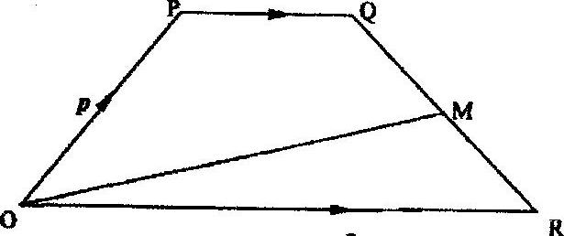

Find OM in terms of p and r. (3 marks)

23. 2011 Q 13 P2
Vector OP=6i + j and OQ+ -2i +5j. A point N divides PQ internally in the ratio
3:1. Find PN in terms of i and j. (3 marks)

- 2012 Q9 P1
Given that OA = 2i + 3j and 3i – 2j
Find the magnitude of AB to one decimal place (3 marks)

- 2015 Q11 P1
Given that P = 5a – 2 b where a = $\left(\begin{matrix}3 \\ 2\end{matrix}\right)$ and b = $\left(\begin{matrix}4 \\ 1\end{matrix}\right)$ find
a) Column vector p (2 marks)
b) P’, the image P under translation vector $\left(\begin{matrix}-6 \\ 4\end{matrix}\right)$ (1 mark)

INDICES
MARKING SCHEMES

1. | $\left(\frac{103}{4} × \frac{81}{100} ×4\right)$ ÷ $\left(\frac{14}{2} ×27\right)$  $\frac{103}{4}$ $×$ $\frac{81}{100}$ $×$ 4 $×$ $\frac{1}{7}$ $×$ $\frac{1}{27}$  = $\frac{8343}{18900}$  =$\frac{309}{700}$  1989Q4 | 2M
2. | $\frac{5^{2x}}{5}$ =${ 12}^{x}$  $\frac{{25}^{x}}{5}$ = ${ 12}^{x}$  $\frac{{25}^{x}}{{12}^{x}}$ = 5  ${2.083}^{x}$= 5  $x log{2.083}$  x = $\frac{\log{5}}{\log{2.083}}$  x = 2.193  1990Q4 | 3M
3. | $4^{x+1}$= 32  $2^{2\left(x+1\right)}$= 2⁵  2x +2 =5  2x =5 - 2  2x = 3  x= $1\frac{1}{2}$ or 1.5  1991Q4 | 3M
4. | $9^{x}$+ $3^{2x}$ = 53 + 1  $9^{x}$+ $3^{2x}$ = 54  $3^{2x}+3^{2x}$=54  Let $3^{2x}$ be y  y + y =54  2y =54  y = 27  $3^{2x}$ =27  $3^{2x}$ = 3³  2x = 3  x= $1\frac{1}{2}$ 1993Q8 | 3M
5. | $7^{2\left(x+1\right)}$+ $7^{2x}$ = 350  $7^{2\left(x+1\right)}$+${ 7}^{2x}$ = 350  ${ 7}^{2x} × { 7}^{2}$ + ${ 7}^{2x}$ = 350  Let ${ 7}^{2x}$ be y  49y +y =350  50y = 350  y = 7  ${ 7}^{2x}$ = 7  2x = 1  x= $\frac{1}{2}$  1995Q5 | 4M
6. | $2^{{4x}^{2}}$ = $2^{3\left(4x-3\right)}$  ${4x}^{2}$ = 12x -9  ${ 4x}^{2}$– 12x + 9 = 0  ${ 4x}^{2}$– 6x – 6x + 9 =0  = (2x –3) (2x – 3) =0  x = 1¹/₂ 1996Q9 | M1  M1  A1  3M
7. | ${\frac{1}{3^{3}}}^{m} ×$ $3^{4\left(-1\right)}$ =$3^{5}$  $3^{-3m }×$ $3^{-4}$= $3^{5}$  -3m $-$4 =5  -3m =9  m = $-$3  1997Q7 | M1  M1  A1
8. | $\frac{P^{2}}{3}$ + $\frac{2}{3}p$= 1  = p² + 2p – 3 = 0  (p-1) (p+3) = 0  P = 10 p= 3  3¹/₂  y = 1  1998Q10 | B1  M1  A1  B1  4M
9. | $\sqrt{2^{x} × 5^{2x}÷ 2^{-x}}$  $\sqrt{2^{x} × 5^{2x}× 2^{x}}$  $\sqrt{2^{2x} × 5^{2x}}$  $2^{x}× 5^{x}$  = ${10}^{x}$ 1999Q4 | M1  A1
10. | Let y = $5^{x}$  y² - 6y + 5 = 0  (y – 5) (y – 1) = 0  y = 5 or y = 1  5¹ = $5^{x}$ and 5⁰ = $5^{x}$  x= 1 or x = 0  2000Q12 | M1  A1  M1  A1  4M
11. | $2^{5\left(x-3\right)} ×2^{3\left(x-4\right)}$=$2^{6}$ ÷ $2^{x}$  5(x – 3) + 3(x + 4) = 6  x =1  2001Q2 | M1  M1  A1
12. | $\frac{{\left(3^{4}\right)}^{2x}×{\left(3^{3}\right)}^{x}}{3^{2x}}$= $3^{6}$  8x + 3x – 2x = 6  9x =6  x =$\frac{2}{3}$  2002Q7 | M1  M1  A1  3 M
13. | $\frac{243 × 3^{2y}}{729×3^{y} ÷3^{\left(2y-1\right)}}$= 81  = $\frac{3^{5} × 3^{2y}}{3^{6}×3^{y} ÷3^{\left(2y-1\right)}}$= $3^{5}$  $\frac{3^{5+2y} }{3^{6+y} ÷ 3^{2y-1}}$ = $3^{5}$  $\frac{3^{5+2y} }{3^{7-y}}$ = $3^{5}$  5+2y – (7-y)=5  Hence 3y -2 = 5  3y = 7  y = ⁷_{/3} = 2 ¹_{/3}  2005Q1 | M1  M1  A1
14. | $\frac{{\left(3^{3}\right)}^{\frac{2}{3}}÷2^{4}}{{\left(2^{5}\right)}^{- \frac{3}{5}}}$= $\frac{3^{2}÷2^{4}}{2^{-3}}$  = $\frac{3^{2}}{2^{4}× 2^{-3}}$  = ⁹/₂ or 4.5  2008Q2 | M1  M1  A1  3M
15. | ⁼ $\frac{{64}^{1/2}×{27000}^{2/3}}{2^{-4}×30×5^{2}}$  = $\frac{8 × \sqrt[3]{{\left(27000\right)}^{2}}}{\frac{1}{16}×30×25}$  = ¹/₈ x 900 x ¹⁶/₂₅  = 72 2009Q5 | M1  M1  M1  A1
16. | ${27}^{3/2}×{\left(\frac{81}{16}\right)}^{-4}$  = $3^{2}×{\left(\frac{3}{2}\right)}^{-1}$  = $3^{2}×\left(\frac{2}{3}\right)$ =6  2010Q8 | M1  M1
17. | 9^{2y} $×$ 2^{x} = 9 x 8  (3²)^{2y} $×$ 2^{x} = 3² x 2³  (3²)^{2y} = 3 and 2^{x} = 2³  4y = 2 and x = 3  y = ½ and x = 3  2012Q5 | M1  M1  A1  3
18. | = $\frac{{243}^{- \frac{2}{5}} × {125 }^{\frac{2}{3}}}{9^{- \frac{3}{2}} }$ = $\frac{3^{-2} × 5^{2}}{3^{-3}}$  = $\frac{27 × 25}{9}$  = 75  2014Q6 | M1  M1

EVALUATION OF NUMERIC EXPRESSIONS
(Using mathematical tables)-MARKING SCHEME

1. | $\sqrt[3]{\left(35.6 × {0.0613}^{2}\right)}$  no log  3.56 X 10¹ 1.5514  6.13 X 10⁻² $\overline{2}$.7875  $\overline{2}$.7875  x 2  $\overline{3}$.5750  $\overline{3}$.5750  + 1.5514  $\overline{1}$.1264  $\overline{1}$.1264 =$\overline{3}$ + 2.1264  3 3 3  = $\overline{1}$.7088  = 0.5114 1989Q1 | 4M
2. | No log  1.34 0.1271  5.24 0.7193  x 0.8  0.5754  2.9 x 10⁻³ $\overline{3}$.4624  0.5754  +$\overline{3}$.4624  $\overline{2}$.0.893  0.1271  - $\overline{2}$.0.893  2.0893  = 122.8 1990Q1 | 4M
3. | N0 log  2.935 o.4676  7.65 x 10⁻² $\overline{2}$. 8837 +  $\overline{1}$.3513  3.274x10⁻¹ - 1.5152  $\overline{3}$ .8361  $\overline{4}$ + 1.8361  2 2  = $\overline{2}$.9181  = 0.0828 1991Q1 | 3M
4. | No log  7.08 0.8500  7.68 x 10¹ 1.8854  $\overline{2}$.9646  7.034 0.8472  $\overline{2}$. 1174  $\overline{3}$ + 1.1174  3  $\overline{1}$.3725  = 0.2358 1992Q1 | 4M
5. | No log  6.45 x 10⁻² $\overline{2}$ .8096  8.2 x10⁻³ $\overline{3}$ .9138  $\overline{2}$. 8096 = $\overline{1}$. 4048  2  $\overline{1}$. 4048  - $\overline{3}$ 9138  1.4910  = 30.97 1993Q2 | 3M
6. | No log  4.562 0.6592  3.8 10⁻² $\overline{2}$ . 5798  $\overline{1}$ .2390  $\overline{1}$.3252  $\overline{4}$ + 3.3252 = $\overline{1}$.8313  4  = 0.6781 1994Q1 | 4M
7. | No log  7.284 x 10⁻² $\overline{2}$.8624  x 2  $\overline{3}$. 7248  6.195 x 10⁻² $\overline{2}$ .7920  $\overline{3}$ + 1.7920 = $\overline{1}$ .5973  3  $\overline{3}$.7248  - $\overline{1}$.5973  $\overline{2}$ .1275  = 0.01341 1995Q1 | 4M
8. | No Log  36.15 1.5581  0.02573 $\overline{2}$.4104  $\overline{1}$.9685  1.938 0.2874  $\overline{1}$.6811 ÷ 3  $\overline{3}$ ÷ 2.6811) ÷ 3  7.829 x 10-¹ = 1.8937  = 0.7829 or 0.7828  1996Q1 | M1  M1  A1  3M
9. | No Log  1934 3.2865 x 2  6.5730  0.0324 3.5105 ÷2  4 + 1.5105  2  2.75525  5.32825  436 2.63950  4.884 2.6888  4.884 x 10²  = 488.4 or 488.5 1997Q1 | M1  M1  M1
10. | No Log  55.9 1.7474  0.2621 $\overline{1}$.4185  0.01177 $\overline{2}$.0708  3.4893  5 + $\frac{2.4893}{5}$ = $\overline{1}$.4979  1.776 X 10² 2.2495  =177.6  1998Q1 | M1  M1  4m
11. | No Log  6.97 0.8319  0.3911 1.5923  0.4242  Log 5 = 0.6990 1.8445  (0.5797 ÷ 4)  0.1449  1.7391 : 4 x 3  2.721 0.4347  1999Q1 | M1  M1  A1  3 M
12. | No. log  1.23 0.0899  0.0089 3.9494  2.0393  1.8839  4.1554 ÷3  6 + 21554 = 2.7185  3  = 0.0523.  2000Q11 | M1  M1  M1  M1  A1  4M
13. | Reciprocal of 0.342 = 2.924  √0.0625 = 0.25 x 2.924  = 0.731  2001Q1 | B1  M1  A1  3M
14. | No. log  3.256 0.5127  0.0536 2.7292  1.2419 : 3  (3 + 2.2419) ÷ 3  0.5589 1.7473  2001Q3 | M1  M1  M1  A1  3 M
15. | No log  0.0056 $\overline{3}$.7482 = $\overline{2}$.8741  1.38 0.1399 = 1.5780  27.42 1.4381  0.001977 $\overline{3}$.2961  2002Q1 | M1  M1  A1  3 M
16. | $\frac{1}{24.56}$ = 0.04072  4.346² = 18.89  0.04072 + 18.89 = 18.93071 = 18.93  2002Q5 | B1 B1  A1  3 M
17. | 23.47 3.3705  0.4666 $\overline{1}$.6689 + 3.0394  $\sqrt[3]{0.0924}$ $\frac{\overline{2}.9657}{3}$= $\frac{\overline{1}.6552}{2}$  2.422 x 10³ 3.3842  2.422 x10³  0.423 x 10³ = 2422  2003Q1 | M1  M1  M1  A1  4 M
18. | 5.25 0.7202  0.042 2.6232  1.3424  -2  1.6717  34.33 1.5357  1.6717  1.8640  = 73.11  2004Q2 | M1  M1  M1  A1  4M
19. | 3x 1.485+13 x 6.410  =4.455+83.33  =87.785  2004Q8 | M1  M1  A1  3M
20. | No Log  - 1.5649  0.46² 2(1.6628) 1.3256  0.8905  185.4 2.2682  2.6223  2.6223 = 3 + 1.6223 = 1.5408  3 3  3.474 x 10⁻¹ =0.3474  2006Q1 | M1  M1  M1  A1  4 M
21. | No Log  0.032 $\overline{2}$.5051  14.26 1.1541 +  $\overline{1}$.6592  0.006 3.7782 -  1.8810  (4) 1.8810 x ²/₃  17.956 1.2540 17.947  2007Q1 | M1  M1  A1  3 M
22. | No Log  - 0.8043  - $\overline{I}$ . 8416 +  0.6459  $\sqrt{0.004636}$ $\overline{3}$.6661 ÷ 2  2.8331  1.8128  6.498 x 10¹ 64.98  2008Q1 | M1  M1  A1  3 M
23. | NO Log  83.46 1.9215 +  0.0054 $\overline{3}$.7324  $\overline{1}$.6539  $1$.562 0.1931 x 2 = 0.3862  $\overline{1}$.2677  $\overline{1}$.2677 ÷ $\overline{3}$ + 2.2677  3 3  0.5700 $1$.7559  5.7 X 10⁻¹  2011Q1 | M1  M1  M1  A1  4M
24. | No. Log  $\sqrt[3]{0.512}$ $\overline{1.}$7093 = $\overline{3.}$+2.7093  3 3  = $\overline{1.}$9031  3.7034 $\overline{1.}$3345  0.5686  2012Q2 | M1
25. | 0.3799  2013 Q3 | M1
26. | No Std form Log  72.56 0.64 (1.84s)² 7.256x10¹ 6.4x10⁻¹ (1.845x10)² 1.8607 + T.8062 1.6669 0.2660 x 2 0.5320  1.6669  -0.5320  1.1349  1.1349  2  = 0.5675  10⁰ x 3.6936  =3.694  2015Q4

EQUATIONS OF STRAIGHT LINES – MARKING SCHEMES

1. | (a) Q(2.5,0)  (b) S(5.5, 6)  1989Q23 | 8M
2. | 2y = 3 – x  Y = ³/₂ – ¹/₂x  Gradient perpendicular line will be 2  y – 5 = 2  x – 5  y-5 = 2(2 x-3)  y -5 = 2x – 6  y = 2x – 6 + 5  y = 2x -1  1992Q9 | 3M
3. | Gradient of perpendicular line is ¼  $\frac{y-5}{x- -8}=-\frac{1}{4}$  4(y-5) =- x -8  4y -20 =- x -8  4y = -x – 8 + 20  4y + x = 12  4y + x = 12  1995Q5 | 2M
4 | a). OT = $\frac{1}{3}\left[\begin{matrix}1 \\ -2\end{matrix}\right]+\left[\frac{2}{3}\right]\left[\begin{matrix}4 \\ 10\end{matrix}\right]=\left[\begin{matrix}3 \\ 6\end{matrix}\right]$  T (3,6)  b). gradient PQ = 4  Gradient normal = $-\frac{1}{4}$  ii). $\frac{y-6}{x- 3}=-\frac{1}{4}$  4(y-6) = (x-3)  4y-24= -x + 3  4y = -x + 27  iii). (6 ¾ - 6)² + (3 – 0)²  = √9.5625  = 3.092  = 3.09 (sig. fig) or 3.093  1997Q24 | M1  M1  M1  A1  B1  A1  B1  A1  8 marks
5. | a) 3y = 6 + ³/₅x  y = 2 + ¹/₅x  Gradient = ¹/₅  b) m x ¹/₅ = -1 m = 5  equation $\frac{y-1}{x- 2}=-5$  y -2 = -5x + 5  y = -5x = 7  1999Q7 | B1  M1  M1  4 marks
6. | Gradient of a 1 (perpendicular) line = 2  Equation of the line  $\frac{y-1}{x- 2}=2$ Or y = 2x -3  2000Q1 | B1  B1  2 mrks
7. | L¹ : $\frac{y-2}{x-1}=5$  y = 5x - 3  L² at x = 4, y = 17  $\frac{y-17}{x-4}=-\frac{1}{5}$  y =- $\frac{1}{5}x$ + $\frac{89}{5}$  2001Q5 | B1  B1  M1  A1  3 marks
8. | Grade, AB -4 – 8  3 –(-3) = -2  Through (3, 4)  $\frac{y-4}{x- 3}=-2$  y = 2x + 10  2003Q4 | M1  M1  A1
9. | Gradient PQ= $-\frac{4+2}{5+1}$ =$-\frac{2}{6}=-\frac{1}{3}$  Midpoint of PQ = (5+-1, -4+-2)  2 2  = (2,-3)  y+3 =3  x -2  y=3x-9  2004Q16 | B1  B1  M1  A1  4 mrks
10. | 7y -3x + 30 = 0  At y – intercept the value of x =0  Therefore 7y = -30  Y = -³⁰/₇ = -4²/₇  The coordinates are (0, -4²/₇)  2005Q11 | B1  M1  A1
11. | Gradient of L1 = 6 – 0 = 3  0 – 4 2  $\frac{y-6}{x-0}=\frac{3}{2}$  2y-12 = 3x  y = ³/₂x + 6  At P; L₁= L₂  $\frac{3}{2}$x + 6 = 2x -2  1.5x = 2x -8  = 16  Substitute to get y.  P(16,30) 2005Q12 | B1  M1  M1  A1
12. | k-8 = -3 k = ½ y-8 = -3  3-k x- ½  y -8 = -3x +$\frac{3}{2}$  2y - 16 = -6x + 3  2y = -6x + 19  2006Q9 | M1  B1
13. | (6+2, 1+3) = (4,2)  2 2  Gradient = $\frac{1-3}{6-2}= \frac{-2}{4}=\frac{-1}{2}$  Gradient ₂ = 2  $\frac{y-2}{x-4}=2$  = 2x-y=6  2007Q7 | B1  M1  M1  A1  4 marks
14. | Equation of line AD  Gradient = $\frac{2- -3}{-2--4}=\frac{5}{2}$  $\frac{y-3}{x-4}$= $\frac{5}{3}$  y = $\frac{5}{2}x$ + 7  2008Q11 | M1  A1  B1  B1
15. | 2y = 5x+8  y = $\frac{5}{2}x$+ 4  Gradient of L₁ = $\frac{5}{2}$  Gradient of L₂ =$\frac{0+4}{-5-5}$ = $-\frac{4}{10}= -\frac{2}{5}$  $\frac{5}{2}$ $×$ $-\frac{2}{5}$= -1  L₁ and L₂ are perpendicular  2008Q15 | B1  B1  B1  3 marks
16. | Y = ²/₅ x + 2  Gradient = ⁻ ²/₅  K – 5 = -2  3 - -2 5  K -5 = -2  K=3  2009Q9 | B1  M1  A1  3 marks
17. | a). Rhombus PQRS √drawn  b). Co-ordinates of T(0.5, 3.5)  2009Q14
18. | Gradient L₂ = - $\frac{1}{2}$  substitute in equation  $\frac{y+2}{x-3}= -\frac{1}{2}$  y = $-\frac{1}{2}x-- \frac{1}{2}$ A1  $- \frac{1}{2}$= c  y = $-\frac{1}{2}x- \frac{1}{2}$  2010Q3 | B1  M1  A1  3
19. | QS = $\sqrt{{12}^{2}+{12}^{2}}$  16.97  2011Q12 | B1  M1  A1  3
20. | 2y = 4x + 5 → y = 2x + $\frac{5}{2}$  Gradient, M₁ of line 2  Gradient , M₂ of perpendicular is given by  2M ₂ = -1 →M₂ = $\frac{1}{2}$  Equation of line L  $\frac{y-1}{x-3}=\frac{1}{2}$  y = $-\frac{1}{2}x+\frac{5}{2}$ or 2y = -x+5  2012Q13 | B1  M1  A1  3
21. | Gradient = $\frac{3-1}{6--2}=\frac{2}{8}=\frac{1}{4}$  - $\frac{y-3}{x-6}=\frac{1}{4}$  y = $\frac{1}{4}x-\frac{6}{4}+ 3$  - M₂M₁ = -1  $\frac{1}{4}\left(-4\right)= -1$  M₂ = - 4  2013 Q12
22. | - Equation of L  Gradient = $\frac{6-3}{-1--2}$  =3  Equation = $\frac{y-6}{x+1}=3$  =$y-3x=9$  - Equation of P  = $\frac{y-6}{x+1}=-\frac{1}{3}$  = 3y + x =17  - Equation of Q  = $\frac{y-2}{x-1}=3$  = $y=3x-1$  $x$ intercept  When $y$ = 0 $⇒ x$ = + $\frac{1}{3}$  $y$ intercept  When $x$ = 0 $⇒ y$ = $-$1  - Intersection of lines P and Q  $$3y+x=17……\left(i\right)$$  $y-3x= -1…….(ii)$  2014Q17 | A1  M1  A1  B1  B1  B1  M1
23. | 21a  3y = 2 x -2  Y = 2/3 x – 2/3  At y = 0 2/3 x = 2/3 x =1  Coordinates R (1,0)  b)  M1=2/3 M2 = -3/2 2y= -3x+3  Use point (1,0) and (x y) y=-3/2x + 3/2  y-0 = -3  x-1 2  c)  Mc=2/3  Points (-4, 1) (x-y) 3y=2x + 14  y-1= 2 y = 2 x + 11  x+4 3 3 3  3y-3=2x +8  ii)  L2 = Y=-3/2 x + 3/2 -13/6 x =13/6  L3-Y=2/3x + 11/3 x=-1  At intersection L2=L3  -3/2 x + 3/2 = 2/3x + 11/3  Y = 3/2 + 3/2 = 6/2 =3  1(3/2 +2/3 ) x = 11/3 – 3/2  coordinates of S  -(9+4) X = 22-9  6 6

TRANSFORMATIONS
REFLECTION, ROTATION, TRANSLATION, ENLARGEMENT

1. | (a)Coordinates of S′ are (2,5),(-1,4), (1, 8) and (-2,7)and those of S" are (-4,3),(-1,4), (-5,6) and (-2,7)  (b) (i) Translation of $\left(\begin{matrix}-11 \\ 3\end{matrix}\right)$  (ii) positoive quarter turn about (1,-2) or +90⁰ turn about point (1,-2)  1989Q22 | 8M
2. | $\left(\begin{matrix}4 \\ 6\end{matrix}\right)$ - $\left(\begin{matrix}0 \\ 2\end{matrix}\right)$ = $\left(\begin{matrix}4 \\ 4\end{matrix}\right)$  $\frac{1}{2}$ $\left(\begin{matrix}4 \\ 4\end{matrix}\right)$ = $\left(\begin{matrix}2 \\ 2\end{matrix}\right)$  $\left(\begin{matrix}0 \\ 2\end{matrix}\right)$ - $\left(\begin{matrix}2 \\ 2\end{matrix}\right)$ = $\left(\begin{matrix}-2 \\ 0\end{matrix}\right)$  Centre of enlargement = (-2, 0)  1991Q7 | 3M
3. | Join A to A′ and bisect it  Join B to B′ and bisect it.  Let the bisectors meet at a point O. This is the centre of rotation  1991Q15 | 3M
4. | Translation = $\left(\begin{matrix}3 \\ 2\end{matrix}\right)$ - $\left(\begin{matrix}0 \\ 1\end{matrix}\right)$ = $\left(\begin{matrix}3 \\ 1\end{matrix}\right)$  B = $\left(\begin{matrix}4 \\ -1\end{matrix}\right)$ - $\left(\begin{matrix}3 \\ 1\end{matrix}\right)$  = $\left(\begin{matrix}1 \\ -2\end{matrix}\right)$ = B(1,-2)  1992Q3 | 3M
5. | Translation =$\left(\begin{matrix}-2 \\ 2\end{matrix}\right)$ - $\left(\begin{matrix}1 \\ 2\end{matrix}\right)$ = $\left(\begin{matrix}-3 \\ 0\end{matrix}\right)$  $\left(\begin{matrix}-3 \\ -3\end{matrix}\right)$ - $\left(\begin{matrix}-3 \\ 0\end{matrix}\right)$ =$\left(\begin{matrix}0 \\ -3\end{matrix}\right)$  = (0 , -3)  1995Q6 | 2M
6. | -5 + T -1  4 1  T = -1 - -5 - 5 = 4  -1 4 4 -5  -4 + 4 = 0  5 -5 0  The image of ( -4, 5) is (0,0)  1999Q2 | M1  A1  2M
7. | 1999Q11
8. | A B C A′ B′ C′  0 1 2 4 1 = 1 1 6  -1 0 1 1 6 -2 -4 1  Co-ordinates of image  A′ (1, -2), B′(1, -4), C′(1 (6, -1)  2000Q9 | M1  M1  A1

9. | 5 - 3 = 2  -4 2 -6  OQ = 2 + 2 = 4  5 -6 -1  PQ = 4 - 5 = - 1  -1 -4 3  PQ - √(-1)² ÷ 3 =10  2001Q7 | B1  M1  A1  3 M
10. | Join any two pairs of object-image points(AAʹ or BBʹ or CCʹ)  The point O is the centre of rotation. Angle of rotation = 60 $± 1$⁰  2003Q7 | B1  B1  B1  3 M
11. | (a)  (b) The four dark lines are the lines of symmetry.  2005 Q4 P2 | 3M
12. | a). Reflection on y axis (or line x=0)  b).  c). –ve quarter turn about (0,0) or about origin  d). Image of ∆’’’Q’’’R’’’  e). Pair ∆s of that are oppositely conguruent  ∆PQR and ∆P’’Q’’R’’  ∆P’Q’R and ∆P’’’Q’’’R’’’  ∆PQR and ∆P’Q’R’  ∆P’’Q’’R’’ and ∆P’’’Q’’’R’’’  2006Q18 | B2  B2  B2  B2
13. | 2008Q21 | B2  B2  B2  B2  B1  B1  10
14. | a) i) Reflection in the line PR or ER  ii) Enlargement with scale factor of -1 about point E  iii) Rotation of 90⁰ about point R  b) i) R ʹS; CʹA  ii) Rʹ Q;C ʹE  2010Q22 | B1  B1  B1  B1  B2  B1  B1
15. | T = $\left({6 \atop -2}\right)$ - $\left({4 \atop 1}\right)$ = $\left({2 \atop -3}\right)$  OA = $\left({1 \atop 2}\right)$ + $\left({2 \atop -3}\right)$ = $\left({3 \atop -1}\right)$  A (3,1)  OB = $\left({3 \atop 5}\right)$ + $\left({2 \atop -3}\right)$ = $\left({5 \atop 2}\right)$  B′ = (5, 2) 2011Q7 | B1  B1  3
16.  (a)  (i)  (ii)  (b)  (c)  (i)  (ii) | OPQR √drawn  O'P'Q'R' √ drawn labeled  Perpendicular bisectors √drawn (at least 2)  Centre or rotation (0, -1)  Angle of rotation -90⁰  Line of reflection x = y drawn  Quadrilateral O''P''Q''R''  Directly congruent quads:  OPQR and O'P'Q'R'  Oppositely congruent quads:  OPQR and O''P''Q''R''  O'P'Q'R' and O''P''Q''R''  2012Q21 | B1  B1  B1  B1  B1  B1B1  B1  B1
17. | (b) (i)  Aʹ(0,2),Bʹ(3,2),Cʹ(3,5),Dʹ(0,5)  (ii) Aʹʹ(0,2),Bʹʹ(-3,2),Cʹʹ(-3,5),Dʹʹ(0,5)  (iii) Aʹʹʹ(-2,0),Bʹʹʹ(-2-3),  Cʹʹʹ(-5,-3),Dʹʹʹ(-5,0)  (c)Reflection in the line y+x = 0  2013 Q23
18. | =$|AB|$ = $\sqrt{{\left(-3+2\right)}^{2}+{\left(7-2\right)}^{2}}$ = $\sqrt{26}$  =$|A^{'}B^{'}|$ = $\sqrt{{\left(4\right)}^{2}+{\left(-20\right)}^{2}}$ = $\sqrt{416}$  Scale Factor = $\frac{|A^{'}B^{'}| }{|AB|}$ = $\frac{\sqrt{416}}{\sqrt{26}}$  = 4  2014Q16 | M1  M1  A1
19. | 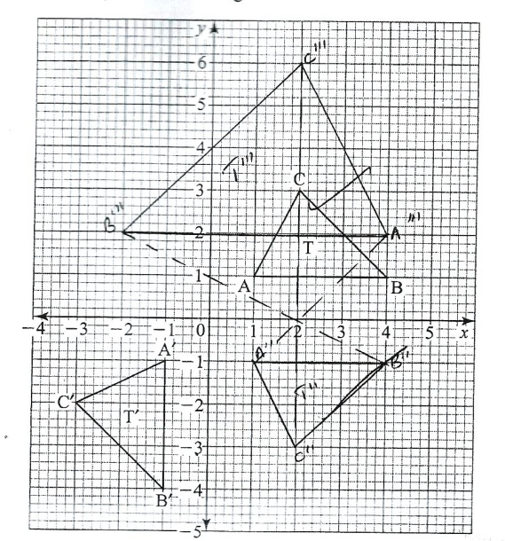  - Y=-x  - Ii)  Reflection of the x axis  Reflection on the line y =0  d)  E.S.F=L.S.F.=2 A.S.F Area image  A.S.F=(L.S.F)2=4 Area object  4=12/A  A=2cm² (object  2015Q21

SIMIRALITY AND CONGRUENCY - MARKING SCHEME

1. | Test for equiangularity:  < AXB = <CXD..........Vertically opposite angles  <BAX = <CXD...........Angles subtended by the same chord BC in the same segment  <ABX = <DCX...........Remaining angles in the triangles must be equal(or angles subtended by same chord AB)  Triangle AXB and DXC are therefore equiangular.  Test for equal sides:  <CAD = <ACB........... alternate angles  But <CAD is subtended by chord CD and angle ACB is subtended by chord AB  Side AB = side CD and both are corresponding sides.  Triangle ABX and DXC are congruent because of AAS i.e. Angle side  1989Q15 | 4M
2. | AC = 3cm + 2cm = 5cm  AE : AC  3 : 5  ${\left(\frac{3}{5}\right)}^{2}$ =  9:25 or $\frac{9}{25}$ 1990Q7 | 2M
3. | ¹/₆ x 12  DE = 2cm  1991Q6 | 3M
4. | A. S. F = ${\left(\frac{3}{5}\right)}^{2}$  = ⁴ /₂₅  Ratio of area Δ ABC to ΔAED = ⁴/₂₅  Therefore: 25 – 4 = 21  25 25 25  Ratio of ΔABC to trapezium  = 4:21  1992Q5 | 3M
5. | (a)<ACD = <BCD......................common to both  <DAC = <BDC.....................alternate angle theorem  <ADC = <CBD......................remaining angles must be equal  Thus Δ ADC and ΔBDC are equiangular  ΔADC and ΔDBC are similar  (b) (i) AB = 5cm  (ii) < ACD = 22.62⁰  1992Q21 | 8M
6. | <AED = <BEC......................Vertically opposite angles  <ADE = <EBC..................... Subtended by the same arc AC  <DAE = BCE....................... Subtended by the same arc BD  ΔAED and Δ BEC are equiangular hence similar.  1992Q15 | 3M
7. | EC = ³/₅ x 8 =4.8  DC = ⁴/₅ x 5  = 4cm  Area of ABDE = Area of ABC – Area of DCE  $\left(\frac{1}{2}×5×8\sin{{30}^{0}}\right)$ - $\left(\frac{1}{2}×4.8×4×\sin{{30}^{0}}\right)$  = 10 – 4.8  = 5.2cm²  1993Q16 | 3M
8. | V .S.F = ${\left(\frac{4}{3}\right)}^{3}$  $\frac{64}{27}$ or 64:27  1993Q2 | 2M
9. | 3 x 1000 litres  V. S .F = 3000  1.5  = 2000  1  L. S. F = $\sqrt[3]{\frac{2000}{1}}$ = 12.599  30 x 12.5992105  = 377.976315  = 378cm  1994Q9 | 3M
10. | V.S.F = ${\left(\frac{3}{5}\right)}^{3}$= $\left(\frac{27}{125}\right)$  125 X 8.1  27  =37.5m³ 1995Q10 | 3M
11. | Vol. Of container  = 36 x 24 x 18 = 15,558cm³  V.S.F = (L.S.F )³ = 1:216  216 = 15,558 = $\frac{15558}{216}$ = 72cm³  = 72cm³  1996Q10 | B1  M1  M1  A1  4M
12. | a). <AEB=<DEC, Vertically opp. <s  <ABE=<EDC, alternative <S  <EAB=<ECD, alternate <S  ∆ABE is similar to ∆ CDE(AAA)  b). BE=3ED  DB:EB=4:3  2002Q15 | B1  B1  B1  B1  4M
13. | Volume scale factor = 4752  1408  = 3.376  v.s.f = (l.sf)³  l.s.f = 3$\sqrt{3.376}$  = 1.5  Area factor = (l.s.f)²  = 1.5²  =2.25  Area of larger cylinder = 352 x 2.25  = 792cm²  2005Q8 | M1  M1  M1  A1  4 M
14 | 42$\frac{2}{3}$ cm³  2008 Q9
15. | a). Volume of water =$\frac{6}{9+x}$ = $\frac{2}{x}$ x = 4.5  ; volume  = ¹/₃x 3.142(6² x 13.5 – 2 x 4.5)  = 508.94 -18.25 = 490.09  b). i). Volume of sphere  Top radium ^{r}/_{14.5} = ²/_{4.5} r=6.440  Volume = ¹/₃ x 3.142 (6.444² x 14.5 -6² x 13.5  = 121.6 = 121 ¹¹/₁₅  ii). ⁴/3$π$r³ = 121.6  r³ = 121.6 x $\frac{3}{4}π$r³  r = 3.073  2009Q21 | M1  M1  A1  M1  A1  M1  A1  M1  M1  A1  10M
16. | L.S.F = 8:24 = 1:3  V.S.F = 1:27  = 160 x 27 – 160  = 4160cm³  2011Q16 | B1  M1  A1  3
17 | - (i) r= 3cm  (ii) 12$π$cm³  - (i) 15cm  (ii) 222$π$cm²  2013 Q24 P1

TRIGONOMETRY-MARKING SCHEME

1. | Tan 580 = h  5  h = 5tan 58⁰  = 5 x 1.600  = 8m 1989Q4 | 2M
2. | h= x tan 48⁰ = (x + 10) tan 45⁰  x tan 48⁰ = (x + 10)tan45⁰  1.1106x =1(x + 10)  1.1106x – 1x = 10  h  0.1106x = 10  x = 90.42cm p 45⁰ 48⁰  h = (90. 42 + 10)1 10m Q x  = 100.42m  1990Q12 | 4M
3. | x  A D  60⁰  B 8km C  x = tan60⁰ x 15  = 25.98  AD = 25.98 + 8  = 33.98  = 34km 1990Q12 | 3M
4. | (a)  10m  40⁰ h  30⁰  X  h = $x$tan 30⁰  h + 10 = $x$tan 40⁰  x = $\frac{h}{\tan{{30}^{0}}}$ = $\frac{h+10}{\tan{{40}^{0}}}$  h tan 40⁰ = tan 30⁰(h + 10)  0.8391h = 0.5774h + 5.774  0.8391h – 0.5774h = 5.774  0. 2617 0.2617  0. 2617 0.2617  h = 22.06  (b) 22.06m + 10m  = 32.06m 1994Q23 | 8M
5 | Tan 45⁰ = h or h = 60m  60  Tan θ = 60 =0.25  240  = 14.04⁰ (14⁰2)  1996Q4 | M1  M1  A1  3M
6. | x  60⁰  30⁰  x = 400 cos 60⁰ = 20⁰m  h=200 sin 60⁰  h=200 x 0.8660  =173.2m  1997Q5 | B1  M1  A1  3 M
7. | Tan 35⁰ = (h + t)  t 15  H + t = 15 tan 35⁰  h 15x0.70020075  10.5031113  10.503m  35⁰ 30⁰  A B  Tan 30⁰ = h  15  h = 15 tan 30⁰  h=15x0.5773502  = 8.6600254  h = 8.611  (b) 10.503 - - 8.661 = 1.842  1998Q6 | B1  B1  B1  3M
8. | (a) AC = $\sqrt{4^{2+ \frac{{\left(\sqrt[4]{3}\right)}^{2}}{3}}}$ =$\sqrt{16+ \frac{16}{3}}$ = $\sqrt{\frac{64}{3}}$  $\frac{8\sqrt{3}}{3}$ or 4.618  (b) BC = $\frac{4.618}{Tan 30}$ = $\frac{4.618}{0.5774}$ = 8cm  1998Q4 | M1  A1  M1  3M
9. | a) x = $\sqrt{3^{2} - 2^{2}}$  Tan θ = 2  √5  b) Sec θ = tan θ + 1  = 4 + 1  5  = 1.8  2000Q7
10. | a) RA = 30 or = RA 30 tan 64⁰  tan 26⁰  = 30  0.4877 or 30 x 2.050  = 61.51 (6.15)  RB = 30 OR = 30 tan 58⁰  Tan 32  = 30 or 30 x 1.600  0.6249  = 48.01 948)  AB = √61.5T² + 48.01³  = √ 3783 + 2305 - √6088  = 78.03  b) tan θ = 48.01  61.51  = 0.7805  θ = 37⁰ 58  Bearing = 360 – 37⁰ 58¹  = 322⁰ 2 (322⁰ 3)  2001Q20 | M1  A1  M1  A1  M1  A1  M1  A1  8 M
11. | θ  A  60m  B  P  50m  78.1  Required angle is the supplement of <PBA or angle marked on diagram.  Tan θ = 50 = 0.8333⁰  60  -180 – 39.8 ⁰ = 140.12⁰(140⁰ 12¹)  Tanθ = -50 = 0.8333  60  -180 – 39.2⁰ = 140.2⁰  2003Q12 | M1  M1  3 M
12. | A  C  B  90-X  4  5  X  Sin (90-x) = AB  AC  Sin (90-x) = ⁸/₁₀ =⁴/₅  Tan x = BC  AB = 0.75  2005Q7 | B1  M1  A1
13. | X=1.8 cos 63⁰  = 1.8 x 0.454  = 0.8172  QS= 3.6 -2 x 0.8172  3.6 – 1.6344  = 1.9656  =1.966m  2006Q11 | M1  M1  A1  3 M
14. | 1² = 5² – (2 √5)² = 5  L=√5  Tan (90-x)⁰= 2 √5 or 2  √5  2007Q8 | A1  M1  2 M
15. | <LKM = 110⁰  <KLM =35⁰ 0r KML =35⁰  Bearing is 185⁰  2007Q15 | M1  A1  A1  3 M
16. | a). < ABQ=180⁰ -95.5⁰= 84.5⁰  < AB = 5.8 OR 5.8  Cos 84.5 Sin 5.5  = 60.5m  = 61m  b). i). ABC = 95.50 + (900-30.50)  = 1550  Scale : 1cm : 10m  C  A  B  6.05cm  3.5cmm  <ACA = 16⁰ + 1⁰(15⁰ or 17⁰)  Therefore, < of depression of A from C  = 30.5⁰ -16⁰ = 14.5⁰ +1⁰  =15.5⁰ or 13.5⁰  2007Q18 | M1  A1  2 M  M1  A1  M1  M1  A1  5 M  A1  M1  M1  A1  3 M
17. | a). Tan 11.3⁰ = ²⁰/_{x}  x = ²⁰/_{Tan 11.30}  ²⁰/_{0.1998197} = 100.09022  = 100.1m  b). PQ = 36 x 1000 x 5  60 x 60  = 50M  BQ = 100.1 + 50 = 150.  Tan θ =²⁰/₁₅₀ = 0.133245  θ = 7.5896  θ = 7.59⁰  c). i). QD = 200-150.1 = 49.9  CD = $\sqrt{{50.9}^{2}- {49.9}^{ 2}}$  = 10.03992  = 10.04M  ii). AX = 20-10.04 = 9.96  Tan x = ^{9.96}/₂₀₀ = 0.0498  α = 2.85097  α = 3⁰ 2008Q20 | M1  A1  M1  M1  A1  M1  A1  M1  M1  A1  10
18. | Let angle between ground and wire be θ⁰  ; 0 + ¹/₃θ = 90  θ = 90 x ^{θ}/₄ = 67.5  Let the wire be x in length  ; Cos 67.5 = $\frac{6}{x}$  X = ⁶/_{Cos 67.5} = ⁶/_{0.382683432}  = 15.68m or 1568cm  2009Q12 | B1  M1  A1  3 M
19. | Sin 3$θ$ = cos2$θ$  Sin 3$θ$ = sin (900 - 20)  If 3$θ$ = 90 - 2$θ$  .: 5$θ$ = 90  $θ$ = 18⁰  2010Q13 | M1  M1  A1  3
20. | Sin (x + 60⁰) = cos 2x  X + 60 + 2x = 90⁰  3x = 30  x = 100  Tan (10 + 60)⁰ = tan 70⁰  2.748(4.S.F) from tables  2011Q5 | M1  M1  A1  3
21. | X = tan⁻¹ $\frac{3}{7}$ = 23.20⁰  Cos (90 – 23.2)⁰ = 0.3939  2012 Q10 | B1  B1  2
22. | 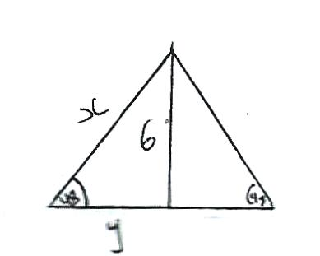  Sin φ = $\frac{OP side}{Hypside }$ Tan 8 = $y$  Sin 48$°$ = $\frac{6}{x }$ y= $\frac{6}{Tan 48 }$  X= Sin φ = $\frac{6}{Sin 48° }$ 5.402 x 2  X = 8.074 = 10.80  P =10.804 + (8.074 x 2 )  = 26.952  = 27.0cm  2015Q5
23. | 20a  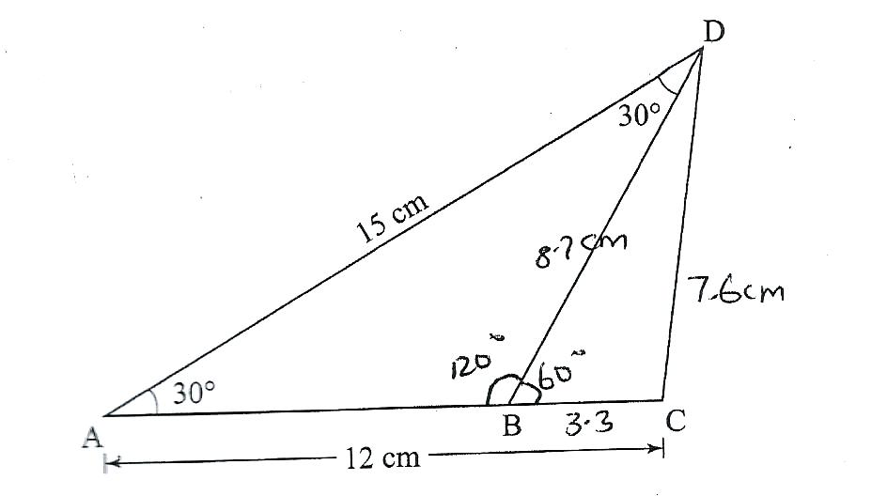  a)CD²-12²+15²-2x12x15 cos 30  CD=$\sqrt{57.23085464}$  CD=7.565  CCD-7.6CM  b  $\frac{AB}{Sin 30 }$ = $\frac{AD}{Sin 120 }$  AB= $\frac{15 Sin 30}{Sin 120 }$  = $\frac{15 x 0.5}{0.866 }$  = 8.7 cm  c)  A= ½ ab Sin C  AB=BD = 8.7 cm  A=¹/₂ X 8.7 x 3.3 sin 60  = 12.43179  =12.4cm².  d)  $\frac{3.3}{Sin <BDC }$ = $\frac{7.6}{Sin 60 }$  Sin <BDC= $\frac{3.3\sin{60}}{7.6 }$  = 0.376037  DC=22.088  =22.5  2015Q20
24. | x = 80⁰  2015Q15 P2

MEASUREMENTS – AREA, VOLUME, PERIMETER, TIME, DENSITY-MARKING SCHEME

1. | 2.4m – 1.8m = 0.6m  3.2 x 0.6m x 2 =3.84m²  2.8m x 0.6m x 2 = 3.36m²  3.8m x 0.6m x 2 x = 3.3m²  3.84m² + 3.36m²  = 7.20m²  1989Q9 | 2M
2. | V = $π$r²h +²/₃$π$r³  = $\left(\frac{22}{7} × 7^{2} ×15 \right)$ +$\left(\frac{2}{3 } × \frac{22}{7} ×7^{3}\right)$  =2310 + 718.67cm³  = 3,028.67cm³  1989Q16 | 4M
3. | A = $\frac{θ}{360}$ $π$r²  30.8 = ${\frac{72}{360}}^{0}$x $\frac{22}{7}$ x r²  r² = 30.8 x 360 x0 7  72 x 22  r² = 77616  1584  r² = 49  r² =7  AB = $\frac{72}{360}$ X $\frac{22}{7}$ X 7  = 8.8cm  1990Q9 | 3M
4. | 20cm- 8cm = 12cm  20² -122 = 400 -144  = 256  $\sqrt{256}$ = 16cm  16 x 2  = 32cm 1990Q1 | 3M
5. | $\frac{a}{\sin{A}}$ = $\frac{B}{\sin{B}}$  $\frac{6}{\sin{30}}$ = $\frac{X}{\sin{{120}^{0}}}$  x = $\frac{6}{\sin{{30}^{0}}}$ $×{\sin{120}}^{0}$  = 10.392cm 1990Q14 | 2M
6. | V =$π$r²  22 x (2.5)² x 14  7  = 275cm³  $\left(\frac{22}{7} ×4 ×0.3\right)$- $\left(\frac{22}{7} ×{\left(\frac{3}{4}\right)}^{2} ×0.3\right)$  26.4 – 3.7125 = 22.6875  7 7 7  $x =\frac{275 ×7}{22.6875}$  = 84.8  = 84 1990Q13 | 4M
7. | A = $π$rl  $\left(\frac{22}{7} ×20 ×5.2\right)$ - $\left(\frac{22}{7} ×10 ×26\right)$  22880 - 5720  7 7  17160  7  2451.42cm² or 2450.76cm²  1991Q12 | 3M
8. | V = $\frac{2}{3}$ $π$r³  $\frac{2}{3}$ x $\frac{22}{7}$ x7  2156cm³  3  40 x 1000 = 2285.7142cm³  17.5  2285.7142 – 2156 = 1567  3  1567 = $\frac{22}{7}$ x 7²x h  h = 1567 x 7  49 x 22  h = 10. 18cm 1991Q17 | 8M
9. | A = 2ab sinθ a=10  b=14.4  = 2 x10 x 14.4 x sin 62⁰  = 254.3cm² 1992Q4 | 3M
10. | A = $\left(\frac{90}{360} ×14 × 4^{2}\right)$ - $\left(\frac{1}{2} ×4 × 4\right)$  12.56 – 8 = 4.56  4.56 x 2  = 9.12cm²  1992Q15 | 4M
11. | (a) vol = $\left\{(7.5 x 3.3) – (7.2 x 5)\right\}$ 3.3  = $\left\{39.75 – 36.0\right\}$3.3  = 3. 75 x 3.3  = 12.375m³  Vol required = 12.375 – 5  = 7.375m³  (b) Vol of blocks = 7.375 – 0.225  = 7.15m³  No of blocks = $\frac{7.15}{0.0135}$ = 529.6  = 530blocks  1992Q17 | 8M
12. | (i)$\frac{0.4}{14.4}$ = $\frac{4}{10}$ x $\frac{10}{144}$ = $\frac{4}{144}$  l.s.f =$\sqrt{\frac{4}{144}}$  $\frac{2}{122}$ $×$2.1 = 0.35m  (ii) V.S.F =${\left(\frac{2}{12}\right)}^{3}$= $\frac{8}{1728}$  1728 X 23.15  8  = 5000litres  1992Q22 | 4M
13. | (a) V = (L $×$ W $×$ H) + (¹/₂ b x h x l)  = (30 x 14 x 1) + (¹/₂ x 3 x 30 x14)  = (420 + 630)  = 1050cm³  (b) vol drained per second  = 3.14 x 72 x 500  = 76930cm³  1050 x 100000 = 13648.77seconds  76930  13648.77 =227minutes  60 1992Q20 | 4M
14. | V = (l $×$ w $×$ h) + $π$r²h  (21 x 30 x40) + $\left[\frac{22}{7} x (10.5)2 x 40\right]$  25200 + 13860  = 39060mm³  39060 = 39.06cm³  1000  Mass = 39.06 x 8.8  = 343.7g  1993Q7 | 4M
15. | V.S.F = ${\left(\frac{1}{3}\right)}^{3}$ = $\frac{1}{27}$  $\frac{27}{27}$ - $\frac{1}{27}$  = 26  27 1993Q15 | 3M
16. | V = $π$r²H + ²/₃$π$r³  (²²/₇ x1.752 x 5) + (²/₃ x ²²/₇ x 4.2³)  336.875 + 1086.624 =1423.499  7 7 7  = 203.357  = 203.4cm³  1993Q3 | 3M
17. | Area of the cross section = 86.62cm²  1993 Q9
18. | 25 $×$ 4 = 100m  100m ÷ 3m = 33 posts  1993 Q10
19. | 489.4cm²  1995 Q9
20. | V =A $×$h  A = $\sqrt{s \left(s-a\right)\left(s-b\right) \left(s-b\right) }$  = $\sqrt{4.5 × 1.5 ×1.5 ×1.5}$  = $\sqrt{15.1875}$ = 3.8971143  v = 3.8971143  = 97.43cm³  1995Q4
21. | $π$r²h = ⁴/₃$π$r³  $π$ x 11² x 50= ⁴/₃$π$r³  R³ = 6050$π$x3  4$π$  r = 4537.5  r = 16.5cm  r=16.56cm  1995Q14 | 2M
22. | 1 + x² = (2x - )² – 1  3x² – 4x -1 = 0  $x=\frac{4±\sqrt{28}}{6}$  = 1.549cm  1996Q7 | M1  M1  M1  A1
23. | Volume of the cone  = ¹/₃ x ²²/₇ x 7 x 7 x 18  = 924cm³  Let change in height be h  Volume of water displaced  = ²²/₇ x 14 x 14 x h  =616cm²  $π$ x 14x x 14x h = ¹/₃ π x 7x 7 x 18  H = 49 x 6 = 1.5cm  14 x 14  1997Q6 | M1  M1  M1  A1  4 M
24. | i). Area of equid. ∆ = ½ x 6x sin 60⁰  = ½ x 6 x 0.8669  = 15.588 (15.59)  x = section area  = ½ x 6 x 6 x 0.8660 x 6  = 15.59 x 6  = 93.54 (93.528)  ii). Vol. of prism = 93.54 x 30  = 2806.2(2805.9)  1997Q16 | M1  M1  A1  M1  A1
25. | Volume = $π$ r2h = $π$ 15 x 1.2  270Л  (b) ¹/₃$π$ x r x 9 = 270$π$  r² = $\frac{270 x 3}{9}$ = 90  r² = $\sqrt{90}$ = 9.49cm  1998Q11 | M1  A1  M1  A1  3M
26. | (a) area of the circular based  ²²/₇ x 2 x 3.5 x 3.5 =38.5cm²  (b) area of the curved S.A  ²²/₇ x 2 x3.5 x20 = 440cm²  (c) ⁴/₃$π$ r² = ²/₃ x ²²/₇ x 3.5²  44 x0.5 x3.5  22x3.5 = 77cm²  (d)38.5 + 440 + 77=555.5cm²  1998Q21 | A1  M1  A1  M1  A1  M1  M1  A1  8M
27. | Initial volume = 4 x 2³ = 3211  3$π$r³ 3  New vol = 32$π$ x 337.5  = 36$π$cm³  1998Q11 | M1  M1  2M
28. | Area = 3.142 x 5 x 13  = 204.23cm²  1999Q4 | M1  A1  2 M
29 | a). (y² – 2x²)cm²  b). 2x² =142  x= 7$\sqrt{2}$  = 9.899 cm  c). area of octagon  y=14 + 2x = 14 + 2 x 9.9 =33.8  A = y²-2x² = 33.82 – 2 x 98  = 1142.44 – 196  = 946.44cm²  1999Q8 | B1  B1  M1  M1  A1
30. | Length of the pipe  - = (0.15 $×$ 0.12 $×$ 01)  7000  = 0.009 ÷ 0.006  =1.5m  1999Q13 | M1  M1  M1  A1  4 M
31. | a) volume of hemisphere  ½ x ⁴/₃ x ²²/₇ x 5.2³  10.4 : 10.4 : 11: h – H – 3h  Big cone V1 = ¹/₃ x ²²/₇ x 5.2² x h  Small cone V₂ = ¹/₃ x ²²/₇ x( 5.2 ) x h  3  V1 – V₂ = 1 x 22 x 5.2² x (3 – 1) h  2 7 9  = 1 x 22 x 5.2² x (26) h  2 7 9  26 h = 10.4  9  H = 10.4 x 9 = 3.6  26  Therefore height of the frustum  = 2h = 7.2cm  b) L = 3.62 + 5.2² = 3.995  3  L = $\sqrt{{10.8}^{2} + {5.2}^{2} = 11.98}$  Area = $π$ r² + $π$ RL - $π$ rl  ²²/₇ x 3 x 22 x 5.2² x 11.98  7 7  -22 x 5.2 x 3.995  7 3  = 9.429 + 195.8 – 21.76  = 183.469  = 183.5cm² 1999Q23 | M1  M1  M1  A1  M1  M1  A1  8 M
32 | Area of rectangle = 19.5 x 16.5cm  = 321.75cm²  Area of 4 triangles = ½ x 6 x 4.5 x 4  = 54cm²  Area of octagon = 321.75 – 54  = 267.75cm²  2000Q9
33 | a) i)  A = ²²/₇ x 4.2 x 4.2 = 55.44cm²  ii) Let standing length cone be L  L – 8 - 3.5  L 4.2 or equivalent  L = 48cm  Curved area of frustum  22 (4.2 x 48 – 3.5 x 40)  193.6cm²  iii) hemispherical surface area  = 1 x 4 x 22 x 3.5 x 3.5  2 7  = 77cm²  - Ratio of areas  = 81.51 : 326.04 = 1:4  Ratio of lengths = 1 :2  Radius of base = 4.2  2  = 2.1cm 200Q20 | B1  M1  A1  M1  A1  M1  A1  8 M
34. | A = ½ x 5 x 5 sin 120⁰  = ½ x 5 x 5 x 0.866  = 10.825 2000Q3 | M1  M1  A1
35. | x = p -$π$r  2  Area of triangle = ½ (p - $π$r)²  2  = ½ (p -$π$r)²  Area of semicircle = ½ $π$r²  Total area = ½ $π$ r² + ¹/₈(p – $π$r)²  2000Q4  2000Q4 | B1  B1  B1  3 M
36 | BO - OD = $\sqrt{{15}^{2}-{12}^{2}}$= $\sqrt{81 }$  =9  AREA = ½ x b x h  = 1 x 9 x 12 x 2 + 1 x ‘ 9 ‘x18 x 2  = 108 + 162  = 270cm²  2001Q2 | M1  M1  A1  3M
37. | 1 x 22 x 6x6 x 9+ 1 x 4 x 22 x 6 x 6 3 7 2 3 7  = 339.4 + 452.6  = 792cm³  2001 Q4 | M1  M1  A1  3 M
38. | Area of pentagons  = ½ x 4.25 x 4.25 sin 72⁰ x 5 x 2  = ½ x 4.25 x 4.25 x 0.9511 x 5 x 2  = 18.06 x 0.9511 x 5 x 2  = 85.88 or (85.9)  Area of rectangle faces  = 5 x 12 x 5 = 300  Total area = 300 + 85.88  = 385.88cm²  2001Q12 | M1  A1  M1  A1  4 M
39. | a). i). volume cylindrical part  = ²²/₇ x 0.7 x 0.7 x 1  = 1.54m³  ii). x- section  = ½ x 0.42 x sin 60⁰ x 6  = ½ x 0.4 x 0.866 x 6  = 0.41568(0.4157)  Volume hexagonal part  = 0.41568 x 4  = 1.6628 (1.663)  b). volume of pillar  (1.54+1.6628)-0.25 x 5  = 3.2028 -1.25=1.9528(1.953)  =Mass =1.953 x 2400  =4687.2kg(4687kg)  2001Q23 | M1  A1  M1  M1  A1  M1  M1  A1  8 M
40. | H = 12 sin 60 = 10.39  AD = (12 cos 60) $×$ 2 + 4 = 16  Area = (¹/₂ x (4 + 16) 10.39  = 103.9 x 2  =207.8 cm²  2002Q6 | M1  A1  3M
41. | x section area = ²²/₇ (4² – 3²)cm  volume = ²²/₇ x 7 x 0.2cm²  4.4 cm³  2002Q11 | M1  A1  2M
42 | ½ x 14 x 8sin θ = 28 sin θ = 28 = 1  56 2  θ = 30⁰ or 150⁰  2003Q10 | M1  A1  2
43 | Area ∆ face = ½ x 6 x 6 x sin60⁰  = 18 x 0.866  = 15.59  Total surface area  = (2 x 15.59) + 3 x 6 x 10)  = 31.18 + 180  = 211.18cm²  2003Q10 | M1  M1  M1  A1  2M

44 | 4x + 2 (3x) = 21  2  7x = 21  X = 3 width is 3cm  2003Q11
45 | a). Ext d = 11cm or r₁ = 5.5cm  Int. d = 9cm or r₂ = 4.5cm  Volume =$π$(r² – r²) x 600cm  = 3.142 (5² – 5- 2-4.5²) x 600cm  = 18,852.cm³  2003Q13 | M1  M1  A1  3 M
46 | a). Volume of milk  ¾ (1.7mx1.4mx2.2m)  =3.927m³  b). i).Volume of each  ¹/₃ x ½ x 16x16 sin 600 x 13.6  = ¹/₃x ½ x 256 x 0.866x13.6  = 502.5cm³  in 2sf=500cm³  ii). Number of full packets  3.927 x 10⁶ x 25 = 7814 x 25  502.5  1. 7814 x 25 = 195350 – 3.927x106  502.5  2. 195350= 7814x25-3.926 log used  3. 195272=7811x15 – altitude  correctly or heroes formula (13.86)  4. 195400=7816x25-when 502.4 is used  5. 195225-using 13.86 or heroes formula 3.926 (7809 x25)  6. 195300= 3.926 x10⁶ = 7812x25  502.5  2003Q17 | M1  A1  M1  M1  A1  B1  M1  A1  8 M
47. | S.A = ½ (4$πr$²)+$π$ r² 75$π$  r² =$\frac{75π}{3π}$ =25  r =5  v = ½ ($\frac{4}{3}π$x${ 5}^{3}$)  = $83\frac{1}{3}π$cm³  2003Q9 | M1  A1  M1  A1  4 M
48 | 1299 cm³  2004Q13 | A1
49. | a) Area of hemispherical part  = ½ x 48r²  = 2 x ²²/₇ x 35 x 35  = 7700cm²  b) Slant height for original / zone  L = 35  L–60=14  L = 200cm  C)Surface area of frustum  $π$RL=$π$rl  Ni = ²²/₇ x 35 x 100 – ²²/₇ x 14 x 40  = 11000 – 1760  =9240cm²  Total surface area  = 7700 + 9240 + ²²/₇ x 14²  = 7700 + 9240 + 616  = 17556cm²  2004Q19 | M1  A1  M1  A1  M1  M1  M1  A1  M1  A1  M1  M1
50. | 7.5  D  A  B  C  AD = $\sqrt{{7.5}^{2}+4^{2}}$  = 72.25  = 8.5  Perimeter = 8.5 x 4  = 34cm 2005Q3 | M1  M1  A1
51. | C  B  A  Area A = $π$r²  ²²/₇ x 4.2 x 4.4  = 55.44cm²  Area B = 2$π$rh x ½  = ²²/₇ x 4.2 x 150  = 1980cm²  Area C = 2 x 4.2 X 150  = 1260cm²  Total area = 55.44 + 1980 + 1260  = 3295.cm²  2005Q12 | B1  M1  M1  A1
52. | Cross sectional area = ½ bh+ 1x b  = ½ x 25 x 1.8 + 25 x 1 = 47.5m²  Volume = 47.5 x 10 = 475m²  b). i). volume A ½ x 25 x1.8 x10  = 225m³  Volume B = 10 x 1 x 25  = 250  Total volume = 250 + 225 = 475m³  1  25  B 54.9kg 2010Q18  A  1.8  ii). 225m³ = 9 hours  Therefore 250m3 = 250 x 9  225  = 10 hours  2005Q19 | B1  M1  A1  B1  M1  A1  B2  A1`
53. | a). Height = $\sqrt{3^{2}-{1.8}^{2}}$ = 2.4  x – sectional area = 9.12cm³  x – sectional area $×$ height  = $\frac{1}{2} ×$2.4 $×$(2+5.6)$×$8  Volume = 9.12 x 8  = 72.96cm³  b). Mass mg  = 72.96 x 5.75  = 419. 52g  c). (i) 246.24= cross section  Area $×$ 8  Cross section Area = $\frac{246.24}{30}×30.85$ cm²  (ii) $\frac{419.52g}{246.24 {cm}^{2}}×$ $\frac{2}{5}$ $=4.259 g/{cm}^{3}$  Area of solution  =9.12 $×2.25$  =20.52cm²  2006Q19 | M1  M1  A1  M1  A1  M1  A1  10 M
54. | a). Slant height  L =$\sqrt{4^{2}+3^{2}}$ =5cm  A_{c} = $π$rl  = 3.142 $×3×5$  = 47.13cm²  A_{cs} = $πDh$  = 3.142 $×6×8$  = 150.82cm²  As = $\frac{1}{2}4πr^{2}=2πr^{2}$  = 2$×$ 3.142$×9$  = 56.56 cm²  b). 15cm: 600cm  1:40  a.s.f = $\frac{1}{1600}$  Area of container  1600 x 254.5cm²  1600 x 254.5  1000  = 40.72m²  Paint needed  40.72 x 0.75  20  = 1.527 litres  Toal = 24.13 + 9.05 +2.54ml  = 40.73m²  Paint needed  ^{40.73}/₂₀ x 0.75ml  = 1.527litres  2006Q23 | B1  M1  M1  A1  B1  B1  M1  M1  M1  A1  10 m
55. | Volume of plate = 1.05 x 100  8.4  = 125cm³  $L^{2}=\frac{125 cm}{0.2}=625$  2007Q7  L = $\sqrt{625}$ = 25cm | M1  M1  A1  3 M
56. | Cos θ = 2.5 = 0.5  5  θ = 60⁰ x 2  surface under water  = 2 x 60 x $π$ x 10 x 12  360  = 125.7 2007Q9 | A1  M1  M1  A1  4 M
57. | a). I.S.F = $\sqrt{\frac{20}{45}}$=$\sqrt{\frac{4}{9}}$= $\frac{2}{3}$  Therefore I.S.F = ⁸/₂₇  Capacity of smaller container  $\frac{8}{27}$x 0.945  0.281 or 280ml (280cm³)  b). let depth be h  45(13-h) =20h  585 =65h  H = 9  c). amount in smaller container  ¹/₅ x 9 x 45 + 20 x 9  =261  Height in smaller container  ²⁶¹/₂₀ = 13.05cm  Difference 13.05 – ⁴/₅ x 9  =13.05 – 7.2  = 5.85cm 2007Q22 | M1  M1  A1  A1  A1  A1  M1  A1  M1  A1  M1  A1  2 M
58. | 23.50 + (7 h 15 minutes + 45 minutes + 5h 40 minutes)  = 1330h  = 1.30pm on Monday  2008Q4 | B1  B1  2 M
59. | Volume of liquid = 384  0.6  Height of liquid = 640 x 3.22  = 19.89cm  2008Q7 | M1  M1  A1  3 M
60. | Volume of sphere = ⁴/₃$π$ x 4.2³  Side of cube = 3 $\sqrt{\frac{4}{3}π×{4.2}^{3}}$  = 6.77 cm  2008Q9 | M1  M1  A1  3 M
61. | Area of rectangular part  = 2x 5.2 x$π$x 18  = 187.2$π$  Area of circular parts  = 2 x 5.22 x$π$  = 54.08$π$  $π$ (187.2+54.08) = 241.28$π$cm²  2008Q13 | M1  M1  A1  3 M
62. | a). ¹/₃ x ²²/₇ x 21 x 21 x 30  = 13860cm³  b). i). ^{r}/₂₁ = ³⁶/₃₀  r = 36 x 21  30  = 25.2cm  ii). ¹/₃ x ²²/₇ x 25.2 x 25.2 x 36  = 23950.08  = 23950.08 – 13860  = 10090.08cm³  iii). $\frac{4}{3}$x $\frac{ 22}{7}$x r³ = 10090.8  r³ = $\frac{10090.08×21}{4×22}$  R = 3$\sqrt{2407.86}$  = 13.40cm  2008Q22 | M1  A1  M1  A1  M1  M1  A1  M1  M1  A1  10
63. | AC = $\sqrt{{85}^{2}-{75}^{2}}$= 1600  = 40  Area of quad ABCD  = ½ x 40 x 75 + $\sqrt{75\left(75-60\right)\left(75-50\right)\left(75-40\right)}$  = 1500 + √984375  =1500 + 992  =2492m²  =0.25ha  2009Q6 | M1  M1  A1  B1  4 M
64. | Time between Monday 0545h and Friday 1945h  = 4x 24 + 14  = 110h  Time lost = 0.5 x 110 = 55 minutes  Time shown in 12 hours system  - = 1850h  = 6.50 p.m  2009Q7 | M1  M1  A1  3 M
65. | 2$π$r² + 2$π$rh = 154  r = h  2$π$r³ + 2$π$r² = 154  4$π$r² = 154  r = $\sqrt{\frac{154}{4 ×3.142}}$  = 3.500  diameter = 2r= 3.500 x 2  = 7.00cm (s dp)  2010Q14 | M1  M1  A1 3
66. | Accept ²/₃ = 0.666  re-use of decimals  Let OC = r  .: CD = $\frac{2}{3}r$ and EF = $\frac{2}{3}r+5$  $\frac{2}{3}r$ + $\frac{2}{3}(r+5$) + 5+5 = 24  $\frac{4}{3}r$= $10\frac{2}{3}$  r=8cm 2010Q15 | M1  M1
67 | - (i)internal volume of box  = 150 x 80 x 40cm³  =480,00cm³  external volume of box  = 152 x 82 x 42cm³  = 523488cm³  Volume of wood  = (523488 – 480,000)cm³  = 43488cm³  (ii) mass of box = 43488 x 0.6  1000  = 26092  = 26.1kg  - (i) no of tins = $\frac{150}{10}$ x $\frac{80}{10}$ x $\frac{40}{10}$  = 240 tins  (ii) total mass  = 26.1 + $\left(\frac{240 ×120}{1000}\right)$  = 54.9kg  2010Q18
68. | $\sqrt{{11.252}^{2}-{6.75}^{2}}$ -9  Perimeter = 2(9+6.75)  = 31.5m  2011Q2 | B1  B1  2
69 | Internal dimensions:  40,20 and 15  Volume unoccupied  = 40 x 20 x 15 – 8000 = 4000  Height unoccupied  4000  40x20  =5cm  2011Q7 | B1  M1  M1  A1  4
70. | (a) (i) surface area of the solid  = $π×$6$×$10+ $\frac{4}{2}$ $×$ $π$ x 6²  = 14.69cm²  (ii) height of the cone:  =$\sqrt{100-36}$ = 8  Therefore: volume of the solid  = ¹/₃ x $π$ x 6² x 8 + ½ x ⁴/₃ x $π$ x 6³  = 753.98cm³  (b) mass of the solid in kg  = 1.3 x 753.98  100  = 0.9802 to 4significant to s.f  2011Q17 | M1  M1  A1  B1  M1  M1  A1  M1  M1  A1
71. | $\frac{24}{2} = \frac{1}{2} ×8 ×x sin30°$  $x = \frac{12}{4sin30} =6cm$  Perimeter = 2(6+8) = 28cm  2012 Q4 | M1  M1  A1  3
72. | Volume of solid  = 1 x 22 x10.5² x 15 – 22 x 3.5² x 8  3 7 7  = 1732.5 – 308  = 1424.5cm³  2012 Q15 | M1  M1  A1  3
73.  (a)  (b)  (c) | $\left|AB\right|$ = $\sqrt{169-25}$ = 12cm  2 x 5 x 12 + 2 x 5 x 15 + 2 x 12 x 15  = 630cm²  Volume = 5 x 12 x 15cm³  Mass = 7.6 x 5 12 x 15  = 6840gm  = 6840  1000  = 6.84kg | B1  M1  M1  A1  M1  M1  M1  A1
(d) | 150 x 120 x 100 cm³  15 x 12 x5 cm³  = 2000cuboids  2012Q18 | M1  A1  10
74 | 18 45 h  2013 Q7
75 | 1.925 kg  2013 Q14
76 | 386cm²  2013 Q15
77 | Volume = $\frac{1}{3}×\frac{22}{7}×{\left(14\right)}^{2}×$ 18  = ${3696 cm}^{3}$  Density = $\frac{4.62 ×1000}{3696}$  = ${1.25 g/cm}^{3}$  2014Q3 | M1  M1  A1
78 | Volume of water in container  = $\frac{80}{100} ×90\left(40 ×25-π × {7.5}^{2}\right)$  = 59276.54975  = $\frac{59276.54975}{1000}$  = 59.3  2014Q13 | M1  M1  M1  A1
79 | Angle for major arc =360 – 105  = 255⁰  Length of arc = $\frac{255 }{360} ×2 ×8.4 ×\frac{22}{7}$  = 37.4cm  2014Q14 | B1  M1  A1
80. | 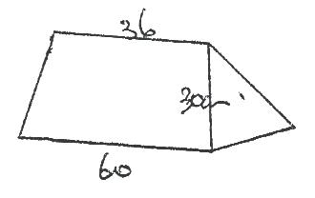  Area of the original material  = ½ h (a + b)  ½ x 30 (60 + 36)  =1440cm².  Cut out area  2015Q15
81. | Volume = (Lengths)³  Length = $\sqrt{1728}$  Lengths =12  X²= 12² + 12 ²  X=$\sqrt{288}$  X=16.970562  X=16.97  2015Q3

MARKING SCHEMES
ALGEBRAIC EXPRESSIONS

NO | SOLUTION | MKS
1. | a² -3ab -12ab + 36b²  a(a – 3b) – 12b(a-3b)  (a -12b) (a-3b)  1989Q2 | 2M
2. | $\frac{\left(6a+b-7\right)\left(a+b\right)}{2\left(a^{2}-b^{2}\right)}$  $\frac{a\left(6a-6b\right)\left(a+b\right)}{2\left(a-b\right) \left(a+b\right)}$  $\frac{6\left(a-b\right)}{2\left(a-b\right)}$  = $3$  1990Q3 | 3M
3. | $\frac{a\left(a-b\right)\left(a+b\right)}{2\left(a+b\right) \left(a-b\right)}$  $\frac{a^{2}-ba+ba+b^{2}}{\left(2a+2b\right) \left(a-b\right)}$  $\frac{a^{2}+ b^{2}}{2a^{2}- 2ab+2ab-2b^{2}}$  $\frac{a^{2}+ b^{2}}{2a^{2}- 2b^{2}}$  $\frac{a^{2}+ b^{2}}{2\left(a^{2}- b^{2}\right)}$  1991Q8 | 3M
4. | Ac = ${\left(\frac{b}{2}\right)}^{2}$  25d =${\left(\frac{-70}{2}\right)}^{2}$  25d =1225  25 25  d=49  1992Q6 | 3M
5. | 2x²y² – 8xy + 3xy -12  2xy (xy -4) + 3(xy -4)  (xy-4) (2xy + 3 )  1993Q1 | 3M
6. | $\frac{\left(x-2\right)\left(x-2\right)-\left(2x+20\right)}{\left(x+2\right) \left(x-2\right)}$  $\frac{x^{2}-4x+4+2x-20}{\left(x+2\right) \left(x-2\right)}$  $\frac{x^{2}-6x-16}{\left(x+2\right) \left(x-2\right)}$  $\frac{x^{2}-8x+2x-16}{\left(x+2\right) \left(x-2\right)}$  $\frac{x\left(x-b\right)=2 2\left(x-8\right)}{\left(x+2\right) \left(x-2\right)}$  $\frac{\left(x+2\right) \left(x-8\right)}{\left(x+2\right) \left(x-2\right)}$  = $\frac{x-8}{x-2}$  1993Q14 | 4M
7. | 28x² + 7x -4x -1  7x (4x + 1) -1(4x + 1)  (4x + 1)(7x -1)  1994Q2 | 2M
8. | $\left(\frac{2x-2}{6x^{2}- 9x+8x-12}\right)$ ÷ $\left(\frac{x-1}{2x-3}\right)$  $\left(\frac{2x-2}{3x \left(2x-3\right)+ 4 \left(2x-3\right)}\right)$ ÷ $\left(\frac{x-1}{2x-3}\right)$  $\left(\frac{2x-2}{ \left(3x+4\right) \left(2x-3\right)}\right)$ $÷$ $\frac{x-1}{2x-3}$  = $\frac{2}{3X+4}$  1995Q2 | 3M
9. | $\frac{\left({3x}^{2}-1\right)- \left(2x-1\right) \left(x-1\right)}{\left(x-1\right) \left(x+1\right) }$  $\frac{\left({3x}^{2}-1\right)- \left({2x}^{2}-2x+1x-1\right) }{\left(x-1\right) \left(x+1\right) }$  $\frac{{3x}^{2}-1+2x+16}{\left(x-1\right) \left(x+1\right)}$  $\frac{x^{2}+ x}{ (x -1 ) (x + 1)}$ = $\frac{x\left( x+1\right)}{ (x -1 ) (x + 1)}$  = $\frac{x}{x-1}$  1995Q8 | 3M
10 | 3x² – 3xy + xy – y²  3x (x-y) + y (x-y)  (x-y) (3x+y)  1996Q2 | M1  A1
11. | G.C.F= xy^{2√}  xy²(x²-4y²)√  xy²(x-2y)(x+2y)√  1997Q2 | B1  B1  B1  3 M
12. | (a + b) (a – b)  (2557 + 2547) (2557 -2547)  5104 x 10 = 51040  1998Q2 | B1  M1  A1
13 | b). 5a -4b-2 $\left[a-(2b+c)\right]$  =5a – 4b – 2a + 4b +2c  =3a + 2c  1999Q1b | M1  A1  4M
14. | (x+y)² + (y-x)²-2(x-y)(x+y)  =x² +2xy+y²+y²-2xy+x²+2x²+2y²  =2x²+2y²-2x²+2y²  =4y²  =2²(2-a)²  1999Q15 | M1  M1  A1  3M
15. | a). i). (x+y)² =x²+2xy + y²  =x² + 2xy + y²  3² = x²+2xy+y²=9  ii). 2xy=9-(x²+y²)  = 9-29  = -20  iii). (x-y)²=x²+y²-2xy  =29 - (-20)  =49  iv). x-y = + √49  = + 7 0r – 7  b). x + y = 3 x + y =3  x-y = 7 x – y = -7  2x = 10 2x -4  x = 5 x = -2  y = -2 y= 5  1999Q21 | B1  B1  B1  B1  B1  B1  B1  B1  8 M
16. | $\frac{\left(3a+b\right) \left(a+b\right)}{\left(4a-b\right) \left(a+b\right)}$  $=\frac{3a+b}{4a-b}$  2000Q2
17. | $\frac{\left(3x-y\right) \left(x-y\right)}{\left(3x-y\right) \left(3x-y\right)}$  $=\frac{x-y}{3x+y}$  2001Q6 | M1  M1  A1  3M
18. | Either (x² + 4y² + 4xy) –  (x²+ 4xy –4y)  = 4xy + 4xy  = 8xy  2002Q2 | B1  B1  A1  3M
19. | 4x² –y²=(2x+y) (2x-y)  2x²-7xy+3y² =(x-3y) (2x-y)  $\frac{\left(2x+y\right) \left(2x-y\right)}{\left(x-3y\right) \left(2x-y\right)}$  $=\frac{2x+y}{x-3y}$  2002Q11 | M1  M1  A1  3 M
20. | ={ (a+¹/_{b} ) – (a-¹/_{b}) – (a+¹/_{b}) + (a+¹/_{b})}  (a²+2ª/_{b}+¹/_{b}²) – (a² +2ª/_{b} + ¹/_{b}²)  = (²/_{b}) (2a)  = 4ª/_{b}  2003Q2 | M1  M1  A1  3 M
21. | (2a+b)(a-2b)  (2a+b)(2a-b)  a-2b  2a-b  2004Q3 | M1  M1  A1  3 M
22. | $\frac{{9t}^{2}-{25a}^{2}}{{6t}^{2}+19at+{15a}^{2}}$  $\frac{{\left(3t\right)}^{2}-{\left(5a\right)}^{2}}{{6t}^{2}+9at+10at+{15a}^{2}}$  $=\frac{\left(3t+5a\right) \left(3t-5a\right)}{\left(3t+5\right) \left(2t+3a\right)}=\frac{3t-5a}{2t+3a}$  2005Q4 | B1  M1  A1  3 M
23. | $\frac{\left(p+q\right) \left(p+q\right)}{p\left(p^{2}-q^{2}\right)+ q\left(p^{2}-q^{2}\right)}$  $=\frac{\left(p+q\right) \left(p+q\right)}{\left(p+q\right) \left(p+q\right) \left(p_q\right)}$  = $\frac{1}{p-q}$  2006Q3 | M1  M1  M1  A1  4 M
24. | (x²-y²)(x²+y²)(x⁴-y⁴)  =x⁴-y⁴) (x⁴-y⁴)  =x⁸-2x⁴y⁴+y⁸  2007Q3 | A1  M1  2 M
25. | $\frac{{15a}^{2}b-{10ab}^{2}}{{3a}^{2}-5ab+{2b}^{2}}$ = $\frac{5ab\left(3a-b\right)}{\left(3a-2b\right) \left(a-b\right)}$  $=\frac{5ab}{a-b}$  2007Q6 | M1  M1  A1  3 M
26. | $\frac{a^{4}-b^{4}}{a^{3}-{ab}^{2}}$ = $\frac{\left(a^{2}+b^{2}\right) \left(a^{2}-b^{2}\right)}{a\left(a^{2}-b^{2}\right)}$  $=\frac{a^{2}+b^{2}}{a}$  2008Q3 | M1  M1  A1  3 M
27. | $\frac{{12x}^{2}+ax-{6a}^{2}}{{9x}^{2}-{4a}^{2}}$  $\frac{\left(4x+3a\right) \left(3x-2a\right)}{\left(3x+2a\right) \left(3x-2a\right)}$  $=\frac{4x+3a}{3x+2a}$  2009Q8 | M1  M1  A1  3 M
28. | - $\frac{1}{y}$ | M1  M1  A1 3
29. | $\frac{4x-{9x}^{3}}{{3x}^{2}-4x-4}$ = $\frac{x\left(2-3x\right) \left(2+3x\right)}{\left(3x+2\right) \left(x-2\right)}$  $\frac{x\left(2-3x\right)}{x-2}$  2011Q6 | M1  M1  A1  3
30. | 2x²y² – 5xy -12  =2x²y² – 8xy +3xy -12  = 2xy (xy-4) + 3(xy -4)  = (2xy + 3) (xy – 4)  2011Q8 | M1  A1  2
31. | (2x² – 3y³)² + 12x²y³  = 4x⁴ – 12x2y³ + 9y⁶ + 12x²y³  = 4x⁴ + 9y⁶  2012 Q3 | M1  A1  2
32. | $$\frac{4m-3n}{m-n}$$  2013 Q4
33. | $${\left(x+2y\right)}^{2}- {\left(2y-3\right)}^{2}$$  = $\left(x^{2}+4xy+ {4y}^{2}\right)-\left({4y}^{2}-12y+9\right)$  (Expansion of both and a subtraction sign)  = $x^{2}+4xy+12y-9$  2014Q8 | M1  A1
34. | a )Bodmas  $\frac{726450}{3}$ = 2421  540396  -242150  298246  b)  8x1000  =8000  2015Q1

LINEAR INEQUALITIES-MARKING SCHEME

1. | 2 ≤ 3 - x 3 – x <5  -1 ≤ -x -x<2  1 ≥ x x >2  -2 < x ≤ 1 or 1 ≥ x > -2  1999Q2 | B1  2 M
2. | 4-2x < 4x – 9 13 < 6x  13< x  6  4x - 9 < x + 11 3x < 20  x < 20  3  Integral value of x  = (3, 4, 5, 6)  2000Q 6 | M1  B1  B1  3 M
3. | 2001Q16 | B1 B1  B1 B1  4 M
4 | -2x < 5-3 4 + 8 ≥ 3x  -2x < 2 12 ≥ 3x  x > -1 4 ≥ x  2002Q8 | B1 B1  A1  3M
5. | x+y≤440  y≥120  x ≥150  2003Q12 | B1  B1 B1  3 M
6. | y>x  y<-x+4  7<3x+3  2004 Q15
7. | 3-2x < x  3<3x  1<x  x ≤ 2x+5  3x<2x+5  3x-2x<5 or x<5 1 < x ≤ 5  2006Q5 | M1  M1  A1  3 M
8. | Let odd integers to:  x, (x + 2), (x + 2 + 2)  x + (x + 2) + (x + 2 + 2) > 219  The numbers are 73, 75, 77  3x > 213  x = 71  2010Q5 | M1  A1  B1 3
9. | (a) 2x – 5 > -11  x >-3  3 + 2x ≤ 13  x ≤ 5  Combined -3 <x ≤ 5  (b) -2, -1, 0 ,1, 2, 3, 4,5  2011Q4 | B1  B1  B1  B1  4
10 | - 1.5 $≤x<$ 5  2013 Q16
11 | =$4≤3x-2 <9+x$  = $4≤3x-2$ $3x-2 <9+x$  =$6≤3x$ $2x <11$  = $x ≥2$ $x <5\frac{1}{2}$  = $2≤x<5\frac{1}{2}$  Integral values: 2,3,4,5  2014Q12 | M1  A1  B1

LINEAR MOTION – MARKING SCHEME

1. | (a)44.25km/h  (b) 244.69km  1989Q21 | 8M
2. | D = S X T  = 16 x ½ =8km  40km – 8km =32  t = $\frac{x}{16}$ = $\frac{32-x }{8}$  8x = 16(32 – x)  8x =512 – 16x  24x = 512  x = 21¹/₃km  t = $\frac{64}{3}$ ÷ 16  = $\frac{64}{3}$ x $\frac{1}{16}$ = $\frac{4}{3}$  Time taken = 1hr 20min  8.00 + 1.20  = 9.20am 1991Q5 | 4M
3. | U = 20m/s  A =2m/s2  T = 5  Area = ½ x 5 (20 +30) + ½ x 30 x 4  = ⁵/₂ x 50 + 30 x 2  = 125 + 60  =185m  1992Q14 | 3M
4. | 120km/h 1992Q2 | 3M
5. | Let the distance covered by Ondiek be x km  Distance covered by Ogot = x-5 in time t  T =x -5 = x  5 10  10x – 50 = 8x  2x = 50  x= 25m  1993Q9 | 3M
6. | 182km  1995Q16 | 3M
7 | Let speed of B be x km/h  And “ “A be (x + 5)km/h  Time for A = $\frac{3120}{x+5}$ hours  Time for B = $\frac{3120}{x}$ hours  = $\frac{3120}{x}$ - 4 =$\frac{3120}{x+5}$  3120(x + 5) -4x(x+15 ) = 3120x  3120x + 15600 – 4x² – 20x  = 3120x  3120x + 15600 – 4x² – 20x  = 3120x  4x² + 20x – 15600=0  x² + 5x – 3900 = 0  (x – 60) (x + 65) = 0  x= 60km/h  1996Q16 | 3M
8. | a). 300 km/h  t  b). speed of the bus = 500  t-1  500 :300 = 5: 3  t-1 t–1  1997Q14 | B1  B1  A1  3 Marks
9. | Speed of slower athlete = 800  108  Distance = 800 x 4  108  = 29.63m  1997Q15 | M1  A1
10. | A  72 P N 72 M 9.1 KM B  Distance covered by bus A at 10a.m  = 90 x 2 = 180km  Bus B Time between 2stops  =72 = 1.2hrs (1hr 12min)  Bus B leaves L at 9.17a.m  Distance between 9.17 – 100a.m  60 x $\frac{43}{60}$ = 43km  At 10a.m bus Bhas covered  (72 + 43) = 115km  Distance between bus A and B at 10a.m  = 360 – (180 + 115) = 65 km  1999Q9 | B1  B1  B1  8M
11. | Let dist. Covered by be x km  X = 220 – x + ¾  60 80  4x = 3(220 – x ) + 3 x 60  4x = 3(220 – x ) + 3 x 60  4x = 660 – 3x + 180  4x = 660 – 3x + 180  7x = 840  x = 120km  Dist. bus covered  1.25 x 60 + 45  1999Q9 | M1  M1  M1  A1  4 M
12. | distance covered  = 15x ¹²/₆₀  = 15km  Distance covered by taxi  = x – 15 = x  75 95  x = 95 x 15  20 x = 71.25km  2000Q2 | B1  M1  A1  3 M
13. | Let x be speed of zebra  3.5x = 1.5 (x+20) + 340  3.5x = 1.5x + 30 + 340  2x = 370  X=185km/h  Buffalo’s speed is 185+20 =205km/h  2001Q15 | M1  M1  A1  3 M
14. | a). 72km/h = 72 x 100m  60 x 605  = 20m/s  b)Let 1 be length of train  1 + 80 = 15  20 1 = 300 – 80  = 220m  2003Q6 | B1  M1  A1  3 M
15. | Distance = 72+78 =150m  Speed =108 +72 =180km/h  Time = 150 x 60 x 60  180 x 1000  =3 sec  2004Q4 | M1  M1  A1  3 M
16. | The speed of the car is (x+20)km/h  Time taken by the car = ²⁸⁰/_{x} hrs  Time taken by the car = ⁷⁸⁰/_{x-20} hrs  ²⁸⁰/_{x}-²⁸⁰/_{x}+20 = ⁷/₆  280(x+20)-280x = ⁷/₆  x (x+20)  7x²+140x=33600  x²+20x-4800=0  x²-60x+80x-4800=0  x(x-60)+80(x-60)=0  (x-60)(x+80)=0  x=80 or x=60km/h  b). time taken by the lorry = 12.15  = 4 hrs  Distance covered by lorry = speed x time  = 60 x 4  = 240km  Time taken by the car = distance  time  = 240  100 = 2.4 hrs  Time left town M = 12.15-2 hrs 24 minutes  = 9.51p.m 2005Q17 | B1  M1  M1  A1  A1
17. | a). i). Distance of bus from Nairobi  560-2.5 x 60  = 350km  ii). Let distance be xkm  for bus x=150+60t  for car x = 100t  100t =150+60t  T = ³/_{h}  = 375km  b). Yet to be covered  500-375 = 125km  Time bus takes  = ¹²⁵/₆₀  2hrs 15 minutes 125 or 125minutes  New speed of car  - 125 = 100  125 – 25 x 10  60 x = 75km/hr  Or  Distance from Nairobi  500 -60 x 25  = 350km  Relative velocity 100 -60  =40km/hr  Time car takes to reach bus  ¹⁵⁰/₄₀ = 3 ¾ h  Distance covered  ³ ⁹/₄ x 100 = 375km  b). Time taken by car for remaining  distance 25min -2hrs 5 minutes  Average speed  125  1 ^{2/}₃ =75km/hr  2006Q20 | M1  A1  B1  M1  M1  A1  B1  B1  M1  A1  10 M  M1  A1  B1  M1  A1  B1  M1  A1
18. | Amount of fuel used = ¹²⁰/₄ x ⁸/₃  = 50litres  Amount of money spent = 80 x 59  = 4720  2007Q16 | M1  M1  A1  3 M
19. | a).  2.5  y  x  b). i). x²+y² =2.5x  ^{y}/_{2.4} = ^{x}/_{3.2}  ii). y = ³/_{4x}  x² + (³/_{4x})² = 2.5²  16x² + 9x² = 6.25 x 16  x² = 6.25 x 16  25  x = 2km  y = ¾ x 2 = 1.5 km  iii). Time taken = ²/_{3.2} or ^{1.5}/_{2.4}  = 0.625hours  2008Q21 | B1  B1  B1  M1  M1  M1  M1  A1  B1  M1  A1  10 M
20. | Distance covered by bus  = 63 x(10.45-8.15)  = 63 x 2.5  = 157.5  Speed of car = 157.5  1.75  = 90 km/h  2009Q4 | M1  M1  A1  3 M
21. | a). ½ x 150h x ½ x 200h+300h  =10450  4754h = 10450  h = 22 m/s  Maximum speed = 22 x 60 x 60  1000  = 79.2km/h  b). Acceleration = 22 m/s  150  = 11  75m/s²  c). ½ x 100 x 11  = 550m  d). Time for half of journey  ½ x 22 (150+t + t) = ½ x 10450  T = 162.5  Total time = 150 + 162.5  = 312.5sec  2009Q21 | M1  A1  B1  M1  A1  M1  A1  M1  A1  B1  10 M
22. | Let the distance be d km  d/75 and d/95  .: Time taken = 25/20 = 11/4 hr  .: d/75 - d/45 = 20/60  = 118.75  d = 118.75 km  2010Q4 | M1  M1  A1  A1
23. | Let d be distance  3d - d = d  5 2 10  % change  = 10 x 100%  d  = d x 2 x 100  10 d  = 20%  2011Q3 | M1  M1  A1  3
24. | (a) (i) let the distance covered by bus be b km  Therefore; time by train = $\frac{700-b}{50}$  Time by bus = $\frac{b}{75}$  $\frac{700-b}{50}$ + $\frac{b}{75}$ = 11¹/₂ – ½  2100 -36 + 2b = 11  150  2100 – b = 11 x 150  b = 2100 – 1650  b = 450  (ii) Time taken by the train  = 700 – 450  50  = 5hours  Total time before departure of bus  = 5hours + 30min  Departure time for the bus:  = 8.00 + 5 hrs + 30 min  = 1.30p.m  (b) time the bus took before departure  = 187.5  75  Time needed to cover the remaining part of  the journey:  = 11¹/₂ – (5¹/₂ + 2¹/₂ + ¼)  = 3¹/₄ hrs  2011Q18 | M1  M1  M1  A1  M1  M1  A1  M1  M1  A1  10
25. | $\frac{x}{8} = \frac{x}{20} +\frac{1}{4}$  $\frac{x}{8} - \frac{x}{20} =\frac{1}{4}$  $x=3\frac{1}{3}$  Distance to shopping centre  $12-3\frac{1}{3}=8\frac{2}{3}km$  2012Q7 | M1  M1  A1  3
26 | - 6m/s  - 3m/s$±$ 0.1  2012 Q13
27 | - (i) 44km  (ii) 11.06 a.m  - 58.67 km/h 2013 Q20
28. | - 15m/s  - Maximum speed  $$\frac{1}{2}\left(15+h\right)×10+\frac{1}{2}\left(10+30\right)h=825$$  $$75+5h+20h=825$$  $25h=750$  $h=30m/s$  - (i) = $\frac{30-15}{10}$  = 1.5m/s²  (ii) = $\frac{0-30}{20}$ = $-$1.5m/s²  - $\left[\frac{1}{5}\left(15+30\right)×10+10×30\right]$ $÷20$  = $\left(225+300\right)÷20$  =26.25 m/s  2014Q19 | B1  M1  M1  A1  M1  A1  B1  M1  M1  A1
29. | 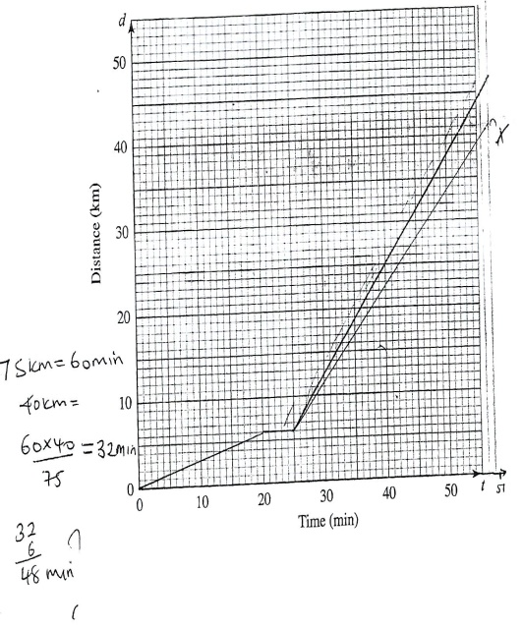  2015Q16

STATISTICS I – MARKING SCHEME

1. | Mean = $\frac{\sum{fx}}{\sum{f}}$ = $\frac{255}{40}$ = 6.375  Size (x) f fx  4 5 6 7 8 9 1 14 18 14 2 1 4 20 108 98 16 9  Σ 40 255  1990Q2 | 2M
2. | Median = L + $\frac{\frac{N}{2}-c.f}{f}$ x i  41.5 + $\frac{\frac{60}{2}-18}{15}$ x 3 =43.9cm  L Height f c.f  41.5 33-35 36-38 39-41 42-44 45-47 48-50 51-53 54-56 1 3 14 15 16 8 2 1 1 4 18 33 49 57 59 60  Σ 60  1991Q6 | 3M
3. | (15x19) – (10+22+16+18+17+21+18+20+17  +18+19+20+20+19+21)  285 – 266  19years 1993Q4 | 3M
4. | Median = L + $\frac{\frac{N}{2}-c.f}{f}$ x i  = 7.5 + $\frac{\frac{39}{2}-15}{8}$ x 4 = 9.75  1995Q3 | 2M
5. | (a) Mode = 934  (b) Assumed mean = 925  (c) Mean=930.75  1997 Q8
6. | (a) cumulative frequency  3, 11, 30, 44, 50  (b) median= L + $\frac{\frac{N}{2}-c.f}{f}$ $×$ i  = 8 + $\frac{\frac{50}{2}-11}{19}$ $×$ 4  = 10.94736  = 10.95 (4 s.f)  1998Q12 | 3M
7. | No. of people = ³⁶⁰/₁₄₄ x 1080 = 2700  No. of children  = 2700 - (510 + 1080)  1110  L of children 1110 x 360  2700  = 148⁰ 1999Q13 | M1  M1  A1
8. | class x<5 x<15 x<25 x<45 x<75  5 14 20.5 29.5 17.5 2.5  10 28 41 29 35 5  H.f.w. 2.8 4.1 5.9 3.5 0.5  Mean of x = $\frac{\sum{fx}}{\sum{f}}$  = $\frac{4975}{199}$ = 25 yrs  1999Q19 | M1
9. | a) Modal class is 150 – 154  b)  C.F 3 18 37 48 50  Median = 149.5 + 7 x 5  19  = 151.34  2000Q4 | B1  M1  A1
10. | 2000Q16
11. | a) Mode = 1  b) Mean  = 0.5+ 1x6+2x4+3x3+4x1+5x1  20  = 1.6  2003Q3 | B1  M1  A1  3 M
12. | Area A= 5x3.2  B = 10 x 1.2  16:12 = f:6  12f = 96  F = 8  2006Q15 | M1  M1  A1  3 M
13. | a). i).  Marks 0-10 10-30 30-60 60-70 70-100  Frequency 12 40 36 8 24  Area of rectangle 60 200 180 40 120  Height of rectangle 6 10 6 4 4  ii)  b). i). Median in group 30-60  ii). 60 + 200 + 6x  = ½ (60+200+180+40=120)  260 + 6x = 300  x = 6 ²/₃  Median = 30 + 6 ²/₃  = 36 ²/₃ 2007Q19 | A1  M1  M1  A1  4M  M1  A1  2 M  M1  M1  A1  3 M
14. | Check height  1.5 – 5.5 – 4  5.5 – 7.5 – 10  7.5 – 13.5 – 3  13.5 -15.5 – 7 given  2009Q16
15. | a). i). Modal class 60-69  ii). Class where median mark lies  0-9 ……………….1  10-19 ……………….3 median is 35  20-29………………..7 median class  30-39………………..14 50 - 59  40-49………………..24  50-59………………..40  60-69………………..60  70-79………………..66  80-89………………..69  90-99………………..70  Class Centres x Fd D=x-A  0 -9 4.5 -49.9 -49.9  10-20 14.5 -79.8 -39.9  20-29 24.5 -79.8 -39.9  30-39 34.5 -139.3 -19.9  40-49 44.5 -99.0 -9.9  50-59 54.5 1.6 0.1  60-69 64.5 20.2 10.1  70-79 74.5 120.6 20.1  80-89 84.5 90.3 30.1  90-100 94.5 40.1 40.1  2009Q18 | B1  B1  B1  B1  M1  B1  B1  A1  M1  A1  10 marks
16. | Total number of seedlings  (5x1) + (10 x3) +(15x1) + (20x4) + (30x1) + 10x2)  = 5+30+15+80+30+20 = 180  % of height (h) : 23 ≤ h < 27  $=\left(\frac{30+15}{180}\right)$ x 100  = 25%  2010Q16
17. | a) Modal frequency = 8  no of kg Freq. mid pts Fx Cf  of meat (f) (x)  1 - 5 2 3 6 2  6 - 10 3 8 24 5  11 –15 6 13 78 11  16-20 8 18 144 19  21-25 3 23 69 22  26-30 2 28 56 24  31 –35 1 33 33 25  Σf =25 Σfx = 410  Mean = 410/25  Lc + cf = 16.4  Median = 15.5 + 12.5 - 11 x 5  8  = 16.4375  c) 2,5,11,19,22,24,25  Median = 15.5 + 2/8 x 5  = 16.75  2010Q23 | B1  M1  M1  A1  B1  B1  A1
18. | Midpoints:  42, 47, 52, 57, 62, 67, 72.  fx = 42, 94, 624, 570, 124, 134, 72  $\overline{x }$ = $\frac{\sum{fx}}{\sum{f}}$ = $\frac{1660}{30}$ = 55$\frac{1}{3}$ kg  2011 Q10
19. | f 160 120 380 240 100  c 50 50 100 100 200  f/c 3.2 2.4 3.8 2.4 0.5
20. | (a) Modal class 40-44  (b)  - Midpoints  22,27,32,37,42,52,57  22 x 2 + 27 x 15 + 32 x 18 + 37 x 25 +  101  42 x 30 + 47 x6 + 52 x3 + 57 x2  101  = 37.25  - Cumulative frequencies  2,17,35,60,90,96,99,101  16 x 5  25 = 3.2  34.5 + 3.2  = 37.7  Difference 37.7 – 37.25  = 0.45 | B1  B1  M1  M1  A1  B1  M1  M1  A1  B1  10
21 | Mean = a + $\frac{\sum{fx}}{\sum{f}}$  = 96 + $\frac{38}{20}$ = 97.9kg  2012 Q8
22 | - 22  - 20.5  2013 Q2
23 | (a)  Class 3-5 6-8 9-11 12-14 15-17 18-20  Freq 3 8 13 10 4 2  (b) (i) Mean length = $\frac{\sum{fx}}{\sum{f}}$  = $\frac{4 × 3+7 ×8+10 ×13+13 ×10+16 ×4+19 ×2}{40}$  = 10.75  (ii) = $\frac{23}{40} ×100$  = $57.5\%$  (c)  2014Q18 | B1  B1  B1  M1  A1  B1  B1  S1  P1  C1
24 | Marks Frequency c.f  1 - 10 2 2  11 – 20 4 6  21 – 30 11 17  31 – 40 5 22  41 - 50 3 25  Median  $20.5 + \left(\frac{25}{2}-6\right)×\frac{10}{11}$  20.5 + 5.9  = 26  Amplitude = 2  Period = $\frac{360}{3}={120}^{0}$  2014Q5 | B1  M1  M1  A1  4  B1  B1  2
25. | Marks 30-34 35-39 40-44 45-49  No. of students 3 6 5 12  Marks 50-54 55-59 60-64 65-69  No. of students 8 9 7  Mid points 27 32 42 47 52 57 62 67  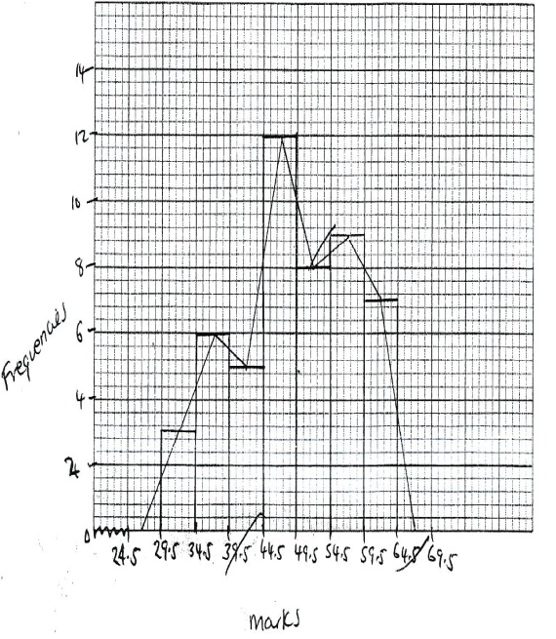  2005Q10

VECTORS (I) – MARKING SCHEME
1. | DE = $\frac{2}{3}$p - $\frac{4}{15}$q  1989Q11
2. | EC = eb + ba + ac  = $-\frac{4}{3}p+ \frac{2}{3}q$ + -2p + q  = $\frac{4}{3}p- \frac{2}{3}q$ - 2p + q  = $\frac{1}{3}q- \frac{2}{3}q$  1990Q8
3. | $\left(\begin{matrix}10 \\ 3\end{matrix}\right)$ - $\left(\begin{matrix}-4 \\ 10\end{matrix}\right)$ =$\left(\begin{matrix}14 \\ -7\end{matrix}\right)$  $\frac{5}{7}$ $\left(\begin{matrix}14 \\ -7\end{matrix}\right)$ = $\left(\begin{matrix}10 \\ -5\end{matrix}\right)$  $\left(\begin{matrix}-4 \\ 10\end{matrix}\right)$ + $\left(\begin{matrix}10 \\ -5\end{matrix}\right)$ =$\left(\begin{matrix}6 \\ 5\end{matrix}\right)$  T (6,5)  1990Q10
4. | CA = -c + a  MA = ½ (-c + a)  MT = MA + AT  -¹/₂c + ¹/₂a + ³/₂c  = $\frac{1}{2}$ a + c  1991Q6
5. | C(0, y)  B(4,3)  N  O(0, 0)  A(2,-1)  1992Q24
6. | 3a B  C D  E  O A  OE =$\frac{1}{2}$ OD, therefore OE is parallel to OD  O is a common point, points O, E, D are collinear  1993Q21
7. | CX = CA + AX  = b + ¼(-b + a)  = b – ¹/₄b + ¹/₄a  = $\frac{3}{4}$b + $\frac{1}{4}$a  1993Q16
8. | CD = - $\frac{3}{4}$ a + $\frac{3}{4}$b  AB = - a + b  - $\frac{3}{4}$ a + $\frac{3}{4}$b = kb –ka  Kb = $\frac{3}{4}$ b k =$\frac{3}{4}$  CD = $\frac{3}{4}$ AB  1994Q10
9. | Let O be the point of intersection of the diagonals, DC = a and DA = b.  Express DO in two different ways using two constants, say m and n  Prove that m = n = $\frac{1}{2}$ , hence DO = $\frac{1}{2}$DB, and AO = $\frac{1}{2}$ AC. This shows that O bisects DB as well as AC!  1994Q15
10. | (a) (i) AV = a + c  (ii) BV = a – b + c  (b) (i)BM = $\frac{5}{7}$a - $\frac{5}{7}$b + $\frac{3}{7}$c  1995Q18
11 | i). AQ : QC = 4:3 allow 8: 6  ii). QC = ³/₇ x 14  = 6cm  1997Q11 | B1  B1
12. | 3v – u = w + v  2u = w + v  1998Q9 | M1  A1  2mks
13. | a). i). AB=b-a  ii). AP= ³/₈ (b-a)  iii). BP = ⁵/₈ (a-b)  iv). OP=OA + AP or OB + BP  = a = ⁵/₅ (b-a)  = ⁵/₈a + ⁵/₈b  OQ: OP  =³/₈a + ⁹/₄₀b :⁵/₈a +³/₈b  = ³/₈(a + ³/₅b) : ⁵/₈ (a+³/₅b)  = 3;5  OQ:QP=3:2  b). OQ=a – ⁵/₈a + ⁹/₄₀b  ³/₈a + ⁹/₄₀b  OQ + k OP  = K(⁵/₈a + ³/₈b)  ⁵/₈a + ⁹/₄₀b  = K(³/₈ba+³/₈b)  3(⁵/₄₀a + ³/₄₀b)= 5K (⁵/₄₀a+ ³/₄₀b)  3 = 5k  OQ:QP=3:2  1999Q21 | B1  B1  B1  MA  A1  M1  M1  A1  8 Marks
14. | QP $\left(\begin{matrix}-8 \\ -2\end{matrix}\right)$  $\frac{1}{2}$QR = $\frac{1}{2}$ $\left(\begin{matrix}-3 \\ -4\end{matrix}\right)$ = $\left(\begin{matrix}\frac{1}{2} \\ -2\end{matrix}\right)$  QT = $\left(\begin{matrix}-8 \\ -2\end{matrix}\right)$ + $\left(\begin{matrix}-1.5 \\ -0.5\end{matrix}\right)$ $\left(\begin{matrix}-9.5 \\ -4\end{matrix}\right)$  Coordinates of T = ( -9 ½ , -4)  2002Q10 | B1  B1  B1  3 marks
15 | a). AB=DC  4 2 = 1 X  0 -4 6 Y  X = 1 -2  Y 5 4  D (-1,2)  b). i). PR = 3q -1p –p  2 2  = 3q -3p  2 2  ii). RQ = q -3q + 1p  2 2  = -1q+1p  2 2  PR = 3(9-P)  2  Rq = - ½ (q-p)  PR = 3 QR  PR // QR is a common point  Hence P.Q.R are collinear  iii). PQ = q-p  QR = 1q-1p  2 2  In PQ, OR = 2 : 1  2004Q21 | M1  M1  A1  B1  B1  B1  B1  B1  5 marks
16.  P  Q  O  2  R  S | a). PS = -PO + OS  = 2p+3r  = 3r-2p  OT = ¹/₇OS + ⁶/₇OP  = ¹/₇ x 3r + ⁶/₇ x2P  = ³/₇r + ¹²/₇p  QT = QP+ PT  = ⁻¹/₃(3p) + ¹/₇(3r-2p)  = -³/₇r ⁻⁹/₇p  b). QT = ³/₇r⁻⁹/₇p  QR = r-3p  Q R= QT if QR = KQT  r -3p = K(³/₂r⁻⁹/₇p)  r=³/₇kr  k = 7/3  also -3p=⁻⁹/₇pk  k = ⁷/₃  2005Q18 | M1  A1  A1  M1
17. | a). p(-2,3) p¹ (10,10)  10 – 2  10 – 3  = $\left(\begin{matrix}12 \\ 7\end{matrix}\right)$  Q¹ = (1+12, 3+ 7)  = (13, 10)  b). m $\left(\begin{matrix}-2 \\ 3\end{matrix}\right)$ - n $\left(\begin{matrix}1 \\ 3\end{matrix}\right)$ = $\left(-\begin{matrix}12 \\ 9\end{matrix}\right)$  -2m-n=-12  3m -3n = 9  m = n+3  2(n+3)+n = 12 3n = 6 m=5  n = 2  2006Q12 | M1  M1  A1  B1  M1  A1
18. | a). OL = 3 $\left(\begin{matrix}1 \\ 6\end{matrix}\right)$ = $\left(\begin{matrix}3 \\ 18\end{matrix}\right)$  ON = $\frac{2}{3}\left(\begin{matrix}15 \\ 6\end{matrix}\right)$ = $\left(\begin{matrix}10 \\ 4\end{matrix}\right)$  LN = ON – OL  = $\left(\begin{matrix}10 \\ 4\end{matrix}\right)-\left(\begin{matrix}3 \\ 18\end{matrix}\right)$=$\left(\begin{matrix}7 \\ -14\end{matrix}\right)$  b). OM = OL + ³/₇ LN  = $\left(\begin{matrix}3 \\ 18\end{matrix}\right)$ + $\left(\begin{matrix}3 \\ 7\end{matrix}\right)$ $\left(\begin{matrix}7 \\ -14\end{matrix}\right)$  $\left(\begin{matrix}3 \\ 18\end{matrix}\right)$ + $\left(\begin{matrix}3 \\ -6\end{matrix}\right)$ = $\left(\begin{matrix}6 \\ 12\end{matrix}\right)$  = M (6,12)  c). i). OT = ⁷/₆ $\left(\begin{matrix}6 \\ 12\end{matrix}\right)$ = $\left(\begin{matrix}7 \\ 14\end{matrix}\right)$  1  ii). LT =$\left(\begin{matrix}7 \\ 14\end{matrix}\right)$ $-$ $\left(\begin{matrix}3 \\ 18\end{matrix}\right)$ = $\left(\begin{matrix}4 \\ -4\end{matrix}\right)$  LB = $\left(\begin{matrix}15 \\ 6\end{matrix}\right)$ $-$ $\left(\begin{matrix}3 \\ 18\end{matrix}\right)$  = $\left(\begin{matrix}12 \\ -12\end{matrix}\right)$  LB = 3 LT  L is common point  2006Q22 | B1  B1  B1  M1  A1  B1  B1  B1  B1  B1  10 marks
19. | AB = 8 3 5  -6 -1 -5  6 -4 10  OP = 0A + AP  = 3 5  -1 + ²/₅ -5  -4 10  = 5  -3  0  2008Q4 | M1  M1  A1  3 marks
20. | a). i). ON = ½ $\left(\begin{matrix}-8 \\ 5\end{matrix}\right)$ = $\left(\begin{matrix}-4 \\ 2.5\end{matrix}\right)$  N is (-4, 2.5)  M = $\left(\frac{-8+12}{2} ,\frac{5-5}{2}\right)$  M is (2,0)  ii). NM = $\left(\begin{matrix}6 \\ -2.5\end{matrix}\right)$  /NM/ = $\sqrt{6^{2}+{2.5}^{2}}$  = 6.5  b). OB = $\left(\begin{matrix}12 \\ -5\end{matrix}\right)$ NM = $\left(\begin{matrix}6 \\ -2.5\end{matrix}\right)$  NM = ½ OB  c). OP = $\left(\begin{matrix}2 \\ 0\end{matrix}\right)$+ 2$\left(\begin{matrix}-6 \\ 2.5\end{matrix}\right)=\left(\begin{matrix}-10 \\ 5\end{matrix}\right)$  OP = $\left(\begin{matrix}-10 \\ 5\end{matrix}\right)$+ $\left(\begin{matrix}-5 \\ 8\end{matrix}\right)$ = $\left(\begin{matrix}-15 \\ 13\end{matrix}\right)$  ; P’ is ( -15, 13)  2009Q20 | B1  M1  A1  B1  M1  A1  B1  A1  B1  M1  M1  A1  10 marks
21. | CO = $\frac{1}{3}\left(\begin{matrix}6 \\ -3\end{matrix}\right)$ =$\left(\begin{matrix}2 \\ -1\end{matrix}\right)$ or  OC = $\left(\begin{matrix}2 \\ -1\end{matrix}\right)$  AD = = $\frac{3}{4}\left(\begin{matrix}4 \\ -4\end{matrix}\right)$ = $\left(\begin{matrix}3 \\ -3\end{matrix}\right)$  CD = CO + OA + AD  = $\left(\begin{matrix}2 \\ -1\end{matrix}\right)$ + $\left(\begin{matrix}2 \\ 1\end{matrix}\right)$ + $\left(\begin{matrix}3 \\ -3\end{matrix}\right)$  = $\left(\begin{matrix}3 \\ -1\end{matrix}\right)$  2009Q6 | B1  M1  A1  3 marks
22. | P Q  p  O r R  RQ = -r + P + ¹/₃r  = P ⁻²/₃r  OM = R + ½ (P-²/₃r)  = $\frac{2}{3}$ r + $\frac{1}{2}$ p  2010Q7
23. | PQ = -(6i + j) (-2i +5j)  = -8i + 4j  PN = ¾ (-8i + 4j)  = -6i + 3j  2011Q13 | M1  M1  A1
24. | $\left({3 \atop -2}\right)-\left({2 \atop 3}\right)$  = $\left({1 \atop -5}\right)$  Magnitude = $\sqrt{1^{2}+{\left(-5\right)}^{2}}$  = $\sqrt{26}$≈ 5.1  2012Q9 | M1  M1  A1  3
25. | a)  P=5 $\left(\begin{matrix}3 \\ 2\end{matrix}\right)$ - 2 $\left(\begin{matrix}4 \\ 1\end{matrix}\right)$  =$\left(\begin{matrix}15 \\ 10\end{matrix}\right)$ - $\left(\begin{matrix}8 \\ 2\end{matrix}\right)$ = $\left(\begin{matrix}7 \\ 8\end{matrix}\right)$  b)  $\left(\begin{matrix}7 \\ 8\end{matrix}\right)$ + $\left(\begin{matrix}-6 \\ 4\end{matrix}\right)$ = $\left(\begin{matrix}1 \\ 12\end{matrix}\right)$  P’ (1,12)  No column vector  2015Q11

