**NAME ………………………………………………..…………………………....ADM ……….…CLASS……**

**ANESTAR SCHOOLS**

**END- YEAR EVALUATION TEST**

**FORM ONE**

**GEOGRAPHY**

**TERM 3 2022**

**TIME: 2 HOURS**

1. Define the following terms;
2. Geography – (2 marks)
3. Environment – (2 marks)
4. Identify four reasons for studying Geography. (4mks)

……………………………………………………………………………………………………………………………………………………………………………………………………………………………………………………………………………………………………………………………………………………………………………………………………………………………………………………………………………………………………………………………………………………………………………………………………………………

1. Explain the relationship between Geography and the following disciplines.
2. Economics; ………………………………………………………………………………………………………………………………………………………………………………………………………………………………………………………………(2mks)
3. Medicine; ……………………………………………………………………………………………………………………………………………………………………………………………………………………………………………………….. (2mks)
4. Explain the origin of the earth and the solar system using the passing star theory. (5mks)

**………………………………………………………………………………………………………………………………………………………………………………………………………………………………………………………………………………………………………………………………………………………………………………………………………………………………………………………………………………………………………………………………………………………………………………………………………………………………………………………………………………………………………………………………………………………………………………………………………………………………………………………………………………………………………………………………………………………………………………………………………………………………………………………………………………………………………………………………………………………………………………………………………………………………………………………………………………………………………………………………………………………………………………………………………………………………………………………………………………………………………………………………………………………………………………………………………………………………………………………………………………………………………………………………………………………………………………………….**

1. (i) Give three reasons why the Earth’s interior is hot. (3mks)

………………………………………………………………………………………………………………………………………………………………………………………………………………………………………………………………………………………………………………………………………………………………………………………………………………………………………………

1. Name two types of earth movements. (2mks)

……………………………………………………………………………………………………………………………………………………………………………………………………………………………………………………………………………………………….

1. (i) Describe three proofs that the earth is Spherical. (3mks)

……………………………………………………………………………………………………………………………………………………………………………………………………………………………………………………………………………………………………………………………………………………………………………………………………………………………………………………………………………………………………………………………………………………………………………………………………………………

(ii)What is the effect of International Date Line on time? (2mks)

……………………………………………………………………………………………………………………………………………………………………………………………………………………………………………………………………………………………………………………………………………………………………………………………………………………………….

1. The table below represents rainfall and temperature figures for station in Africa. Use it to answer the following questions.

|  |  |  |  |  |  |  |  |  |  |  |  |  |
| --- | --- | --- | --- | --- | --- | --- | --- | --- | --- | --- | --- | --- |
| Month: | JAN | FEB | MAR | APR | MAY | JUN | JUL | AUG | SEP | OCT | NOV | DEC |
| Temp 0C: | 27 | 28 | 28 | 28 | 27 | 25 | 25 | 24 | 25 | 26 | 27 | 26 |
| Rainfall:(mm): | 25 | 38 | 99 | 140 | 277 | 439 | 277 | 69 | 142 | 201 | 71 | 25 |

1. Calculate annual range of temperature for the town. (2mks)
2. Calculate the total annual rainfall for the town. (2mks)
3. State any three conditions necessary for the formation of dew. (3mks)

…………………………………………………………………………………………………………………………………………………………………………………………………………………………………………………………………………………………………………

…………………………………………………………………………………………………………………………………………………………………………………………………………………………………………………………………………………………………………

1. Name three instruments found in a Stevenson screen. (3mks)

………………………………………………………………………………………………………………………………………………………………………………………………………………………………………………………………………………………………………………………………………………………………………………………………………………………………………………..

1. State the necessary conditions considered when siting a weather station. (3mks)

…………………………………………………………………………………………………………………………………………………………………………………………………………………………………………………………………………………………………………………………………………………………………………………………………………………………………………………………………………………………………………………………………………………………………………………………………………………………………………………………………………………………………………………………………………………………………………

1. Name three methods of weather forecasting. (3mks)

………………………………………………………………………………………………………………………………………………………………………………………………………………………………………………………………………………………………………………………………………………………………………………………………………………………………………………………………

…………………………………………………………………………………………………………………………………………………….

1. List six factors that influence the temperature of a place. (6mks)

…………………………………………………………………………………………………………………………………………………………………………………………………………………………………………………………………………………………………………………………………………………………………………………………………………………………………………………………………………………………………………………………………………………………………………………………………………………………………………………………………………………………………………………………………………………………………………

1. Give two types of statistical data. (2mks)

……………………………………………………………………………………………………………………………………………………………………………………………………………………………………………………………………………………………………………………………………………………………………………………………………………………………………………………………………………………………………………………………………………………………………………………………………………………

1. The table below shows coffee production in Kenya from 1970 to 1975 in 000’s tones.

Year: 1970 1971 1972 1973 1974 1975

Tonnage in 000’s: 19 20 28 11 17 15

1. Draw a simple bar graph to represent the above data. (8mks)
2. State three advantages of simple bar graph. (3mks)

…………………………………………………………………………………………………………………………………………………………………………………………………………………………………………………………………………………………………………………………………………………………………………………………………………………………………………………………………………………………………………………………………………………………………………………………………

1. Identify three types of scale. (3mks)

………………………………………………………………………………………………………………………………………………………………………………………………………………………………………………………………………………………………………………………………………………………………………………………………………………………………………………………………

1. Identify basic marginal information found on a map. (3mks)

…………………………………………………………………………………………………………………………………………………………………………………………………………………………………………………………………………………………………………………………………………………………………………………………………………………………………………………………………………………………………………………………………………………………………………………………………………………………………………………………………………………………………………………………………………………………………………

1. What is the importance of work schedule? (4mks)

………………………………………………………………………………………………………………………………………………………………………………………………………………………………………………………………………………………………………………………………………………………………………………………………………………………………………………………………………………………………………………………………………………………………………………………………………………………………………………………………………………………………………………………………………………………………………….

1. (i) State two characteristics of Minerals. (2mks)

……………………………………………………………………………………………………………………………………………………………………………………………………………………………………………………………………………………………………………………………………………………………………………………………………………………………………………………………

1. Name three major types of rocks. (3mks)

……………………………………………………………………………………………………………………………………………………………………………………………………………………………………………………………………………………………………………………………………………………………………………………………………………………………….

1. (i) Define mining. (2 mks)

…………………………………………………………………………………………………………………………………………………………………………………………………………………………………………………………………………………………………………

1. State formations in which Minerals occur. (2mks)

………………………………………………………………………………………………………………………………………………………… ……………………………………………………………………………………………………………………………………………………………………………………………………………………………………………………………………………………………………………………………………………………………………………………………………………………………………………………………………....................................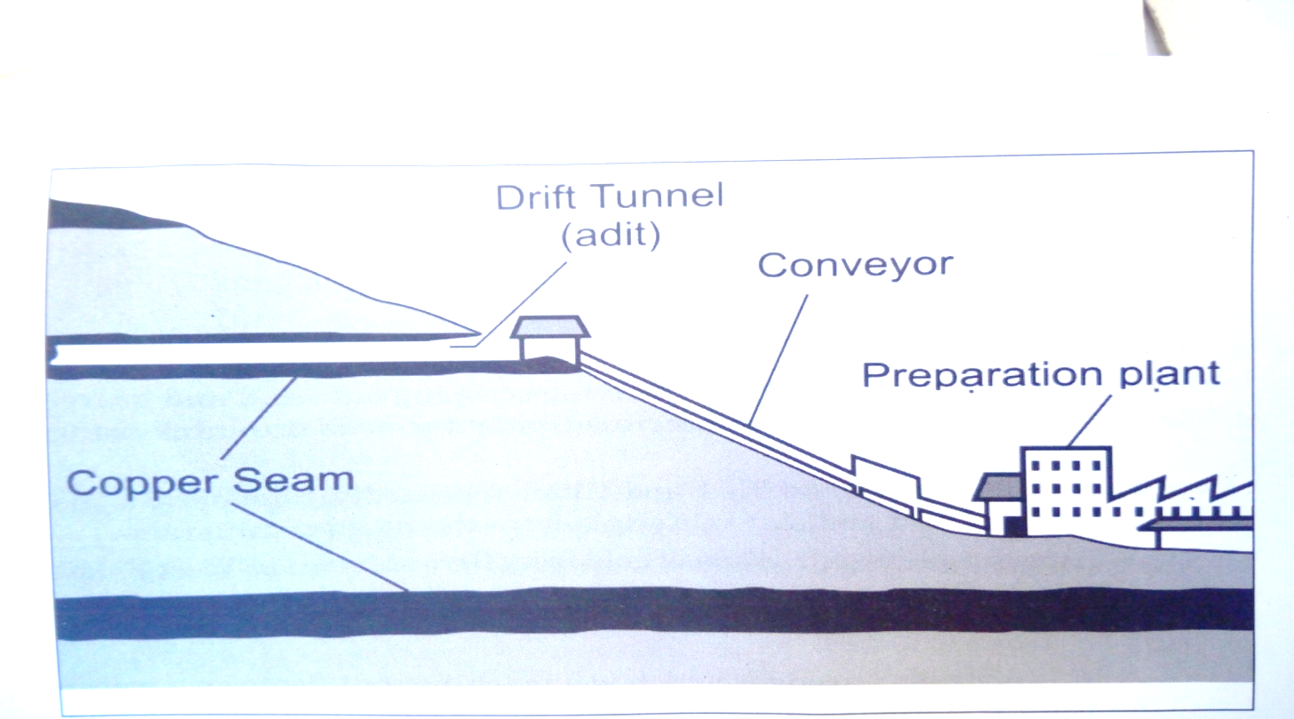

1. Identify method of mining shown above. (1mk)