

**CEKENAS END OF TERM TWO EXAM-2021**

**FORM FOUR**

***Kenya Certificate of Secondary Education. (K.C.S.E)***

**BIOLOGY**

**(THEORY)**

**PAPER 2**

**TIME : 2 HOURS**

**MARKING SCHEME**

1. (a) It’s the ratio of carbon (IV) oxide produced to oxygen consumed during aerobic respiration;

Acc. RQ = (1mk)

(b) ;=1; (2mks)

(c) Brewing in breweries;

Manufacture of organic acids and vinegar for food/preservation;

In baking bakeries;

Dairy industries;

Production of biogas;

Sewage treatment; Mark the 1st three (3mks)

(d) To increase the surface area for (respiratory) enzymes) (1mk)

(e) Lactic acid and energy; (1 mk) both must be correct to award

2. (a) Secretion of sebum which is antiseptic; secretion of sweat which is antiseptic; cornified layer is made of dead cells which prevents microbial entry; (3mks)

(b) Respiratory surfaces

* Mucus on the lining of the trachea traps dust particles and micro-organisms;
* hairs in the nostrils traps dust particles and micro-organisms;
* Sense cells n the alfactory epithelium ensures only clear air is inhaled;
* Macrophage cells in the alveoli engulf and digest pathogens; (3mks)

(Mark any 3)

(c) Alimentary canal

* Hydrochloric acid in the stomach kill any microorganism/bacteria swallowed with food;
* Parts of the alimentary canal like the stomach have goblet cells that secret mucoid lining; (2mks)

3. (a) (i) Eliminate/ absorbs oxygen; (1mk)

(ii) investigate whether light is necessary for germination; (1mk)

(b) (i) At 40 temperature; enzymes are inactive due to low temperature hence low percentage germination; At 600 temperature is very high/higher than optimum, enzyme denatured hence no germination;

At 350 temperature is optimum for enzymes controlling germination hence high percentage germination. (3mks)

(c) I Oxygen;

III Optimum/favourable/suitable temperature;

IV water; (3mks)

4. (a) Population density;

Population growth;

Population dispersion; (3mks)

(b) Area = 30m × 20m =600m2

Grasshoppers = 12/3; = 4 grasshoppers/m2;

Therefore in 600m2 = 600× 4; = 2400 grasshoppers; (4 mks)

(c) Transect/ line transect/ Belt transect/ capture recapture; Acc the first (1mk)

5. (a) The gene for foot deformity being dominant; express itself in both, homozygous and heterozygous condition; (2mks)

(b) Parental genotype Dd × dd;

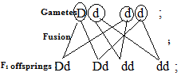

2deformed ; 2 normal; Acc. punnet square.

1 : 1;

(c) The individuals are readily selected against by natural selection; (1mk)

6. (a)

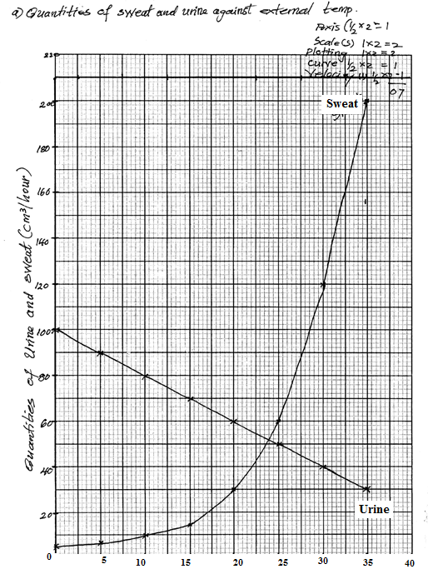

(b) 240C  0.5;

(c) Sweat produced increases with increase in temperature; due to increased vapourisation of sweat; in which latent heat of vapourization is absorbed from the body to cool it; (3mks)

(d) As temperature increases, the amount of urine produced decreases; since increased sweating raises osmotic pressure of blood; more water is reabsorbed into the blood; more water is reabsorbed in to the blood in kidney tubules; resulting in production of little concentrated urine; (4mks)

(e) (i) Erector fill muscles contract; hair stands erect; trapping air; therefore less heat is lost; (3mks)

(ii) Through vasoconstriction, less blood flows near the skin surface; reducing heat loss by concentration and radiation; (2mks) Convection and radiation should be there to award the 2nd marks.

7. (a)

* Plants in arid/ semi arid habitat have leaves covered with thick waxy cuticles; that are waterproof; allowing for reduced rate of transpiration;
* Sunken stomata in some desert area plants; have water vapour accumulating in the pit so that it is not carried away by wind;
* Most plants have fewer or no stomata on the upper surface of the leaf; hence less water loss from the plant;
* Some plants have small stomata; thus reducing transpiration rate;
* Plants with needle like/spine leaves; exposes small surface area hence their rate of transpiration is low;
* Leaves with shinny surfaces; reflect/light reducing transpiration rate;
* Some plants have leaves covered with hairs/scales that trap a layer of moisture on the leaf surface; reducing the rate of transpiration; (14mks)

(b)

* Xylem vessels are made of dead cells to allow for easy passage of water since dead cells do not absorb water;
* Their walls are lignified which makes them firm and rigid to avoid collapsing in order to withstand movement of water under pressure;
* Lignin enables vessels to be waterproof thus cannot absorb water being transported.
* Walls of vessels have bordered pits which allow smooth flow of water from roots to the leaves;
* Xylem vessels lack cross walls between their cells, this allows movement of water up the stem with minimal resistance;
* Xylem vessels are long and continuous and this allows smooth flow of water and mineral salts to adjacent cells and tissues.
* They have narrow lumen to enhance capillary enabling fast movement of water up the stem;
* They posses thick walls which enhance adhesive forces of water molecules to xylem walls enabling effective uptake of water and mineral salts;

Total 8 max 6

8.

* Has secretory glands/crypts of lieberkuhn; which secrets enzymes maltase/ sucrose/ peptidase/ lipase to complete digestion of sugars/proteins/lipids; respectively.
* Goblet cells secrets mucus; allows for smooth movement of food/protects wall of ileum from action of digestive enzymes;
* Very long; to provide large surface area for absorption;
* Highly folded/coiled; to slow down movement of food to allow more time for digestion/absorption/increase surface area for absorption;
* Has numerous villi; which increase surface area for absorption; microvilli; which further increase surface area for absorption;
* Ileum wall/ villi has a thin epithelium which is only one cell thick; reduces distance over which digested food has to diffuse;
* Villi are highly vascularized/ have a rich network of blood capillaries; rapidly transport from small intestine food materials that diffuse concentration gradient for efficient absorption of digested food materials into the blood;
* Villi have lacteals for absorption of fatty acids and glycerol/lipids;
* Cells of the ileum walls have large numbers of mitochondria; release energy that aids in active transport across epithelium;
* The ileum has a narrow lumen; allowing close contact of food to intestinal walls;

Total 22 max 20 marks