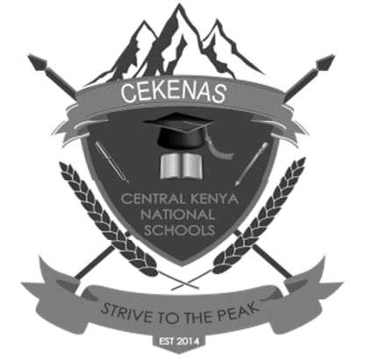

**CEKENAS END OF TERM TWO EXAM-2021**

**FORM FOUR**

***Kenya Certificate of Secondary Education. (K.C.S.E)***

**BIOLOGY**

**PAPER 3**

**(PRACTICAL)**

**MARKING SCHEME**

1. (i) L1 – Slit separate /open/ bent outward. (1mk)

L2- Slit remain closed (1mk)

(ii) L1, Since solution L1 is hypotonic and cell sap hypertonic, cortex cells; gained water by osmosis and expand; increase in size. Epidermal cells being waterproof didn’t take in water; hence curving outwards. (3mks)

(b) (i)

B- Rough endoplasimic reticulum

C- Matrix/mitochondrion

D- Trypsin (3mks)

(ii)

- Pacreatic lipase

-Pacreatic amylase

-Trypsin (3mks)

2. (a) Succulent fruit. (2mks)

Berry

(b)

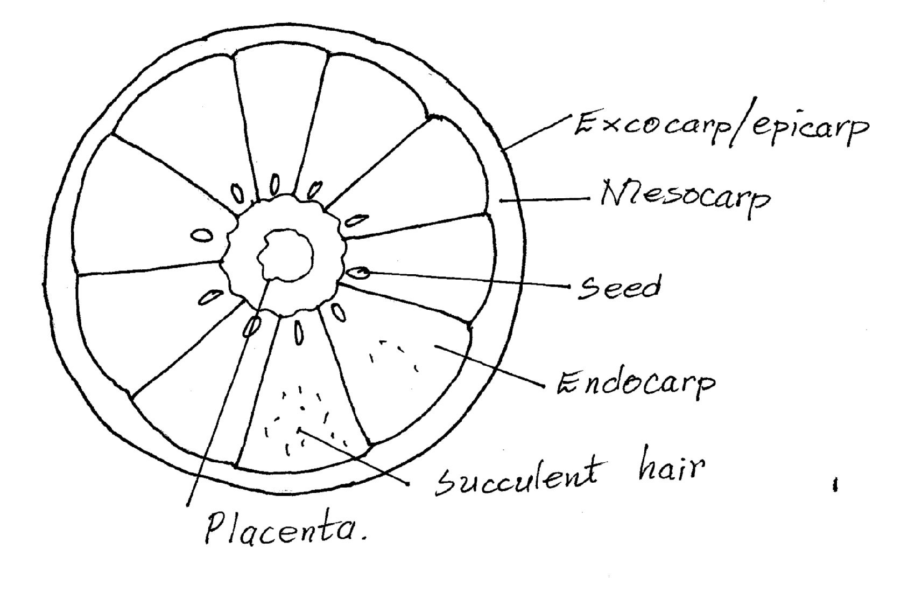

Labelling -Any 4 correct labels, 2mks

Drawing – 1mk

Check on – Smooth continuous lines

* No shading
* Double lines for mesocarp.

(c)

* + Succulent to attract animals that feed on them;
  + Brightly coloured to attract animals that feed on them;
  + Scented to attract animals that feed on them;
  + Seeds covered by hard seed coat that resists the digestive enzymes of the feeding animals; Any 2 correct adaptations

|  |  |  |  |
| --- | --- | --- | --- |
| **Food substance** | **Procedure** | **Observation** | **Conclusion** |
| Vitamin C  (Ascorbic acid); | -Put some DCIP solution into a test tube. Add the juice dropwise to the DCIP shaking after each drop; | DCIP gets decolourised | Presence of vitamin C |
| Lipid/fat/oil; | Rub a drop of food substance on a filter paper. Warm the paper above the Bunsen burner flame to dry; | -Translucent spot not formed; | Absence of vitamin C; |

3. (a) Cervical vertebra rej cervical bone but mark reasons. (1mk)

(b)

* Has short/small neural spine
* Has vertabterial canal/ vertebraterial canal
* Branched/divided transverse processes/process.
* Has cervical rib.

(c) Neck region/cervical region (1mk)

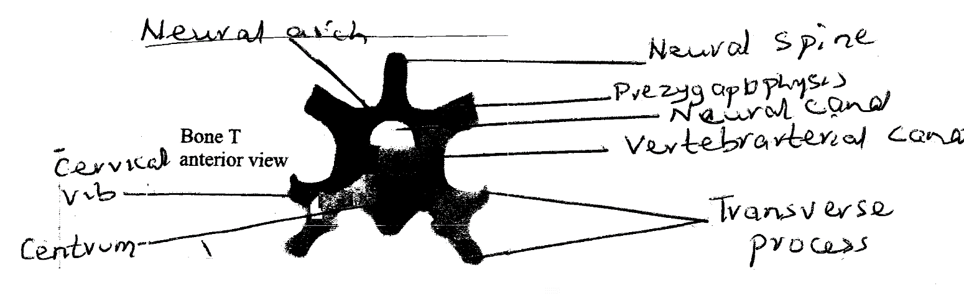

* Neural canal; for passage of spinal cord; (6mks)
* Neural spine; for muscle attachment;
* Transverse process; for muscle attachment;
* Vertebraviterial canal; passage of blood vessel and nerves
* Nural arch (and centrum) ;protect the spinal cord
* Centrum; support body weight.
* Prezygapophysis, for articulation with other vertebra. Mark the 1st 3 points

(i) 5.6cm 0.1

(ii) Magnifaction = 3 mks

= × 1.25

(iii) Anterior end

-Presence of prezygapopysis facing upwards

**CEKENAS END OF TERM TWO EXAM-2021**

**FORM FOUR**

***Kenya Certificate of Secondary Education. (K.C.S.E)***

**BIOLOGY**

**PAPER 3**

**(PRACTICAL)**

**CONFIDENTIAL INSTRUCTIONS**

Each candidate requires the following

* Two pieces of Sukuma wiki (kale) peticles each measuring 5cm in length.
* 40 ml concentrated sodium chloride solution labelled L2. In a petri dish.
* 40 ml distilled water labelled L1 in a petri dish.
* A scapel.
* A mature lemon fruit labelled Q
* A filter paper
* Access to DCIP Solution
* 50 ml beaker
* Access to means of heating/ Bunsen burner