**Term 3 - 2022**

**CHEMISTRY (QUESTION PAPER)**

**FORM THREE (3)**

**Time: 2 Hours**

**PAPER 2**

**Name**: …………………………………………………………. **Adm** **No**: ……………….

**School**: ……………………………………………………….. **Class**: …………………..

**Signature**: …………………………………………………….. **Date**: …………………...

**Instructions to candidate**

1. Write your name, admission number, and stream in the spaces provided.
2. Answer **ALL** questions in the spaces provided
3. All working **MUST** be clearly shown where applicable
4. KNEC mathematical tables and silent non-programmable electronic calculators may be used
5. This paper consists of *9 printed pages*
6. The candidate should check the question paper to ascertain that all the pages are printed as indicated and that no question is missing

**FOR EXAMINERS’ USE ONLY**

|  |  |  |
| --- | --- | --- |
| **Question** | **Maximum Score** | **Candidate’s Score** |
| **1 – 7** | **80** |  |

1. The grid below represents part of the periodic table. Study the information and answer the questions that follow. The letters do not represent actual symbols of elements

|  |  |  |  |  |  |  |  |  |
| --- | --- | --- | --- | --- | --- | --- | --- | --- |
| **Z** |  | | | | | | |  |
| **E** |  |  |  | **L** |  | **W** | **B** | **V** |
|  | **R** | **G** | **U** |  |  |  | **X** |  |
| **A** | **M** |  |  |  |  |  |  |  |

1. Which element would form a trivalent cation? (1 Mark)

___________________________________________________________________________

1. Write the equation for the reaction that would occur between **R** and **B** (1 Mark)

___________________________________________________________________________

1. What is the name of the elements that are found in the region labelled **G**? (1 Mark)

___________________________________________________________________________

1. Which is the most reactive non-metallic element in the table above? Explain (2 Marks)

___________________________________________________________________________

___________________________________________________________________________

1. How does the atomic radius of **L** compare with that of **B**? Explain (2 Marks)

___________________________________________________________________________

___________________________________________________________________________

1. The table below shows some properties and electron arrangement of ions of elements represented by letters **D** to **K** which are not actual symbols of elements. Study the information and answer the questions that follow.

|  |  |  |  |
| --- | --- | --- | --- |
| **Ion** | **Electron arrangement of ion** | **Atomic radius of element (nm)** | **Ionic radius of element (nm)** |
| D- | 2.8 | 0.072 | 0.136 |
| E+ | 2.8.8 | 0.231 | 0.133 |
| F3+ | 2.8 | 0.143 | 0.050 |
| G2+ | 2.8.8 | 0.133 | 0.074 |
| H2+ | 2.8 | 0.160 | 0.064 |
| I+ | 2.8 | 0.186 | 0.095 |
| J3- | 2.8.8 | 0.110 | 0.190 |
| K- | 2.8.8 | 0.099 | 0.181 |

1. State the atomic numbers of elements **F** and **G** (1 Mark)

___________________________________________________________________________

___________________________________________________________________________

1. Select **two metals** that belong to period 3 (1 Mark)

___________________________________________________________________________

1. Element **I** reacts violently with water. Write the equation for this reaction (1 Mark)

___________________________________________________________________________

1. Why is the ionic radius of **G** smaller than its atomic radius? (1 Mark)

___________________________________________________________________________

1. Compare the reactivities of elements **G** and **H**. Explain (2 Marks)

**___________________________________________________________________________**

**___________________________________________________________________________**

1. The flow chart below represents the main steps in the industrial manufacture of sodium carbonate. Study it and answer the questions that follow.

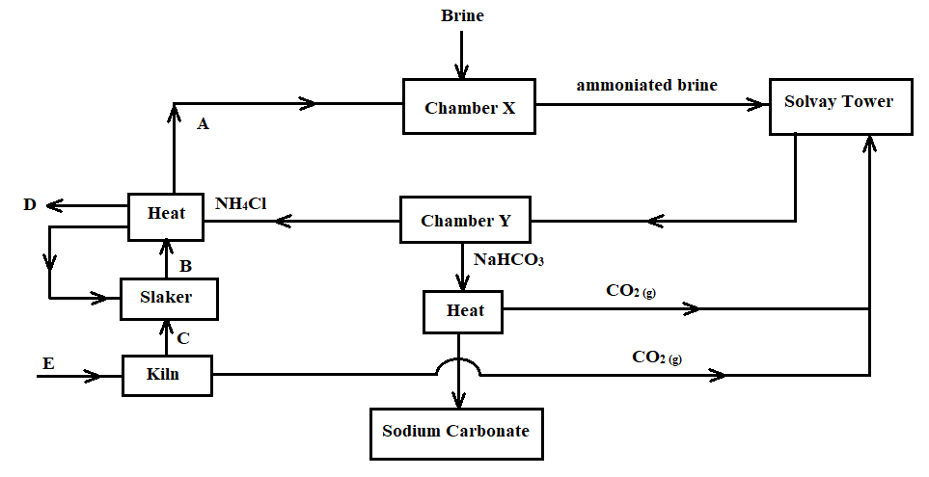

1. What is the name given to this process? (1 Mark)

___________________________________________________________________________

1. Name the substances labelled **A, B, C,** and **D**. (2 Marks)

**A** ________________________________ **B** ______________________________________

**C** ________________________________ **D** ______________________________________

1. Identify substance **E** and write a chemical equation for the process it undergoes to produce **C** (2 Marks)

___________________________________________________________________________

___________________________________________________________________________

1. Name the process that takes place in the chamber marked **Y** (1 Mark)

___________________________________________________________________________

1. The process taking place in the chamber marked **X** requires the industry to be located near a large water body. Explain (2 Marks)

___________________________________________________________________________

___________________________________________________________________________

1. Name two by-products that are recycled in this process (1 Mark)

___________________________________________________________________________

___________________________________________________________________________

1. Ammonia is a raw material in the industrial manufacture of sodium carbonate. Write the chemical equations for the processes taking place in the carbonator and roaster

Carbonator: _________________________________________________________ (1 Mark)

Roaster: ____________________________________________________________ (1 Mark)

1. Considering the two reactions, and assuming that there was no recycling process, calculate the volume of ammonia at s.t.p. that would be required to produce 10.6kg of sodium carbonate if the factory is operating at 80% efficiency (3 Marks)

(C = 12.0, O = 16.0, H = 1.0, Na = 23.0, N = 14.0, molar gas volume at s.t.p. is 22.4dm3)

___________________________________________________________________________

___________________________________________________________________________

___________________________________________________________________________

___________________________________________________________________________

1. Sodium carbonate may be prepared using the double salt, trona (Na2CO3•NaHCO3•2H2O). Why is it difficult to show that trona contains water of crystallization by heating? (1 Mark)

___________________________________________________________________________

___________________________________________________________________________

1. Study the flow chart below and use it to answer the questions that follow.

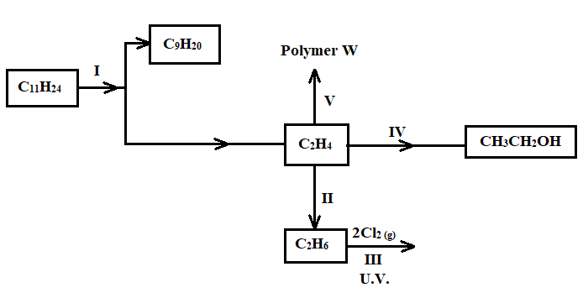

1. Name the process labelled **I** (1 Mark)

___________________________________________________________________________

1. Describe how acidified potassium manganate (VII) solution can be used to distinguish between C2H4 and C2H6. (2 Marks)

___________________________________________________________________________

___________________________________________________________________________

___________________________________________________________________________

1. State **one** industrial application of the process in **step II** (1 Mark)

___________________________________________________________________________

1. Write an equation for the reaction in **step III** (1 Mark)

___________________________________________________________________________

1. The compound **C10H22** is cracked to obtain an alkane **X** and another hydrocarbon. The cracking takes place according to the following equation

**C10H22 🡪 C5H10 + X**

1. Write down the formula of substance **X** (1 Mark)

________________________________________________________________________

1. The cracking process requires the use of a catalyst. State **two** reasons why a catalyst is used in this reaction (2 Marks)

________________________________________________________________________

________________________________________________________________________

1. Draw and name the compound **C5H10** (2 Marks)

________________________________________________________________________

________________________________________________________________________

1. Name the type of reaction that takes place when **C5H10** reacts with chlorine gas (1 Mark)

________________________________________________________________________

1. Draw the structure of the main product of this reaction (1 Mark)

________________________________________________________________________

________________________________________________________________________

1. What are structural isomers? (1 Mark)

___________________________________________________________________________

1. Draw and name any **two** structural isomers of **C5H10** (2 Marks)

___________________________________________________________________________

___________________________________________________________________________

1. The flow diagram below shows the process of obtaining nitrogen from a sample of air. Use it to answer the questions that follow.

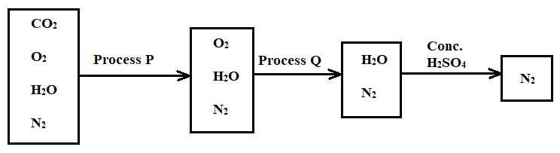

**Diag**

1. What is the purpose of processes **P** and **Q**? (2 Marks)

Process **P** ___________________________________________________________________

Process **Q** __________________________________________________________________

1. Identify the reagents used in the processes **P** and **Q** (2 Marks)

Process **P** ___________________________________________________________________

Process **Q** __________________________________________________________________

1. Write equations for the reactions taking place during processes **P** and **Q** (2 Marks)

Process **P** ___________________________________________________________________

Process **Q** __________________________________________________________________

1. Comment on the purity of the nitrogen gas collected (2 Marks)

___________________________________________________________________________

___________________________________________________________________________

1. A student categorised air as a compound and not as a mixture. Give **two** reasons as to why the student was wrong (2 Marks)

___________________________________________________________________________

___________________________________________________________________________

1. The diagram below illustrates an experiment setup used for the preparation of dry chlorine in the laboratory

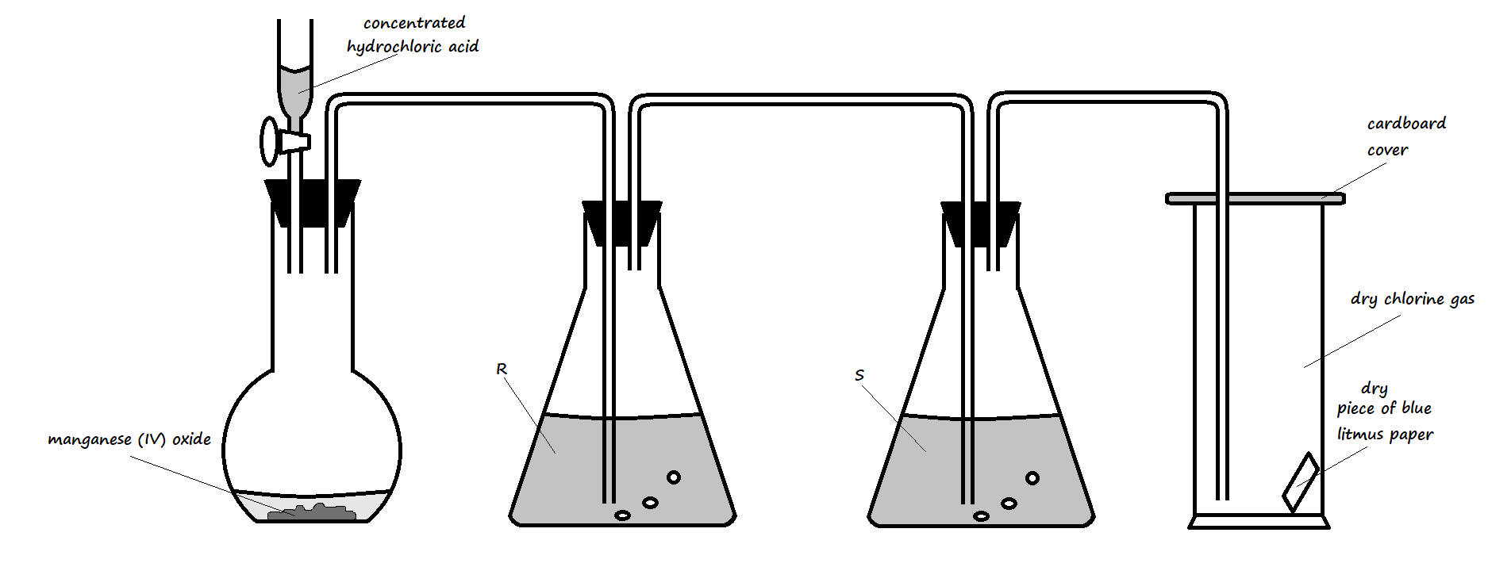

1. State **one** mistake that is in the setup (1 Mark)

___________________________________________________________________________

1. Write an equation for the reaction that would occur in the flask (1 Mark)

___________________________________________________________________________

1. What is the role of manganese (IV) oxide in the setup? (1 Mark)

___________________________________________________________________________

___________________________________________________________________________

1. State the identity and roles of the following in the setup:
2. Solution **R** (2 Marks)

___________________________________________________________________________

___________________________________________________________________________

1. Solution **S** (2 Marks)

___________________________________________________________________________

___________________________________________________________________________

1. State and explain one important precaution that should be observed when carrying out this experiment (2 Marks)

___________________________________________________________________________

___________________________________________________________________________

1. State and explain the observation made on the blue litmus paper in the gas jar (2 Marks)

___________________________________________________________________________

___________________________________________________________________________

1. State **three** uses of chlorine gas (3 Marks)

___________________________________________________________________________

___________________________________________________________________________

___________________________________________________________________________

1. Study the setup below and use it to answer the questions that follow.

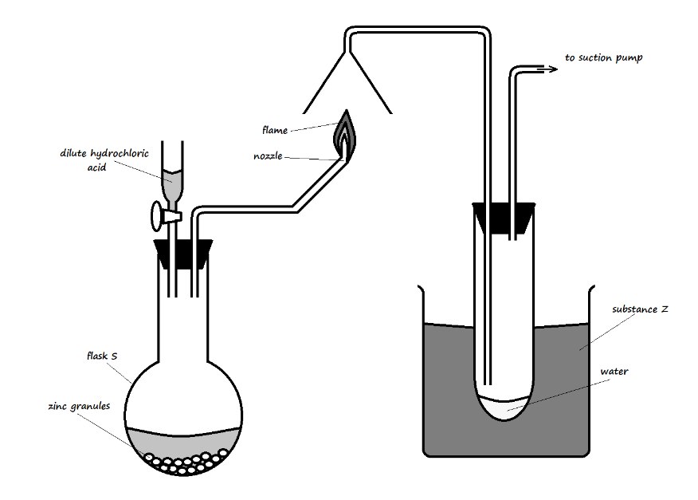

1. Identify substance **Z** and state its purpose in the experiment (2 Marks)

________________________________________________________________________

________________________________________________________________________

1. Write an equation for:

The reaction in the flask (1 Mark)

________________________________________________________________________

The reaction at the nozzle (1 Mark)

________________________________________________________________________

1. Describe a test for the product formed in flask **S** (2 Marks)

________________________________________________________________________

________________________________________________________________________

________________________________________________________________________

1. The diagram below was used to study a property of hydrogen gas. Study it and use it to answer the questions that follow.

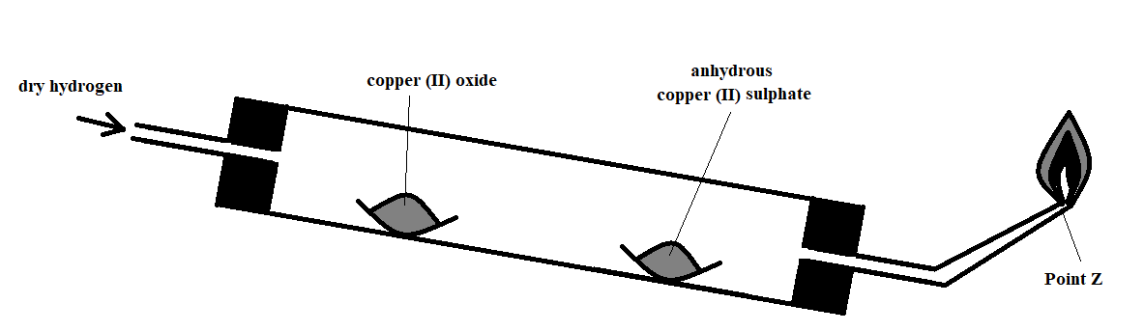

1. Name the missing condition in the setup (1 Mark)

________________________________________________________________________

1. State **two** observations that may be made in the combustion tube (2 Marks)

________________________________________________________________________

________________________________________________________________________

1. What is the importance of the reaction at the nozzle? (1 Mark)

________________________________________________________________________

________________________________________________________________________

1. What would be observed if the copper (II) oxide were replaced with zinc oxide? (1 Mark)

________________________________________________________________________

________________________________________________________________________

1. Why is it important to tilt the combustion tube as demonstrated in the diagram? (1 Mark)

________________________________________________________________________

________________________________________________________________________

1. State one other use of hydrogen apart from that demonstrated by the reaction in the setup (1 Mark)

________________________________________________________________________