**NAME…………………………………………………………………….. ADM.NO …………………...**

**SCHOOL …………………………………………………………………. SIGN ………………………..**

**CLASS ……………………………………………………………………..DATE** **………………………**.

**BIOLOGY**

**PAPER 1**

**FORM FOUR**

**NOV-DEC, -2021**

**TIME: 2 HOURS**



**CEKENAS END OF TERM TWO EXAM-2021**

**FORM FOUR EXAM**

***Kenya Certificate of Secondary Education***

**BIOLOGY**

**PAPER 1**

**FORM FOUR**

**TIME: 2 HOURS**

**INSTRUCTIONS**

* *This paper consist of sections A,B and C*
* *Answer all the questions in the three questions in the spaces provided.*
* ***This paper consists of 2 printed pages. Candidates should check the question paper to ascertain that all pages are printed as indicated and that no questions are missing.***

**FOR EXAMINERS USE ONLY**

|  |  |  |
| --- | --- | --- |
| **SECTION** | **MAXIMUM SCORE** | **STUDENTS SCORE** |
| **A** | **30** |  |
| **B** | **30** |  |
| **C** | **20** |  |
| **TOTAL** | **80** |  |

1. Name the characteristic of life that is demonstrated by?

(a) A vine climbing up a tree (1mk)

………………………………………………………………………………………………………

………………………………………………………………………………………………………

(b) A football fan watching a game on television and cheering. (1mk)

………………………………………………………………………………………………………

………………………………………………………………………………………………………

2. A student collected a plant with the following features

-Vascular bundles in the stem scattered with no cambium

-Fibrous root system.

Name the sub-division and class to which the above plant belonged

-Sub division……………………………………………………………………………… (1mk)

-Class…………………………………………………………………………………………(1mk)

3. List 3 limitations of using light microscope to estimate the cell size. (3 mks)

………………………………………………………………………………………………………

………………………………………………………………………………………………………

………………………………………………………………………………………………………

………………………………………………………………………………………………………

4. Explain why;

(a) Red blood cell bursts when placed in distilled water. (2 mks)

………………………………………………………………………………………………………

………………………………………………………………………………………………………

(b) Fresh water amoeba doesn’t burst when placed in distilled water. (2mks)

………………………………………………………………………………………………………

………………………………………………………………………………………………………

………………………………………………………………………………………………………

5. The table below shows the number of teeth in the jaws of an animal.

|  |  |  |  |  |
| --- | --- | --- | --- | --- |
|  | Incisors | canines | Pre-molars | molars |
| Upper Jaw | 0 | 0 | 6 | 4 |
| Lower Jaw | 8 | 0 | 6 | 6 |

(a) Write the dental formula of the organism. (1mk)

………………………………………………………………………………………………………

………………………………………………………………………………………………………

(b) State the mode of feeding of this animal. (1 mk)

………………………………………………………………………………………………………

………………………………………………………………………………………………………

(c) Give two reasons for your answer above. (2mks)

………………………………………………………………………………………………………

………………………………………………………………………………………………………

………………………………………………………………………………………………………

………………………………………………………………………………………………………

6. A person walked bare foot in a swampy area. After a few weeks he started experiencing abdominal pains and diarrhoea. His urine and stool contained blood. Name the disease and the causative agent of the disease the person was most likely suffering from.

Disease……………………………………………………………………………… (1 mk)

Causative agent……………………………………………………………………… (1mk)

7. (a) State why people with blood group AB are referred to as universal recipients. (1 mk)

………………………………………………………………………………………………………

………………………………………………………………………………………………………

(b) An individual was found to be of blood group B+. Name the antigens present on the person red blood cells. (2mks)

………………………………………………………………………………………………………

………………………………………………………………………………………………………

………………………………………………………………………………………………………

8. (a) State the disadvantage of self-pollination in plant. (1mk)

………………………………………………………………………………………………………

(b) State two features that discourage self-pollination. (2mks)

………………………………………………………………………………………………………

………………………………………………………………………………………………………

………………………………………………………………………………………………………

9. In an experiment a piece of brain was removed from a rat. It was found that the rat had large fluctuations of body temperature. Suggest the part of the brain that had been removed. (1mk)

………………………………………………………………………………………………………

………………………………………………………………………………………………………

10. Name one disorder caused by gene mutation and one caused by chromosomal mutation.

Gene mutation (1mk)

………………………………………………………………………………………………………

Chromosomal mutation (1 mk)

………………………………………………………………………………………………………

11. A student was only able to read a book clearly at arms length but not at normal distance.

(a) State the eye defect the person suffered from. (1 mk)

………………………………………………………………………………………………………

………………………………………………………………………………………………………

(b) Why was he unable to read the book clearly at normal distance. (1 mk)

………………………………………………………………………………………………………

………………………………………………………………………………………………………

(c) How can the defect be corrected (1 mk)

………………………………………………………………………………………………………

………………………………………………………………………………………………………

12. Explain the importance of seed dormancy (2mks)

………………………………………………………………………………………………………

………………………………………………………………………………………………………

………………………………………………………………………………………………………

13. The diagram below represents a bone of a mammal

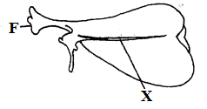

(a) Identify the above bone. (1mk)

………………………………………………………………………………………………………

(B) Name the part labelled X. (1mk)

………………………………………………………………………………………………………

………………………………………………………………………………………………………

(c) Name the bone that articulates at the part labelled F. (1mk)

………………………………………………………………………………………………………

………………………………………………………………………………………………………

14. Explain how a larger body mass helps a desert squirrel through the cold season. (2mks)

………………………………………………………………………………………………………

………………………………………………………………………………………………………

………………………………………………………………………………………………………

15. Plasmodium Vivax and plasmodium Ovale are transmitted by a mosquito. State with a reason whether the two organisms can be interbreed. (2mks)

………………………………………………………………………………………………………

………………………………………………………………………………………………………

………………………………………………………………………………………………………

16. (a) Name one waste product that is transported in the blood but not removed by the kidney. (1mk)

………………………………………………………………………………………………………

………………………………………………………………………………………………………

(b) Explain what happens in humans when the concentration of glucose in the blood rises above the normal level. (3mks)

………………………………………………………………………………………………………

………………………………………………………………………………………………………

………………………………………………………………………………………………………

………………………………………………………………………………………………………

17. The set up below was used to investigate a certain physiological process.

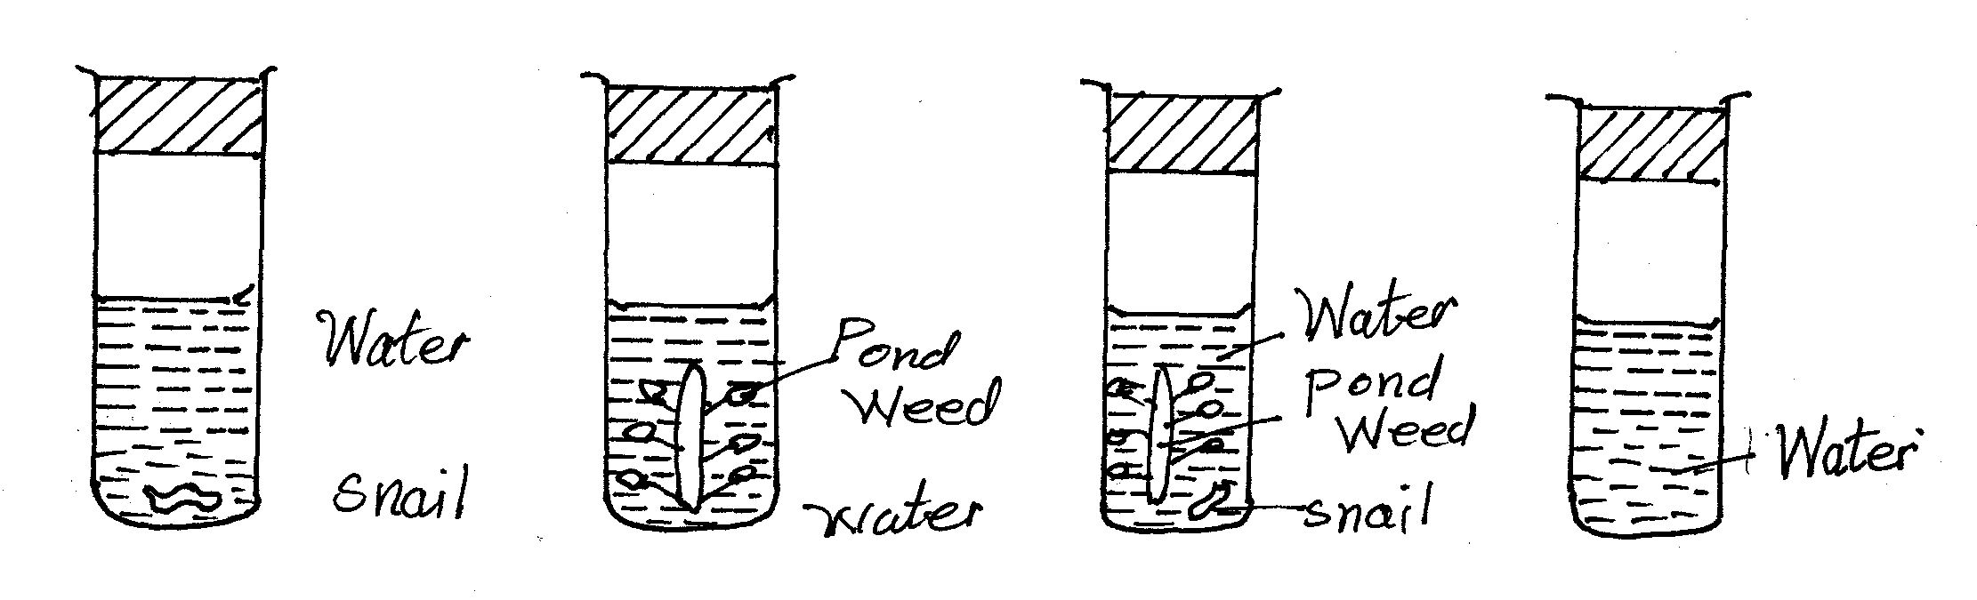

(a) Explain which of the 4 test tubes will have

(i) Most dissolved oxygen. (2mks)

………………………………………………………………………………………………………

………………………………………………………………………………………………………

(ii) Most dissolved carbon (IV) oxide. (2mks)

………………………………………………………………………………………………………

………………………………………………………………………………………………………

18. The wings of a bird and those of a housefly adapt the two organisms to arboreal habit.

(i) Give the evolutionary process that may have given rise to those structures. (1mk)

………………………………………………………………………………………………………

………………………………………………………………………………………………………

(ii) What name is given to such structures, (1mk)

………………………………………………………………………………………………………

………………………………………………………………………………………………………

19. State the fluids that provide cushion in the organs.

(a) Lungs………………………………………………………...........……… (1mks)

(b) Heart….…………………………………………………………………… (1mk)

(c) Knee ….………………………………………………………………… (1 mk)

(d) Eye ball ….………………………………………………………………… (1 mk)

20. Name three methods by which plants eliminate their waste. (3mks)

………………………………………………………………………………………………………

……………………………………………………………………………………………………… ………………………………………………………………………………………………………

21. (a) Explain the following observation that when a student immersed the leaf in hot water and observed bubbles coming out only on the lower surface. (2mks)

………………………………………………………………………………………………………

………………………………………………………………………………………………………

………………………………………………………………………………………………………

………………………………………………………………………………………………………

(b) Explain why it is necessary to destarch a leaf before setting it up for photosynthesis experiment. (1 mk)

………………………………………………………………………………………………………

………………………………………………………………………………………………………

(c) Give a reason why chlorophyll is removed from the leaves before they are tested for starch. (1 mk) ………………………………………………………………………………………………………

………………………………………………………………………………………………………

22. (a) State one function of cilia in organisms. (1 mk)

………………………………………………………………………………………………………

………………………………………………………………………………………………………

(b) Name two parts of human body which have cilia. (2mks)

………………………………………………………………………………………………………

………………………………………………………………………………………………………

23. Identify the following responses

(i) Euglena migrates from a dark place towards light. (1mk)

………………………………………………………………………………………………………

………………………………………………………………………………………………………

(ii) Hair and leaves of insectivorous plants close rapidly and trap insects when insects land on a plant. (1mk)

………………………………………………………………………………………………………

………………………………………………………………………………………………………

(b) Explain the biological significance of the response named in a(i) above (1mk)

………………………………………………………………………………………………………

………………………………………………………………………………………………………

24. Name the organelle that would be most abundant in;

(i) White blood cell. (1 mk)

………………………………………………………………………………………………………

………………………………………………………………………………………………………

(ii) Salivary glands (1mk)

………………………………………………………………………………………………………

………………………………………………………………………………………………………

25. Name the hormone that control the following activities

(a) Metamorphosis in young insect (1 mk)

………………………………………………………………………………………………………

………………………………………………………………………………………………………

(b) Formation of abscission layer in leaves and fruits. (1 mk)

………………………………………………………………………………………………………

………………………………………………………………………………………………………

26. The diagram, below represents the structure of a nerve cell.

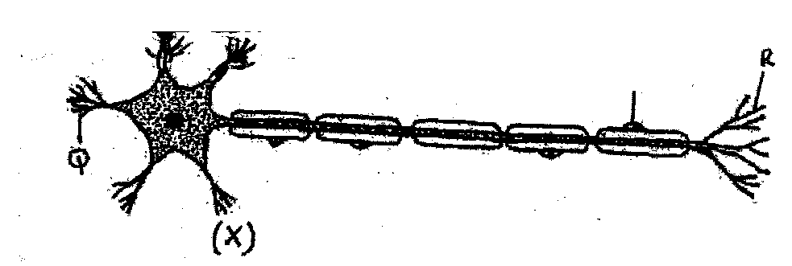

(a) Identify the nerve cell. (1 mk)

………………………………………………………………………………………………………

………………………………………………………………………………………………………

(b) Give a reason for your answer in (a) above . (1 mk)

………………………………………………………………………………………………………

………………………………………………………………………………………………………

(c) Using an arrow show the direction of an impulse on the diagram (1 mk)

………………………………………………………………………………………………………

………………………………………………………………………………………………………

27. State 3 structural differences between skeletal and smooth muscles. (3mks)

………………………………………………………………………………………………………

……………………………………………………………………………………………………… ………………………………………………………………………………………………………

………………………………………………………………………………………………………

28. Explain why an athlete practicing at high altitude zones have a higher number of Red blood cells than those at sea level. (3 mks)

………………………………………………………………………………………………………

………………………………………………………………………………………………………

………………………………………………………………………………………………………

………………………………………………………………………………………………………

29. Explain the importance of the following procedures during microscopy.

(i) Use of cover slip. (1 mk)

………………………………………………………………………………………………………

………………………………………………………………………………………………………

(ii) Mounting the specimen on a drop of water. (1 mk)

………………………………………………………………………………………………………

………………………………………………………………………………………………………

**THIS IS THE LAST PRINTED PAGE**