

**CEKENAS END OF TERM TWO EXAM-2021**

**FORM FOUR**

***Kenya Certificate of Secondary Education.(K.C.S.E)***

**233/1**

**CHEMISTRY**

**PAPER 1**

**(THEORY)**

**Nov-Dec-2021**

**MARKING SCHEME**

1. Add water ✓½ to the mixture. Water mixes with ethanol and forms a lower layer while the upper layer is pentane ✓½. Use separating funnel✓½ to separate pentane and use fractional distillation to obtain ethanol from water.

2. (a) K and M ✓1 (for both)

(b) K✓½ and M✓½

This is because K is an acid and M is a base and aluminum hydroxide being amphoteric would react with both ✓1

3. (a) NH4

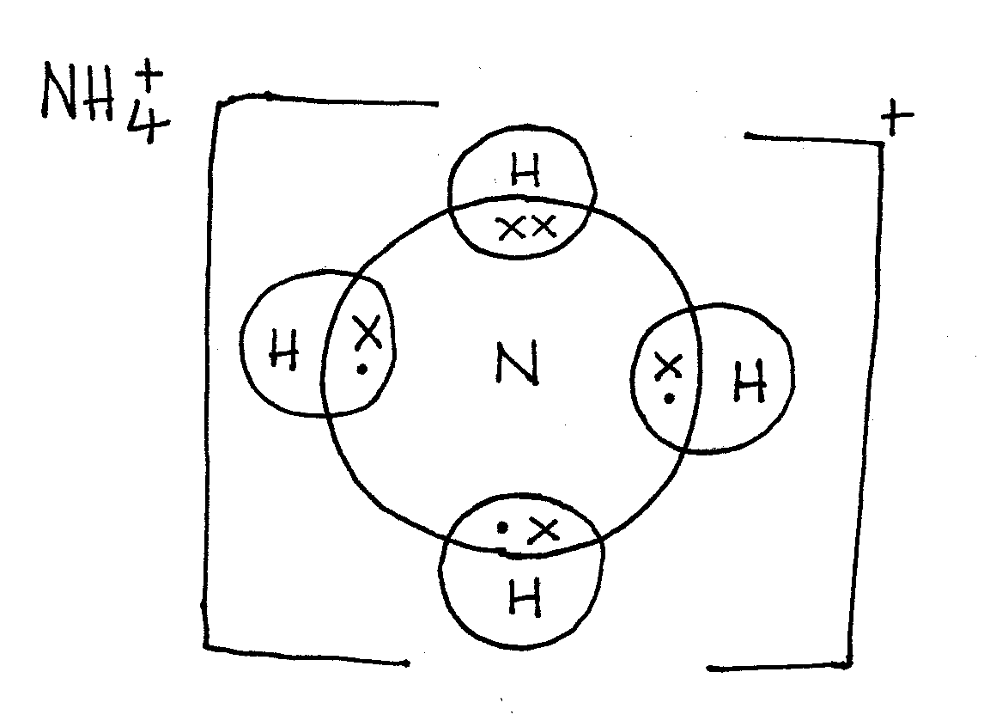

(b)

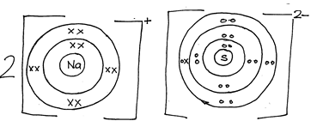

4. Add 100cm3  of 0.5M✓1 NaOH/50cm3 of 1M NaOH t 50cm3 of 0.5 H2SO4 in a beaker and shake, evaporate to saturation ✓½ and allow it to cool ✓½ for crystals to form, filter ✓½ and dry the crystals between filter papers ✓½

5. (a) When gases react, they do so in volumes that bear a simple ratio to one another and to the volumes of products if a gaseous, temperature and pressure remains constant.

(b) CxHy(g) + O2(g) 🡺 CO2(g) + H2O(g) ✓½

100 300 200 200

1mol 3mol 2mol 2mol✓½

CxHy(g) +3O2(g) 🡺 2CO2(g) + 2H2O(g) ✓½

C4Hy(g) +3O2(g) 🡺 2CO2(g) + 2H2O(g) ✓

C2H4✓

6. (a) i) Cu(s) 🡺 Cu2+(aq) +2e- ✓1

ii) CU2+(aq) +2e- 🡺 Cu(s) ✓1

(b) Blue colour of CuSO4 remains the same ✓½ the Cu2+ discharged at cathode were replaced when copper dissolves ✓½

7. Gas P – Hydrogen ✓½

Solid R – Magnesium Oxide ✓½

Solid T – Copper metals ✓½

Liquids S – Water ✓½

8. (a) Chlorine is diatomic molecule while argon is monoatomic, therefore chlorine has a larger ✓½ molecular mass hence stronger/ more van der waal forces than argon.

(b) S, ✓½ has smallest ✓½ radius and highest number of delocalized electrons/3 delocalized electrons ✓½ hence strongest ✓½ metallic bonding.

9. (a) Electolysis ✓1

(b) To lower the m.p of aluminium oxide ✓1

(c) Aluminium has thin oxide layer ✓ which prevent it from reacting with oxygen.

10. (i) Dinitrogen tertaoxide/ N2­O4 ✓1

(ii) Insert a glowing splint inside the gas ✓½ jar the splint relight✓½

(iii) 2Pb (NO3)2(s) 🡺 2PbO(s) + 4NO2(g) + O2(g) ✓1 (penalize ✓½ missing/wrong state symbols unbalanced penalize fully)

11. (a) 

(b) -Treatment of cancerous tumor through radioactivity.

-Sterilizing hospital/surgical instrument/equipment by exposing them to gamma radiation

-For providing power in heart pace setters.

-Radioactive iodine is used in patient with defective thyroid to enable doctors to follow the path of iodine through the body. (Any two correct answer)

12. (a) A state of balance where the rate of forward reaction equals the rate of backward reaction✓1

(b) More of HI forms ✓½ i.e favour the forward endothermic✓½ reaction

(c) Has no effect ✓½ , molecules are equal on both sides of the system.

13. Q= 1t

t= 32× 60+10=1930 seconds

Q = 0.5× 1930 ✓½ = 956C✓½

If 0.44g = 965C

88 g = ?

✓½ ✓½

96500C - 1 mole of electron

193000C =  + 2✓½✓½ sign must be there to score

14. (a) Bubbles of a colourless gas with pungent smell ✓1.

-White crystals are blackened /charred to a mass of black spongy/frothy solid substance✓1

(b) It is insoluble in water hence cannot be washed ✓½easily ✓½

15. ✓1

1=10.13✓

16. (i) Sulphur/ S

(ii) Sodium chloride/ NaCl

(iii) Potassium chloride (KCl)/Potassium chlorate (I) / KClO

17. (a) Yellow deposit ✓ and white solid ✓½

Magnesium continues ✓½ to burn with a bright flame/Burning masgesium produce intense heat energy which decomposes ✓½ SO2 to yellow sulphur with oxygen. Magnesium combine with oxygen to form magnesium oxide.

(Mark any two correct observations and 2 correct explanation)

(b) Mg(s) + SO2(g) 🡺 MgO(s) + S(s)

18. (a)

|  |  |
| --- | --- |
| Physical | Chemical |
| * No new substance formed * No change in mass * Reversible * Not accompanied by great heat change | * New substance formed * Change in mass * Irreversible * Accompanied by great heat change |

(b) Process I – Physical

Process II – Chemical

19. NaoH(aq) HCl(aq) 🡺 NaCl(aq) +H2O(l)

Ratio 1:1

Moles of acid  ✓½✓½

Moles of NaoH in 1000cm3 = ✓½✓½

Conc = 0.6 × 40 = 24g/l ½ = 24g/l✓½

20. (a) Atoms of the same element with the same atomic number but different mass number.

(b)

✓ 1 ✓½

=24.263✓½

21. (a) Test-tube I : Effervescence occurred ✓1

Test-tube II : No efferevescence ✓1

(b) Ethanoic acid dissolves in water and dissociate partially ✓½hence producing hydrogen ✓½ ion which are responsible for acidic properties of the solution.

In methylbenzene it only dissolves but does not dissociate ✓½ therefore no hydrogen ✓½ ions in the solution.

22. ΔH = MCΔ

✓½✓½

Moles of ethanol = 16/46 = 0.3478 moles ✓½

0.3478 moles – 163.8kJ ✓½

1 mole - ✓½

23. (a)

(b) Propylethanoate ✓1

(c) 3-bromo-2-methylpent-1-ene✓1

24. (a) Maximum mass of solute required to saturate 100g of solvent/water at a g iven temperature ✓1

(b) mass of solid × 30.4-26.2 = 4.2g✓½

mass of water = 42.4 – 30.4 =12g✓½

12g of water dissolves 4.2g

100g

of water.✓½✓½

25. i) 4NH3(g) + 5O(2)(g) 🡺 4NO(g) + 6H2O(l)

NB: unbalanced – zero no or wrong state symbols symbols penalize ½

ii) To provide activation energy for the reaction

iii) 

26. (a)

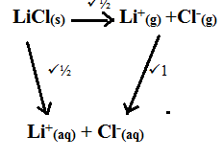

(b) Hsolution= ΔHlattice + ΔHhydration

=891 + -884✓½ = +7kJ/mol ✓½

27. (a) Cooling✓1

(b) Latent heat of fusion ✓1