**Term 3 - 2022**

**CHEMISTRY (QUESTION PAPER)**

**FORM ONE (1)**

**Time: 2½ Hours**

**Name**: …………………………………………………………. **Adm** **No**: ……………….

**School**: ……………………………………………………….. **Class**: …………………..

**Signature**: …………………………………………………….. **Date**: …………………...

**Instructions to candidate**

1. Write your name, admission number, and stream in the spaces provided.
2. Answer **ALL** questions in the spaces provided
3. All working **MUST** be clearly shown where applicable
4. KNEC mathematical tables and silent non-programmable electronic calculators may be used
5. This paper consists of *11 printed pages*
6. The candidate should check the question paper to ascertain that all the pages are printed as indicated and that no question is missing

**FOR EXAMINERS’ USE ONLY**

|  |  |  |
| --- | --- | --- |
| **Question** | **Maximum Score** | **Candidate’s Score** |
| **1 – 25** | **80** |  |

1. Equal volumes of water in two separate boiling tubes were separately heated using two different Bunsen burner flames.

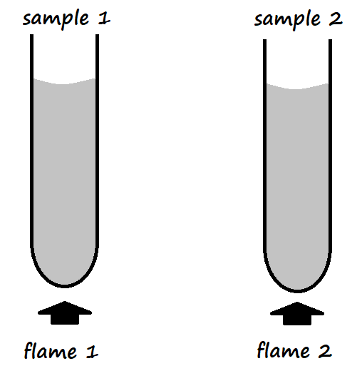

Sample 1 registered a higher temperature than sample 2.

1. Name and draw flame 2 (2 Marks)

Name _____________________________________________________________________

1. State the condition under which flame 1 is produced by a Bunsen burner (1 Mark)

___________________________________________________________________________

___________________________________________________________________________

1. The table below shows the colours obtained when some indicators were added to various solutions

|  |  |  |  |
| --- | --- | --- | --- |
| **Solution** | **Phenolphthalein Indicator** | **Methyl Orange Indicator** | **Indicator W** |
| Distilled water |  |  | Green |
| Ammonium hydroxide | Pink |  | Blue |
| Hydrochloric acid |  | Red | Red |
| Sodium hydroxide |  |  | Violet |

1. Fill in the blank spaces in the table above? (3 Marks)
2. State the possible identity of Indicator **W**. (1 Mark)

___________________________________________________________________________

1. What is the advantage of using Indicator **W**? (1 Mark)

___________________________________________________________________________

1. State the laboratory rules that should be applied to prevent the following accidents:
2. Mistaking hydrochloric acid to be distilled water (1 Mark)

___________________________________________________________________________

___________________________________________________________________________

1. A student got burnt after secretly lighting up a magnesium ribbon (1 Mark)

___________________________________________________________________________

___________________________________________________________________________

1. A student got severe stomach upset after eating some bread during a Chemistry laboratory session (1 Mark)

___________________________________________________________________________

___________________________________________________________________________

1. The setup below was arranged for the collection of **dry** hydrogen gas in the laboratory. Use it to answer the questions that follow.

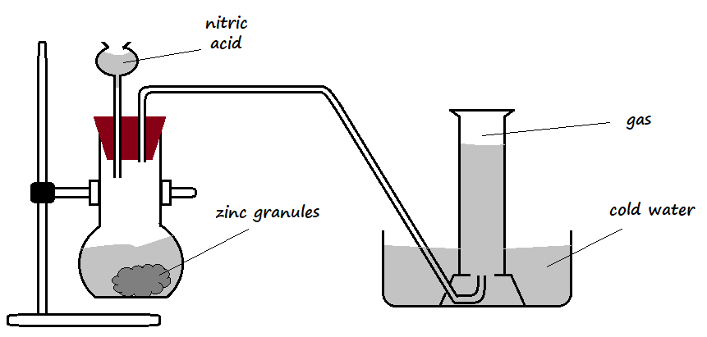

1. Identify **two** mistakes in the set-up (2 Marks)

___________________________________________________________________________

___________________________________________________________________________

1. Suggest remedies for the mistakes identified in **a)** above (2 Marks)

___________________________________________________________________________

___________________________________________________________________________

1. Dry hydrogen gas was passed over heated lead (II) oxide in a combustion tube as shown in the diagram below.

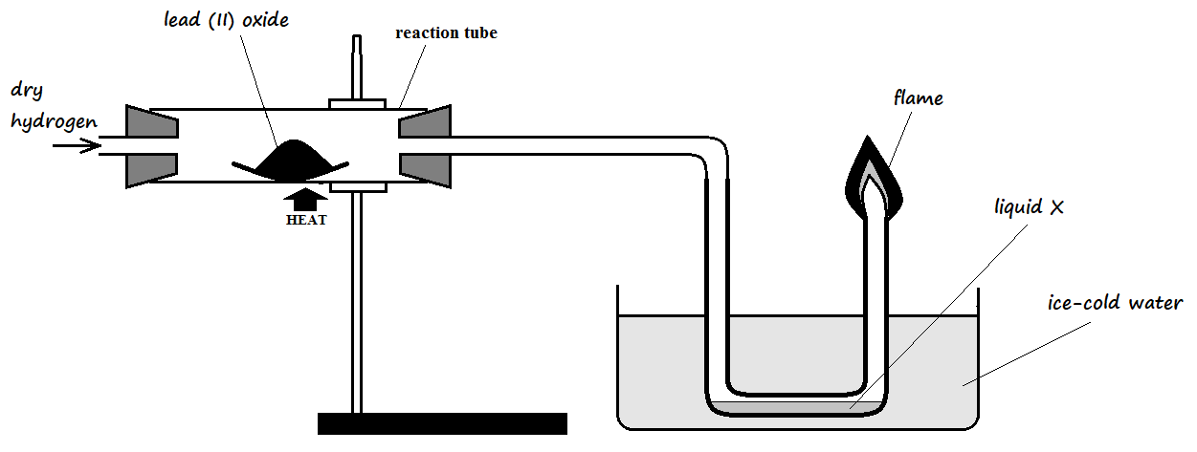

1. State **two** observations that were made in the combustion tube (2 Marks)

___________________________________________________________________________

___________________________________________________________________________

1. Write a word equation for the reaction taking place in the combustion tube (1 Mark)

___________________________________________________________________________

1. The products of a burning candle were passed through a U-tube containing anhydrous cobalt (II) chloride as shown in the diagram below

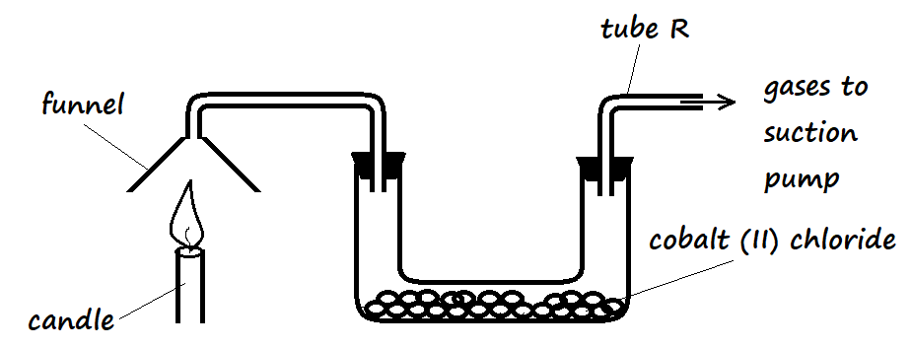

1. State the observation that was made in the U-tube (1 Mark)

___________________________________________________________________________

___________________________________________________________________________

1. Write a word equation for the reaction taking place in the U-tube (1 Mark)

___________________________________________________________________________

1. Name the gas that came out through tube **R** (1 Mark)

___________________________________________________________________________

1. Copper turnings were packed in a combustion tube connected to two syringes as shown in the diagram below. Syringe **R** contained 120cm3 of air while syringe **S** was empty.

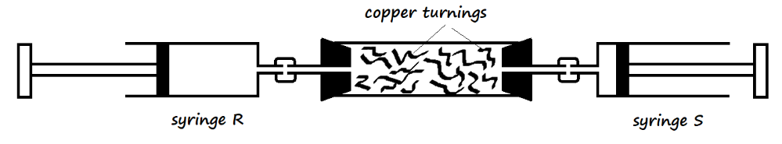

The copper turnings were heated strongly as air was being passed from syringe **R** to syringe **S** slowly and repeatedly, until there was no further change in volume of air in syringe **R**. The final volume of air was 95.5cm3.

1. Why was air passed over the heated copper turnings slowly and repeatedly? (2 Marks)

___________________________________________________________________________

___________________________________________________________________________

1. State **one** observation made in the combustion tube during the experiment (1 Mark)

___________________________________________________________________________

1. Determine the percentage of oxygen used during the experiment (2 Marks)

___________________________________________________________________________

___________________________________________________________________________

___________________________________________________________________________

1. The apparatus below was used to separate a mixture of liquid **A** and **B**

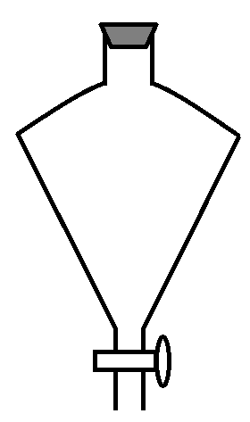

State **two** properties of the liquids that make it possible to separate them using this apparatus (2 Marks)

_____________________________________________________________________________

_____________________________________________________________________________

1. A mixture contains iron filings, sulphur, and table salt. Describe a procedure that a student can use to separate the mixture and recover all the components of the mixture. (3 Marks)

______________________________________________________________________________

______________________________________________________________________________

______________________________________________________________________________

______________________________________________________________________________

1. Draw **two** separate diagrams to differentiate a flat-bottomed flask of 250ml and a volumetric flask of 250ml (2 Marks)

|  |  |
| --- | --- |
| Flat-bottomed flask | Volumetric flask |
|  |  |

1. State the main use of a volumetric flask (1 Mark)

___________________________________________________________________________

___________________________________________________________________________

1. Flat bottomed flasks and volumetric flasks are made of glass. Explain (1 Mark)

___________________________________________________________________________

___________________________________________________________________________

1. The diagram below shows the cooling curve of a certain substance

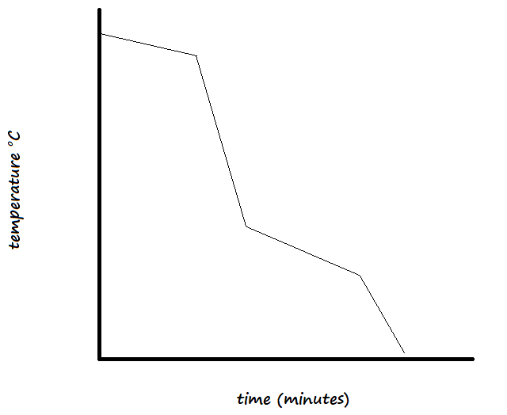

Is this substance pure or impure? Explain (2 Marks)

______________________________________________________________________________

______________________________________________________________________________

1. Write word equations for the following reactions: (3 Marks)
2. Sodium and water

___________________________________________________________________________

1. Calcium oxide and nitric acid

___________________________________________________________________________

1. Magnesium carbonate and hydrochloric acid

___________________________________________________________________________

1. Salt is normally sprinkled on roads during winter in temperate countries.
2. State and explain why salt is put on roads during winter (2 Marks)

___________________________________________________________________________

___________________________________________________________________________

1. Why is this practice of great concern to motorists (1 Marks)

___________________________________________________________________________

___________________________________________________________________________

1. Explain how each of the following components is removed from a sample of air, before the fractional distillation of liquefied air:
2. Carbon (IV) oxide (1 Mark)

___________________________________________________________________________

___________________________________________________________________________

1. Water vapour (1 Mark)

___________________________________________________________________________

___________________________________________________________________________

1. Solid impurities (1 Mark)

___________________________________________________________________________

___________________________________________________________________________

1. Why is it important to remove carbon (IV) oxide from the air sample? (1 Mark)

___________________________________________________________________________

___________________________________________________________________________

1. Name the constituent element in each of the following compounds:
2. Copper (II) sulphate (1½ Marks)

___________________________________________________________________________

1. Sodium nitrate (1½ Mark)

___________________________________________________________________________

1. Potassium iodide (1 Mark)

___________________________________________________________________________

1. Complete the table below (3 Marks)

|  |  |
| --- | --- |
| **English Name** | **Symbol** |
| Sodium |  |
|  | P |
| Lead |  |
|  | K |
|  | Au |
|  | Hg |

1. State the difference between a compound and a mixture (2 Marks)

___________________________________________________________________________

___________________________________________________________________________

___________________________________________________________________________

1. The diagram below represents a change

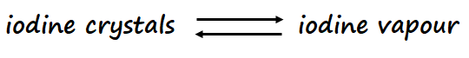

1. What type of change is represented above? (1 Mark)

___________________________________________________________________________

1. Give **four** characteristics of the change (2 Marks)

___________________________________________________________________________

___________________________________________________________________________

___________________________________________________________________________

___________________________________________________________________________

1. Give any **three** apparatus that are used to measure accurate volumes of liquids and solutions in the laboratory (3 Marks)

______________________________________________________________________________

______________________________________________________________________________

______________________________________________________________________________

1. Define the following:
2. Boiling point (1 Mark)

___________________________________________________________________________

___________________________________________________________________________

1. Matter (1 Mark)

___________________________________________________________________________

___________________________________________________________________________

1. Indicator

___________________________________________________________________________

___________________________________________________________________________

1. Substance **W** is highly soluble in propanone, while substance **M** has low solubility in propanone. Which of the two substances will travel the shortest distance on an adsorbent material during paper chromatography? Explain (3 Marks)

______________________________________________________________________________

______________________________________________________________________________

______________________________________________________________________________

1. Name the following apparatus and state its use in the laboratory (2 Marks)

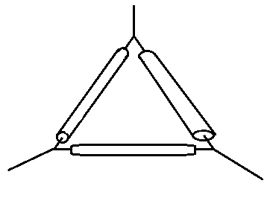

___________________________________________________________________________

___________________________________________________________________________

1. When separating solid copper (II) sulphate from a copper (II) sulphate solution, the solution was first heated then transferred to a water bath. Why was it important to heat the solution over a water bath? (2 Marks)

______________________________________________________________________________

______________________________________________________________________________

1. State **two** major differences between the properties of solids and those for gases (2 Marks)

______________________________________________________________________________

______________________________________________________________________________

1. After carrying out the process of distillation, describe how one can confirm that the distillate contains no dissolved solute (2 Marks)

______________________________________________________________________________

______________________________________________________________________________

1. Which method of separation can be used to obtain the following:
2. Petrol from crude oil (1 Mark)

___________________________________________________________________________

1. Oil from sunflower seeds (1 Mark)

___________________________________________________________________________

1. Distinguish between a homogenous mixture and heterogenous mixture (2 Marks)

___________________________________________________________________________

___________________________________________________________________________