**JOINT EVALUATION EXAM FORM 3 END TERM 3 - 2019**

**JULY/AUGUST 2018**

**121/2**

**MATHEMATICS PAPER 2**

**MARKING SCHEME**

1. No log

 2x0.4031=0.8062

83.45 1.9215

 2.7277

790.9  T.8296

7.909 x 10 =2.8981

2. 

 











3. 







4. 











5. 













6 







B is 

7.



8



9 

10. 

11. NC=

V

18cm

C

V

B

N

17.292cm

N

5cm

M

12. 

13. Let original number be 



14. 

15. 

16. 

17. (a). Taxable income 30,000+10480 =40,480

In $=2024

435x2= 870

435x3= 1305

435x4= 1740

435x5= 2175

284x6= 1704

Gross tax = 7794

(b). Net tax = 7794 – 800

=6994

(c). 870+1305+1740+2175+

New net tax = 13866 – 800

= 13066

Increase in tax = 13066 – 6994

= 6072

%tage increase = 

18

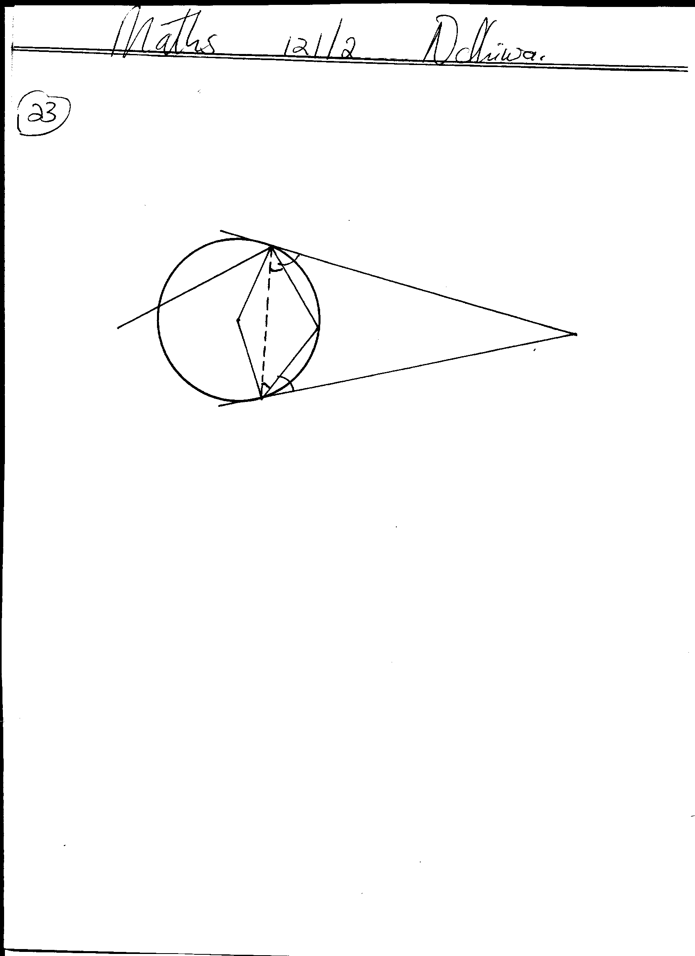

**R**

**T**

**U**

**S**

**P**

**Q**

**400**

**300**

**400**

**300**

a) ∠ QRS = 400 angles in alternate segment

b) ∠ RTQ = ½ (1800 – 400) = 700

angle at the centre is twice that subtended at the circumference.

c) ∠RPQ1800 – (70+70) = 400 angle sum of a triangle

d) Reflex ∠ QOR = 3600 – 1400 = 2200 angles at a point

e) ∠ TRO = (1800 – 700) = 550

2

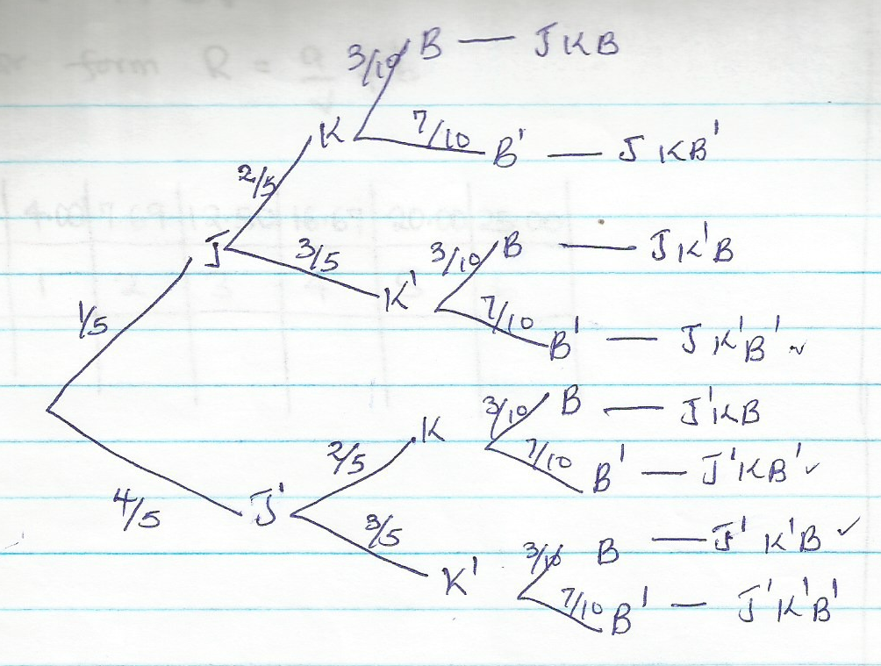Base angles of isosceles triangle

19 (a)

(b)(i) p

(ii). 

(iii) 

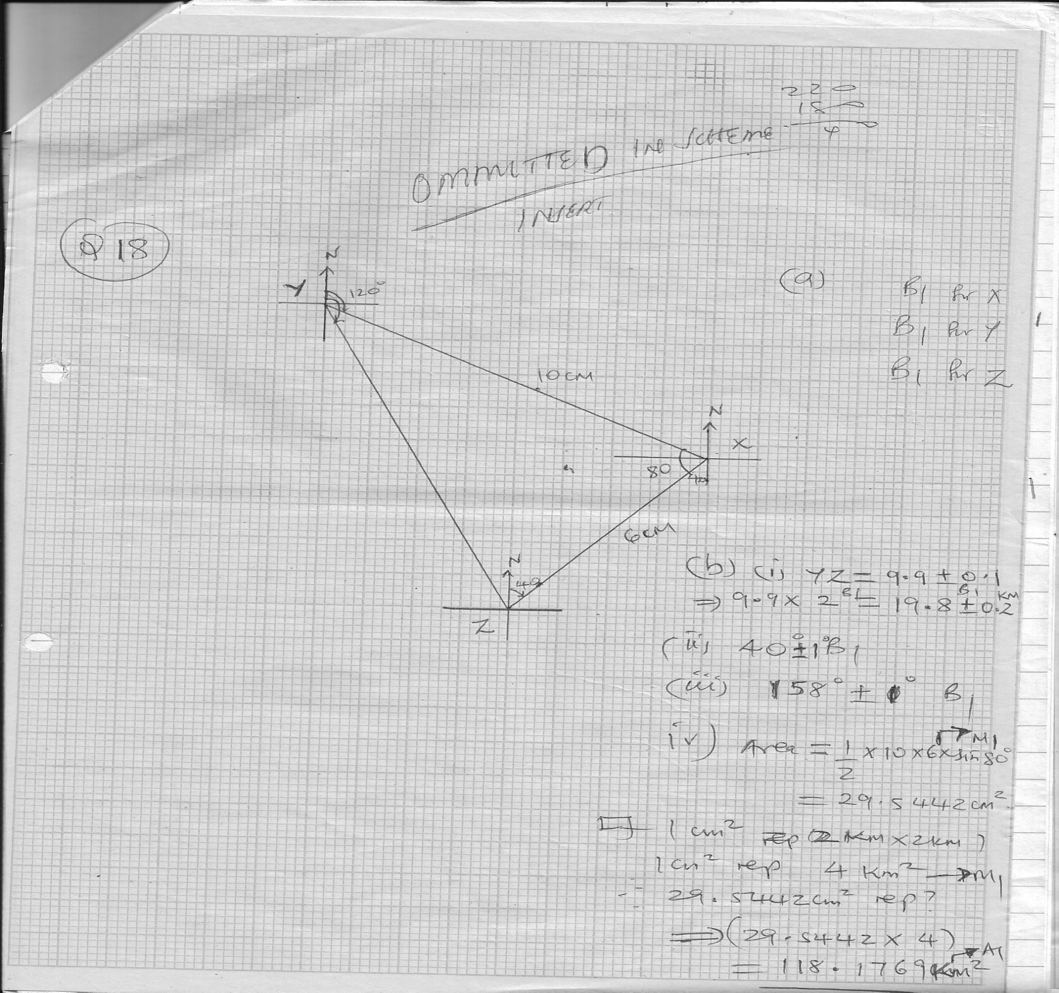

(a) B1 for x

B1 for y

B1 for Z

20.

(b) (i) YZ=9.90.1

9.9x2=19.80.2

(ii)401o

(iii)1581o

(iv) Area = ½ x10x6xsin80o

= 29.544cm3

21. (a). 

If 1cm2 rep 2kmx2km

1cm2 rep 4km2

29.544cm2 rep

(29.544x4)

= 18.176km2

[[[ (b)

(c). Sn = 

|  |  |  |  |  |  |  |  |  |
| --- | --- | --- | --- | --- | --- | --- | --- | --- |
| X | -3 | -2 | -1 | 0 | 1 | 2 | 3 | 4 |
| X2 | 9 | 4 | 1 | 0 | 1 | 4 | 9 | 16 |
| 2x2 | 18 | 8 | 2 | 0 | 2 | 8 | 18 | 32 |
| -3x | 9 | 6 | 3 | 0 | -3 | -6 | -9 | -12 |
| -5 | -5 | -5 | -5 | -5 | -5 | -5 | -5 | -5 |
| y | 22 | 9 | 0 | -5 | -6 | -3 | 4 | 15 |

22.

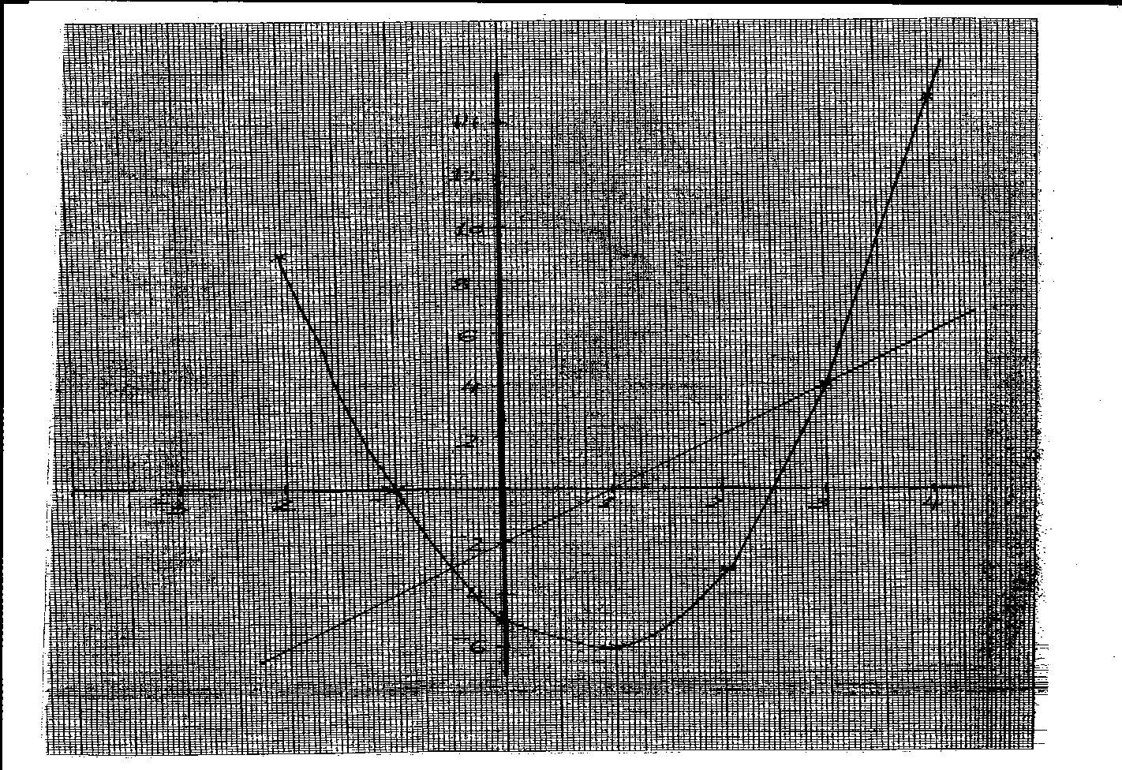

**P1**

**C1**

**L1**

**03**

**y= 2x2 – 3x – 5 = 0**

**y=2x-2**

1. y = 2x2 – 5x – 5

0 = 2x2 – 5x -5

Y=0

X=-1 or x = 2.5

1. y = 2x2 – 3x – 5

0 = 2x2 – 5x – 3

Y = 2x-2

X = -0.5 or x = 3

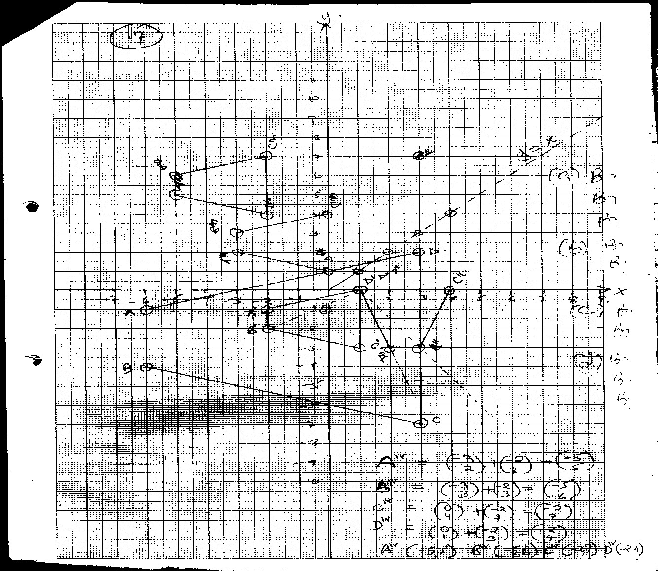

23.

24. V.S.F = 

L.S.F = 

A.S.F = (4/3)2 = 16/9

a) 

Curved S.A of larger container

9x = 16 x 112







b) Volume of hemisphere = 

= 452.57



Total volume of solid = 452.57 + 339.429

= 791.999cm3