Name: ………………………………………….. Class: ……..…..............................................

Date: …………………………………………Adm No: ……………………………………..

121/2
MATHEMATICS
PAPER 2

TIME: 2 HOURS 30 MINUTES

MWALIMU OGEKE YOUTUBE CHANNEL
MARCH 2022 KCSE PREDICTOR SERIES1 EXAMS
Kenya Certificate of Secondary Education (K.C.S.E.)
FORM FOUR

INSTRUCTIONS TO CANDIDATES:
- Write your name, admission number , Signature and write date of examination in the spaces provided
- The paper contains two sections. Section I and Section II.
- Answer ALL the questions in section I and any five questions in section II.
- Answers and working must be written on the question paper in the spaces provided below each question.
- Show all steps in your calculations below each question.
- Marks may be given for correct working even if the answer is wrong.
- Non programmable silent electronic calculators and KNEC mathematical table may be used, except where stated otherwise.

FOR EXAMINERS USE ONLY
SECTION I
Question | 1 | 2 | 3 | 4 | 5 | 6 | 7 | 8 | 9 | 10 | 11 | 12 | 13 | 14 | 15 | 16 | TOTAL
Marks
SECTION II
GRAND TOTAL

Question | 17 | 18 | 19 | 20 | 21 | 22 | 23 | 24 | TOTAL
Marks

SECTION I (50 Marks)
Answer all the questions in the spaces provided in this section.
- Use logarithm tables correct to 4 significant figures to evaluate. (3 Marks)
$$\frac{\sqrt[3]{0.07214 x 2.037}}{69.8}$$

- Solve for x in the equation (2 marks)
$$log (5x-15)-log(2x-3) =1$$

- Given that z varies directly as the square of x and inversely as the square root of y. If $x = 2$, $y = 9$ when $z = 3,$ find $z$ when $x= 3$ and $y = 4$. (3 marks)

- Evaluate (3 marks)

- In the figure below, AB is a diameter of the circle. Chord PQ intersects AB at N. A tangent to the circle at B and meets PQ produced at R.
Given that PN = 14 cm, NB = 4 cm and BR = 7.5 cm, calculate the length of;
- NR (2 marks)

- AN (2 marks)

- Calculate the semi-interquartile range of 3,4,1,2,3,6,8,5,7,9. (3 marks)

- Given that a = 3i – 2j + 3k and b = 2i - 4j – 3k where i, j and k are unit vectors,find
|2a + 3b| (3 Marks)

- Make x the subject of the formula in
a = ${\left(\frac{bx}{b+x}\right)}^{\frac{1}{3}}$
Hence find the value of x when a = 2 and b = 6. (4 Marks)

- Expand ${\left(a-x\right)}^{6}$ upto the term in${\left(x\right)}^{3}$. Use your expansion to estimate the value of ${\left(2.99\right)}^{6}$to 3 decimal places. (4 Marks)

- A coffee blender has two brands of coffee, Tamu and Chungu. A kilogram of Tamu costs Sh. 70 while a kilogram of Chungu costs Shs. 64. In what ratio should he mix the two brands to make a blend which costs Shs. 68 per kilogram? (2 Marks)

- Find the centre and radius of a circle whose equation is x²+ y²+ 8x + y² – 2y – 1 = 0 (3 Marks)

- The original area of an object after two successive transformations given by $\left[\begin{matrix}2 & 1 \\ 3 & 5\end{matrix}\right]$ and $\left[\begin{matrix}3 & 1 \\ 0 & 1\end{matrix}\right]$ in that order becomes 168 square units. Find the original area of the object.
(3 marks)

- Find the equation of the perpendicular bisector of line PQ where the co-ordinates of P and Q are P (-2, 8) and Q (4, 7). (3 Marks)

- The surface areas of two spheres are 36cm² and 49cm². If the volume of the smaller sphere is 20.2cm³, calculate the volume of the larger one. (2 Marks)

- During inter-school competitions, rugby and football teams from Ranje sec school took part. The probability that the rugby would win their first match was $\frac{1}{8}$ while that the handball team could lose was $\frac{4}{7}$. Find the probability that at least one team won the first match. (4 marks)

- In an experiment, water was heated and its temperature changes recorded at intervals of 2 minutes as shown in the table below.

Time (Min) | 0 | 2 | 4 | 6 | 8 | 10 | 12 | 14 | 16
Temperature ($℃$) | 25 | 35 | 42.5 | 50 | 60 | 67.5 | 77.5 | 85 | 92.5

- On the grid provided, plot the points and draw the line of best fit. (3 marks)

- Use the line of best fit to estimate the time taken for the temperature of the water to be $75℃$. (1 mark)

17. a) Complete the table below for the functions y =3 cos 2x + 2 and y=Sin 2x, giving your
answer values to two decimal places. (2mks)
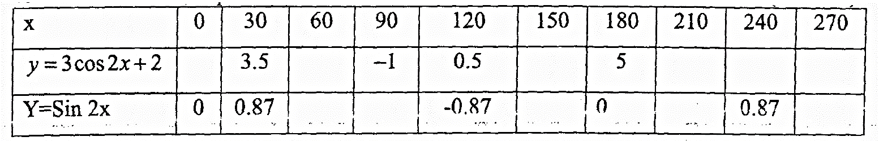
b) On the grid provided, draw the graphs of y =3 cos 2x +2 and Y=Sin 2x for (4 mks)
c) Use your graph to solve the equation: Sin 2x-2=3cos 2x for (2mks)

d) State the amplitude and the period of the wave y =3 cos 2x + 2 (2mks)
18. a) Three quantities P, Q and R are such that P varies directly as Q and inversely as the square root of R. Given that P = 2250 when Q = 450 and R = 64, write down an equation connecting P, Q and R. (4 marks)

(i) If Q is decreased by 16% and R increased by 44%, calculate the percentage change in P. (3 mks)

(b)In a soccer competition, the number of goals (G) scored in a penalty shoot — out is partly constant and partly varies as the skill (S) of the player. Given that G = 8 when S =2 and G = 12 when S= 4, find the value of G when S 6. (3 marks)

19. A transformation by the matrix maps A (0,0), B (2,0) C(2,3) and D (0,3) onto A¹ B¹ C¹ D¹ respectively.
(a) On the graph paper provided, draw quadrilateral ABCD and its image A¹B¹C¹D¹ (3mks)
(b) Hence or otherwise , determine the area of ABCD and A¹B¹C¹D¹ (3mks)

(c) A transformation represented by the matrix maps A¹B¹C¹D¹ on A²B²C²D². On the same axis draw the image of A¹B¹C¹D¹ (2mks)
(d) Determine the matrix of the single transformation which Maps A²B²C²D². onto ABCD. (3mks)

20. The diagram below shows the curve y = x³ - 3x² - 9x + k, where k is a constant. The curve has a minimum point on the x-axis.
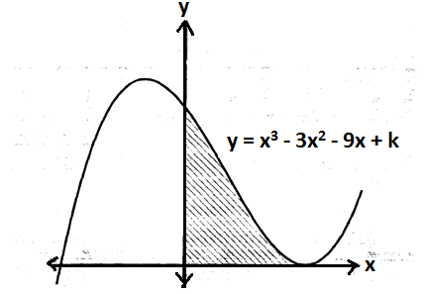

a) Find the value of k (5mks)

b) The coordinates of the maximum point of the curve. (2mks)

c) Find the area of the shaded region. (3 mks)

21. OPQ is a triangle in which OP=$P$and OQ=q. $x$ is a point on OP such that OP:XP=5:2 and y is another point on PQ such that PY:YQ=1:2. Lines OY and XQ intersect at T.
- Express the following vectors in terms of P and q
- $PQ$ (1 mark)

- $OY$ (1 mark)

- $OX$ (1 mark)

- If $OT=kOY$and $QT=hQX$ express $OT$ in two different ways. Hence or otherwise find the values of h and k. (6 marks)

- Determine the ratio OT:TY (1 mark)

22. If $\left(x-11/8\right)$, x and $\left(x+3/2\right)$ are the first three consecutive terms of a geometric progression;
- Determine the values of $x$ and the common ratio. (4 marks)

- Calculate the sum of the first 6 terms of this progression. (3 marks)

- Another sequence has the terms
-13, -16, -19, ……………………………-310.
Find the sum of this sequence. (3 marks)

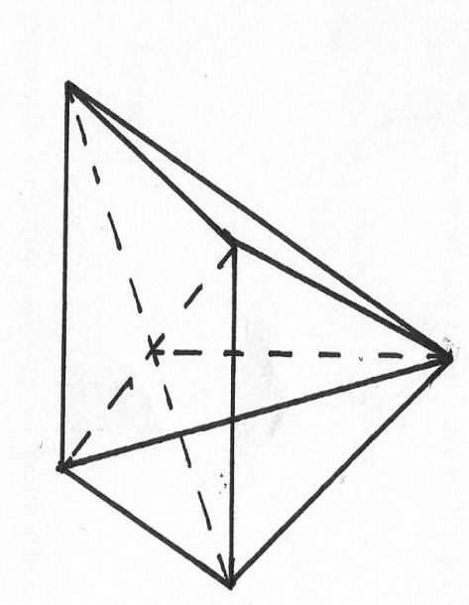
23. . ABCDE is a right pyramid on a horizontal square base of side 10 cm. The slant edges are all 8 cm long. Calculate;

(a) The height of the pyramid (3 marks)

(b) The angle between;
(i) A slant face and the base (2 marks)

(ii) A slant edge and the base (2 marks)

(c) The angle between the planes ABE and DCE (3 marks)

24.A transport company runs a fleet of two types of buses operating between Meru and Nairobi.Coach buses and Minibuses. A coach bus carries 52 passengers and 200kg of luggage while a minibus carries 32 passengers and 300kg of luggage. On one Saturday, there were 500 passengers with 3500 kg of luggage to be transported, the company could only use a maximum of 15 buses all together.
(a) if the company uses x coach buses and y minibuses write down all inequalities that satisfy the given conditions. (4mks)

(b) Represent the inequalities graphically in the grid provide
(use a scale of 1cm to represent 1 unit) (3mks)

(c) if the cost of running one coach bus is sh.7200 and that of running one minibus is sh. 6000
use the graph above to determine the minimum cost of running the vehicles (3 mks

