**Name**…………………………………… …………………………..………… Index No:………………………….

**121/2** Candidate’s Signature …………..……………

**MATHEMATICS** Date: …………………………

**PAPER 2**

**TIME: 2 ½ HOURS**

**121/2**

**Mathematics**

**Paper 2**

**2 ½ Hours**

**INSTRUCTIONS TO CANDIDATES**

* Write your **name** and **indexnumber** in the spaces provided at the top of the page.
* The paper contains two sections; section I and II.
* Answer ***all*** the questions in section I and any five questions from section II.
* All answers and working **Must** be written on the question paper in the spaces provided below each question.
* Non- programmable silent electronic calculators and **KNEC** mathematical tables may be used except where stated otherwise.
* Mark may be given for correct working even if the answer is wrong. .

**For Examiners Use Only**

**Section I**

|  |  |  |  |  |  |  |  |  |  |  |  |  |  |  |  |  |
| --- | --- | --- | --- | --- | --- | --- | --- | --- | --- | --- | --- | --- | --- | --- | --- | --- |
| 1 | 2 | 3 | 4 | 5 | 6 | 7 | 8 | 9 | 10 | 11 | 12 | 13 | 14 | 15 | 16 | Total |
|  |  |  |  |  |  |  |  |  |  |  |  |  |  |  |  |  |

**SectionIIGRAND TOTAL**

|  |  |  |  |  |  |  |  |  |  |
| --- | --- | --- | --- | --- | --- | --- | --- | --- | --- |
| Question | 17 | 18 | 19 | 20 | 21 | 22 | 23 | 24 | Total |
|  |  |  |  |  |  |  |  |  |  |

*This paper consists of 16 printed pages. Candidates should check to ascertain that all pages are printed as indicated and that no questions are missing.*

**SECTION I (50 MARKS)**

***Answer all questions in this section in the spaces provided.***

1. Use logarithms in all steps to evaluate. (4mks)



1. By using completing square method, solve for *x*in 4x2 – 3x – 6 = 0 (3mks)
2. Make **p** the subject in T =  (3mks)
3. If  -  = a + b 

Find the value of **a** and **b** where **a** and **b** are rational numbers. (3mks)

1. (a) Find the first three terms in ascending powers of *x* of ( 2 –x)5 (1mk)

(b) Hence find the value of the constant **k**, for which the coefficient of ***x*** in the expansion of

( k + x) (2- x)5 is - 8 (2mks)

**~**

**~**

1. **OA** = 3i + 4j – 6k and **OP** = i + 15k. **P** divides **AB** in the ratio 3 : – 2. Write down the coordinates of **B**. (3mks)

**~**

**~**

**~**

**~**

**~**

1. Simplify **(3 marks)**



1. Find the relative error in the area of a parallelogram whose base is 8cm and height 5cm. (3mks)
2. (a) Find the inverse of the matrix **(1 mark)**

(b) Hence solve the simultaneous equation using the matrix method **(2 marks)**

4x +3y = 6

3x + 5y = 5

1. A straight line L1 has its X intercept a = -3 and its y-intercept b = 5.
2. Write the equation of L1 in the form
3. Find the equation of another line L2 which passes through (1, -2) and is perpendicular to L1 (3mks)
4. Use reciprocals, squares and square root tables only to evaluate (3mks)
5. Using a ruler and a pair of compasses only construct triangle ABC such that BC=6cm, <ABC=75o and BCA=45o. Drop a perpendicular to BC from A to meet BC at O hence find the area of triangle ABC (3mks)
6. A two digit number is such that the difference between the ones digit and the tens digit is 2. If the two digits are interchanged, the sum of the new and the original number is 132. Find the original number (3mks)
7. A quantity P varies partly as the cube of **Q** and partly varies inversely as the square of **Q**. when **Q** = 2, **P** = 108 and when **Q** = 3, **P** = 259. Find the value of **P** when **Q** = 6. (3mks)
8. Solve for *y* in the following equation below: (4mks)

logy + log4 = 2

1. Obtain the values of *x* for which the matrix is singular (3mks)

x3 x

1 1

**SECTION II (50 MARKS)**

***Answer any five questions in this sections in the spaces provided.***

1. The table below shows income tax rates.

|  |  |
| --- | --- |
| Monthly taxable income | Rate of tax( Ksh/£) |
| 1 – 435  436 – 870  871 - 1305  1306 – 1740  Excess over 1740 | 2  3  4  5  6 |

An employee earns a monthly basic salary of sh. 30,000 and is also entitled to taxable allowances amounting to Ksh. 10,480.

1. Calculate the gross income tax (4mks)
2. The employee is entitled to a personal tax relief of Ksh. 800 per month. Determine the net tax.(2mks)
3. If the employee received a 50% increase in his total income, calculate the parentage increase on the income tax. (4mks)
4. In the figure below, **O** is the centre of the circle. **PQ** and **PR** are tangents to the circle at **Q** and **R** respectively. ∠**PQS** = 40 and ∠**PRS** = 300. **RTU** is a straight line.

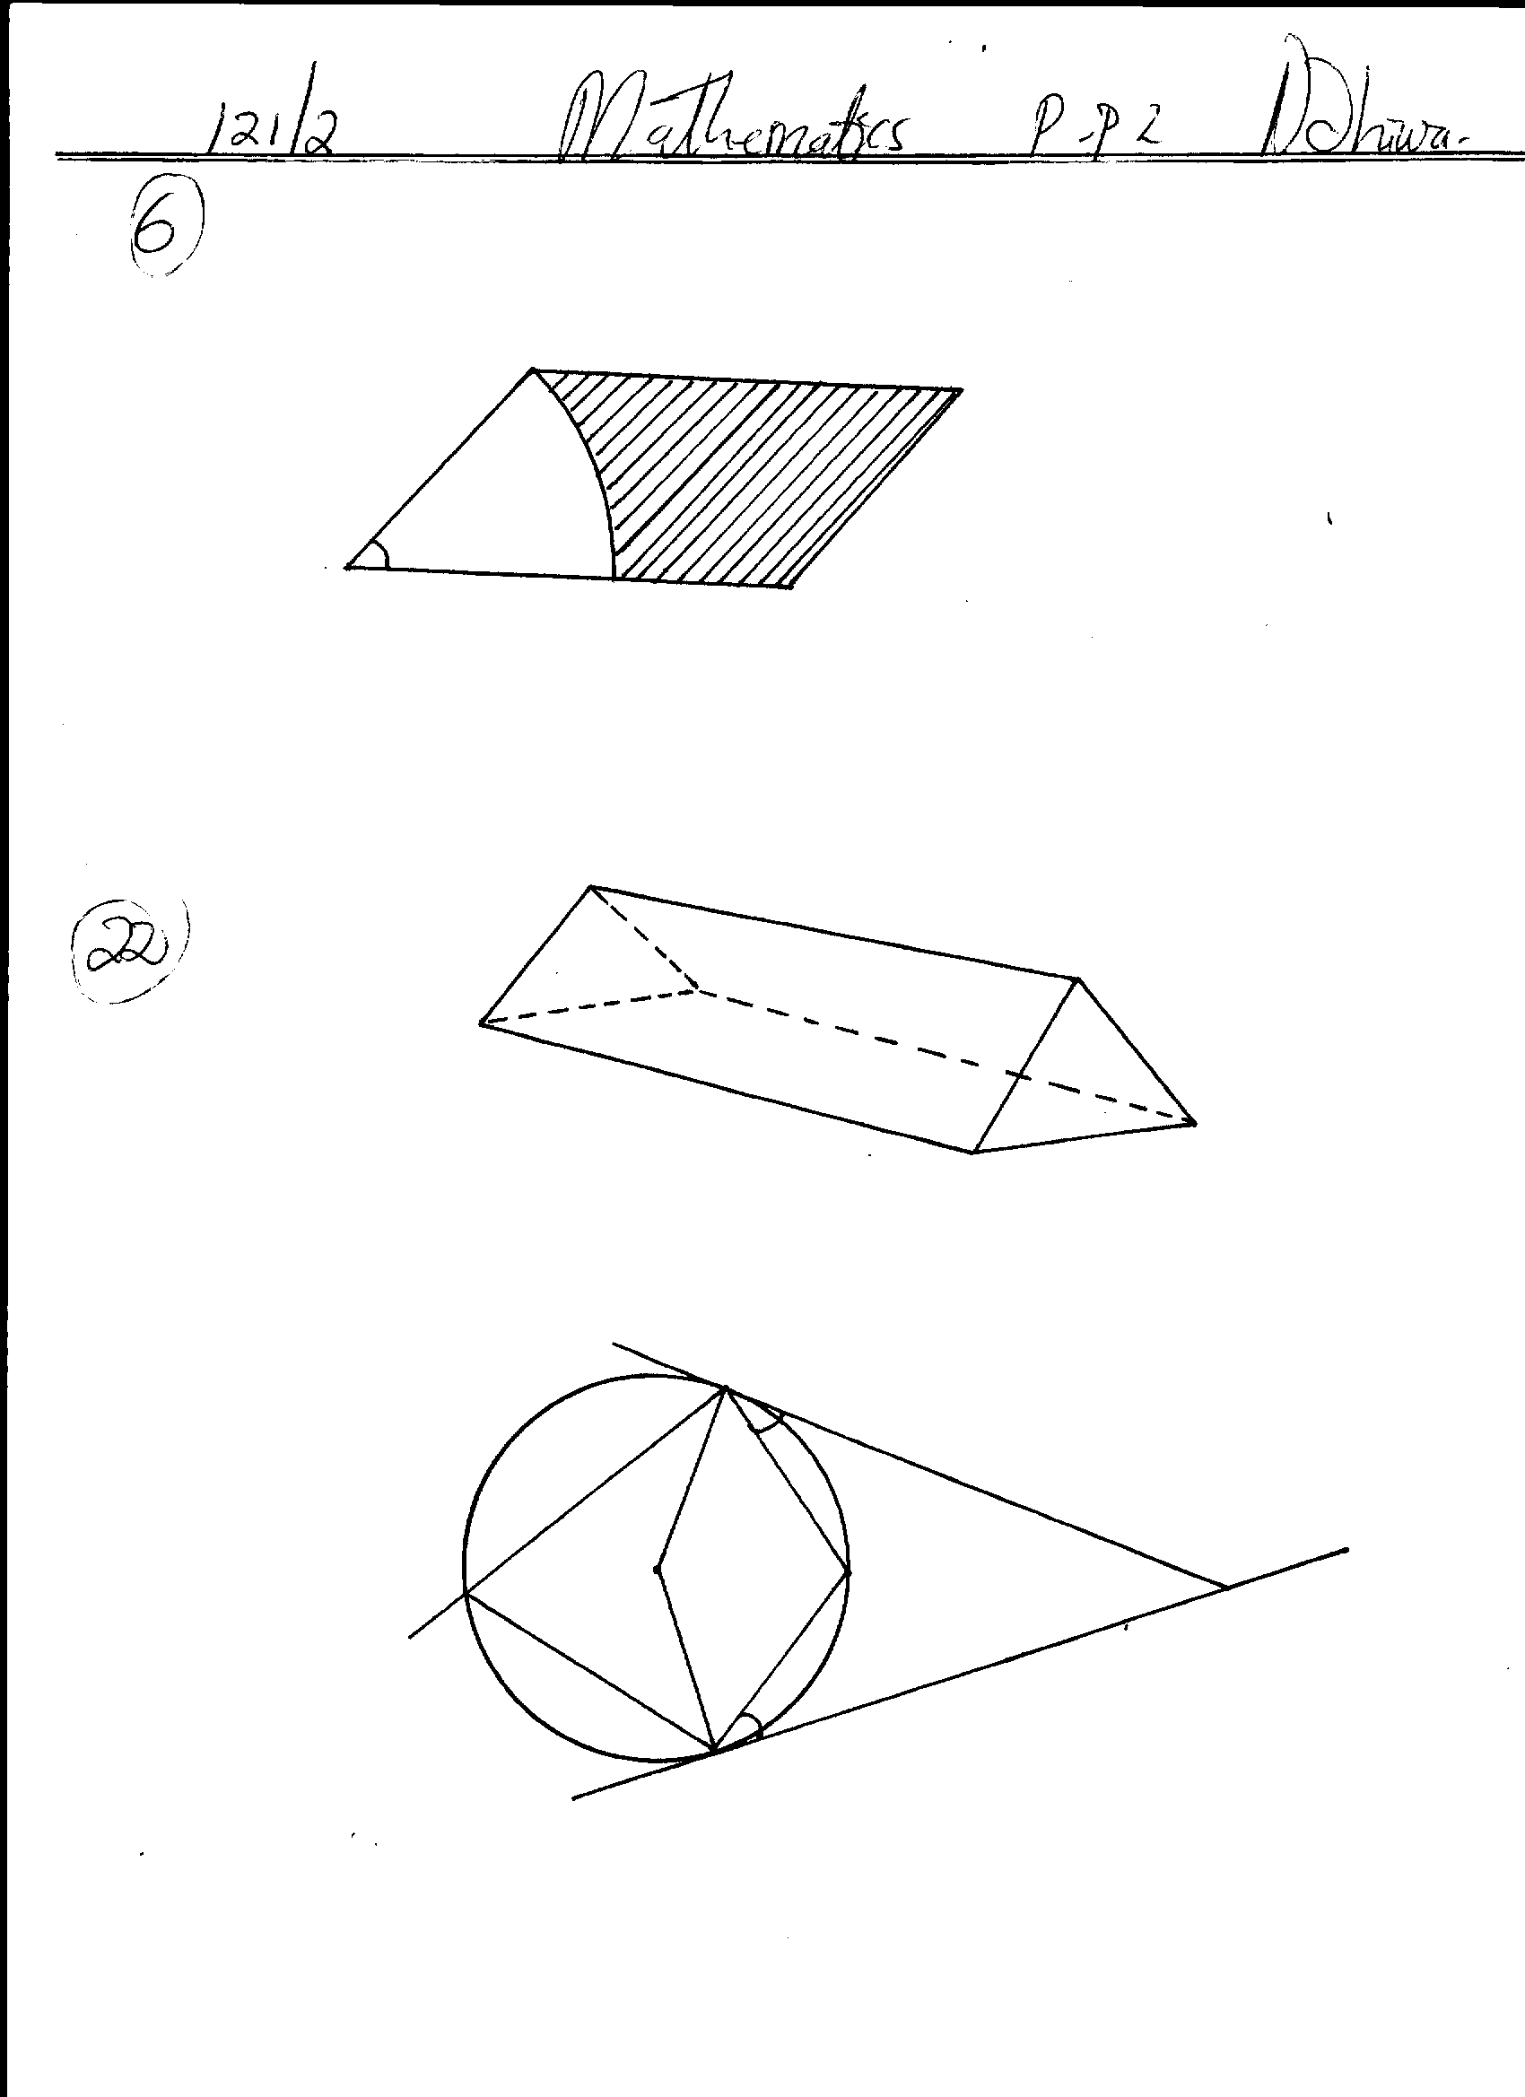

**U**

**T**

**R**

**P**

**O**

**Q**

**S**

**400**

**300**

Calculate by giving reasons

(a) ∠**QRS** (2mks)

(b) ∠**RTQ** (2mks)

(c) ∠**RPQ** (2mks)

(d) Reflex ∠**QOR** (2mks)

(e) ∠**TRO** given that **TR** = **TQ** (2mks)

1. Three darts players Jane, Kelly and Brony are playing in a completion the probability that Jane, Kelly and Brony hit the bull’s eyes is , and respectively.
2. Draw a probability tree diagram to show all the possible outcomes for the players. (4mks)
3. Calculate the probability that :
4. Jane or Brony hit the bull’s eye. (2mks)
5. All the three fail to hit the bull’s eye. (2mks)
6. Only two fails to hit the bull’s eye. (2mks)

20. Three towns **X, Y** and **Z** are such that **X** is on a bearing of 1200 and 20km from **Y.** Town **Z** is on a bearing of 2200 and 12cm from **X**

(a) Using a scale of 1cm to represent 2km, show the relative position of the places (3mks)

(b) Find;

(i) The distance between **Y** and **Z** (2mks)

(ii) The bearing of **X** from **Z** (1mk) (iii) The bearing of **Z** from **Y** (1mk)

(iv) The area of the figure bounded by **XYZ** (3mks)

1. The fourth, seventh and sixteenth term of an arithmetic progression are in geometric progression. The sum of the first six terms of the arithmetic progression is 12.

Determine the

1. First term and the common difference of the arithmetic progression. (6mks)
2. Common ratio of the geometric progression. (2mks)
3. Sum of the first six terms of the geometric progression. (2mks)

22. Draw the graph of *y = 2x2 - 3x - 5* taking the values of ***x***in the interval -2 ≤ x ≤ 4. (5mks)

1. Use the graph in to solve the equation 2x2 - 3x - 5 = 0 (2mks)

(c) Using a suitable straight line, solve the equation 2x2 - 5x - 3 = 0 (3mks)

23. Draw the quadrilateral with vertices at **A** (-6,-1) **B** (-6,-4) **C**(3,-7) and **D** (3,2).

1. On the same grid draw the image of **ABCD** under enlargement centre (0,-1) scale factor 1/3 label the image **A1 B1 C1 D1** (3mks)
2. Draw **A11B11C11D11** the image of **A1 B1 C1 D1**under rotation of +ve 900 about (1,0) (2mks)
3. Draw **A111B111C111D111** the image of **A11 B11 C11 D11**under a reflection in the line y-x = 0 (2mks)
4. Draw **A1VB1VC1VD1V** the image of **A111 B111 C111 D111**under translation (2 3) and write the co-ordinate of the final image. (3mks)

24. The volume of two similar solid cylinders are 4096cm3 and 1728cm3.

(a) If the curved surface area of the smaller one is 112cm2. Find the height of the larger cylinder if the radius is 7cm. (4mks)

b) The diagram below represents a solid made up of a hemisphere mounted on a cone. The radius of

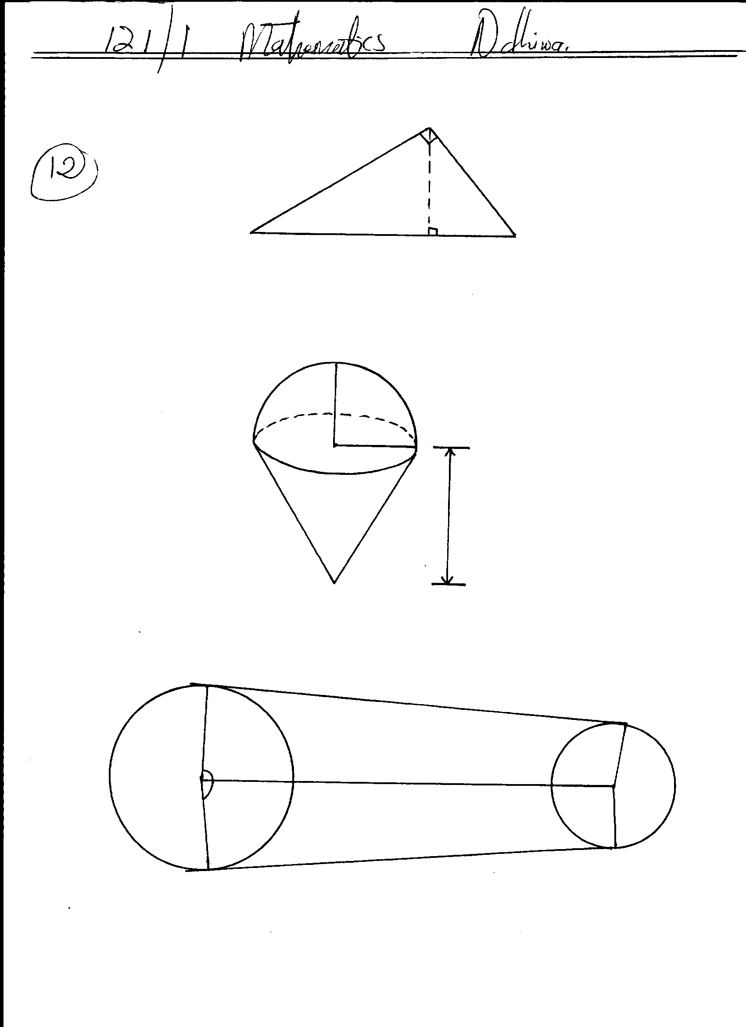

**r = 6cm**

**9cm**

the hemisphere and cone are each 6cm, and the height of the cone is 9cm.

Calculate the volume of the solid. Take π = 22 (6mks)

7