**NAME …………………… …………………………………ADM NO ………………………….…….**

**SCHOOL.……………………………………………………CANDIDATE’S SIGN……...……………**

**DATE……………………………………..**

**121/1   
MATHEMATICS ALT. A  
Paper 1   
Nov-Dec-2021**

**Time: 2 ½ Hours**



**CEKENAS END OF TERM TWO EVALUATION EXAM-2021**

**FORM FOUR EXAM**

***Kenya Certificate of Secondary Education.(K.C.S.E***

**MATHEMATICS ALT. A  
Paper 1   
INSTRUCTION TO CANDIDATES**

*a) Write your name and Index number in the spaces provided above.   
b) Sign and write the date of examination in the spaces provided above.   
c) The paper consists of* ***two*** *sections.* ***Section I*** *and* ***Section II.*** *d) Answer* ***ALL*** *the questions in Section I and any* ***FIVE*** *questions in Section II.   
e) Show all the steps in your calculations, giving your answer at each stage in the spaces provided*

*below each question.   
f) Marks may be given for correct working even if the answer is wrong.   
g) Non-programmable silent electronic calculators and KNEC Mathematical tables may be used*

*except where stated otherwise.   
h) Candidates should answer the questions in English.*

***i) This paper consists of 16 printed pages.***

***j) Candidates must check the question paper to ascertain that all pages are printed as indicated***

***and that no question(s) is/are missing***

**FOR EXAMINER’S USE**

**SECTION I**

|  |  |  |  |  |  |  |  |  |  |  |  |  |  |  |  |  |
| --- | --- | --- | --- | --- | --- | --- | --- | --- | --- | --- | --- | --- | --- | --- | --- | --- |
| 1 | 2 | 3 | 4 | 5 | 6 | 7 | 8 | 9 | 10 | 11 | 12 | 13 | 14 | 15 | 16 | **Total** |
|  |  |  |  |  |  |  |  |  |  |  |  |  |  |  |  |  |

**SECTION II**

|  |  |  |  |  |  |  |  |  |
| --- | --- | --- | --- | --- | --- | --- | --- | --- |
| 17 | 18 | 19 | 20 | 21 | 22 | 23 | 24 | **Total** |
|  |  |  |  |  |  |  |  |  |

**Grand Total**

**SECTION I: (50MKS)**

**ATTEMPT ALL THE QUESTIONS FROM THIS SECTION**

1. Without using mathematical tables or calculator, evaluate (3mks)



2. Without using mathematical tables or calculator, evaluate (3mks)



3. The currency exchange rates of a given bank in Kenya are as follows

|  |  |  |
| --- | --- | --- |
| Currency | Buying | Selling |
| 1 Sterling pound | 135.50 | 135.97 |
| 1 US dollar | 72.23 | 72.65 |

A tourist arrived in Kenya with 5000 US dollars which he converted to Kenya shillings upon arrival. He spent Kshs, 214,000 and converted the remaining to sterling pounds. How many pounds did he receive. (3mks)

4. Without using mathematical tables or calculator evaluate  (3mks)

5. Simplify  (3mks)

6. The base of a right pyramid is a rectangle of length 96cm and width 72cm. Each slant edge of the pyramid is 156cm. Calculate the volume of the pyramid. (3mks)

7. John bought two shirts and three pairs of trouser at Ksh 1750. IF he had bought three shirts and two pairs of trousers, he would have saved Khs 250. Find the cost of a shirt and a trouser. (3mks)

8. Three litres of water (density 1g/cm3) is added to twelve litres of alcohol. (density 0.8g/cm3). What is the density of the mixture? (3mks)

9. List the integral values of x which satisfy the inequalities below. (3mks)

 

10. Point B is 6 kilometers from A on a bearing of 1500. Point C is 5km from A on a bearingof 1200. Using a scale drawing of 1cm to represent 1km, find the distance of C from B. (3mks)

11. Charles keeps goats and sheep. The number of goats exceeds the number of sheep by 4, during drought ¼ of the goats and 1/6 of the of the sheep died. If he lost a total of 64 animals, how many animals did he have originally. (4 mks)

12. Give that x is acute angle and  without using mathematical tables or calculator find Tan (90-x). (2mks)

13. Without using mathematical tables or calculator evaluate . (3mks)



14. The gradient of the tangent to the curve y=ax3 +bx at point (1,1) is -5. Calculate the value of a and b. (4 mks)

15. The sum of interior angles of a regular polygon is 24 times the size of an exterior angle.

(a) Find the number of sides of the polygon (3mks)

(b) Name the polygon (1 mk)

16. A rally car travelled for 2hrs 40minutes at an average speed of 120km/h. The car consumes an average of a litres for every 4 kilometers. A litre of fuel cost Ksh 60. Calculate the amount of money spent on fuel. (3mks?)

**SECTION II**

***ANSWER ANY FIVE QUESTIONS***

17. Three business business partners Kamau, Tatwa and Makau contributed Kshs 100,000, Ksh 80,000 and Ksh 50,000respectively to start a business. After one year the business realized a profit in which they shared in the ratio of their contributions.

(a) If Makau’s share of profit was Ksh. 20,000, how much was the total amount of profit? (3mks)

(b) At the beginning of the second year, Makau boosted his shares by Ksh. 10,000. If the business profit increased by 20% at the end of the second year. Calculate

(i) Kamau’s share of the profit. (4mks)

(ii) The difference between Kamau’s and Tatwa’s share of the profit. (3mks)

18. The following data was obtained from masses of some pregnant women in maternity clinic.

|  |  |  |  |  |  |
| --- | --- | --- | --- | --- | --- |
| Masses X (Kg) |  |  |  |  |  |
|  | 16 | 20 | 18 | 14 | 15 |

(a) Represent the information in the table above on a histogram on the graph paper provided.

(6mks)

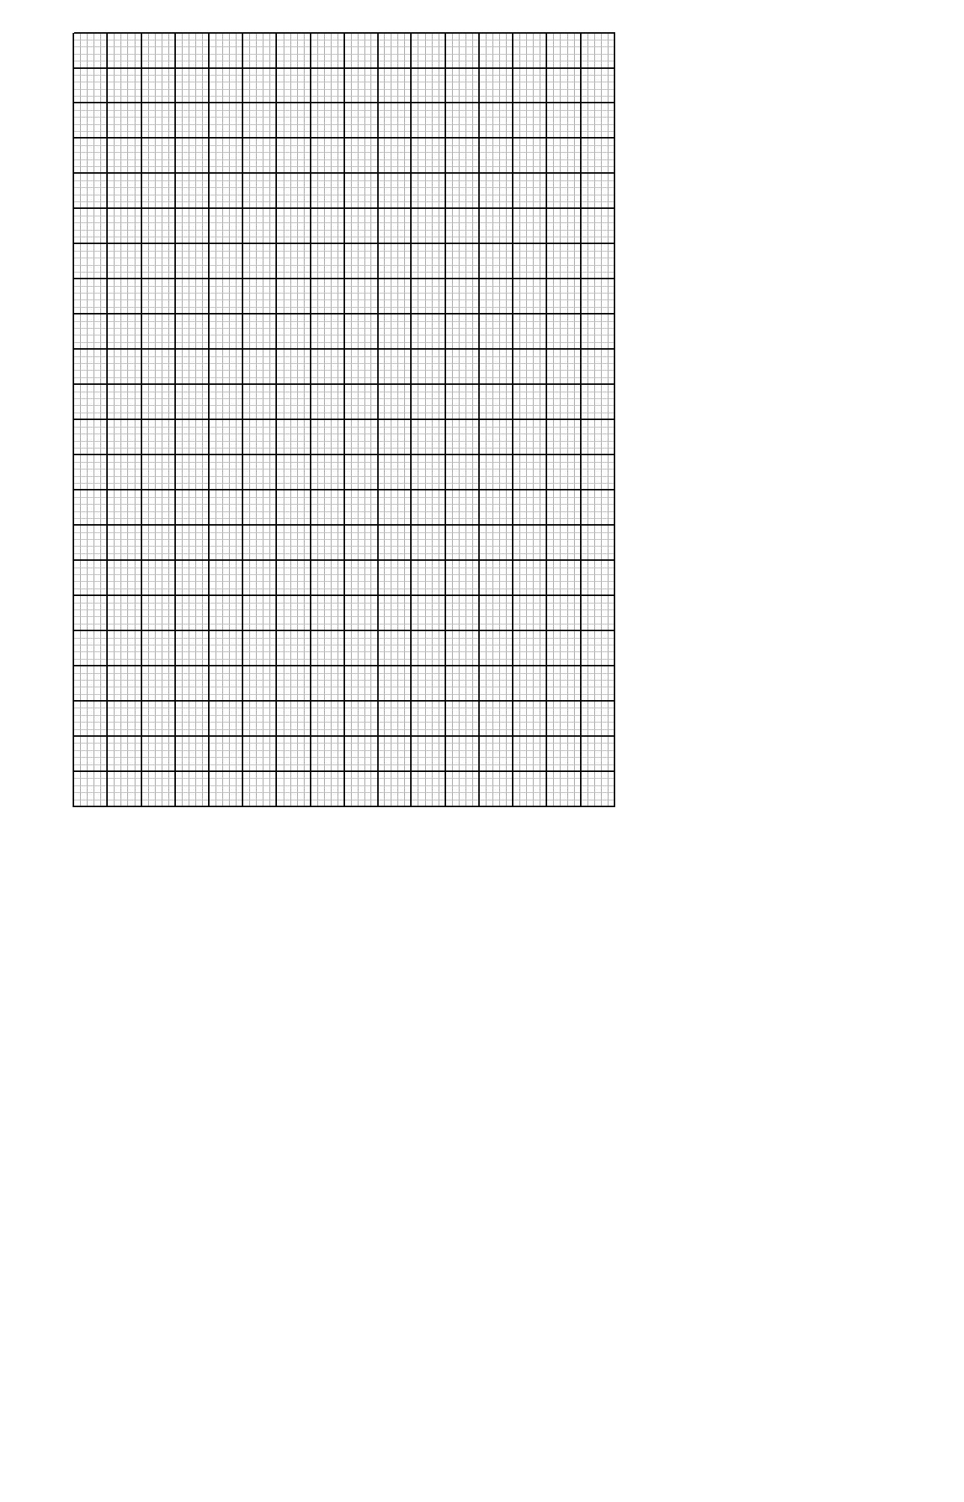

(b) Use the information in the table above to estimate

(i) The mean mass (2mks)

(ii) The median mass (2mks)

19. The figure below is a frustum of a solid cone of the base radius 24cm and top radius 8cm. The height of the frustum is 10.5cm. (Take )

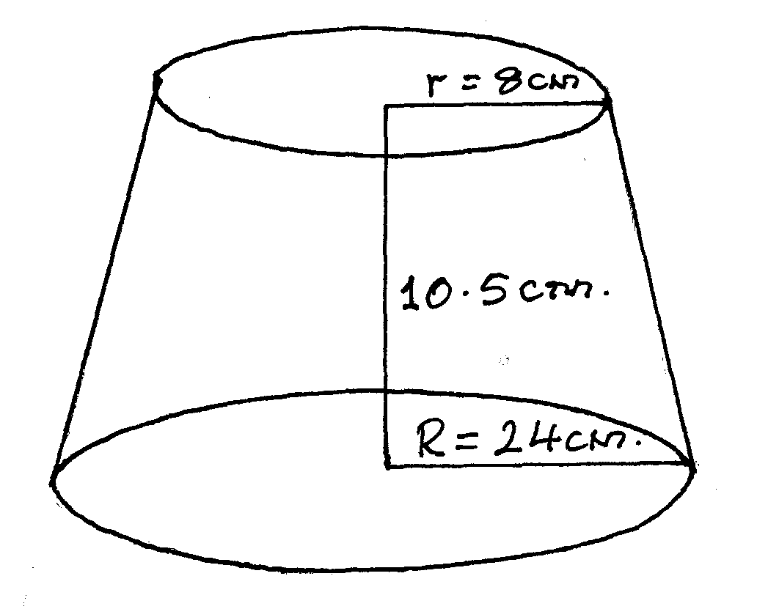

Calculate

(i) The height of the cone of the frustum was part of (2mks)

(ii) The slant height of the cone of the frustum was part of. (1mk)

(iii) The surface area of frustum (4 mks)

(iv) The volume of the frustum. (3mks)

20. The figure below shows two equal circles of radius 7cm, each with centres at X and Y. The two circles are in Contact at Q.

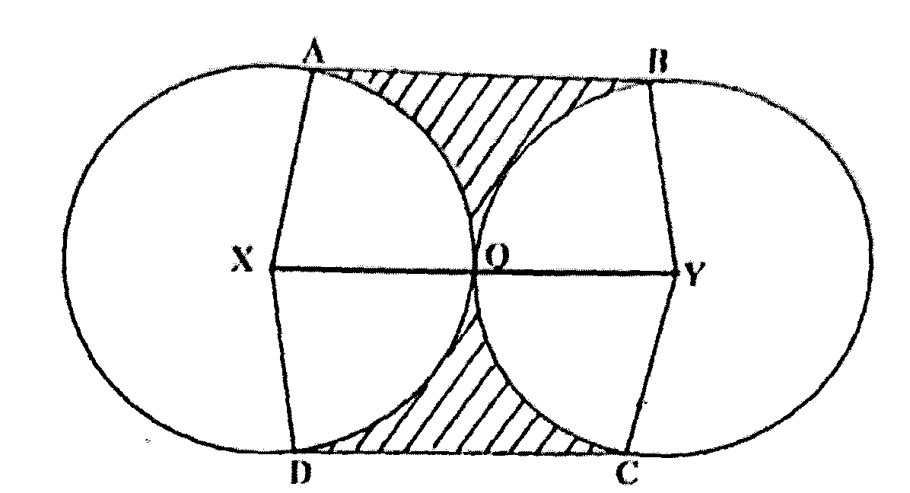

Given that angle AXD = angle BYC= 1200 and lines AB, XQY and DC arc parallel. Calculate the area of:

(a) The minor sector XAQD (Take ) (2mks)

(b) The trapezium XABY. (5mks)

(c) The shaded region. (3mks)

21. A particle start from rest and moves in a straight line. Its velocity Vms-1 is given by V=t2 -3t+2 where t is the time in seconds taken from point O.

(a) Find

(i) The velocity when t=3 (2mks)

(ii) The displacement from O when t=3 (3mks)

(iii) The acceleration of the particle when t= 3 (2mks)

(b) At what time is the particle momentarily at rest. (3mks)

22. The distance between towns M and N is 280km. a car and a lorry travel from M to N. The average speed of the lorry is N. The average speed of the lorry is 20km per hour less than that of the car. The lorry takes one hour and ten minutes more than the car to travel from M to N.

(a) If the speed of the lorry is Xkm per hours find X. (6mks)

(b) The lorry left town M at 8.1 5am. The car left town M and overtook the lorry at 12.1 5p.m. Calculate the time the car left town M. (4mks)

23. In the figure below, AB=16cm, AC=12cm, AD=14cm, CD=5.64cm and <CAB=500

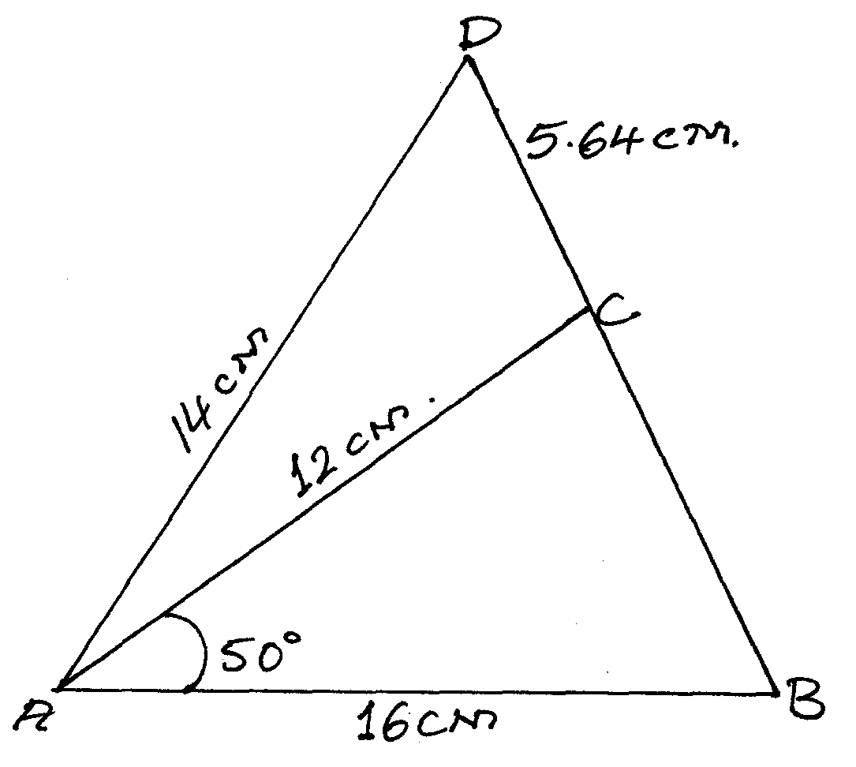

Calculate to one decimal place.

(a) The length BC (2mks)

(b) The size of angle ABC (3mks)

(c) The size of angle CAD (3mks)

(d) The area of triangle ACD (2msk)

24. (a) Express  in the form ax2 +bx+c= 0 where a, b and c are constants, hence solve for x. (4 mks)

(b) Wamuyu did M test and scored a total of 240 marks. She did two more tests which she scored 28 and 26 respectively. The mean score of the first M test was 6 more than the mean score for all the test she did. Find the total number of test that she did. (6mks)

**THIS IS THE LAST PRINTED PAGE**