MEASUREMENT I

1. 1995 Q1 P1
Name the instrument that would be most suitable for measuring the
thickest of one sheet of this question paper. (1 mark)

2. 1995 Q7 P1
State the assumption made when calculating the size of a molecule in
the thin oil film experiment (1 mark)

3. 1996 Q1 P1
The micrometer screw gauge represented by figure 1 has thimble
scale of 50 divisions. What is the reading shown (1 mark)
4. 1996 Q3 P1
State two factors that should be controlled in manufacturing a
cylindrical container of uniform thickness, which should normally
be in a standing position?

5. 1997 Q1 P1
Figure 1 shows a measuring cylinder, which contains water initially
at level A. A solid of mass 11 g is immersed in the water, the level rises to B

Determine the density of the solid. (Give your answer to 1 decimal place) (3 marks)

6. 1997 Q4 P1
A butcher has a beam balance and masses 0.5 kg and 2kg. How would
he measure 1.5 kg of meat on the balance at once?

7. 1998 Q1 P1
Figure 1 shows a fencing post whose length is being measured using
a strip of a measuring tape.

Use this information to answer questions 7 and 8.
State the accuracy of the tape: (1 mark)

8. 1998 Q2 P1
What is the length of the post? (1 mark)

9. 1998 Q2(b) P2
Fig. 1 shows a block with a graduated side, and of dimension
4cm x 4cm x 16cm, just about to be lowered into a liquid contained
in an overflow can.

During an experiment with this set-up, the following information was recorded;
-The block floated with three quarters of it submerged
-Initial reading of balance=0 grammes
-final reading of balance= 154 grammes.

Use the information to determine the density of the:
(i) Block (7 marks)
(ii) Liquid (2 marks)

(Use g= 10ms² . give your answers to 1 decimal place.)

10. 2000 Q1 P1
Fig 1 shows part of a measuring cylinder calibrated in cm³ containing
water whose level is indicated. Some 3.0cm of is added into the
cylinder. Indicate on the diagram the new level of water. (1 mark)

11. 2001 Q1 P1
Fig. 1 shows a burette partly filed with a liquid. The burette was
initially full to the mark O. If the quantity of the liquid removed has
a mass of 22g, determine the density of the liquid. (3 marks)
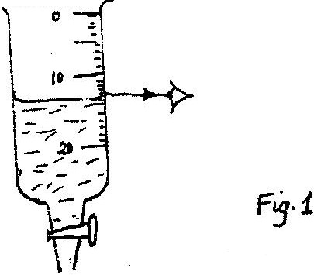

12. 2001 Q3 P1
Fig 3 shows two identical hollow spheres. Spheres A is completely
filled with the liquid while B is partly filled with identical liquid.
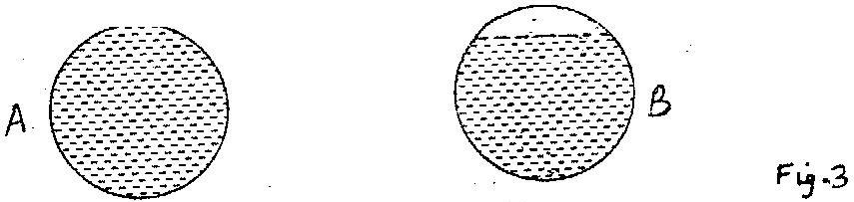

When the two spheres are rolled gently on a horizontal surface. It is
observed that the sphere B stops earlier that the sphere A. Explain
this observation.

13. 2001 Q3a P2
You are provided with the following:
A large shallow tray Water Lycopodium powder Some olive oil.
Either a piece of thin wire with a kink and a millimetre scale or a
Burette, a metre rule.

Describe an experiment to estimate the diameter of a molecule of the Olive oil.

14. 2003 Q1 P1
Figure 1 shows a measuring cylinder containing some liquid
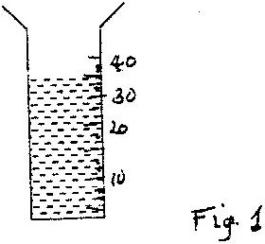

Another 5cm³ of the liquid is added into the cylinder. Indicate on
the diagram the new level of the liquid. (1 mark)

15. 2005 Q1 P1
Figure 1 shows the reading on a burette after 55 drops of a liquid
have been used.
If the initial reading was at Zero mark, determine the volume of one drop.
(2 marks)
16. 2006 Q1 P1
Figure 1 shows the change in volume of water in a measuring cylinder
when an irregular solid is immersed in it.
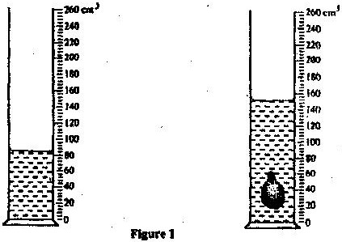

Given that the mass of the solid is 567 g, determine the density of the
solid in gcm⁻³
(Give your answer correct to 2 decimal places) (3 marks)

17. 2006 Q14b,c P1
(b) In an experiment to estimate the diameter of an oil molecule, an oil
drop of diameter 0.05 cm spreads over a circular patch whose diameter
is 20 cm
Determine
(i) The volume of the oil drop (2 marks)
(ii) The area of the patch covered by the oil (2 marks)
(iii) The diameter of the oil molecule (3 marks)

(c) State
(i) Any assumption made in (b) (iii) above (1 mark)
(ii) Two possible sources of errors in this experiment (2 marks)

18. 2008 Q1 P1
A drug manufacturer gives the mass of the active ingredient in a tablet
as 5 mg. Express this quantity in kilogramme and in standard form. (1 mark)
19. 2008 Q2 P1
The masses of equal volumes of a certain liquid and of water were
found to be my and m_{w} respectively. Given that the density of water
is 1gcm⁻³, express the density, p, of the liquid in terms of m_{v} m_{w}
(show your work) (2 marks)

20. 2009 Q1 P1
In an experiment to measure the density of a liquid, a student filled
a burette with a liquid to the 0cm³ mark . Figure 1 shows a section
of the burette showing the level of the liquid after 54.5g of the liquid
had been run out.

Determine the density of the liquid. (3 marks)

21. 2010 Q2 P1
A stop watch started 0.50s after the started the start button was
pressed. The time recorded using the stopwatch for a ball bearing
failing through a liquid was 2.53s. Determine the time of fail. (3 marks)
22. 2010 Q9 P1
When a drop of oleic acid of known volume is dropped on the
surface of water in a large trough, it spreads out to form a large
circular patch. State one assumption made when the size of the
molecule of oleic acid is estimated by determining the area of the patch.

23. 2010 Q16 P1
In an experiment to determine the density of sand using a density
bottle, the following measurements were recorded:

Mass of empty density bottle - 43.2g
Mass of density bottle full of water = 66.4g
Mass of density bottle with some sand = 67.5g
Filled up with water = 82.3g

Use the above data to determine the:
a) Mass of the water that completely filled the bottle: (2 marks)
b) Volume of water that completely filled the bottle: (1 mark)
c) Volume of the density bottle: (1 mark)
d) Mass of sand
e) Mass of water that filled the space above the sand. (1mark)
f) Volume of the sand:
g) Density of the sand (2 marks)

24. 2011 Q18 (a) P1
Figure 15 shows a metal bolt which is threaded.

Explain how a metre rule can be used to measure the pitch (distance
between peaks) of the threading. (2 marks)

25. 2012 Q1 P1
Figure 1 shows a measuring cylinder containing some water.
Determine the reading on the measuring cylinder, after three drops of
water each of volume 0.6cm³ are added (2 marks)

26. 2012 Q18a P1
(a) Figure 12 shows a set up used to determine the mass of a solid S. The
rod is pivoted at its centre of gravity C.

- State two measurements that need to be made to determine the
mass of solid S. (1 mark)

- Write an expression to show how the measurements in (i) above
are used to obtain the mass of S. (2 marks)

27. 2014 Q1 P1
A student measured the length of a wire four times using a metre rule and
obtained the following readings: 18.6cm; 18.5cm; 18.6cm and 18:5cm.
Determine the length the student should record.
(2 marks)
28. 2015 Q2 P1
Figure 2 (a) shows the initial reading of a burette used to measure the
volume of oil. After 50 drops of the oil were run out, the final reading
was as shown in. Figure 2 (b)
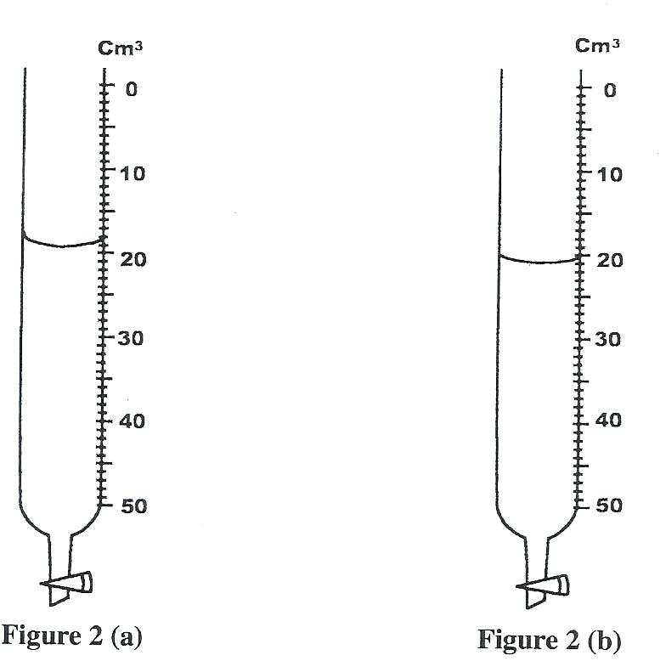

Determine the volume of one drop of oil (1 mark)

FORCES
1. 1995 Q3 P1
The diagram in figure 4 shows two glass tubes of different diameters
dipped in water
Explain why h₂ is greater than h₁ (3 marks)

2. 1996 Q11 P1
Name two forces that determine the shape of liquid drop on the
solid surface. (2marks)

3. 1997 Q3 P1
Give a reason why the weight of the body varies from place to place (1 mark)

4. 1997 Q4 P1
A butcher has a beam balance and masses 0.5 kg and 2kg. How would
he measure 1.5 kg of meat on the balance at once? (1 mark)

5. 1997 Q8 P1
State the reason why water spilled on a glass surface wets the surface (1 mark)

6. 1997 Q13 P1
Figure 6 shows a beam AB supported at points A and B. A large F is
applied on the beam as shown. Mark on the diagram, the position X,
where a notch is likely to appear.
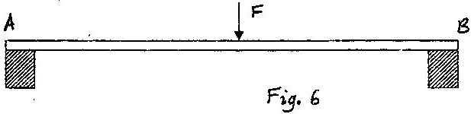

7. 1998 Q13 P1
Fig. 4 shows a capillary tube placed in though of mercury.
Give a reason why the level of mercury in the capillary tube is
lower than in the beaker. (1 mark)

8. 1998 Q5 P1
A metal pin was observed to float on the surface of pure water.
However the pin sank when a few drops of soap solution were
carefully added to the water. Explain his observation. (2 marks)

9. 2000 Q2 P1
A bag of sugar is found to have the same weight on planet earth as
an identical bag of dry sawdust on planet Jupiter. Explain why the
masses of the two bags must be different. (2 marks)

10. 2003 Q11 P1
One of the factors that affect the surface tension of a liquid is the
presence of impurities. State one other factor. (2 marks)

11. 2004 Q10 P1
State one way of reducing surface tension in water. (1 mark)

12. 2005 Q11 P1
Fig 8 shows water drops on two surfaces. In 8 (a) the glass surface
is smeared with wax while in 8 (b) the glass surface is clean.
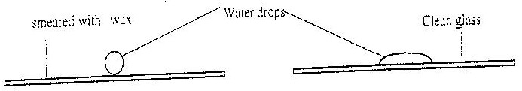
Water drops
Clear glass
Smeared with wax

a) b)
Fig 8
Explain the difference in the shapes of the drops. (2 marks)

13. 2006 Q2 P1
Figure 2 (a) shows body being acted on by two forces, F₁ and F₂

On figure 2 (b) draw the force F₃ that has same effect on the body as
the two forces (1 mark)

14. 2006 Q10 P1
Figure 6 shows the path taken by a matatu travelling on a horizontal
ground (a winding road)
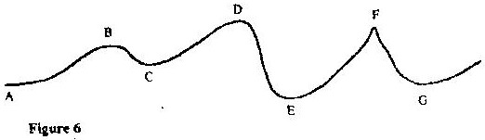

The speed of the matatu is constant. Identify with reason the point
along the path which a load placed loosely on the rack (carrier) of
the matatu is most likely to roll off. (2 marks)

15. 2008 Q3 P1
Fig. 1 shows a brick placed on a plane inclined at an angle θ to the
horizontal. The weight, W, of the brick is shown.

a) On the same diagram show with arrows the other two forces acting
on the brick and name them. (1 mark)

b) State how each of the two forces named (a) above is affected when
the angle θ is reduced. (1 mark)

16. 2009 Q3 P1
A steel needle when placed carefully on water can be made to float.
When a detergent is added to the water it sinks. Explain this o
bservation. (2 marks).

17. 2010 Q10 P1
The weight of a solid in air is 5.0N. When it is fully immersed in a
liquid of density 800kgm⁻³ its weight is 4.04N. Determine:
- The up thrust in the liquid
- The volume of the solid.

18. 2011 Q7 P1
Figure 6 shows a small toy boat floating on water in a basin. X and Y
are two points near the toy.

Toy boat

X Y
----------------------- -----------------------------
-----------------------------------------------------------------------------
------------------------------ Water ------------------------------------
------------------------------------------------------------------------------
Fig 6.
When a hot metal rod is dipped into the water at point X, the toy is
observed to move towards Y. Explain this observation. (2 marks)

19. 2012 Q2 P1
A student pulls a block of wood along a horizontal surface by applying
a constant force. State the reason why the block moves at a constant
velocity. (1 mark)

20. 2012 Q3 P1
A solid weighs 16.5 N on the surface of the moon. The force of the
gravity on the moon is 1.7Nkg⁻¹. Determine the mass of the solid. (3 marks)

21. 2013 Q6 P1
State how the measurements in question (5) are used to determine
the upthrust of the object.
22. 2013 Q11 P1
Figure 6 (a) and 6 (b) show capillary tubes inserted in water and
Mercury respectively.

It is observed that in the water the meniscus in the capillary tube is
higher than the meniscus in the beaker, while in mercury the meniscus
in the capillary tube is lower than the meniscus in the beaker. Explain
these observations. (2 marks)

23. 2015 Q3 P1
A spring extends by 6 cm when supporting a mass of 0.06 kg on earth.
When the spring is used to support the same mass on the moon, it extends
by 1 cm. Determine the moon's gravitational strength.
(Take gravitational field strength on earth as 10 Nkg¹) (3 marks)
PRESSURE
1. 1995 Q4 P1
Figure 2 shows a liquid being siphoned from one beaker to another.
Refer to this diagram where answering questions 1, 2 and 3
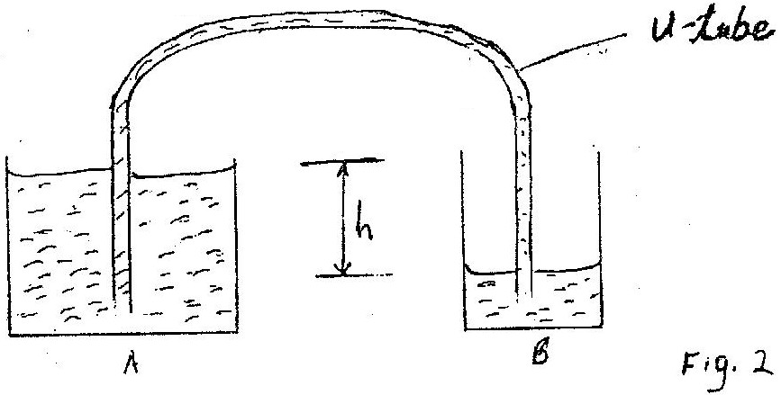

Indicate on the diagram the direction of flow of the liquid (1 mark)

2. 1995 Q5 P1
Show that the force driving the liquid through the U – tube is
proportional to the height, h (3 marks)

3. 1995 Q6 P1
State what would happen to the flow if the system in figure 2
were put in vacuum (1 mark)

4. 1995 Q13 P1
The diagram in figure 4 shows two glass tubes of different
diameters dipped in water
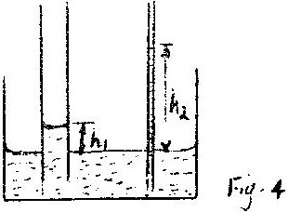

Explain why h₂ is greater than h₁ (3 marks)

5. 1996 Q4 P1
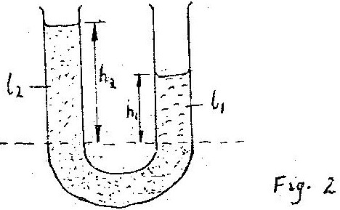

Figure 2 shows a U tube containing two liquids L₁ and L₂ of densities
0.8 g cm⁻³ and 1.8 cm⁻³ respectively in equilibrium. Given that h₂ = 8 cm
determine the value of h₁ (3 marks)

6. 1996 Q5 P1
A small nail may pierce an inflated car tyre and remain there without
pressure reduction in the tyre. Explain this observation (2 marks)

7. 1997 Q5 P1
The height of the mercury column in a barometer at a place is 64cm.
What would be the height of a column of paraffin in barometer at
the same place?
(Density of paraffin = 8.0 x 10² kgm⁻³, Density of mercury = 1.36 x 10⁴ kgm⁻³)
(3 marks)
8. 1997 Q5 P1
State one advantage of fitting wide tyres on a vehicle that moves
on earth roads.
(3 marks)
9. 1999 Q4 P1
A vacuum pump was used to pump out air from the glass tube
immersed in liquids as shown in figure3.
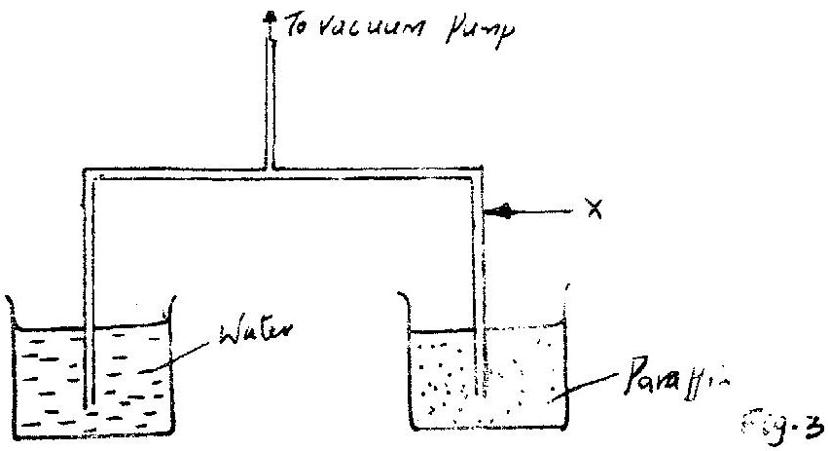

After sometime the level of paranum rose to position A. Mark 1, the
corresponding position for the water level. Give a reason for your answer. (3 marks)

10. 2001 Q4 P1
State the reason why it may not be possible to suck liquid into your
mouth using drinking straw on the surface of the moon. (3 marks)

11. 2001 Q3c P2
A hole of area 2.0 cm² at the bottom of a tank 2.0m deep is closed
with a cork. Determine the force on the cork when the tank is filled
with water. (Density of water is 1000kg/m³ and acceleration due to
gravity is 10m/s²). (4 marks)

12. 2002 Q5 P1
The total weight of a car with passengers is 25,000N. The area of
contact of each of the four tyres with the ground is 0.025m².
Determine the minimum car tyre pressure. (3 marks)

13. 2003 Q4 P1
The reading on a mercury barometer at a place in 700mm. What is
the pressure at the place Nm⁻² (Density of mercury is 1.36 x 10⁴ kgm⁻³) (3 marks)
14. 2005 Q4 P1
A can with a hole on the side is filled with water to a certain height.
Water jets out as shown in Fig. 4(a). a second identical can is filled
with water to the same height and a block of wood floated on the
water as shown in Fig. 4 (b)

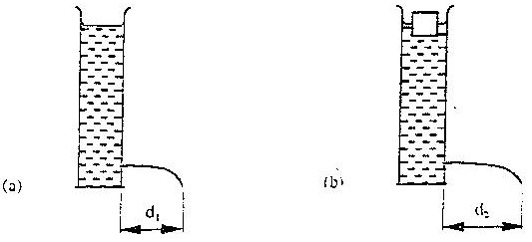
Fig 4a Fig 4b

State the reason why the maximum distance of the jet, d₂ is greater than d₁ (1 mark)
15. 2006 Q3 P1
State Pascal’s principle of transmission of pressure in fluids (1 mark)

16. 2006 Q3 P1
State Pascal’s principle of transmission of pressure in fluids (1 mark)

17. 2007 Q4 P1
Figure 3 shows the levels of two liquids A and B after some air has
been sucked out of the tubes through the tap. Use this information
and the figure to answer questions 17 and 18.
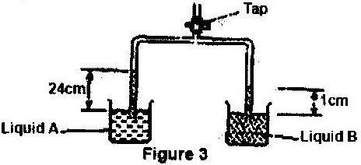

State the reason for the rise in the levels of the liquids when air is
sucked from the tubes

18. 2007 Q5 P1
Given that the density of liquid B is 1200 kgm³, determine the
density of liquid A. (3 marks)

19. 2008 Q8 P1
Fig. 4 shows a conical flask 15cm high, filled with a liquid of density
1200kgm⁻³. The atmospheric pressure of the surrounding is 8.4 x 10⁴ Pa.

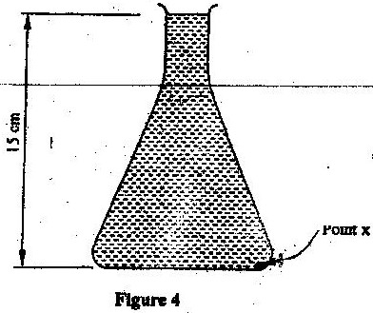

Determine the pressure at the point marked X, at the bottom of
the flask.
(3 marks)
20. 2009 Q4 P1
Figure 2 shows two cylinders containing a liquid and connected with
a tight-fitting flexible tube. The cylinders are fitted with air-tight pistons
A and B as shown
Figure 2
When equal forces,F, are applied on the pistons as shown, it is observed that
piston A moves up while piston B moves down. Explain this observation. (2 marks).
21. 2010 Q11 P1
Some water in a tin can was boiled for some time. The tin can then sealed
and cooled. After some time it collapsed. Explained this observation. (2 marks).

22. 2010 Q11 P1
When a bicycle pump was sealed at the nozzle and the handle slowly
pushed towards the nozzle, the pressure of the air inside increased.
Explain this observation. (1 mark)

23. 2012 Q7
A balloon is filled with a gas which is lighter than air. It is observed to
rise in air upto a certain height. State a reason why the balloon stops
rising. (1 mark)
24. 2011 Q14 P1
Figure 9 shows a syringe full of water. It has two identical holes A and
B drilled along its cylinder. The cylinder nozzle is closed

State with a reason how the speeds of the jets of water from A and B
compare when the piston is pushed into the cylinder. (2 marks)

25. 2012 Q15(c) P1
In an experiment to demonstrate atmospheric pressure, a plastic bottle
is partially filled with hot water and the bottle is then tightly corked.
After some time the bottle starts to get deformed.
(i) State the purpose of the hot water. (1 mark)
(ii)State the reason why the bottle gets deformed (1 mark)
(iii) Explain your answer in c (ii) (2 marks)

26. 2012 Q19 P1
(a) Figure 14 shows a lift pump.

Explain why, when the piston is:
- Pulled upwards, valve A opens while valve B closes. (2 marks)
- Pushed downwards, valve A closes while valve B opens. (2 marks)

(b) After several strokes, water rises above the piston as shown in figure 15.
State how water is removed from the cylinder through the spout. (1mark)

(c) A lift pump can lift water to a maximum height of 10m.Determine the
maximum height to which the pump can raise paraffin.

(take density of paraffin as 800kgm-3 and density of water as 1000kgm⁻³). (3marks)

(d) State one factor that determines the height to which a force pump can
lift water. (1mark)

27. 2013 Q3 P1
Figure 2 shows some air trapped by mercury in a glass tube. The tube
is inverted in a dish containing mercury.

Given that the atmospheric pressure is 760 mmHg and the height of
mercury column in the tube is 600 mm, determine the pressure of the
air trapped in the tube in mmHg. (3 marks)

28. 2013 Q9 P1
Explain why brakes fail in a hydraulic breaking system when air
gets into the system. (2 marks)

29. 2014 Q5 P1
Figure 3 shows two cylinders of different cross-sectional areas connected
with a tube. The cylinders contain an incompressible fluid and are fitted
with pistons of cross-sectional areas 4cm² and 24cm².

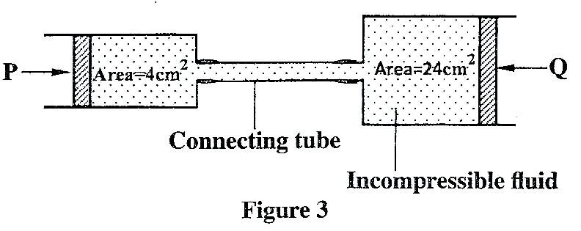

Opposing forces P and Q are applied to the pistons such that the pistons
do not move. If the pressure on the smaller piston is 5N cm⁻². Determine
force Q. (2 marks)

30. 2015 Q4 P1
State two factors that determine the pressure at a point in a liquid. (2 marks)

30. 2015 Q5 P1
A student wearing sharp pointed heeled shoes is likely to damage
a soft wooden floor. Explain. (2 marks)

THE PARTICULATE NATURE OF MATTER

1. 1996 Q11 P1
Name two forces that determine the shape of liquid drop on the
solid surface.
(2 marks)
2. 1996 Q37 P1
In the Brownian motion experiment, smoke particles are observed
to move randomly. Explain how this motion is caused (2 marks)

3. 1997 Q25 P1
Ice changes to water at 0⁰C. Equal masses of the ice and water at
0⁰C are each heated to 1⁰C. Give a reason why more heat energy is
required to heat ice.

4. 1998 Q23 P1
Cleavage in crystals is possible in certain directions only. Explain this
observation.

5. 2000 Q6 P1
State the reason why gases are easily compressible while liquids are
solids are not

6. 2001 Q5 P1
Fig. 4 (i) shows a beaker filled with water. Some potassium permanganate
was gently introduced at the bottom of the beaker at the position shown.

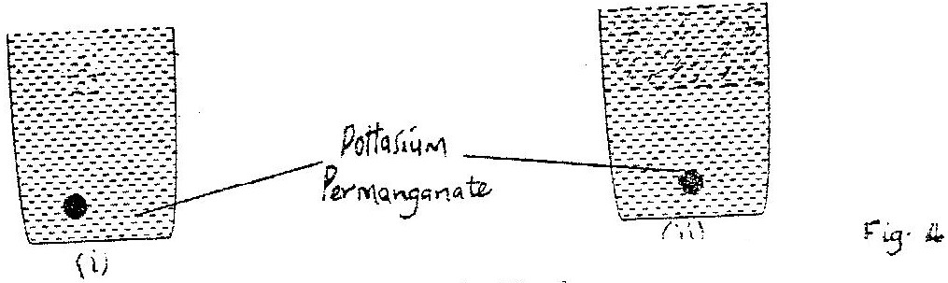

Fig. 4(ii) shows the appearance of the liquid after about 30 minutes.
Explain how this appearance was caused. (2 marks)

7. 2001 Q3 (b) P2
Small quantities of hydrogen and helium gas at the same temperature
are released simultaneously at one end of a laboratory. State with gas
is more likely to be detected at the other end. (2 marks)

8. 2003 Q5 P1
Explain the cause of random motion of smoke particles as observed
in Brownian motion experiment using a smoke cell. (2 marks)

9. 2005 Q7 P1
Two identical tubes A and B held horizontally contain air and water
respectively. A small quantity of coloured gas is introduced at one end
of A while a small quantity of coloured water is introduced at one end
of B. State with reason the tube in which the colour will reach the
other end faster. (1 mark)

10. 2006 Q14a P1
Distinguish between solid and liquid states of matter in terms of
intermolecular forces (1mark)

11. 2007 Q15 P1
Brown motion of smoke particles can be studied by using the apparatus
shown in figure 9 to observe the motion, some smoke is enclosed in
the smoke cell and then observed through the microscope.
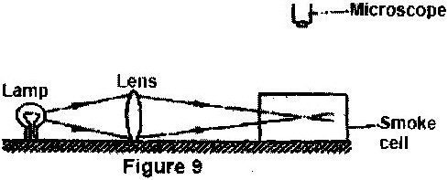

(a) Explain the role of the smoke particle, lens and microscope in the
experiment
(b) State and explain the nature of the observed motion of the smoke
Particles (3 marks)

(c) State what will be observed about the motion of the smoke particles
if the temperature surrounding the smoke cell is raised slightly. (1 mark)

12. 2008 Q9 P1
Explaining the difference between a liquid and a gas in terms of
intermolecular distances and forces. (2 marks)

13. 2009 Q5 P1
Two identical beakers A and B containing equal volumes of water are
placed on a bench. The water in A is cold while the water in B is warm.
Identical pieces of potassium permanganate are placed gently at the
bottom of each beaker inside the water. I t is observed that the spread
of colour in B is faster than in A. Explain this observation. (2 marks).

14. 2011 Q8 P1
When the temperature of a gas in a closed container is raised, the
pressure of the gas increases. Explain how the molecules of the gas
cause the increase in pressure. (2 marks)

15. 2011 Q10 P1
State the reason why it is easier to separate water into drops than to
separate a solid into smaller pieces. (1 mark)

16. 2012 Q4 P1
A bottle containing a smelling gas is opened at the front bench of a
classroom. State the reason why the gas is detected throughout the room. (1 mark)

17. 2013 Q13 P1
A drop of blue ink is introduced at the bottom of a beaker containing
water. It is observed that after sometime, all the water in the beaker
turns blue. Name the process that takes place. (1 mark)
18. 2014 Q14 P1
In a smoke cell experiment to demonstrate Brownian motion, smoke
particles are seen moving randomly. State the cause of the randomness. (1 mark)

19. 2015 Q6 P1
Figure 3 shows the arrangement of molecules in the three states of matter.
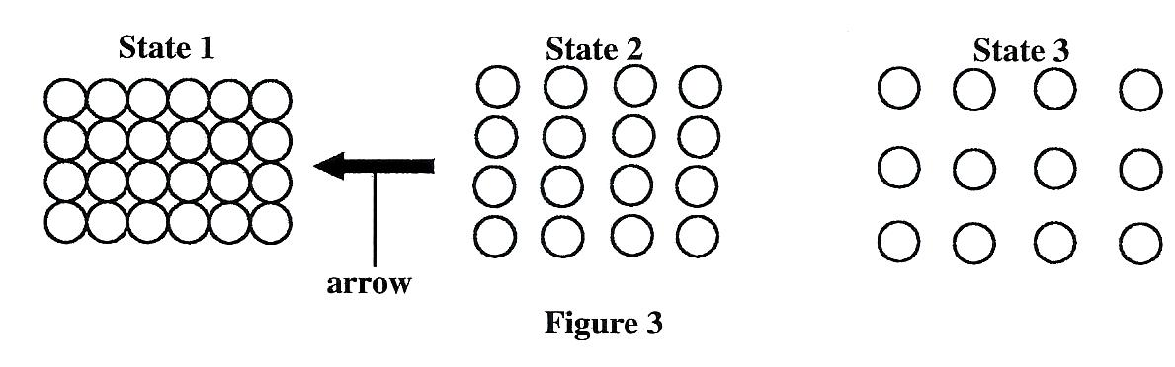
(a) Name the process represented by the arrow. (1 mark)
(b) State the reason for the arrangement of molecules in state 3. (1 mark)

THERMAL EXPANSION
1. 1995 Q8 P1
One property of a liquid that is considered while construction a
liquid – in – glass thermometer is that the liquid expands more than
the glass for the same temperature change. State any other two
properties of the liquids that are considered (2 marks)

2. 1995 Q34 P1
State two variables that must be controlled in an experiment for
comparing the thermal conductivities of different metal rods of
the same diameter
(2 marks)
3. 1996 Q6 P1
Give a reason why a concrete beam reinforced with steel does not
crack when subjected to changes in temperature (2 marks)

4. 1997 Q7 P1
Explain why a glass container with thick walls is more likely to
crack than one with a thin wall when a very hot liquid is poured
into them. (2 marks)

5. 1997 Q9 P1
Figure 3 shows two aluminium containers, A and B placed on a
wooded table. A and B have equal volumes of hot water initially
at the same temperature.

6. 1997 Q1a P2
Figure 1 shows a circuit diagram for controlling the temperature of a room.

  - State and explain the purpose of the Bimetallic strip (2 marks)
  - Describe how the circuit controls the temperature when the
switch is closed (2 marks)

7. 1998 Q16 P1
In figure 4 one end of a metal rod is placed in steam and the other
end in melting ice. The length of the rod in between in lagged.
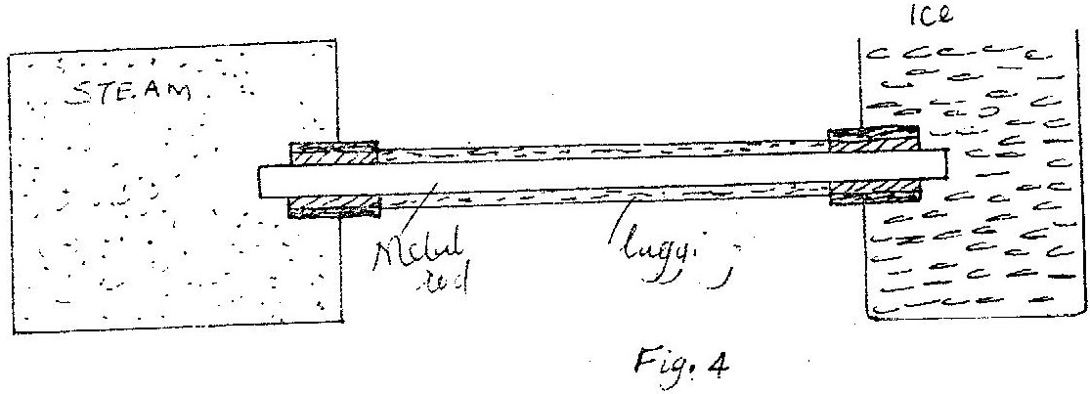

State two factors that determine the rate at which ice melts.

8. 1998 Q31 P1
Fig 10 shows a fire alarm circuit.

Explain how the alarm functions. (3 marks)

9. 1999 Q6 P1
Figure 5 shows a bimetallic strip at room temperature. Brass
expands more than invar when heated equally.

Sketch the bimetallic strip after being cooled several degrees
below room temperature. (1 mark)

10. 2000 Q7 P1
Fig. 4 shows a bimetallic thermometer.
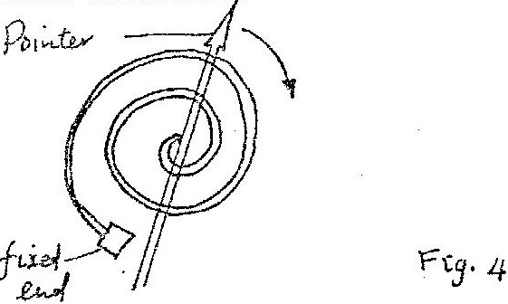

Explain how a rise in temperature causes the pointer to move in
the direction shown. (3 marks)

11. 2001 Q6 P1
Fig. 5 shows a flask fitted with a glass tube dipped into a beaker
containing water at room temperature. The cork fixing the glass tube
to the flask is airtight.

Use the information and the figure to answer questions 11 and 12.
State what is observed when ice- cold water is poured on the flask. (1 mark)

12. 2001 Q7 P1
Give a reason for the observation in question 11. (1 mark)

13. 2003 Q6 P1
In the set up shown in Figure 4, it is observed that the level of the
water initially drops before starting to rise. Explain this observation (2 marks)

14. 2004 Q2 P1
The system in figure 2 is in equilibrium at room temperature.
The system is taken outside where the temperature is 10⁰c higher
for some time.
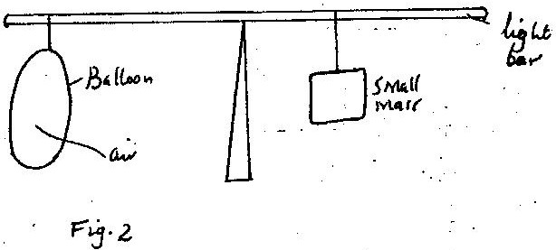

Explain why it tips to the right immediately it is returned to the room. (2 marks)

15. 2004 Q4 P1
Give a reason why water is not a suitable liquid for use in a barometer. (1 mark)

16. 2004 Q5 P1
The temperature of water in a measuring cylinder is lowered from
about 20⁰ c to 0⁰. On the axes provided, sketch the graph of the
Volume against temperature assuming the water does not freeze. (2 marks)

Volume

Temperature
17. 2006 Q4 P1
Figure 3 shows a bimetallic strip with a wooden handle, suspended
horizontally using a thin thread.
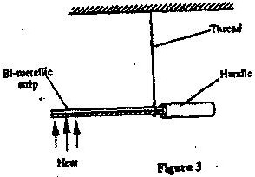

The strip is heated at the point shown. Explain why the system
tips to the right (2 marks)

18. 2008 Q4 P1
Water is known to boil at 100⁰C. A student heated some water and
noticed that it boiled at 101⁰C.
State two possible reasons for this observation. (2 marks)

19. 2008 Q5 P1
Fig: 2 shows a flask filled with water. The flask is fitted with a cork
through which a tube is inserted. When the flask is cooled, the water
level rises slightly, then falls steadily.

Explain observation. (3 marks)

20. 2009 Q6 P1
A Clinincal thermometer has a constriction in the bore just above
the bulb. State the use of this constriction. (1 mark)

21. 2010 Q3 P1
When a liquid is heated in a glass flask, its level at first fails, then
rises. Explain this observation.

22. 2010 Q5 P1
Some water in a tin can was boiled for some time. The tin can then
sealed and cooled. After some time it collapsed. Explained this observation.

23. 2011 Q4 P1
Figure 3 shows an aluminium tube tightly stuck in a steel tube.

Steel tube Aluminium tube

junction
Figure 3

Explain how the tubes can be separated by applying a temperature change
at the junction given that aluminium expands more than steel for the same
temperature rise. (2 marks)

- 2012 Q5 P1
Figure 2 shows a flat bottomed flask containing some water. It is heated
directly with a very hot flame.

Explain why the crack is likely to crack (2 marks)
- 2012 Q17(c) P1
In an experiment to investigate the unsual expansion of water, a fixed
mass of water at 0⁰C was heated until its temperature reached 20⁰c .
On the axis provided, sketch a graph of density against temperature of the
water from0⁰C to 20⁰c (2 marks)
Density (g/cm³)

temperature (0⁰C)

- 2013 Q7 P1
Figure 3 shows a piece of wood fitted into a copper pipe and a piece
of paper wrapped tightly around the junction.

It is observed that when a flame is applied around the paper at the junction,
the side of the paper around the wood burns first,. Explain this observation.
(2 marks)
27. 2014 Q 12 P1
On the axis provided, sketch the graph which shows the relationship
between volume and temperature of a fixed mass of water in the
temperature range O⁰ to 10⁰C.
(1 mark)

28. 2015 Q7 P1
Two containers A and B of equal dimensions but different metals
are fitted with Identical glass casings. The two containers initially at
the same temperature are simultaneously filled with boiling water. It is
observed that the glass casing on A breaks earlier than the one on B.
Explain this observation. (2 marks)

29. 2015 Q16b P1
State three ways of increasing the sensitivity of a liquid in glass thermometer
(3 marks)

HEAT TRANSFER
1. 1995 Q10 P1
In the set up shown in figure 3, water near the top of the boiling tube
boils while at the bottom it remains cold.

Give a reason for the observation (1 mark)

2. 1995 Q34 P1
State two variables that must be controlled in an experiment for
comparing the thermal conductivities of different metal rods of the
same diameter (2 marks)

3. 1996 Q7 P1
Give a reason why heat transfer by radiation is faster than heat
transfer by conduction (1 mark)

4. 1998 Q9 P1
Water of mass 3kg at a temperature of 90ºC is allowed to cool for
10 minutes. State two factors other than humidity that determine
the final temperature.

5. 1998 Q16 P1
In figure 4 one end of a metal rod is placed in steam and the other end
in melting ice. The length of the rod in between in lagged.

State two factors that determine the rate at which ice melts. (1 mark)

6. 2000 Q8 P1
A wooden bench and a metal bench are both left in the sun for a long
time. Explain why the metal bench feels hotter to touch.

7. 2000 Q22 P1
Two identical blocks of copper are taken from the same furnace. One
block is dropped into a well - lagged calorimeter containing 200g of
methylated spirit. Both water and spirit were initially at the same
temperature. After being given time to stabilize the temperature, it was
found that more spirit than water had evaporated.

State two factors that could have caused this difference.

8. 2001 Q19 P1
Fig 12 shows two identical containers A and B into which a copper
rod is fitted. The containers are well lagged.
Figure 12
The liquids in the containers were initially at the same temperature if
the heat is a applied continuously at the position shown, state with reason
for the container through which the loss of heat is likely to be higher. (2 marks)

9. 2001 Q1(a) P2
Figure 1 shows a cross-section of a vacuum flask.
Supports
cork
A

- Name the parts labelled A and B
- Explain how the heat losses are minimized when hot liquid is
poured into the flask. (3 marks)

- Boiling water is poured into two identical vacuum flasks A and B.
Flask A is partially filled while flask B is completely filled. Both
are closed tightly. State with reason the flask in which the water is
likely to have a higher temperature eight hours later. (2 marks)

10. 2002 Q7 P1
An electric heater is placed at equal distances from two similar metal
cans A and B filled with water at room temperature. The outer surface
of can is shiny while that of can B is dull black. State with reasons which
can will be at a higher temperature after the heater is switched on for some time.

11. 2003 Q7 P1
When a Bunsen burner is lit below wire gauze, it is noted that the flame initially burns below the gauze as shown in Figure 5 (i).After sometime, the flame burns below as well as above the gauze as shown in Figure 5(ii).

5(i) 5(ii)

Explain this observation (2 marks)

12. 2004 Q7 P1
Two identical aluminium rods as shown in figure 4. One rests on
metal block the other on the wooden Block. The protruding ends are
heated on a Bunsen burners shown.

State with reason on which bar the wax is likely to melt.

13. 2005 Q5 P1
In a vacuum flask the walls enclosing the vacuum are silvered on the
inside. State the reason for this. (1 mark)

14. 2007 Q6 P1
Figure 4 show two identical balloons A and B. The balloons were
filled with equal amounts of the same type of gas. The balloons are
suspended at distances X₁ and X₂ from a metal cube filled with boiling
water and placed on an insulating material. Use this information to
answer questions 14 and 15.
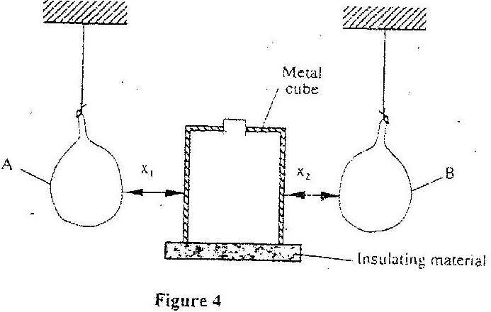

State the mode by which heat travels from the cube to the balloons (1 mark)

15. 2007 Q7 P1
The face of the cube towards A is bright and shiny and the face towards
B is dull black. State with reason the adjustments that should be made
on the distances X₁ and X₂ so that the rate of change of temperature in
both balloons is the same. (2 marks)
16. 2007 Q14 P1
Figure 8 shows a uniform light bar resting horizontally on corks
floating on water in two beakers A and B.
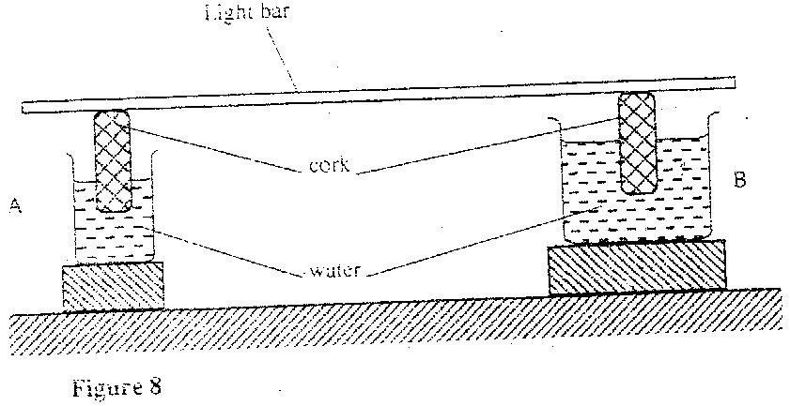

Explain why the bar tilts towards side A when equal amount of heat
is supplied to each beaker (2 marks)

17. 2008 Q6 P1
Fig. 3 shows a hot water bath with metal rods inserted through one
of its sides. Some wax is fixed at the end of each rod. Use this
information to answer questions 17 and 18.

What property of metals could be tested using this set-up? (1mark)

18. 2008 Q7 P1
Besides the length of the rods that is kept constant, what else should
be kept constant when comparing the property for the different
metal rods? (1mark)

19. 2009 Q7 P1
Use the following information to answer questions 19 and 20
Two identical empty metal containers P and Q are placed over
identical bunsen burners and the burners lit. P is dull black while
Q is shiny bright. After each container attains a temperature of 100⁰C
the burners are turned off . Identical test tubes containing water are
suspended in each container without touching the sides as shown
in the figure 3.

Figure 3.

Explain why the container Q may become hot faster than P. (2 marks)

20. 2009 Q8 P1
Explain why the water in test-tube in P becomes hotter faster than in Q.
(2 marks)

21. 2010 Q4 P1
A paper windmill in a horizontal axis was placed above a candle
as shown in figure 2.

When the candle was lit the paper windmill begun to rotate. Explain
this observation.

22. 2011 Q5 P1
Figure 4 shows two identical beakers P and Q full of water at 90⁰c. Two
similar cold wet clothes are wrapped, one around the top of P and the other
around the bottom of Q.

-----------------------------------------------------------
-----------------------------------------------------------
Cold wet
cloth Water cold wet cloth

Figure 4
P Q
State with a reason, the beaker in which the water cools faster. (2 marks)

23. 2012 Q17a-c P1
(a) Figure 11 shows how an underground room was ventilated. It had
two vents, one at A and other at B. A fire was lit at point C.

Explain what happened to the ventilation when the fire was lit. (3 marks)
(b) Explain how a vacuum flask minimizes loss of heat through radiation (1 mark)
24. 2014 Q7 P1
Figure 4 shows a source of heat placed at equal distances from two
identical flask X and Y containing air. The surface of X is painted
black while Y is clear.

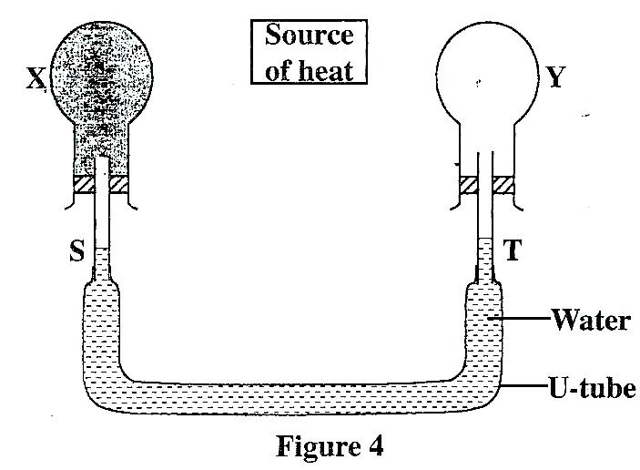

X and Y are linked by U- tube filled with water whose levels S and T
are initially the same. It is later observed that S falls while T rises. Explain this observation.
(2 marks)
25. 2015 Q12 P1
Figure 6 shows a glass tube with water fitted with two identical thermometers
A and B. It is heated as shown.
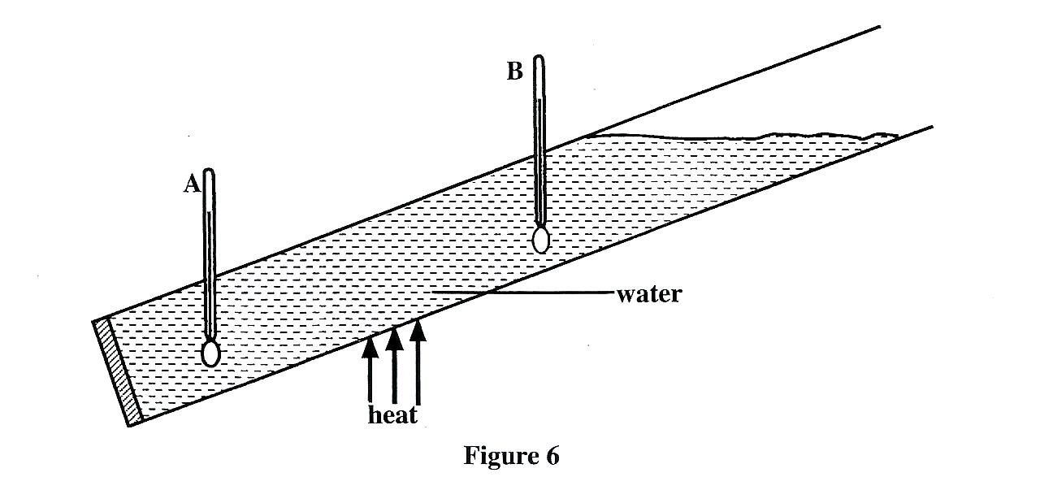

State with a reason which one of the two thermometers shows a higher
temperature (2 marks)

RECTILINEAR PROPAGATION OF LIGHT

1. 1995 Q9 P1
What property of light is suggested by the formation of shadows? (1 mark)

2. 1996 Q8 P1
A vertical object placed on a bench is observed to have three
shadows of different sharpness, in different directions. Explain
this observation (3 marks)

3. 1997 Q10 P1
Figure 4 shows two point objects A, and B, placed in front of a mirror M
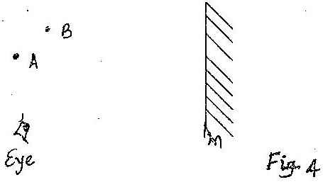

Sketch a ray diagram to show the positions of their images as seen
by the eye.
(3 marks)
4. 1998 Q27 P1
During total eclipse of the sun, both light and heat are observed to
disappear simultaneously. Explain the observation.

5. 1998 Q32 P1
Fig 11 shows a double slit placed in front of a source, s of waves, and a director D is placed beyond the slits, such that its position can be
adjusted along the line XY.

State with a reason, what the detector records along XY.

6. 1998 Q33 P1
What is meant by virtual image? (1 mark)

7. 1999 Q8 P1
Figure 6 shows a ray of light incident on plane mirror at point O.
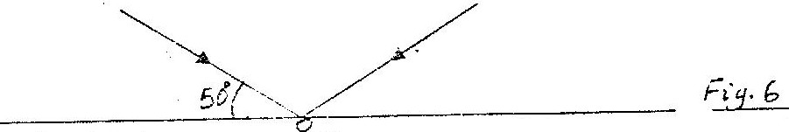

The mirror is rotated clockwise through an angle 30⁰ about an axis perpendicular to the paper. Determine the angle through which the
reflected ray rotated. (2 marks)

8. 2000 Q9 P1
Fig. 5 shows an object O placed in front of a plane mirror.
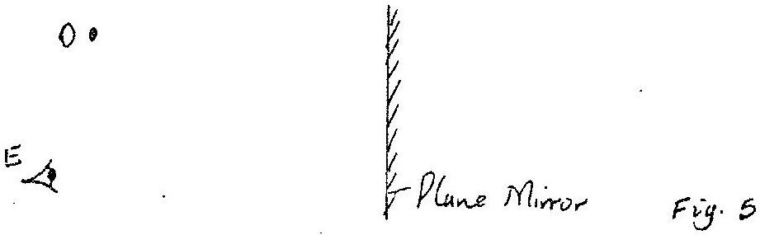

On the same diagram draw rays to locate the position of the image I,
as seen from the eye E. (3 marks)

9. 2001 Q8 P1
Fig. 6 shows an object O being viewed using two inclined mirrors M₁
and M₂. Complete the diagram by sketching rays to show the position
of the image as seen by the eye E. (2 marks)

10. 2003 Q8 P1
Figure 6 shows a ray of light being reflected from a mirror.
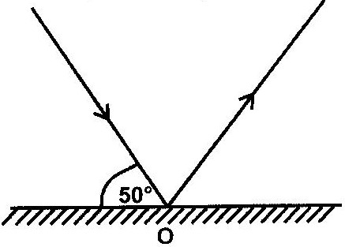

What is the angle of reflection? (2 marks)
11. 2004 Q7 P1
Figure 5 shows two mirrors inclined at an angle of 60⁰ to each other. A
ray of light is shown

Sketch the same diagram, the path of the ray until it leaves the two
mirrors. Indicate the angles at each reflection. (1 mark)

12. 2005 Q6 P1
Fig 5. Shows an arrangement of a source of light, an opaque object
and a screen.

Using A, B and C as point sources, sketch on the same figure labelled
ray diagram to show what is observed on the screen. (2 marks)

13. 2006 Q2 P2
In a certain pinhole camera, the screen is 10cm from the pinhole.
When the camera is placed 6m away from a tree, a sharp image of
the tree 16cm high is formed on the screen. Determine the height
of the tree.

14. 2007 Q1 P2
Figure 1 represents a pinhole camera
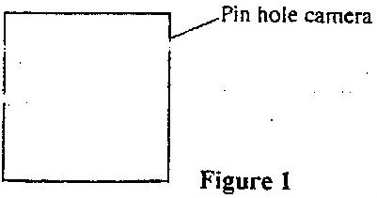

Sketch rays to show the formation of an enlarged image in the camera.
Label both the object and the image (2 marks)

15. 2008 Q1 P2
Figure 1 shows three point sources of light with an opaque object placed
between them and the screen.
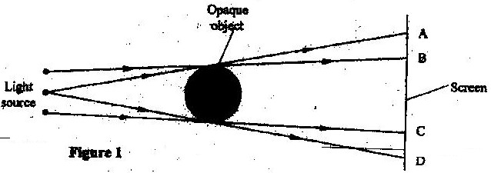
Opaque object

Light
source
Screen

Figure 1

Explain the nature of the shadow formed along B and C. (2 marks)

16. 2009 Q1 P2
State the number of images formed when an object is between two
plane mirrors placed in parallel (1 mark)

17. 2009 Q2 P2
Figure 1 shows a ray of light incident on a mirror at an angle of 45°.
Another mirror is placed at an angle of 45° to the first one as shown. .

Sketch the path of the ray until it emerges. (2 marks)

18. 2010 Q1 P1
Figure 1, shows a ray of light incident on a plane mirror at O. The mirror is then rotated anticlockwise about O from position M to position M₂ through an angle of 10°. The final reflected ray is OC.

Determine the angle of deviation BOC.

19. 2011 Q1 P2
Figure 1 shows an object placed in front of a plane mirror.

Sketch the image of the object as seen in the mirror. (1 mark)

20. 2012 Q1 P2
Figure 1, show a place mirror XY placed equidistant from two parallel
lines AB and PT.
Four students stands at P, Q, R and T in front of the mirror
- Indicate the positions of the images of students at Q,R and T on line AB (1 mark)
- State which of the tree images are visible to the student standing at P. (1 mark)
- Using rays indicate on the figure, how (b) above is possible (1 mark)
21. 2012 Q2 P2
Figure 2. Shows two mirrors PQ and QR inclined at an angle of 110⁰. A
ray of light is incident on mirror PQ at an angle of 60⁰.
Complete the diagram to determine the angle of reflection of the ray in the
mirror QR.
(3 marks)
22. 2013 Q1 P2
State the reasons why when a ray of light strikes a mirror at 90º, the
reflected ray travels along the same path as the incident ray. (1mark)

23. 2013 Q2 P2
Explain why the image formed in a pin hole camera gets blurred
when the hole is enlarged. (2 marks)

24. 2014 Q18b P2
Draw a ray diagram to show the formation of a partially dark shadow
and a totally dark shadow during the eclipse of the sun. (3 marks)

25. 2015 Q1 P2
Figure 1 shows three mirrors arranged at right angles to each other. A
ray of light is incident on one of the mirrors.
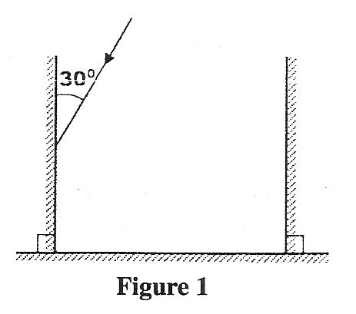
Complete the diagram to show the path of the ray after reflection on
each of the mirror (3 marks)

ELECTROSTATICS I
1. 1995 Q11 P1
You are provided with a charged electroscope, an insulator and a conductor.
Describe how you would use these apparatus to distinguish in the insulator
from the conductor (2 marks)

2. 2001 Q9 P1
Fig. 7 shows “windmill” which when connected to the dome of a positively
charged Van de Graff generator is observed to rotate as indicated. A, B, C and
D are sharp points

Explain how this rotation is caused.

3. 2003 Q9 P1
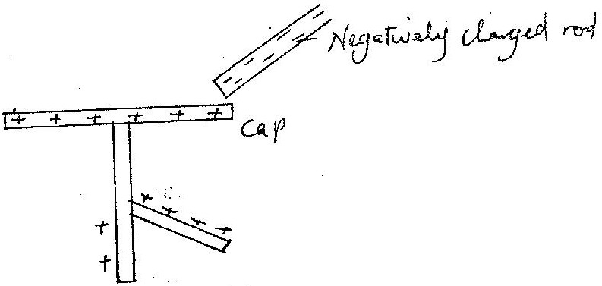
Figure 7 shows a highly negatively charged rod being brought slowly near
the cap of a positively charged leaf electroscope. It is observed that the
leaf initially falls and then rises.

Figure 7
Explain this observation (2 marks)

4. 2004 Q8 P1
Figure 6 (a) shows three spherical balls of the same size placed on insulating
stands. Balls A and B are conductors while ball C is non conductor. Ball A was
initially charged as shown. The quantity of charge is represented by the number
of dashes.
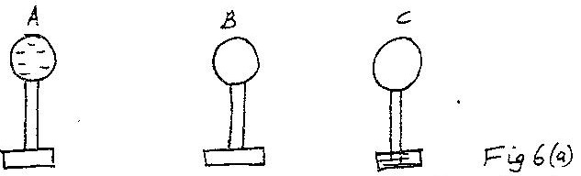

Ball A is made to touch B momentarily and then C. Show on Figure 6(b), the
final distribution of charge on the balls. (1 mark)

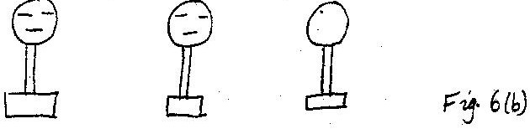

5. 2004 Q4(b) P1
i) In the space provided below, sketch a labeled diagram to show how pinhole
camera forms an image of a vertical object placed in front of the pinhole.

ii) a building standing 200m from a pinhole camera produces on the screen of the
camera an image 2.5cm high 5.0cm behind the pinhole. Determine the actual
height of the building.

6. 2005 Q38 P1
Fig 18 shows two spherical materials one an insulation conductor, the other a conductor, Negative charge are introduced at point A in each case.
Insulator
Conductor

One the same figure indicate the final position of the charges. Explain
your answer. (2marks)

7. 2006 Q3 P2
A metallic body shaped as shown in figure 2 is positively charged and
insulted from the ground as shown in the figure.
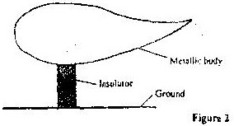

Metallic body
Insoluble
Ground

Figure 2

On the figure show the charge distribution (1 mark)

8. 2008 Q2 P2
A leaf electroscope A is charged and placed on the bench. Another
uncharged leaf electroscope B is placed on the same bench and moved
close to A until the caps touch. State and explain what is observed on
the leaves of A and B.
(2 marks)
9. 2009 Q3 P2
A conductor is slowly brought near the cap of a positively charged electroscope.
The leaf first collapses and then diverges. State the charge on the conductor (1 mark)
10. 2010 Q4 P2
A positively charged sphere is suspended by an insulating thread. A
negatively charged conductor is suspended near it. The conductor is
first attracted, after touching the sphere it is repelled. Explain this
observation. (2 marks)

11. 2011 Q2 P2
Figure 2 shows two identical pith balls A and B suspended with insulated
threads. They /are separated by an insulator X. A is positively charged and
B is negatively charged. The quantity of charge on A is three times the
quantity of charge on B.

Sketch on the space besides the figure, the final position of the pith
balls after the insulator is removed. (1 mark)

12. 2012 Q4 P2
Figure 4, Shows a negative point charge placed near a positively charged rod.
Draw on the diagram, the resulting electric field pattern (2 marks)

13. 2014 Q10 P2
State two uses of a charged gold leaf electroscope. (1 mark)

14. 2014 Q16b P2
Figure 8 shows a negatively charged rod placed near an uncharged
conductor resting on an insulating support.
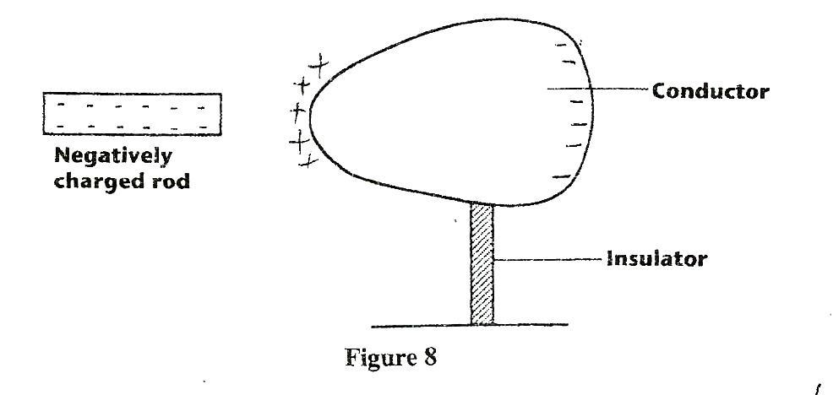

i)Show the charge distribution on the conductor (2marks)

ii) State the effect
I) Of momentarily touching the conductor with a finger while the
charged rod is still near the conductor (1mark)

II) On the charge distribution of withdrawing the negatively charged rod
after momentarily touching the conductor (1 marks)

III) In the space provided, sketch a diagram to show how the charge in
(II) would have been distributed if the conductor was a sphere (1mark)

15. 2015 Q2 P2
It is observed that when a charged body is brought near the cap of
a positively Charged, electroscope, the divergence of the leaf increases.
State the type of charge on the body. (1 mark)

CELLS AND SIMPLE CIRCUITS

1. 1995 Q12 P1
State two advantages of an alkaline battery over a lead acid battery (2 marks)

2. 1996 Q19 P1
In large current circuits large resistors in parallel are preferred to
low resistors in series explain (2 marks)

3. 1997 Q15 P1
A current of 0.5A flows in a circuit. Determine the quantity of
charge that crosses a point in 4 minutes. (3 marks)

4. 1998 Q10 P1
A car battery requires topping up with distilled water occasionally.
Explain why this is necessary and why distilled water is used. (2 marks)

5. 2000 Q10 P1
State one advantage of an alkaline accumulator over a lead – acid
accumulator.
(2 marks)
6. 2001 Q10 P1
Explain how polarization reduces current in simple cell. (2 marks)

7. 2003 Q10 P1
State one advantage of a lead – acid accumulator over a nickel – iron
(NiFe) accumulator. (1 mark)

8. 2003 Q23 P1
In the circuit diagram shown in fig. 12, the lamps are Identical and
the cells are also identical.
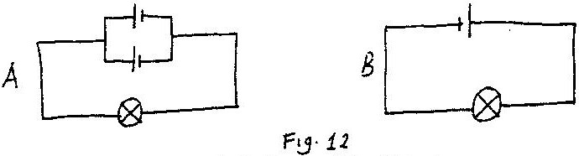

State with reason, in which circuit the lamp will be lit for longer period. (2 marks)

9. 2004 Q9 P1
State the purpose of Manganese dioxide in a dry cell

10. 2004 Q15 P1
Figure 10 show two circuits in which identical dry cells and identical
bulbs are used. Use the information in the figure to answer questions 10 and 11.
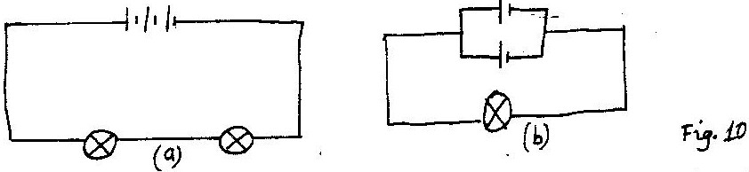

Explain why the bulb in Figure 10(10) will be brighter than each of the
bulbs in Figure 10 (a) (2 marks)

11. 2004 Q16 P1
Give the reason why the cells in figure 10(b) can be used for a longer
period than the cells in Figure 10 (a) (1 mark)

12. 2005 Q9 P1
Fig 7 shows the features of a dry cell(Leclanche’). Use the information
in the figure to answer question 12 and 13
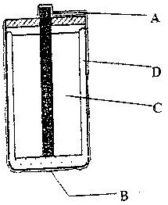

Fig 7

State the polarities of the parts labelled A and B. (1 mark)

13. 2005 Q10 P1
Name the chemical substance in the parts labelled C and D (2 marks)

14. 2006 Q4 P2
State a reason why the caps of the cells of a lead- acid battery are
opened when charging the battery. (1 mark)

15. 2007 Q2 P2
State one advantage of an alkaline cell over a lead – acid cell (1 mark)

16. 2009 Q4 P2
Give a reason why it is necessary to-leave the caps of the cells open
when charging an accumulator (1 mark)

17. 2010 Q17(a) P2
(a) Figure 12, shows an electrical circuit including three switches, Sj, S₂, S₃,
and three identical lamps L,, L₂, L₃. A constant potential difference is
applied across X and Y.
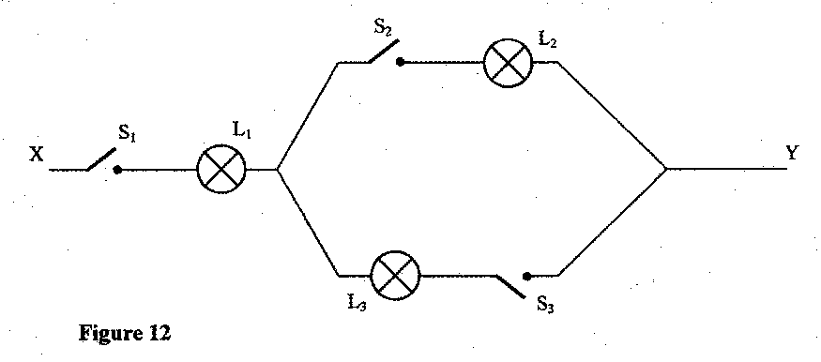
(i) Other than Lj, state the lamp that will light when S: and S₂ are closed.
(1 mark)
(ii) How does the brightness of L_{l} in (i) above compare with its
brightness when all the switches are closed? (1 mark)
(iii) Explain the observation in part (ii) above. (1 mark)

18. 2011 Q4 P2
Figure 4 shows the cross-section of a dry cell. Use the information on]
the figure to answer questions 18 and 19

Name the parts labeled A and B (2 marks)

19. 2011 Q5 P2
State the use of manganese (IV) oxide in the cell (1mark)

20. 2012 Q3 P2
Figure 3, shows four identical light bulbs connected to a 15 volt battery whose internal resistance is negligible.
Determine the reading of the voltmeter V. (2 marks)

21. 2015 Q3 P2
State the reason for topping up a lead - acid accumulator with
distilled water. (1 mark)
MEASUREMENT 1
MARKING SCHEME

- 1995 Q1 P1
Micrometer screw gauge

- 1995 Q7 P1
Oil spread until it is one molecule thick or film taken as a perfect circle or oil drop has been taken as perfect sphere/ cylinder/ uniform thickness

- 1996 Q1 P1
15.00 + 0.30 = 15. 30 mm; or 1.53cm or 1.53 x 10²m

- 1996 Q3 P1
Length of container/ height/
Width of the base/base area/diameter/radius of the base/thickness

- 1997 Q1 P1
Volume = 7.4 – 4.6 = 2.8cm
Density = mass
Volume
= 11g
2.8 cm³
= 3.9gcm⁻³
- 1997 Q4 P1
Balance: meat + 0.5 kg on one side and 2 kg on the other:

- 1998 Q1 P1
Accuracy of measuring tape is 10m or 0.1 cm + 5cm or 0.05m.

- 1998 Q2 P1
Length of post is 1.7m (1.50 x 1.55) Range

- 1998 Q2(b) P2
b i) Volume of block = 4x4x16 = 256 cm3
Mass of block = 154 gm
D= m=154=0.6g/cm³ deny ½ mark if not to d.p
V 256

ii) Volume of liquid ¾ of 256 = 192 cm³
Density of liquid = 154 = 0.8g/cm³
192
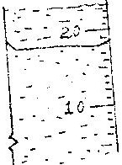
- 2000 Q1 P1

- 2001 Q1 P1
Volume removed = 11.5cm³
Density = mass = 22 1.9cm⁻³
Volume 11.5

- 2001 Q3 P1
Centre of gravity of A is at (geometric) centre while that of B is lower when rolled. Centre of gravity of A stays in one position while that of B tends to be raised resisting motion as it resists; thus slowing down B. OR B there is friction force between the surfaces which resists motion.

- 2001 Q3a P2
a) Fill tray with water to the brim and level on bench; sprinkle lycopodium
powder on the water surface either pick an oil drop with kinked wire; and
measure the volume of a drop; put one drop at centre of the tray let oil
spread and measure maximum diameter d of the patch; hence reproducing speech.

V = ⁴/₃Лr³ where r = radius of a drop
But v = Л(^{d}/₂)²t
Where t is the diameter of oil drop
T = 4v
Лd²

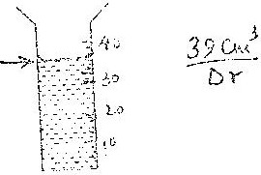
- 2003 Q1 P1

39cm³

- 2005 Q1 P1
Volume of 55 drops =8ml accept cm³
Or Volume of one drop =8/55
= 0.1454/0.1455/0.145/0.15cm³
- 2006 Q6 P1
Volume = 68cm³
Mass = 567g
Density = m = 567
V 68
= 8.34 gcm⁻³

- 2006 Q14b,c P1
(b) (i) Volume = 4/3 π r³
= 4/3 π x 0.025³
= 6.54 x 10⁻⁵ cm³

(ii) Area = π r²
= π x 10²
= 314 cm²

(iii) A x diameter of molecule = volume;
314 x d = 6.54 x 10⁻⁵
d = 2.1 x 10⁻⁷ cm

(c) (i) The oil is assumed to have spread to thickness of one molecule
(ii) Sources of errors:
- Getting the right oil
- Measuring drop diameter
- Measuring diameter of patch
- Getting drop of a right size

- 2008 Q1 P1
Water 5 x 10⁻⁶ kg RD = ML = P
ML
- 2008 Q2 P1
For liquid RD = ML
MW

P = ML x 1g/cm³
MW

- 2009 Q1 P1
Volume run out = 46.6 cm³
Density = m/_{v}=54.5/46.6=1.16953
=1.17g/cm³
- 2010 Q2 P1
- 2.53 + 0.5 = (working must be shown)

- 2010 Q9 P1
- The patch is one molecule thick
- The patch is perfectly circular

- 2010 Q16 P1
a) Mass of the water that completely filled the bottle:
= 66.4 - 43.2
= 23.2g

b) Volume of water that completely filled the bottle:
23.2g/1gcm³ = 23.2cm3
(NB: working must be shown)

c) Volume of the density bottle:
23.2cm3

d) Mass of sand
(67.5 - 43.2) g - 24.3g (working must be shown)
e) Mass of water that filled the space above the sand.
82.3 - 67.5 = 14.8g (working a must)

f) Volume of the sand:
Volume of the sand = volume of bottle - volume of added water
= 23.2 - 14.8
= 8.4cm³
g) Density of the sand
P = ^{M}/_{V} = 24.3g = 2.893cm³
8.4cm³
(NB: at least 2 dec places)

24. 2011 Q18(a) P1
Count the number of peaks (n) , measure the length and divide this length by (n-1)

25. 2012 Q1 P1
Total volume = 0.6 x 3 Reading = 7.6 + 1.8
= 1.8cm³ = 9.4cm³

Working for 1.8 must be shown

26. 2012 Q18a P1
(a) (i)lengths BC and CD
(ii) 100 x BC = S x CD OR 1 x BC = 105 x CD
S = $\frac{100BC}{CD}$ S = $\frac{BC}{10CD}$ reject use of (g) / mass.
27. 2014 Q1 P1

18.6 + 18.5 + 18.6 + 18.5
4
= 74.2 = 18.55cm = 18.6 cm
4

28. 2015 Q2 P1
22m³ – 19cm³ = 2cm³
50 drops = 2cm³
1 drop = ?
1 drop = $\frac{2}{50}$ cm³ = 0.04cm³

FORCES
MARKING SCHEME

- 1995 Q13 P1
Surface tension / adhesive forces supports water column or more capillarity in tube
2 than tube 1
  - Surface tension is the same in both tubes and equal to the weight of water column supported
  - Narrow tube has longer column to equate weight to wider tube
  - Volume of water in the tubes is same hence narrower tube higher column

- 1996 Q11 P1
Adhesion
Cohesion/ surface tension

- 1997 Q4 P1
Altitude or latitude/ radius of earth changes/ acceleration due to gravity from place to place away from the earth

- 1997 Q3 P1
Balance: meat + 0.5 kg on one side and 2 kg on the other:

- 1997 Q8 P1
Adhesion of water to glass is greater than cohesion

- 1997 Q12 P1
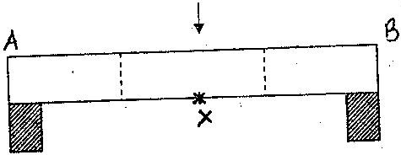

- 1998 Q5 P1
Addition of soap solution to pure water reduces the strength of the skin tension holding pin from sinking and so it sinks. Surface tension supports the pin. Addition of soap reduces tension/weakens/broken.

- 1999 Q5 P1
Cohesion between Hg molecules is greater than adhesion between Hg and glass molecules/cohesion force or adhesion. Force.

- 2002 Q2 P1
Acceleration of gravity on Jupiter is higher than that of earth, so a bag of saw dust must be less massive if the greater acceleration on earth is to produce the same pull as sugar bag on earth.

- 2003 Q11 P1
Temperature

- 2004 Q10 P1
Adding detergent/Impurities/increasing temp/heating (Any give 1mark)

- 2005 Q11 P1
In (a) cohesive forces between water molecules are greater than adhesive forces between water and wax while in (b) adhesive forces between water and glass molecules are greater than cohesive forces between water molecules.

- 2006 Q2 P1
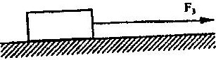

- 2006 Q10 P1
At F, radius of curve is smallest and so greatest centripetal force is required to
keep luggage on carrier; ( F =mv²) (2 marks)
R
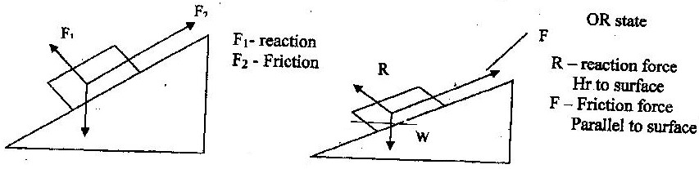
- 2008 Q3 P1
(a)

b) R – Increases OR R – Approaches W
F – increases F – increases reason (F α R)

- 2009 Q3 P1
Needle floats due to the surface tension force.
Detergents reduce surface tension, so the needle sinks.

- 2010 Q10 P1
i) The upthrust in the liquid (1 mark)
u = 5.0 - 4.04
u = 0.96N

b) The volume of the solid. (2 marks)
Weight of liquid displaced = 0.96N
Mass of liquid displaced = 0.096kg
V = ^{M}/^{P} = ^{0.096}/⁸⁰⁰ = 1.2 x 10-4m3
1.2 x 102cm3
120cm3
- 2011 Q7 P1
On dripping the hot rod at X, the water at X expands making water molecules to
move away from x. Hence the toy moves towards y

- 2012 Q2 P1
Frictional force is equal to the applied force (out in the opposite direction),
hence the net / resultant force applied is zero

- 2012 Q3 P1
$m=\frac{w}{g}$
$=\frac{16.5}{1.7}$
= 9.71kg
- Accept 9.7 since values in the question are given to an accuracy of decimal place.
- Accept calculator value of 9.70588235
- Accept truncated values e.g 9.705

- 2013 Q6 P1
Upthrust = weight of the object in air - weight of the object in the fluid

- 2013 Q11 P1
In (a), the adhesive force between water and capillary tube is stronger than the cohesive force between the water molecules while in (b) the cohesive force between
mercury and the tube is higher than the adhesive force between mercury and the tube

- 2015Q3 P1
Extension on earth = 6cm caused by 0.06kg, $K=\frac{F}{e}=\frac{0.06N}{0.06}=10N/m$
On the moon : K = 10N/m, e = 0.01 F = Ke = 10 x 0.01 = 0.1N
Grams on the moon = $\frac{w}{m}=\frac{0.1}{0.06}=$ 1.667N/m

PRESSURE
MARKING SCHEME
- 1995 Q4 P1
Flow from a to B

- 1995 Q5 P1
Pressure difference between liquids in A and B is P = $ρ$gh where e is liquid,
g = acceleration due to gravity and h is height
But force = P x cross section area of siphon, P = F/A
Thus F = $ρ$gh A Since e.g. A are constants
Fα h
- 1995 Q6 P1
No change in flow OR the flow will still continue
- 1995 Q13 P1
Surface tension/adhesive forces support water column or more capillarity in tube 2 than tube 1
  - Surface tension is the same in both tubes and equal to the weight of water column supported
  - Narrow tube has longer column to equate weight to wider tube
  - Volume of water in the tubes is same hence narrower tube higher column

- 1996 Q4 P1
h_{p} p₁ g = h₂ p₂g Same as h₁ p₁= h₂ p₂
h₁ = h₂ p₂g = 8 x 18
pg 08
= 18cm;

- 1996 Q5 P1
(i) Rubber is elastic and when a nail pushed through it stretches and grips
the nail firmly without allowing air leakage
(ii) Valve effect pressure from inside causes tyre rubber to press firmly
on the nail
- 1997 Q5 P1
H₁ P₁g = h₂ p₂g
H₂ = 1.36 x 10⁴ x -64
8 x 10²
= 1088cm;/ 10.88m.

- 1998 Q7 P1
Low contact pressure between tyre and earth/no sinking.

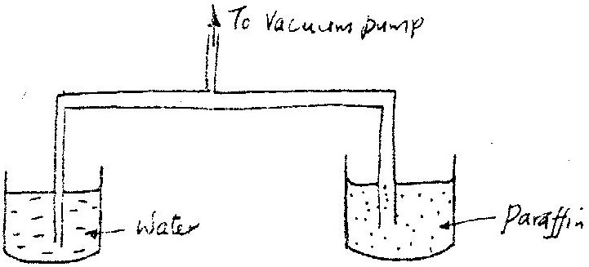
- 1999 Q4 P1

Reason: P water is greater than $∅$ paraffin=height of water required is therefore less
than that of paraffin

- 2001 Q4 P1
No air on moon surface / no air pressure / no atmosphere.

- 2001 Q3c P2
c) p= pgh; Or mass = D x V
= 1000 x 2x10 = 1000x 2x²/₁₀₀₀
= 20000 N/M²

F = P x A M = 0.4kg
= 20,000N/m² x (2 x 10⁴m²) F = mg = 0.4 x 10
= 4N =4N

- 2002 Q5 P1
P = F
A
Total press = 25000 N
0.025 x 4m² = 250,000N/m²
= 250000 Pa
- 2003 Q4 P1
P = phg / p = dhg
= 1.36 x 10⁴ x 0.7
= 9.52 x 10⁴ or 95200 Nm⁻² Allow g = 9.8m/s² (follow through working)
or 95200Pa

- 2005 Q4 P1
There is extra/ more/higher/ increased pressure in (b) due to the wooden block increasing distance d₂

- 2005 Q(2b) P1
- Pressure on liquid by $F_{1}=\frac{F_{1}}{A_{1}}$
- Pressure on load piston = pressure by effort piston on liquid
$A_{2}={25A}_{1}; \frac{F_{1}}{A_{1}}=\frac{F_{2}}{A_{2}}→F_{2}=\frac{F_{1}×A_{2}}{A_{1}}=\frac{100×{25A}_{1}}{A_{1}}=2500N$
- Gases are compressible, thus cannot transmit pressure

- 2006 Q3 P1
Pressure at a point in a fluid is transmitted equally to all points of the fluid and to the walls of the container.

- 2007 Q4 P1
Sucking air reduces pressure inside the tube; so that atmosphere pressure forces the liquid up the tube

- 2007 Q5 P1
Look for symbols
P_{A} gh_{A} = Pagh_{B} formula or correct
P_{A}g x 24 = 1200 g x 16 substitute substitution
P_{a} = 800 kgm⁻³ answer answer

- 2008 Q8 P1
P₁ = $ρ$gh or Pr = PA + heg
= 1200 x 10 x 15 x 10⁻² = 8.4 x 10⁻⁴ + 15 x 1200 x 10⁻² x 10
= 1800 pa = 8.58 x 10⁴ pa
Total pressure = (8.4 x 10⁴ ) + 1800
= 8.58 x 10⁴ pa (85800pa)

- 2009 Q4 P1
When equal forces applied; pressure on B is greater than on A due to smaller area.Pressure difference is transmitted through to liquid causing rise upward. Force on A is greater than B hence upward tension.

- 2010 Q3 P1
- Air (molecules) expelled by heating
- Pressure inside is less that atmospheric pressure

- 2010 Q11 P1
- Volume decreases so more collisions per second.

- 2011 Q14 P1
Since A and B are identical, the speeds of the jets of water are the same. This is because pressure at the same pressure at the same horizontal level is equal and is transmitted equally throughout the liquid in all directions

24. 2012 Q7
When upthrust is equal to the weight of the balloon (and its contents)

25. 2012 Q15(c) P1
(i) to expel air / to remove air / push air out / drive air out
(ii) Pressure of air outside the bottle is greater than pressure inside. / atmospheric
pressure outside is greater than pressure inside
(iii) cooling causes condensation of vapour; creating a partial vacuum; /creating
fewer vapour and air molecules inside.

26. 2012 Q15 P1
(i) valve B rests / closes / fall under its own weight (and pressure / weight above
pressure in the cylinder decreases / lowers / reduces and water rises in cylinder
pushing valve A open (opening valve A) / pressure in the cylinder decreases
(water pushed by) atmospheric pressure opens valve A
(ii) Valve A rests / closes its own weight / the weight of the water / both pressure and
weight of water above it. Increased /higher/high pressure is created in region
between valve A and valve B foreign valve B to open or water(pressure) opens
valve B

(b) The water is lifted up by the piston and comes out through the spout; / pulling up
piston / moving up piston.

(c) p_{w}gh_{w} = e_{p}gh_{p}
hp = $\frac{1000×10}{800}$
= 12.5m

(d) - force applied on piston or
- ability of the parts of the pump to withstand the pressure of the liquid column.

27. 2013 Q3 P1
$P_{atm}=hpg+P_{trapped air}$
760mmHg = 600mmHg + $P_{air}$
$P_{air}$ = 760 – 600 = 160mmHg

28. 2013 Q9 P1
Air is compressible, hence pressure is not uniformly transmitted equally

29. 2014 Q5 P1

F=PA F1= F2 = 5 P = F =F2
= 5x24 A1 A2 A1 A2
=120 N F= 5 x 24 20 = Q
= 120N 4 25
Q=120N
30. 2015Q4, 5 P1
4. depth / height of the liquid
density of the liquid

5. Sharp pointed heels have a very small area of contact and they therefore
Exert maximum pressure on the floor hence more damage

THE PARTICULATE NATURE OF MATTER
MARKING SCHEME

- 1996 Q11 P1
Adhesion
Cohesion/ surface tension

- 1996 Q37 P1
Air molecules are in constant random motion; smoke particles collide
with these molecules hence their random motion

- 1997 Q25 P1
Extra heat is required to change ice to water / latent heat of fusion

- 1998 Q23 P1
Layers of the crystal material are arranged according to faces/ plans/ flat surfaces. Cleavage is only possible parallel to those faces/places/flat surfaces.

- 2000 Q6 P1
Particles of gases are relatively far apart while those of liquids and liquids are closely parked

- 2001 Q5 P1
When the permanganate dissolves / or breaks up into particles (molecules) these diffuse through the water molecules

- 2001 Q3(b) P2
Hydrogen since its less dense it diffuses faster.

- 2003 Q5 P1
Air molecules are in continuous random motion. They bombard / knock / collide with smoke particles

- 2005 Q7 P1
A or tube with air
Gas molecules move faster/quicker than water molecules OR Diffusion of gases is faster/more than in water/Grahams law the density of air is less than that of water

- 2006 Q14a P1
(a) In solids the molecules are held in position by intermolecular forces that are very large. In liquids the molecules are able to roll over one another since the forces are smaller (1 mark)

- 2007 Q15 P1
Smoke particles
Show the behaviour or movement of air molecule

Smoke particles are larger than air molecules/ visible and light enough
to move when bombarded by air molecules
Lens Focuses the light from the lamp on the smoke particle; causing
them to be observable
Microscope Enlarge the smoke particle so that they are visible/ magnifies
Smoke particles
(b)
Smoke particle move randomly / zigzag / haphazardly
Air molecules bombard the smoke particles/ knock, hit
Air molecules are in random motion
(c)
The speed of motion of smoke particles will be observed to be higher
smoking particles move faster, speed increases, increased random motion

- 2008 Q9 P1
- Intermolecular distances are longer/ bigger/ in gas than in liquids
- Forces of attraction in liquids are stronger/ higher/ greater/ bigger/ than in
gases

- 2009 Q5 P1
Molecules inside warm water move faster than in cold water. For
Kinetic energy in warm water is higher than in cold water/move
with greater speed /molecules vibrate faster in warm water.

- 2011 Q8 P1
Raising the temperature of the gas increases the average speed of gas molecules hence bombard the wall of the container more often therefore more force is
applied to the container wall. Since the surface area of the container wall is
constant there is an increase of pressure on the walls of the container.

- 2011 Q10 P1
The inter molecule forces between water molecules are weaker than in a solid.
16. 2012 Q4 P1
The gas diffuses from the region of higher concentration to a region of low
concentration.

17. 2013 Q13 P1
Diffusion

18. 2014 Q14 P1
Collision / bombardment of particles / molecules with air molecule s/particles
which are in random motion / haphazard / zigzag

19. 2015 Q6 P1
(a) freezing (b) weak cohesive force between the particles

THERMAL EXPANSION
MARKING SCHEME

- 1995 Q8 P1
The liquid expand uniformly, expansion is measurable (large enough),
thermal conductivity

- 1995 Q34 P1
-Temperature of source be the same
- Length be the same / wax
- Amount of wax (detector) be the same

- 1996 Q6 P1
Concrete mixture and steel have approximately the same linear expansively.
They expand/ contract at the same rate
- 1997 Q7 P1
Glass is a bad conductor of heat, the difference in temperature between
the inside and the outside cause unequal expansion

- 1997 Q9 P1
The rate of cooling depends on the rate of evaporation
Rate of evaporation depends on the surface area
Surface area A, < surface area B for evaporation

- 1997 Q1a P2
i) -To make and beak contact / circuit
- It bends and straightens or the metals expand differently.
ii) Current flows, heating takes place, temperature rises, strip is heated and
bends way from contact ; disconnects heater; temperature; drops
reconnected heater or completes circuit.

- 1998 Q16 P1
Length of the rod; diameter/cross sectional area of the rod/thickness
nature/type of rod material/conductivity.

- 1998 Q31 P1
When mercury is heated (during a fire); it expands and makes contact,
completing the circuit to ring the bell.

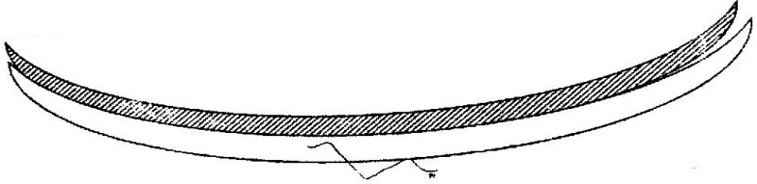
- 1999 Q6 P1

- 2000 Q7 P1
Since the strip is bimetallic when temperature rises the outer metal expands more than the inner metal; causing the strip to try and fold more; this causes the pointer to move as shows

- 2001 Q6 P1
Water rises up the tube into the flask or water is sucked into the tube
or bubbles are seen momentarily.

- 2001 Q7 P1
Cold water causes air in the flask to contract // reduces pressure inside flask or when cold water is poured it causes a decrease in volume of air the flask or pressure increases in the flask // volume of the flask decreases.

- 2003 Q6 P1
Glass flask initially expands / Heating increases the volume of the flask; hence the water level drops. Eventually water expands more than glass, leading to the level rising.

- 2004 Q2 P1
Air in the balloon expands/volume of balloon increases; displaces more air raising the up thrust of air;

- 2004 Q4 P1
Density of water is low/It will result to a very log barometer/ very long tube

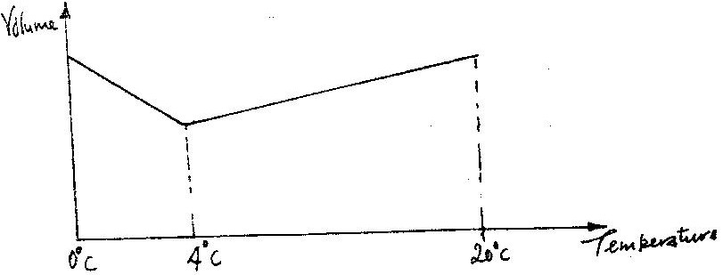
- 2004 Q5 P1

NB at 4⁰ c graph must be curved
- 4⁰ must be marked
- If drawn using a ruler N0 mark
- If 20⁰ c is marked, it must be higher than 0⁰c

- 2006 Q4 P1
On heating, the bimetallic strip bends; This causes the position of the centre of gravity of the section to the left to shift to the right causing imbalance and so tips to the right

- 2008 Q4 P1
- Atmospheric pressure is higher than normal/ standard or boiling was below
- Pressure of impurities

- 2008 Q5 P1
When flask is cooled it contracts/ its volume reduces but due to poor conductivity of the glass/ materials of the flask water falls as its contraction is greater than that of glass.
- marks are independent unless there is contradiction)
- 2009 Q6 P1
Prevents /holds, traps, breaks mercury thread to bulb when thermometer is removed from a particular body of the surrounding.
- 2010 Q3 P1
- Air (molecules) expelled by heating
- Pressure inside is less that atmospheric pressure

- 2010 Q5 P1
- Flask which is in intact with heat expands first
- Liquid expands more than glass.

- 2011 Q4 P1
Put the junction at a lower temperature than the room temperature .Aluminium
contacts more than steel hence its diameter reduces more therefore separating

- 2012 Q5 P1
Glass is a poor conductor; unequal expansion/uneven expansion/
non-uniform expansion leads to cracking

- 2012 Q17(c) P1
Density(g/cm³
Temperature(⁰c)
4

- 2013 Q7 P1
The heat on the copper side is conducted away while that on the wooden side is not
since wood is an insulator and thus does not conduct heat. This makes the paper burn
on the side of the wood

27. 2014 Q 12 P1
On the axis provided, sketch the graph which shows the relationship between volume
and temperature of a fixed mass of water in the temperature range O⁰ to 10⁰C.
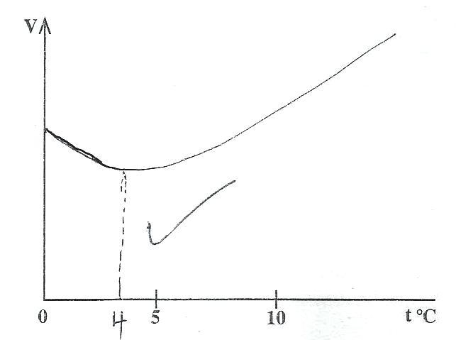

4⁰C Must be shown
Minimum volume is at 4⁰C
28. 2015 Q7 P1
The metal of making container A is better than that of B. It conducts heat
faster to the glass causing it to expand and break.

29. 2015 Q16b P1
Reducing the size of the bore – making the bulb thin – reducing the size of the bulb
HEAT TRANSFER
MARKING SCHEME

- 1995 Q10 P1
Water/ or glass are poor conductor of heat

- 1995 Q34 P1

Temperature of source be the same
- Length of rods be the same / wax
- Amount of wax (detector) be the same

- 1996 Q7 P1
Radiation is at the electromagnetic waves Φ infrared while conduction involves particles, which move at lower speed
- 1998 Q9 P1
Surface area of water . Nature of surface of the container/colour/texture /material/ (ambient temperatures).

- 1998 Q16 P1
Length of the rod; diameter/cross sectional area of the rod/thickness nature/type of rod material/conductivity.

- 2000 Q8 P1
This is because metal is a good conductor, so that heat is conducted from outer parts to the point touched; while wood is a poor conductor

- 2000 Q22 P1
Boiling point of spirit is lower than that of water. Specific heat capacity is lower than that of water.
- Spirit has a lower heat of vaporisation than water

- 2001 Q19 P1
Heat loss will be higher in A
Menthylated spirit will boil faster / evaporates / more volatile causing loss of heat through latent heat of vaporization.

- 2001 Q1(a) P2
(i) A-Vacuum
B - Silvered shiny walls
- Heat loss

- By evaporation is minimized by cork
- Through radiation is minimized by silvered walls
- Through conduction is minimized by double walls.
- Temperature is likely to be higher in flask B, since some heat is lost by flask A.
The air above the water forms convection currents.

10. 2002 Q7 P1
Can B Good absorber of radiation.

11. 2003 Q7 P1
Initially the wire gauze conducts heat away so that the gas above does not reach the ignition temp/point. Finally the wire gauze becomes not raising the temp of the gas above ignition point.

- 2004 Q7 P1
Wooden Block - Wooden block is a poor conductor of heat all the heat goes in
melting the wax.

- 2005 Q5 P1
Reduce/ minimize the transfer of heat by radiation OR Reduce the loss of heat OR gain of heat by radiation.

- 2007 Q6 P1
Radiation

- 2007 Q7 P1
X₂ is made greater than X₁ / X₁ is made shun X₂
X₂ is made larger than X₁
Since B receives radiation at a higher rate, it must be moved
Further from sources for rates to be equal: since A receives radiation at
a lower rate than B.

- 2007 Q14 P1
F₁ d₁ = f₂ d₂
Since the quantity of water A is smaller, heat produces grater change of
temperature in A; This causes greater expansion causing the cork of temperature in A; this cause greater expansion causing the cork to sink further.
Per unit volume/ greater decrease in density/ lower density in A

- 2008 Q6 P1
Heat conductivity/ rates of conduction/ thermal conductivity
(NB: If heat conduction no mark)

- 2008 Q7 P1
x sectional area/diameter/thickness/radius

- 2009 Q7 P1
Dull surface radiate faster than brighter surface.
P- looses more of the heat supplied by burner than Q
Q – shiny surface is a poorer radiator /emitter of heat thus retains more
heat absorbed. (There must be a comparison between P & Q)

- 2009 Q8 P1
Heat travels from container to test tube by radiation so the dull surface P, gives more heat to the test tube.

- 2010 Q4 P1
- Flame heats air which/becomes less dense (expands) /and move
upwards expand
- This will push the blade upwards/creates convection currents hence rotate.

- 2011 Q 5 P1
- P, connection current takes place in p more than Q because cooling takes place at the top making the cold water to none downwards

23. 2012 Q 17 a-c
(a) -Fire heats air around region C which expands and becomes less dense;
-The less dense air/smoke rises up the vent and emerges at A;
-Cool (more dense) air move down the vent at B introducing fresh air into the
room.
(b) The flask has double walls which are silvery (shinning surface) on both sided
The shiny surface is a good reflector of heat.
(c)

24. 2014 Q7 P1
- Flask painted black absorbs more heat causing more / faster expansion of
air above S than T.
- Black is a better absorber of heat causing more / faster expansion of air.

25. 2015 Q12 P1
Thermometer B – the convection of hot water rises up.

RECTILINEAR PROPAGATION OF LIGHT
MARKING SCHEME
- 1995 Q9 P1
Rectilinear propagation/ light travels in a straight line

- 1996 Q8 P1
There are three different sources of light of the different intensities; brighten/ dimmed / different direction/ amount quality. Similar sources/ at different distances from the object

- 1997 Q10 P1
A ray from A A ray from B
Relative positions of A and B correctly drawn

- 1998 Q27 P1
Moon covers the sun/obstruction of sun by the moon
Both heat and light have same velocity/both are electromagnet waves.

- 1998 Q32 P1
There will be no variation of intensity of light/ uniform intensity/no bands/one

- 1998 Q33 P1
Is the one which cannot form on a screen
Is formed by rays which are not real
Is formed by extending rays.
Formed by apparent rays.

- 1999 Q8 P1
Angle of rotation of reflected ray=2(angle of rotation of mirror)
=2 x 30 = 60⁰
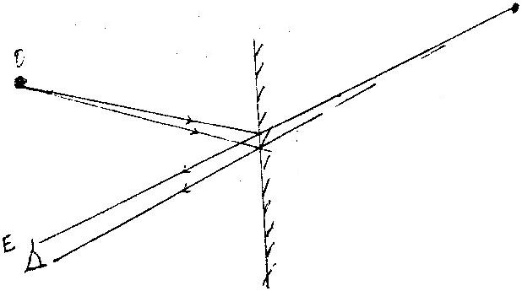
- 2000 Q9 P1

- 2001 Q8 P1
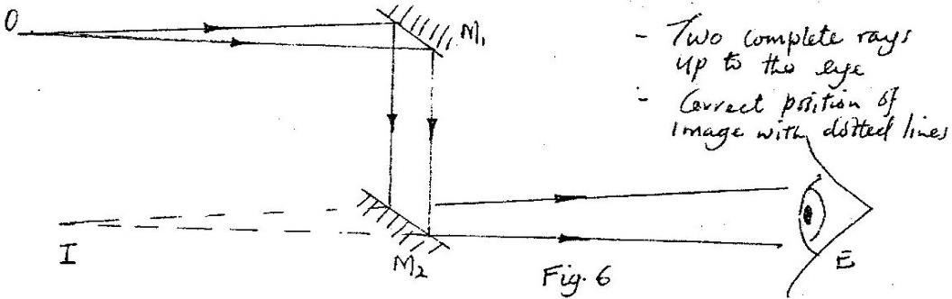

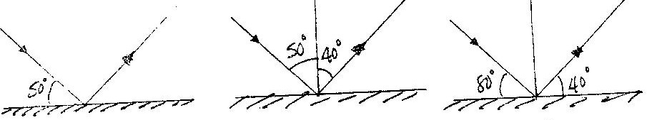
- 2003 Q8 P1

R = I = 90 = 40º
Or
R = 180 – 100 = 80 = 40º
2
- 2004 Q7 P1
NB- Check correct rays with arrows.
- At least one angle on each reflecting surfaces must be marked

- 2005 Q6 P1
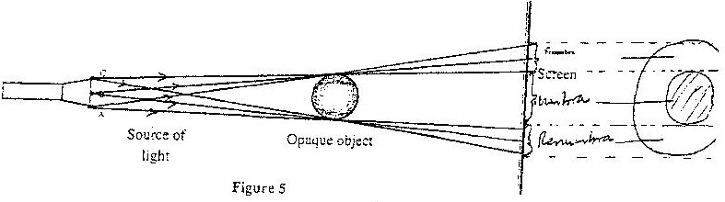

2 sec of rays with arrows labelling of umbra (totally dark) and partly dark (Penumbra)

- 2006 Q2 P2
Magnification =
Image dist = height of image
Object dist height of object
10 = 16
600 h
H = 9.6 m

- 2007 Q1 P2
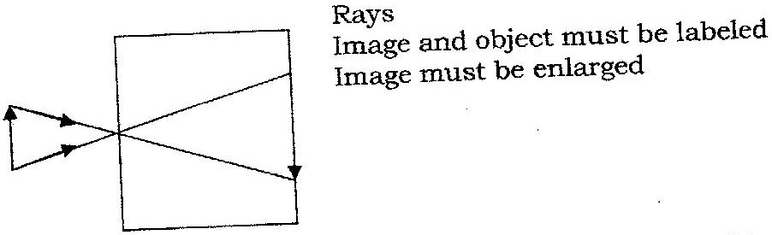

- 2008 Q1 P2
BC - Total absence of light; umbra, completely dark
- Total darkness
Rays are completed blocked from this region by the object

- 2009 Q1 P2
Infinite (very many, uncountable, several)

- 2009 Q2 P2
45⁰
45⁰

45⁰

- 2010 Q1 P2
Initial deviation = 80⁰, Reflected ray rotates 2 x 20 = 20⁰
Final deviation = 80 + 20 = 100⁰
- 2011 Q1 P2
- 2012 Q1 P2
(a)
(b) T and R
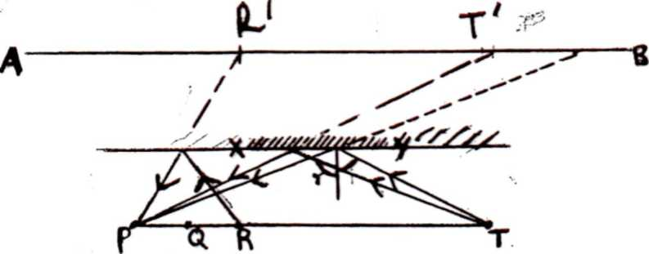
(c)

Reflected ray from T moves towards P;

- 2012 Q2 P2

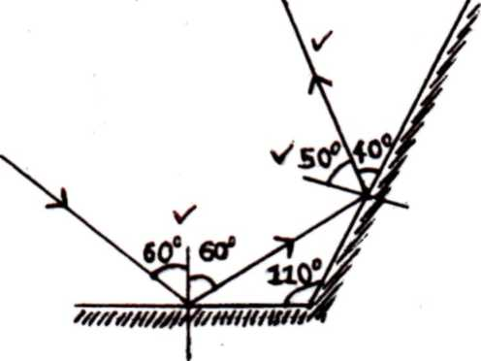
-1st reflection
- 2nd reflection
- 50⁰(correct angle)

- 2013 Q1 P2
The incident ray is normal to the surface of the mirror hence reflected along the
same path

- 2013 Q2 P2
This is due to overlapping of different images falling on the same spot on the screen

24. 2014 Q18b P2

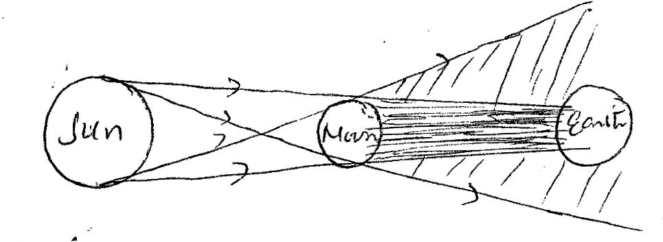
Outer pair of rays
Inner pair of rays
Proper labeling of umbra and penumbra
Hints: Size of the sun and size of the earth
Moon should be close to the earth
Rays must have arrows and must be tangent to the sun and moon

25. 2015Q1 P2

ELECTROSTATICS I
MARKING SCHEME

- 1995 Q11 P1
Each material is brought in turn to touch the cap. The conductor will discharge the electroscope while the insulator will not (accept bring near conductor gauge)

- 2001 Q9 P1
Point action takes place at sharp points (A , B, C, D ), charge concentrates at sharp points causing high pd, this causes air the surrounding to be ionized. The positive ions are repelled causing points to move in opposite direction.

- 2003 Q9 P1
The negative charges on the rod initially neutralize the positive charges on the leaf and the plate / A the road is moved towards the cap electrons are repelled to the leaf, making it to fall.
As the road is brought nearer, the excess negative charges on the leaf and
the plate. Current for a longer (Do not accept cheaper)

- 2004 Q8 P1
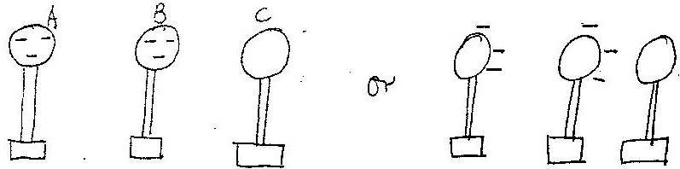

- 2005 Q8 P1
b. i)

ii) m= ht of Image = distance of image
ht of object distance of object

^{h0}/₂₀₀ = 25/5 h0= 200x25/5 = 100m
- 2005 Q38 P1
Conductor allows charge to be distributed/movement/spread.
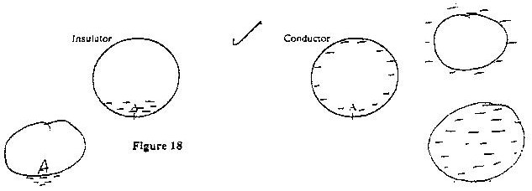

- 2006 Q3 P2
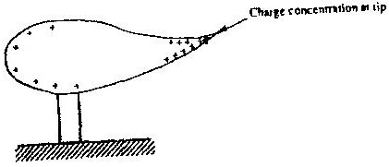

- 2008 Q2 P2
Leaf in A falls a bit while leaf in B rises a bit
The two leaf electroscope share the charge

- 2009 Q3 P2
Negative change

- 2010 Q4 P2
The conductor is initially attracted because of opposite charge. It is then neutralized and charged positive/negative, hence repelled

- 2012 Q4 P2
Correct pattern√
Correct arrows√ at least three field lines drawn
Check correct direction of field lines (2 marks)

- 2012 Q4 P2

13. 2014 Q10 P2
- Estimate the quantity of charge
- Test for insulating properties
- Test for sign of charge
- Test for presence of the charge

14. 2014 Q16b P2
(i)

Concentration at sharp end
+ve & -ve charges in correct position
Can be inside or outside
ii)
(I) Conductor loses negative charges to earth.

(II) The conductor acquires an net positive charge which redistributes itself.

(III) +ve charge uniformly distributed

15. 2015 Q2 P2
Positive charge

CELLS AND SIMPLE CIRCUITS
MARKING SCHEME

- 1995 Q12 P1
Can be short – circuited without being destroyed
Can withstand rough treatment
Do not deteriorate when not in use

2. 1996 Q19 P1
Parallel resistor allow diversion of current; hence may not overheat; / current shared by parallel resistor

3. 1997 Q15 P1
Q = It Q = 0.5 x 4x x 60; = 120C

4. 1998 Q10 P1
Evaporation and cell reaction cause loss of water. Distilled water does not
introduce impurities to the cell.
- 2000 Q10 P1
  - Longer life/ electrolyte never need attention
  - Can stay discharged without being destroyed
  - Can be charged with large currents faster charging
  - More rugged/ not damaged by rough condition of use/ robus
  - Delivers large current, light

- 2001 Q10 P1
By forming hydrogen layer / cover or hydrogen atoms or molecules which insulate the copper plate OR forming it cells between hydrogen and zinc which opposes the zinc copper cell or by forming a hydrogen layer / cover which increases internal resistance.

- 2003 Q10 P1
It has very low internal resistance

- 2003 Q23 P1
Circuit A
Current draw from each cell is less than in B / In A there is les internal resistance.

- 2004 Q9 P1
To depolarize/ oxidizer/ reduces polarization/oxidizes H₂ to H₂ to
H₂O/Changes H₂ to H₂O/ removes H₂ (any give 1 mark)

- 2004 Q15 P1
The bulb in 10(a) offers higher resistance which results to low current flow hence less brighter.

- 2004 Q16 P1
Either in (10b) current from each cell is less than in (10 a)
Or
Power supplied in 10(b) is less than in 10(a)

- 2005 Q9 P1
A-Positive
B-Negative

- 2005 Q10 P1
C- Ammonium jelly/chloride/paste/solution/NH₄Cl
D-Mixture of carbon and manganese (iv) oxide/MnO₂

- 2006 Q4 P2
To allow escape of gases (H₂ and O₂) from battery

- 2007 Q2 P2
Alkaline cell lasts longer than lead acid cell/ remain unchanged longer
Alkaline cell is more rugged than lead acid cell/ robust/ can withstand
rough handling
Alkaline cell is lighter than lead – acid cell (any one

- 2009 Q4 P2
Allow gassing/ release of gases.
OR release H₂ and O₂ produced at the electrodes.

- 2012 Q3 P2
V + V + $\frac{V}{2}=\frac{5V}{2}$
$\frac{5V}{2}$ =15V
V= 6V method√
Therefore $\frac{V}{2}=\frac{6}{2}$ = 3V correct answer√

- 2010 Q17(a) P2
- L₂
- L₁ is brighter
- When the switches are all closed the total resistance is less then

- 2013 Q4 P2
A= carbon rod or graphite rod
B = mixture of manganese (IV) oxide with carbon powder

- 2013 Q5 P2
Manganese (IV) oxide is a depolarizer or oxidizing agent. It’s used to oxidize hydrogen to water

- 2014 Q3 P2
Distilled water has no impurities that can react with the acid

