NAME: ………………………………… ADM NO: ……… CLASS: ………….
ANESTAR SCHOOLS
MATHEMATICS
FORM 1
END OF TERM 3 EXAM – 2022
TIME: 2 HOURS

Attempt all the questions in the spaces provided.
No.
1. | ($\frac{5}{6}$ - 1$\frac{2}{3}$ + 1$\frac{1}{4}$) x 1$\frac{5}{7}$  = $\frac{5}{6}$ + $\frac{5}{4}$ - $\frac{5}{3}$) x $\frac{12}{7}$  = 10 + 15 – 20) x 17  12 7  = 5 x 12  12 7  = 5  7 | M1  M1  A1
 |  | 3
2. | 3x + 2y = 23  2x – y = 6  2x – y = 6  -y = 6 – 2x  y = 2x – 6  3x + 2 (2x – 6) = 23  3x + 4x – 12 = 23  7x = 23 + 12  7x = 35  x = 5  2(5) – y = 6)  10 – y = 6  y = 4 | M1  A1  A1 | Substitution method must be used otherwise NO MARKS
 | LCM  2 300 500 750  2 150 250 375  3 75 125 375  5 25 125 125  5 1 5 5  1 1 1 1  LCM = 2² X 3 X 5³ = 1500L  1500 + 200 = 1700L | 3  B1  M1  A1 | Finding the  LCM
 |  | 3
4. | Exterior angle = 180º -156º  = 24  No. of sides = 360º = 15  24º | M1  A1
 |  | 2
5. | Area of bigger sector  36 x 3.142 x 10.5 x 10.5 = 34.641  360  Area of smaller sector  36 x 3.142 x 7 x 7 = 15 .396  360  Shaded = 34.641 – 15.396  = 19.245cm² | M1  M1  A1
 |  | 3
6. | x + 1 - x - 3 = 4  2 3  6 x + 1 - 6 x – 3 = 6(4)  2 3  3(x + 1) - 2(x – 3) = 24  3x + 3 – 2x + 6 = 24  x+ 9 = 24  x = 24 – 9  x = 15 | M1  M1  A1
 |  | 3
7. | 8260439  Sum of all digits odd positions = 8 + 6 + 4 + 9 = 27  Even positions = 2 + 0 + 3 + = 5  Difference = 27 – 5 = 22  22 is a multiple of 11 hence divisible by 11 | M1  A1
 |  | 2
8. | Numerator: 36 – 8x – 4 + 5  36 + 32 + 5 = 73  Denominator  3x – 3+ - 8 (8) = -9 – 64  = -73  N = 73 = -1  D -73 | M1  M1  A1
 |  | 3
9. | Cross section area  (2 x 7) + 22 x 7² = 168cm²  7  Volume = (168 x 300)cm³  = 50,400cm³  Mass v x d + 50,400 x 8.87  1000  = 447.048kg | B1  M1  A1
 |  | 3
10. | (15000 X 124 .65) 92  100  Ksh 1720170  ½ x 1720170 = 860085  860085 = 8971.3675  95.87  = 8971 US dollars | M1  M1  A1
11. | John Jane  3 years ago 3 x x  2 years time 3x + 5 x + 5  3x + 5 + x + 5 = 62  4x + 10 = 62  4x = 52  x = 13  Difference = 39 – 13 = 26 | M1  A1  A1 | Difference does not change
 |  | 3
12. | $<$PNM = 180 – 54 = 126º  $$<NPM= <NMP=180-126=27°$$  2  $<LMP= <$NPM = 27º  Hence $<LPM=180-\left(27+50\right)$  = 103º | B1  B1  A1
 |  | 3
13. | 0.000125  0.0225²  0.0001255 = 1.25 x 1  10000  = 1.1180 x 1  100  = 0.01118  0 .0225² = 2 .25 ² = 6.25  100 10000  = 625  0.0118  625 | B1  B1  A1
 |  | 3
14. | W:A:J = 3:7 :9  Atieno = 7 = 7  3+7+9 19  7 = 63,000  19  19 = ?  19  63,000 x 19  7  = Ksh 171,000 | M1  M1  A1
 |  | 3
15. | Men Days Hrs Acres  5 2 10 1  2 ? 6 3  2 x 5 x 10 x 3 = 25 days  2 6 1 | B1  M1
 |  | 2
16. | 130% = 1560  100% = ?  1560 x 100 = 1200  130  120% = 1200  100% = ?  1200 x 100 = 1000  120 | M1  M1  A1
 |  | 3
17.  3 | 5  4  5  3  5  4  5  3  3  5  Area (5 x 4) 2 + (4 x 3) 2 + (5 x 3) 2  40 + 24 + 30 = 94cm² | B1  B1  A1 | Sketch
18. | 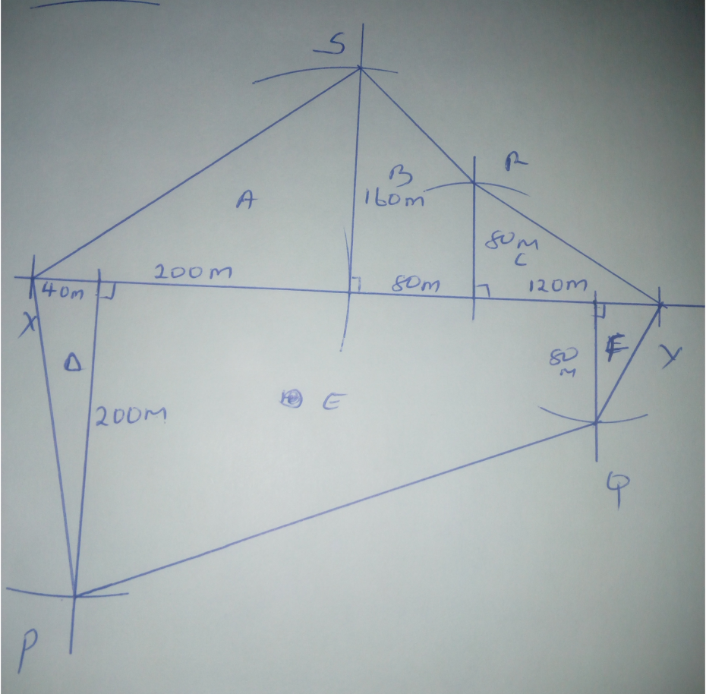 | B1  B2  B1 | Baseline  Offsets  Complete diag
 | Area of A= $1/2$x 200x160= 16,000 m²  Area of B= $1/2$(160+80)80= 9,600 m²  Area of C= $1/2$x120x80 = 2,400 m²  Area of D= $1/2$x40x200= 4,000m²  Area of E= $1/2$(200+80)= 44,800m²  Area of F= $1/2$x40x80 = 1,600m²  Total = 78,400m²  = 7.84 hectares | B3  B1  A1 | Every 2 correct  1 Mark  Area in m²

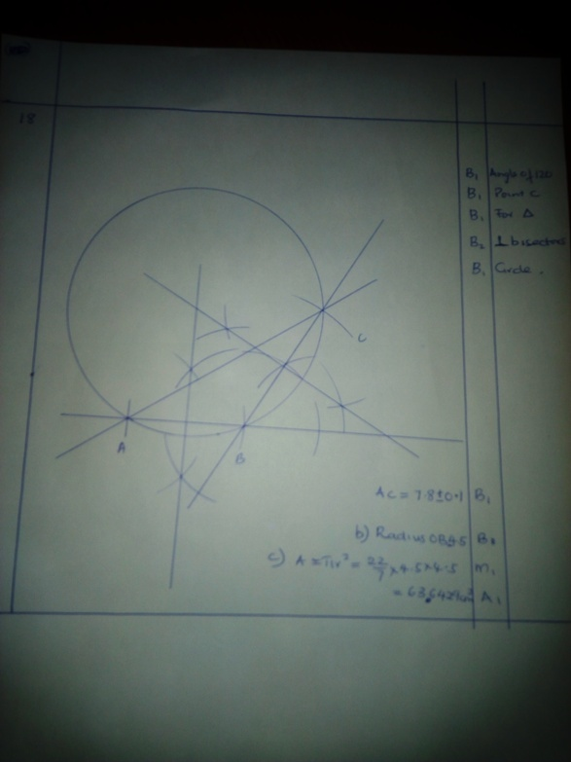

19 | Time taken= arrival- departure time  = 1600 hr - 0830 hrs  =7hrs 30 min  7x60 +30= 450 minutes  b) 1340hrs- 1310 hrs= 30 minutes  30x60= 1800 seconds  c) 1600-1200 = 4.00 p.m.  d) speed= d/t  = 300/7.5= 40 km/h  Time taken= 4hrs 20 min

20. | - 5.6m =560 cm  V$=πr^{2}$l =${22}/7$x14x14x560  = 344,960 cm³  - Mass= density x volume  = 0.5 x 344,960  =172,480g  1000g= 1 kg  172480 g= ?  172480/1000 =172.40 kg  - i) S.A= $πdl+2πr^{2}$  = ${22}/7$x28 x560 + 2x${22}/7$x14x14  =49,280 + 1,232  = 50,512cm²  ii)  ${50512}/{1000}$= 5.0512m²  1m² = kshs 50  5.0512m²= ?  50x5.0512=kshs 252.56
