INTRODUCTION TO CHEMISTRY
1. 2000 Q 15
State any two differences between luminous and non – luminous flames
(2 marks)

2. 2007 Q 4
The diagram below shows a Bunsen burner when in use.
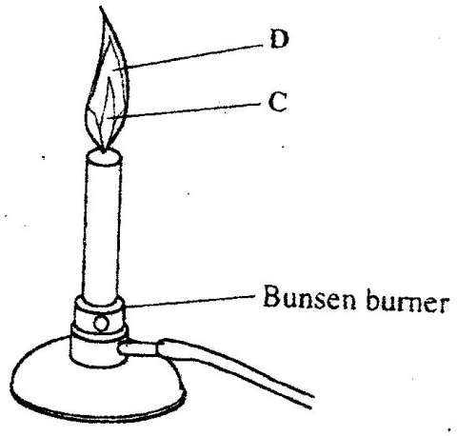

Name the regions labelled C and D. (2 marks)

3. 2014 Q1 P1
Explain how the hotness of a Bunsen burner flame can be increased (1 mark)

SIMPLE CLASSIFICATION OF SUBSTANCES

            - 1995 Q 7 P1
The curve below represents the variation of temperature with time when
pure and impure samples of a solid were heated separately.

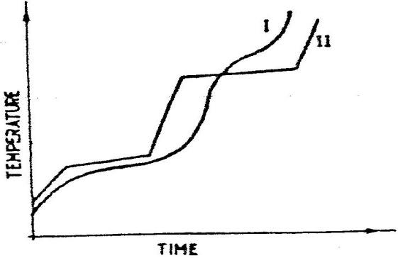

Which curve sows the variation in temperature for the pure solid? Explain (2marks)

            - 1995 Q 15
Explain how you would separate mixture of nitrogen and oxygen gases
given that their boiling points are – 196ºC and 183⁰C respectively (2 marks)

            - 1995 Q 6 P2
(a) The table below gives information about the major constituents of
crude oil. Study it and answer the questions that follow.

Constituent | Boiling point (⁰C)
Gases  Petrol  Kerosene  Diesel oil  Lubricating oil  Bitumen. | Below 40  40-175  175-250  250-350  350-400  Above 400

(i) Which one of the constituents or crude oil has molecules with the
highest number of carbon atoms? (2 marks)

(ii) Name the process you would use to separate a mixture of petrol
and diesel and explain how the separation takes place. (2 marks)

(iii) Explain why the constituent of crude oil and write its formula
(1 mark)
(iv) Name one gas that is likely to be a constituent of crude oil and
write its formula. (1 mark)

(b) What condition could cause a poisonous gas to be formed when
Kerosene is burnt? Explain (2 marks)
(c) Give one use of bitumen (1 mark)

            - 1997 Q 22 P1
In an experiment to separate a mixture of two organic liquids, liquid M
(b.p 56ºC) and liquid (b.p. 118⁰C), a student set up the apparatus shown below.
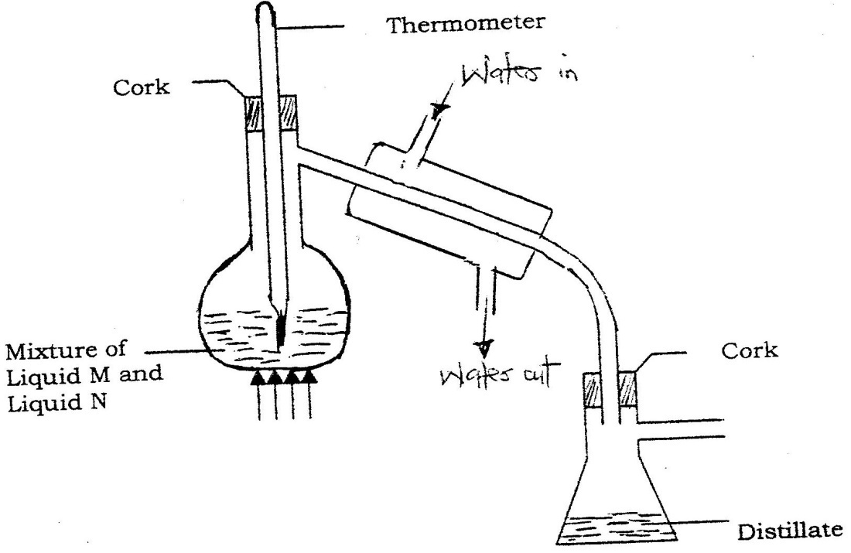

a) Identify two mistakes in the set – up (2 marks)
b) What method would the student use to test the purity of the
distillates obtained? (1 mark)

            - 1998 Q 17 P1
The diagram below represents a paper chromatogram for three brands
of juices suspected to contain banned food colorings.

K
L
M
x
x
x
Brand of juice

The results showed the presence of banned food colorings in L and M only.
On the same diagram:
- Circle the spots which show the banned food colorings (2 marks)
- Shoe solvent front. (1 mark)

            - 1998 Q 17 P1
The diagram below shows the physical state of matter. Study it and
answer the questions that follow.
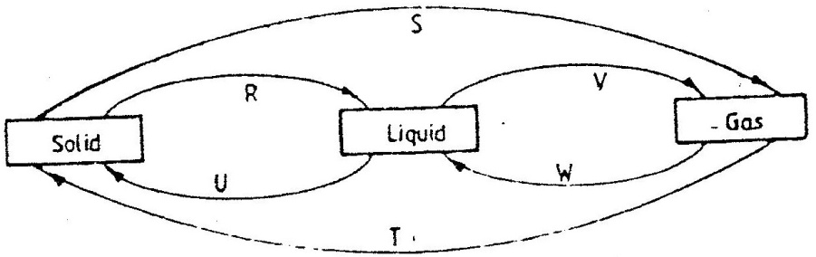

Identify the processes R, V, w and U (2 marks)
        - Name one substance which can undergo the process represented
by S and T. (1 mark)

            - 2000 Q 1 P1
Explain the change in mass that occurs when the following substances are
separately heated in open crucibles
(a) Copper metal
(b) Copper (II) nitrate (3 marks)

8. 2001 Q 4a P2
a) Fraction distillation of liquid air usually produces nitrogen and oxygen
as the major products.

i)Name one substance that is used to remove carbon dioxide from the
air before it is changed into liquid.

ii)Describe how nitrogen gas is obtained from the liquid air.
(Boiling points nitrogen = - 196ºC, oxygen = -183ºc

9. 2003 Q 9
The set – up below represents the apparatus that may be used to separate
a mixture of two miscible liquids C and D whose boiling points are 80⁰C and 110⁰C.
Thermometer
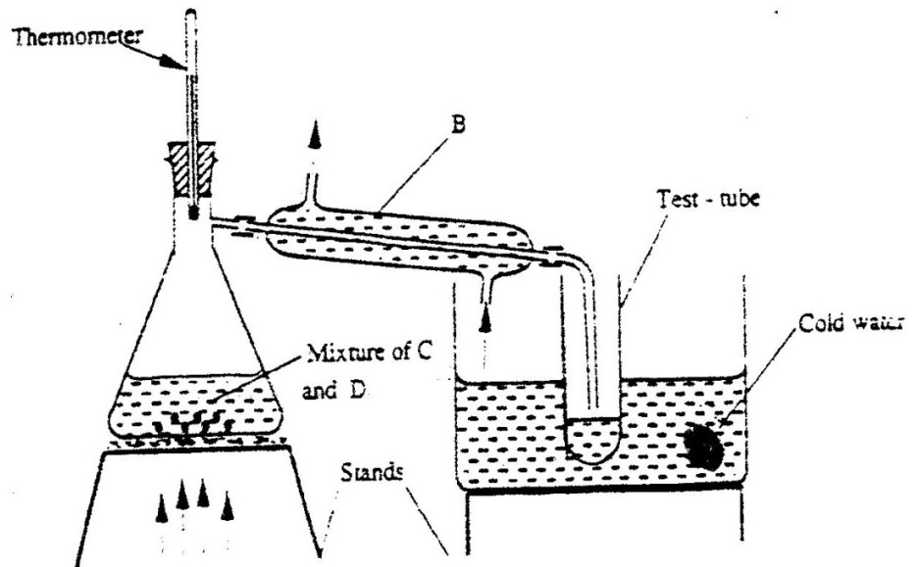

Test - tube

Cold water
Mixture of C
and D

Stands

Heat

- name B
- What is the purpose of the thermometer (1 mark)
- Which liquid was collected in the test tube? (1 mark)

- 2004 Q 27
Apiece of chromatography paper was spotted with coloured inks obtained
from pens labelled 1 to 6. The diagram below shows the spots after the
chromatogram was developed.

1 2 3 4 5 6
Black Yellow Red Blue Green
Starting point for spots
Solvent front

a) Which two pens contained in the same pigment? (1 mark)
b) Which pens contained only one pigment (1 mark)
c) According to the chromatogram, which pigments are present in
the ink of pen number 6. (1 mark)

- 2004 Q 6a P2
- Crude oil is a source of many compounds that contain carbon and
hydrogen only.
(i) Name the processes used to separate the components of crude
Oil (1 mark)
(ii) On what two physical properties of the above components does
the separation depend? (2 marks)

- 2005 Q 1 P2
(a) The diagram below shows spots of pure substance A,B, and C on a
chromatography paper. Spot D is that of a mixture
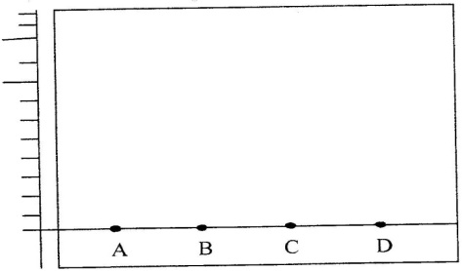

After development, A, B and C were found to have moved 8cm, 3cm and 6 cm
respectively. D has separated into two spots which had moved 6cm and 8 cm

(i) On the diagram
I Label the baseline ( origin) (1 mark)
II Show the positions of all the spots after development (3 marks)

(ii) Identify the substances present in the mixture D (2 marks)

(b) Describe how solid ammonium chloride can be separated from a
solid mixture of ammonium chloride and anhydrous calcium chloride (2marks)

(c) The table shows liquids that are miscible and those that are immiscible

Liquid | L₃ | L₄
L₁ | Miscible | Miscible
L₂ | Miscible | Immiscible

Use the information given to answer the questions that follow

(i) Name the method that can be used to separate L1 and L3 from a
mixture of two
(1 mark)
(ii) Describe how a mixture of L₂ and L4 can be separated (2 marks)

- 2006 Q25 P1
Study the properties of substances V1 to V4 in the table below and answer
the questions that follow.

Substance | Solubility in water | Solubility | Melting Point(ºC) | Boiling point(ºC)
V1 | Insoluble | Soluble | -30 | 250
V2 | Insoluble | Insoluble | 1535 | 3000
V3 | Insoluble | Soluble | 16.8 | 44.8
V4 | Insoluble | Soluble | 75 | 320

a) Which of the substances are liquids at 240C?
b) Describe how a mixture containing V2 and V4 can be separed (2marks)

- 2006 Q26 P1
The graph below shows a curve obtained when water at 20oC was heated for
15 minutes.
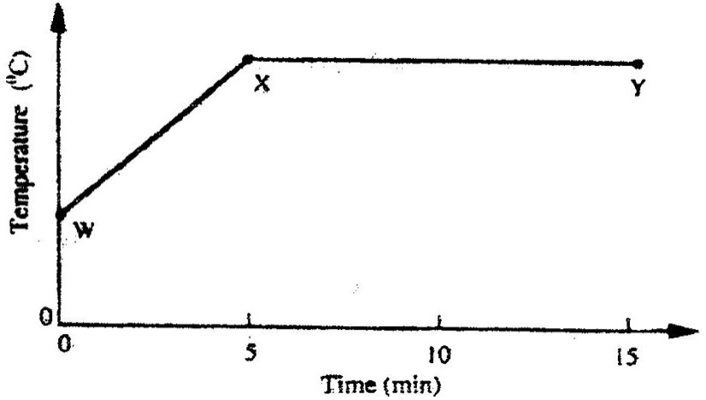

a) What happens to the water molecules between points W and x? (1mark)
b) In which part of the curve does a change of state occur? (1mark)
c) Explain why the temperature does not rise between points X and Y. (1mark)

- 2006 Q 10a P1
Name the process which takes place when:
a) Solid carbon (IV) oxide (dry ice) changes directly into gas (1 mark)

16. 2008 Q 14 P1
Samples of urine from three participants F, G and H at an international
sports meeting were spotted onto a chromatography paper alongside two
from illegal drugs A₁ and A_{2.}A chromatogram was run using methanol. The
figure below shows the chromatogram.
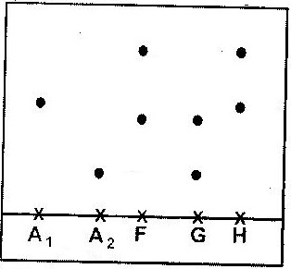

a) Identify the athlete who had used an illegal drug. (1 mark)
b) Which drug is more soluble in methanol? (1 mark)

17. 2008 Q 25 P1
The graph below is a cooling curve of a substance from gaseous state
to solid state.
Temperature (⁰C)
t₀
t₁
t₂
t₃
t₄

Time (minutes)
Give the name of the:
a) Process taking place between t₀ and t_{1.} (1mark)
b) Energy change that occurs between t₃ and t₄ (1mark)

18. 2008 Q 1a P2
a) Biogas is a mixture of mainly carbon (IV) oxide and methane.

(i) Give a reason why biogas can be used as a fuel. (1mark)

(ii) Other than fractional distillation, describe a method that can be
used to determine the percentage of methane in biogas. (3 marks)

19. 2009 Q 20
Classify the following processes as either chemical or physical. (3 marks)

Process | Type of change
(a) heating copper(II) sulphate crystals
(b) Obtaining kerosene crude oil
(c) souring of milk

20. 2009 Q 5a,b P2
(a) Figure 3 shows the changes that take place between state of matter.
Some of them have been identified and others labelled.

(i) Give the names of the process:
I H (1 mark)
II G (1 mark)
(ii) Name one substance that can undergo process F When left in an open
Container in the laboratory (1 mark)

(iii) The process J is called deposition. Using water is an example; write an
equation that represents the process of deposition. (1 mark)

(b) Figure 4 shows the heating curve for water

(i) Give the names of the intermolecular forces of attraction in the segments.
I MN (1 mark)
II RS (1 mark)

21. 2010 Q 25 P1
Hydrate cobalt(II) chloride exists as pink crystals and anhydrous
cobalt(II) chloride is a blue powder. Describe a laboratory experiment
that can be used to show that the action of heat on hydrated
cobalt(II) chloride is a reversible reaction. (3 marks)

22. 2011 Q3 P1
A mixture contains ammonium chloride, copper (II) oxide and sodium chloride.
Describe how each of the substances can be obtained from the mixture (3 marks)

23. 2012 Q5 P1
A sample of water in a beaker was found to boil at 101.5 °C at 1
atmosphere pressure. Assuming that the thermometer was not faulty,
explain this observation.
(1 mark)
24. 2012 Q2 P1
Iron (III) oxide was found to be contaminated with copper (II) sulphate.
Describe how a pure sample of iron (III) oxide can be obtained. (3 marks)

25. 2013 Q15 P1
The chromatogram below was obtained from a contaminated food sample
P. Contaminants Q, R, S and T are suspected to be in P. Use it to answer
the following questions.
- Identify the contaminants in mixture P. (1 mark)
- Which is the most soluble contaminant in P.? (1 mark)
26. 2014 Q19 P1
Draw a set up that can be used to separate a mixture of sand and iodine (3 marks)

27. 2014 Q22 P1
The set up below was used to separate a mixture of methanol and propanol.
Study it and answer the question that follow.

- State the function of X (1 mark)
- Which liquid will collect first in the beaker? give a reason. (2 marks)

28. 2015 Q3 P2
(a) Name the method that can be used to obtain pure iron (III) chloride
from a mixture of iron (III) chloride and sodium chloride. (1 mark)

(b) A student was provided with a mixture of sunflower flour, common salt and
a red dye. The characteristics of the three substances in the mixture are given
in the table below.

Substance | Solubility in water | Solubility in ethanol
Sunflower flour | Insoluble | Insoluble
Common salt | Soluble | Insoluble
Solid red dye | Soluble | Soluble

The student was provided with ethanol and any other materials needed.
Described how the student can separate the mixture into its three components
(3 marks)

ACIDS, BASES AND INDICATORS

1. 1990 P1A Q 21
Explain why concentrated Sulphuric acid is a weaker acid than
dilute Sulphuric acid

2. 1992 P1A Q 6
Solution may be classified as strongly basic, weakly basic, neutral. Weakly
acid, strongly acidic. The information below gives solutions and their PH
values. Study it and answer the questions that follow.

Solution | PH value
B  C  D | 0.5  6  14.5

Classify the solutions in the table above using the stated classifications.
(3 marks)
3. 1994 P1A Q 9
In the equation below, identify the reactant that acts as an acid and explain
how you arrive at our choice.

NH₄⁺_{(aq)} + H₂O_{(I)} NH_{3(aq)} + H₃O⁺_{(aq)} (2 marks)

4. 1995 P1A Q18
Study the diagram below and answer the questions that follow.
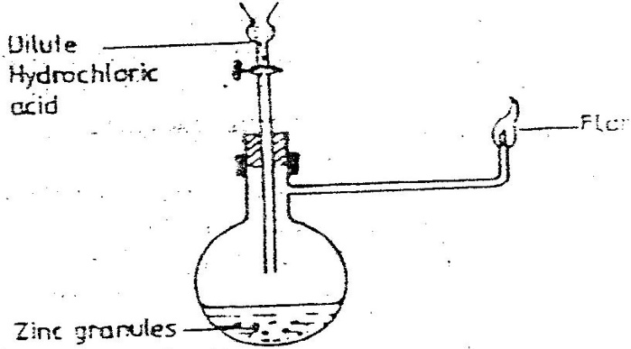
Dilute hydrochloric acid

flame

Zinc granules

Write an equation for each of the two reactions that take, place in the
experiment represented by the diagram above (2marks)

5. 1997 P1A Q17
In the equation below, identify the reagent that acts as a base. Give a reason
(2 marks)
H₂O_{2(aq)} + H₂O_{(l)} H₃O⁺_{(aq)} H₂O_{(aq)}

6. 1998 PP1A Q12
Distinguish between a strong and weak acid. Give an example of each
(2 marks)
7. 1998 PP1A Q24
A beekeeper found that when stung by a bee, application of a little solution
of sodium hydrogen carbonate helped to relieve the irritation from the
affected area. Explain (2 marks)

8. 1999 P1A Q3
State and explain the observations that would be made when a few drops of
concentrated Sulphuric acid are added to a small sample of hydrated copper
(II) sulphate. (2 marks)

9. 1999 P1B Q1a
The table below gives the volume of the gas provided when different volumes
of 2M hydrochloric were reacted with 0.6g of magnesium powder at room
temperature

Volume of 2M hydrochloric acid (cm³) | Volume of gas (cm³)
0  10  20  30  40  50 | 0  240  480  600  600  600

Write an equation for the reaction between magnesium and hydrochloric acid

10. 2000 Q 27 PP1
State and explain the function of tartaric acid in baking powder

11. 2001 Q 8 PP1
10gm of sodium hydrogen carbonate were dissolved in 20cm³ of water in a
boiling tube. Lemon juice was then added drop wise with shaking until there
was no further observable change.

a) Explain the observation, which was made in the boiling tube when
the reaction was in progress (2 marks)

b) What observation would have been made if the lemon juice had been
added to copper turnings in a boiling tube? Give reason? (2 marks)

12. 2001 Q 26 PP1
The Ph of a sample of soil was found to be 5.0.An agricultural office recommended
the addition of calcium oxide in the soil. State two functions of the calcium oxide
in the soil.

13. 2003 Q 7 PP1
In an experiment equal amounts of magnesium powder were placed into
test – tube 1 and 2 as shown below
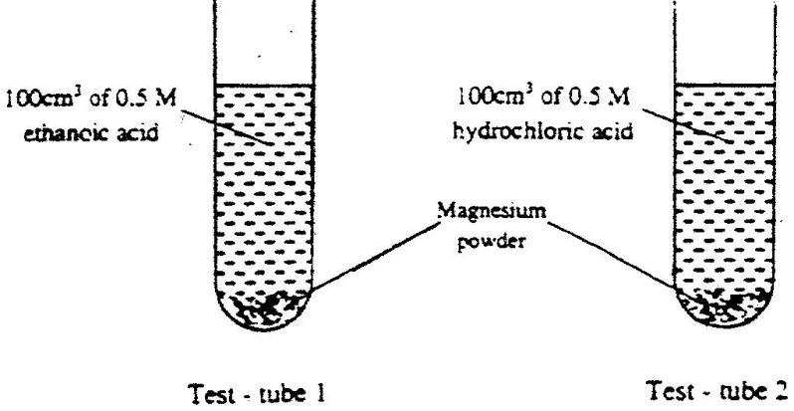
100cm³ of 0.5M hydrochloric acid
100cm³ of 0.5M ethanoic acid

Magnesium powder

Test – tube 1 Test – tube 2

Explain why the amount of hydrogen gas liberated in test – tube 2 is
greater than in test- tube 1 before the reaction is complete.

14. 2003 Q 18 PP1
The table below shows the tests carried out on a sample of water and
the results obtained.
 | Tests | Results
I | Addition of sodium hydroxide solution | White precipitate which dissolves in excess
II | Addition of excess aqueous ammonia | Colourless solution obtained
III | Addition of dilute hydrochloric acid and barium chloride | White precipitate

a) Identify the anion present in the water
b) Write an ionic equation for the reaction in III
c) Write the formula of the complex ion formed in II

15. 2003 Q 1d PP2
Write two ionic equations to show that aluminium hydroxide
is amphoteric (2 marks)

16. 2004 Q 8
When wood is burnt, a grey powder called ash remains. The ash is stirred
with water and filtered, a colourless solution is obtained.

a) What is the main component of the colourless solution? (1mark)

b) Explain your answer in (a) above (2marks)

17. 2004 Q 2a PP2
a) The set-up below was used to collect gas F, produced by the reaction
between water and calcium metal.
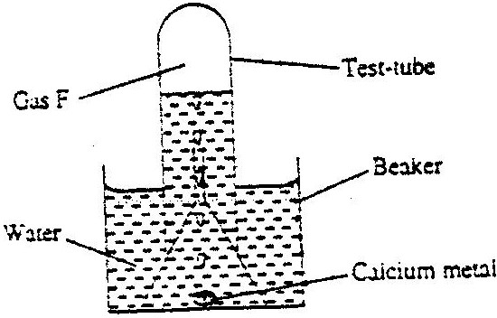
Test - tube
Gas F

beaker
Water

Calcium metal

(i) Name gas f

(ii) At the end of the experiment, the solution in the beaker was found to
be a weak base. Explain why the solution is a weak base. (2 marks)

(iii) Give one laboratory use of the solution formed in a beaker. (1 mark)

18. 2006 Q 19
Give one use of magnesium hydroxide. (1 mark)

19. 2006 Q 24
a) Complete the table below to show the colour of the given indicator in

Indicator | Colour in
 | Acid solution | Basic solution
Methyl orange | ……………. | Yellow
Phenolphthalein | Colourless | ………………

b) How does the pH value of 0.1 M potassium hydroxide solution
compare with that of 0.1M aqueous ammonia? Explain. (2 marks)

20. 2007 Q 5
When a student was stung by a nettle plant, a teacher applied an
aqueous solution of ammonia to the affected area of the skin and the student
was relieved of pain Explain. (2 marks)

21. 2007 Q 16
The table below shows the tests that were carried out on solid N and the
observations made.

I | Test | Observations
II | Dilute hydrochloric acid was added to solid N. | A colourless solution was formed.
III | To the colourless solution obtained in test II, excess sodium hydroxide solution was added. | A white precipitate was formed which dissolved to form a colourless solution.

Write the formula of the anion in;
a) Solid N (1 mark)
b) The colourless solution formed in test III (1 mark)

22. 2008 Q 3
Complete the following table by filling in the missing test and observations
(3 marks)

No. | Gas | Test | Observation
I | Chlorine | Put a moist red litmus paper into the gas
II | Sulphure (IV) oxide |  | Paper turns green
III | Butane | Add a drop of bromine water

23. 2008 Q 10 P1
When magnesium was burnt in air, a solid mixture was formed. On addition of
water to the mixture a gas which turned moist red litmus paper blue was
evolved. Explain these observations.

24. 2009 Q 22 P1
A student added very dilute sulphuric (VI) acid to four substance and
recorded the observations shown in the table below

Test | Substance | Gas given off
1 | Sodium | Yes
2 | Iron | No
3 | Carbon | Yes
4 | Copper | No

For which tests chart below to answer the questions that follow.

25. 2009 Q 30 P1
Starting with red roses, describe how;
- A solution containing red pigment may be prepared; (1 mark)
- The solution can be shown to be an indicator (2 marks)

26. 2011 Q 20 P1
Describe how the PH of anti- acid (Actal) powder can be determined
in the Laboratory (2 marks)

27. 2014 Q27 P1
a) Name a suitable solvent for extracting an indicator form flowers: (1 mark)

b) Give a reason why the solvent named in (a) above is used (1 mark)

28. 2015 Q15 P1
Given the following substances: wood ash, lemon juice and sodium chloride.

(a) Name one commercial indicator that can be used to show whether
wood ash, lemon juice and sodium chloride are acidic, basic or neutral. (1 mark)
b) Classify the substances in 15(a) above as acids, bases or neutral (2 marks)

A cid | Base | Neutral

AIR AND COMBUSTION

1. 1989 Q 11
Explain why a mixture of copper oxide and magnesium reacts when heated
while there is no reaction when a mixture of copper and magnesium
oxide is heated. (2 marks)

2. 1992 Q 18
- Write the formula for the oxide of
- Magnesium (1 mark)
- Chlorine (1 mark)
- Write an equation for the reaction between the oxide of chlorine
and water (1 mark)

3. 1995 Q8 P1
The diagram below represents a set – up that can be used to prepare and
collect oxygen.
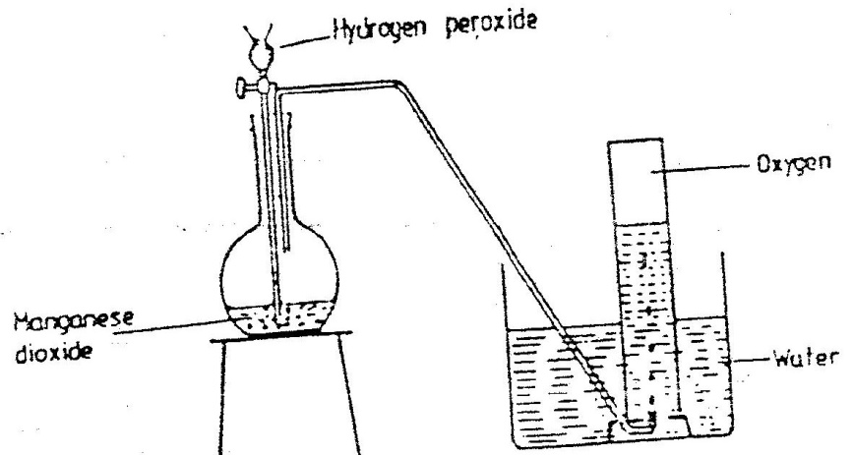
Hydrogen peroxide

oxygen

Manganese dioxide

water

a) Write an equation for the reaction that takes place (1mark)

b) What property of oxygen makes it possible for its collection as indicated
by the diagram (1mark)

c) Explain why it is important not to collect any gas for the first few.
Seconds of the experiment. (1mark)

4. 1995 Q15 P1
Explain how you would separate mixture of nitrogen and oxygen gases
given that their boiling points are – 196⁰C and 183⁰C respectively (2marks)

5. 1996 Q12 P1
When magnesium metal is burnt in air, it reacts with both oxygen and
nitrogen gases giving a white ash. Write two equations for the reactions
that take place. (2marks)

6. 1997 Q1 P1
The set – up below was used to study some properties of air.
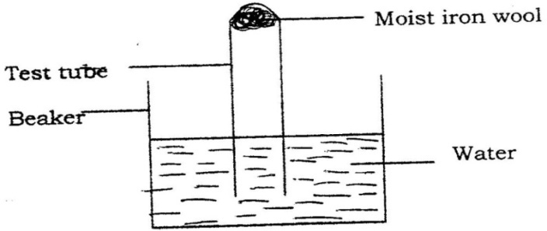

State and explain two observations that would be made at the
end of the experiment.

7. 1999 Q17 P1
In an experiment a certain volume of air was passed from syringe to syringe
over heated zinc powder as shown in the diagram below
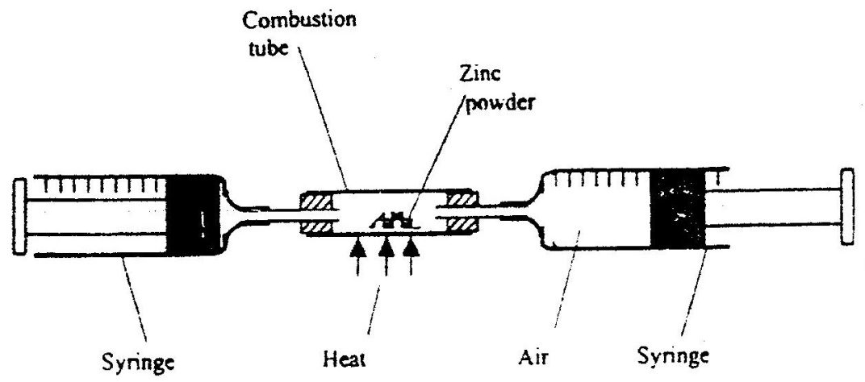

The experiment was repeated using excess magnesium powder. In which
of two experiments was the change in volume of the air greatest. (Give reasons)
(3 marks)

8. 2000 Q21 P1
Name another gas, which is used together with oxygen in welding (1 mark)

9. 2001 Q16 P1
The diagram below shows an iron bar, which supports a bridge. The Iron
bar is connected to a piece of magnesium metal.
Iron bar
Soil
Connecting wire
Magnesium metal

Explain why it is necessary to connect the piece of magnesium metal to the iron bar.

10. 2001 Q 19 P1
Explain why burning magnesium continue to burn in a gas jar full of sulphur
dioxide while a burning splint would be extinguished. (3 marks)

11. 2002 Q3 P1
The oxides of elements A and B have the properties shown in the table
below. (the letter do not represent the actual symbols of elements)

A | B
Gaseous at room temperature | Solid at room temperature
Dissolves in water to form an acidic solution | Dissolves in water to form an alkaline solution

Give one example of elements A and B (3 marks)

12. 2002 Q22 P1
The diagram below is set – up for the laboratory preparation of oxygen gas
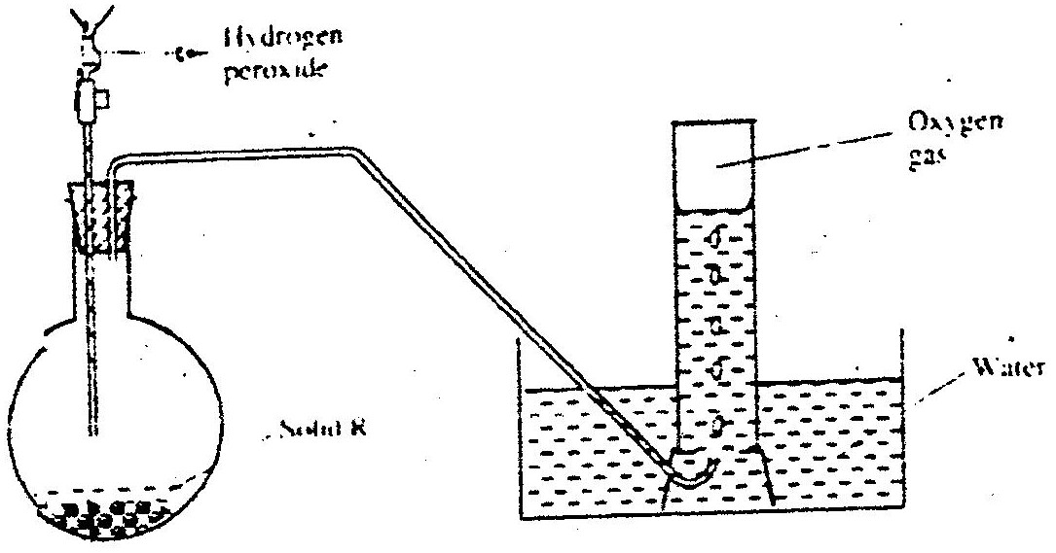
Hydrogen peroxide

Oxygen gas

water
Solid R

(a) Name solid R
(b) Write an equation for the reaction that takes place in the flask
(c) Give one commercial use of oxygen

13. 2003 Q 16 P1
Air was passed through several reagents shown in the flow chart below.

Air
Excess heated copper turnings
Excess heated magnesium powder
Concentrated KOH solution

- Write an equation for the reaction which takes place in the chamber
with magnesium powder (1 mark)

- Name one gas, which escapes from the chamber containing
magnesium powder. Give a reason for your answer (2 marks).

14. 2004 Q8 P1
When wood is burnt, a grey powder called ash remains. The ash is
stirred with water and filtered, a colourless solution is obtained.

a) What is the main component of the colourless solution? (1 mark)
b) Explain your answer in (a) above (2 marks)

15. 2005 Q 23
The set – up below was used to obtain a sample of iron
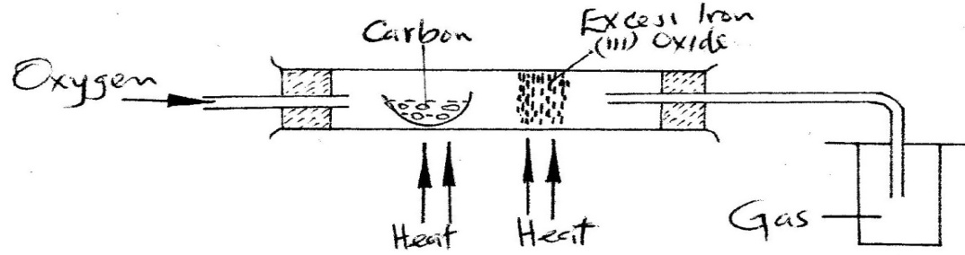

Write two equations for the reactions which occur in the combustion tube (2 marks)

16. 2005 Q 5 PP2
In an experiment, a piece of magnesium ribbon was cleaned with steel
wool. 2.4 g of the clean magnesium ribbon was placed in a crucible and
completely burnt in oxygen. After cooling, the product weighed 4.0 g

(a) Explain why it was necessary to clean the magnesium ribbon (1 mark)
(b) What observation was made in the crucible after burning (1 mark)
(c) Why was there an increase in mass? (1 mark)
(d) Write the equation for the reaction which took place in the crucible (1 mark)

(e) The product in the crucible was shaken with water and filtered.
Explain the observation which was made when blue and red litmus
papers were dropped into the filtrate. (3 marks)

(f) Calculate the volume of oxygen gas used during the burning. (O=16.0; Molar
volume of gas = 24,000cm³ a room temperature)

17. 2006 Q 2
The diagram below represent a set-up that was used to show that part of
air is used during burning.
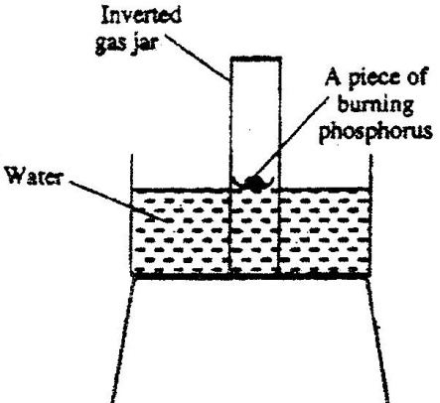

a) Given that phosphorus used was was in excess, draw a diagram of the
set-up at the end of the experiment (when there was no further
observable change). (1 mark)

b) Suggest one modification that should be made on the apparatus if
the percentage of the air used is to be determined. (1 mark)

18. 2007 Q 1a
State two factors that should be considered when choosing fuel for cooking
(2 marks)
19. 2009 Q 4
An experiment was set up shown in the diagram below.
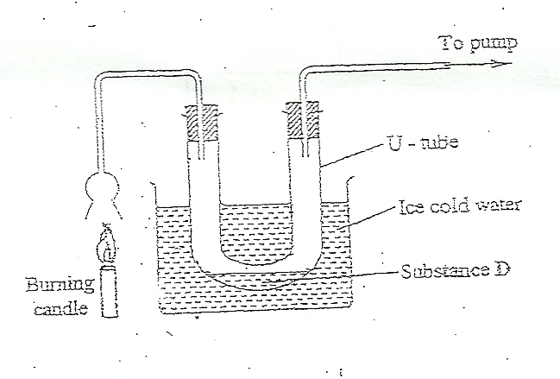

(a) Identify substance D. ……………………………….. (1 mark)
(b) Describe how the other product of the burning candle could be
prevented from getting into the environment (2 marks)

20. 2009 Q 21
Give the name of the product formed when magnesium reacts with phosphorus.
(1 mark)
21. 2012 Q1 P1
Charcoal is a fuel that is commonly used for cooking. When it burns it
forms two oxides.
(a) Name the two oxides (2 marks)
(b) State one use of the two oxides (1 mark)

22. 2010 Q26 P1
A water trough, aqueous sodium hydroxide, burning candle, watch class and
a graduated gas jar were used in an experimental set up to determine the
percentage of active part of air. Draw a labeled diagram of the set up at
the end of the experiment. (3 marks)

23. 2012 Q3 P1
In an experiment, dry hydrogen gas was passed over heated Lead (II) Oxide
as shown in the diagram below.
State and explain the observations made in the combustion tube (3 marks)

24. 2012 Q24 P1
The following set up of three-tubes was used to investigate rusting of iron. Study
it and answer the questions that follow.
(a) Give a reason why rusting did not occur in test-tube C. (1 mark)
(b) Aluminium is used to protect iron sheets from rusting. Explain two
ways in which aluminium protects iron from rusting. (2 marks)

25. 2013 Q1 P1
The set up below can be used to prepare oxygen gas. Study it and answer the
questions that follow.

- Identify X (1 mark)
- What property of oxygen makes it possible for it to be collected as
shown in the above
set up? (1 mark)
- State two uses of oxygen (1 mark)
26. 2014 Q16 P1
A measuring cylinder fitted with moist steel wool was inverted in a trough
Of water as shown in the diagram below

(a)State and explain the observations made on the;
i) Moist steel wool after four days. (1 mark)
ii) Water level in the measuring cylinder after four days. (1 mark)
(b) What would be the effect of using steel wool moistened with salty water?
(1 mark)

WATER AND HYDROGEN
- 1990 P1A Q 25
Use the information shown in the diagram below to answer the question
that follows?
Hydrogen gas
Metal Oxide
Heat

  - Explain why it is important to pass the hydrogen for some time
before lighting it at point Z.
  - Write an equation for reaction that takes place when hydrogen
burns at point Z.

2. 1991 P1A Q 3
When hydrogen gas is passed over heated lead (II) oxide a
reaction occurs. The diagram below shows a set up that could be used
for this reaction.
Hydrogen burning
Lead oxide
Dry hydrogen

Heat

(a) What observation would be made in the combustion tube? (2 marks)

3. 1991 P1A Q 11
A solution of hydrogen chloride gas in water liberates hydrogen
when reacted with Zinc metal while a solution of the same gas in
methylbenzene does not. Explain (2 marks)

4. 1995 Q 10 P1
In an experiment, rods of metals P, Q and R were cleaned with sand paper
and placed in a beaker containing water. Another set of rods was also cleaned
and placed in a beaker containing dilute acid. After placing the rods in the
two liquids bubbles of gas were seen around some of the rods as shown in
the diagrams below.
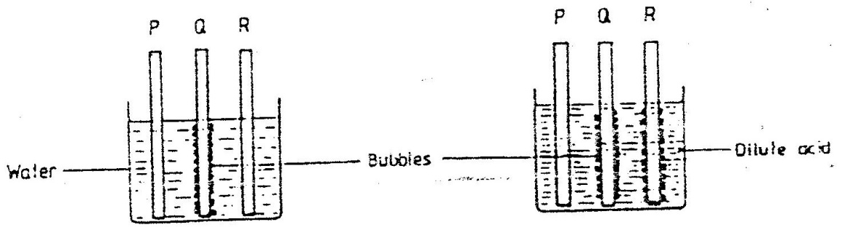

Dilute acid
Water
Bubbles

a) Why is it necessary to clean the rods with sand paper before
dipping them into the liquids. (1mark)

b) Arrange the three metals in order of their reactivity starting with
the most reactive.

5. 1995 Q 18
Study the diagram below and answer the questions that follow.
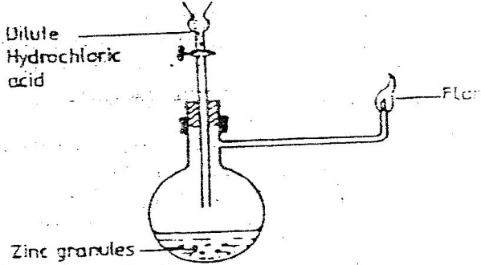
Dilute hydrochloric acid
Flame

Write an equation for each of the two reactions that take, place in
the experiment represented by the diagram above (2 marks)

6. 1996 Q 22 P1
The diagram below represents a set-up that was used to react lithium
with water study it and answer the questions that follow:
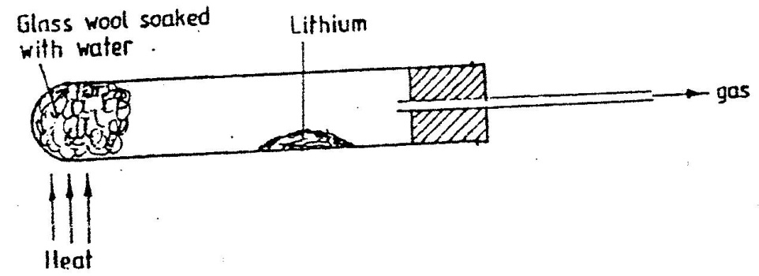

a) Write an equation for the reaction that takes place; given that the
atomic number of lithium is 3. (1 mark)
b) Why would it not be advisable to use potassium in place of lithium
in the above set-up? (1mark)

7. 1997 Q 21 P1
A student set up the experiment below to collect gas K the glass wool
was heated before heating the Zinc powder.
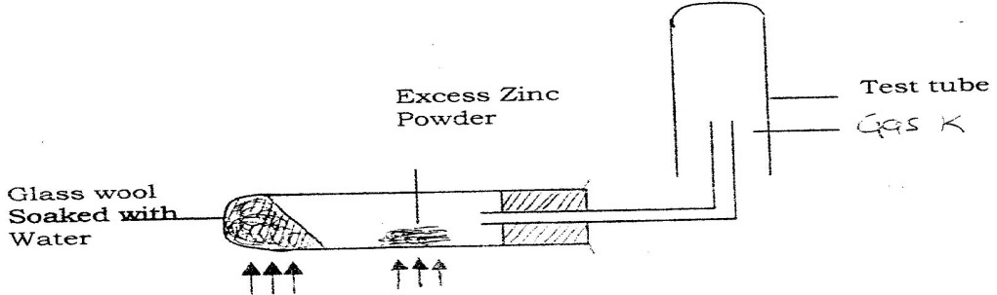

Why was it necessary to heat the moist glass wool before heating zinc powder

8. 2000 Q 17 P1
Study the set- up below and answer the questions that follow
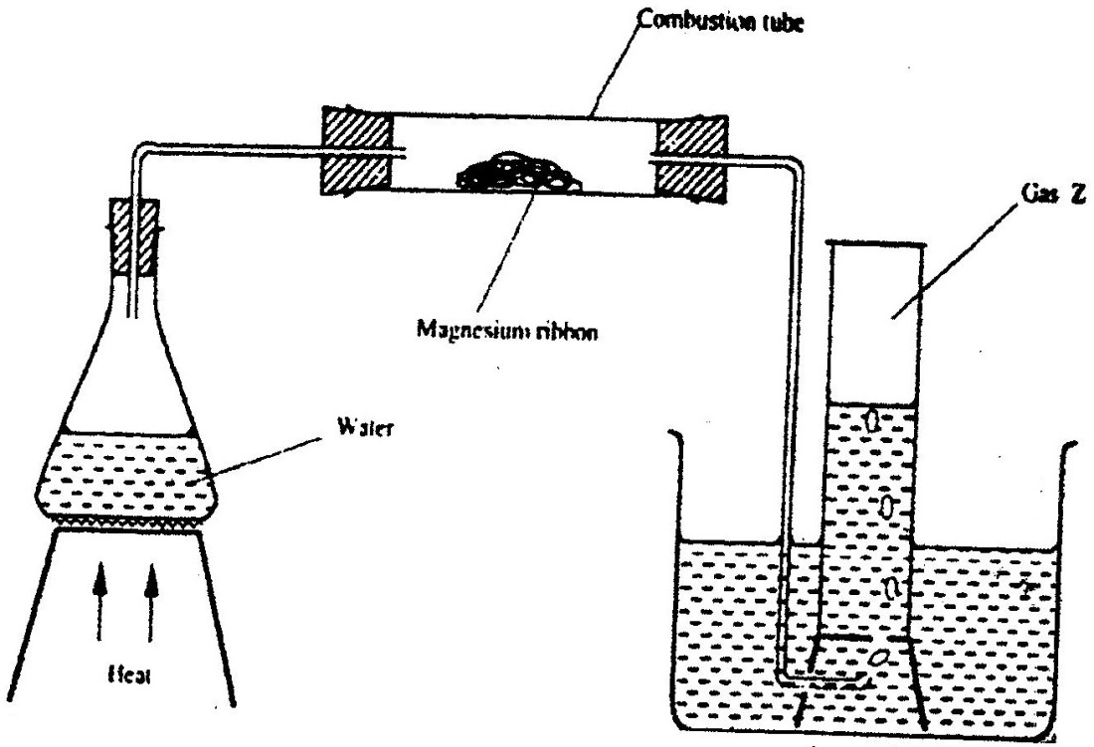

(a) Write an equation for the reaction, which take place in the combustion tube
(b) What property of gas Z allows it to be collected as shown in the diagram

9. 2002 Q 22
The diagram below is set – up for the laboratory preparation of oxygen gas
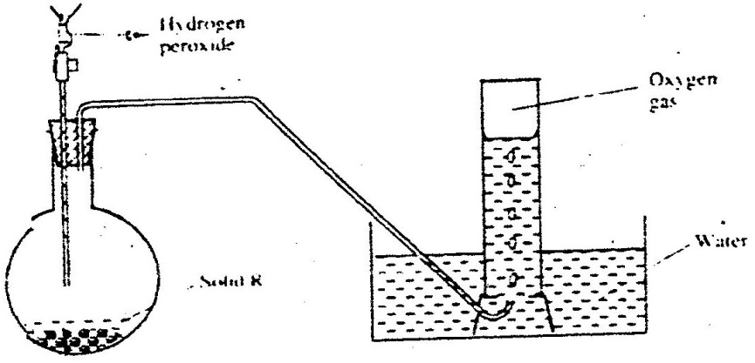
Hydrogen peroxide

Oxygen gas

Water
Solid R

(a) Name solid R
(b) Write an equation for the reaction that takes place in the flask
(c) Give one commercial use of oxygen

10. 2002 Q 2 P2
(a) Candle wax is mainly a compound consisting of two elements.
Name the two elements (2 marks)

(b) The set- up below was used to investigate the burning of a candle study
it and answers the questions that follow
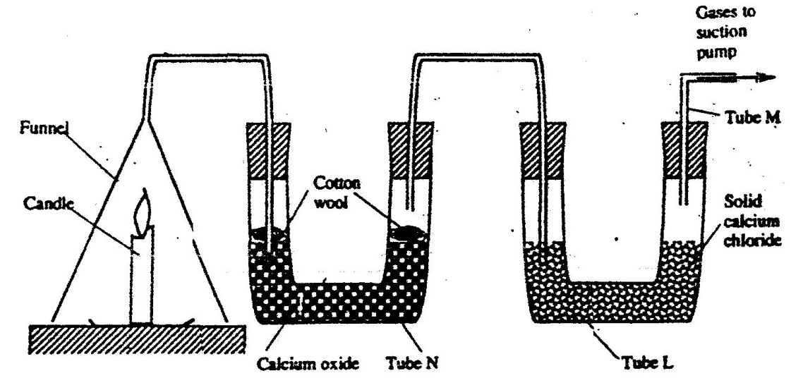

(i) What would happen to the burning candle if the pump was turned off?
Give reasons

(ii) State and explain the changes in mass that are likely to occur in tube N
by the end of the experiment (3 marks)

(iii) Name two gases that come out through tube M (2 marks)

(iv) Name another substance that could be used in the place of
calcium oxide in tube N

11. 2003 Q 6 P2
The set – up below was used to prepare hydrogen gas
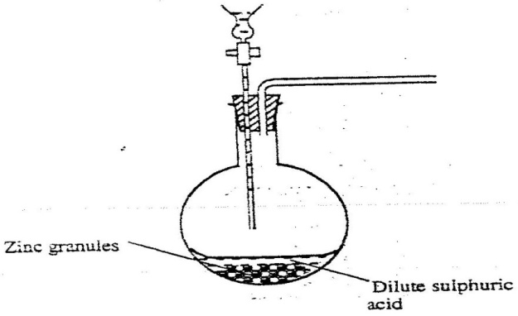

a) Complete the diagram to show how a dry sample of hydrogen gas
can be collected (3 marks)
b) Write an equation for the reaction, which takes place when hydrogen
gas burns in air. (1 mark)

c) i) 1.2 litres of hydrogen gas produced at room temperature and pressure
when 3.27g of zinc was used. Determine the relative atomic mass of zinc.
(Molar gas volume is 24 litres) (4 marks)

d) State two industrial uses of hydrogen gas.

12. 2004 Q 1 P1
When a candle was brunt completely. The total mass product was found
to be greater than the original mass of the candle. Explain

13. 2005 Q 3
The set-up below was used to demonstrate the effect of heat on hard water
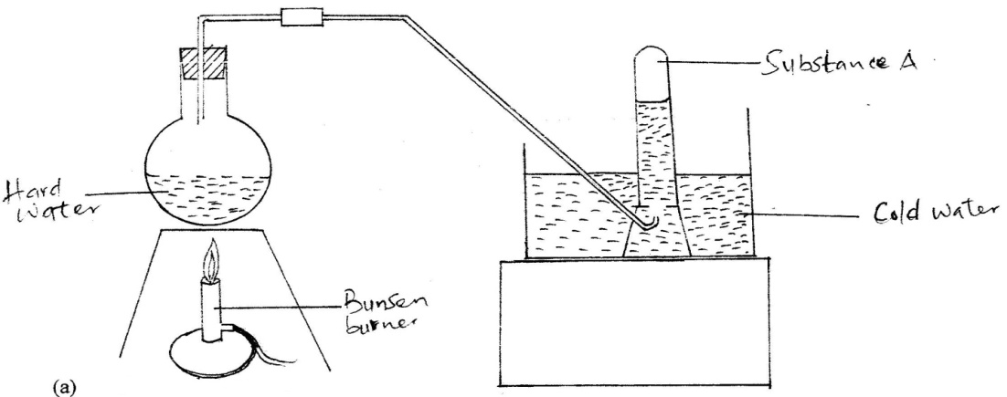

        - Name substance A. (1 mark)
        - Explain why the heating of hard water produced substance A. (2 marks)

14. 2006 Q 18
Study the diagram below and answer the question that follows.

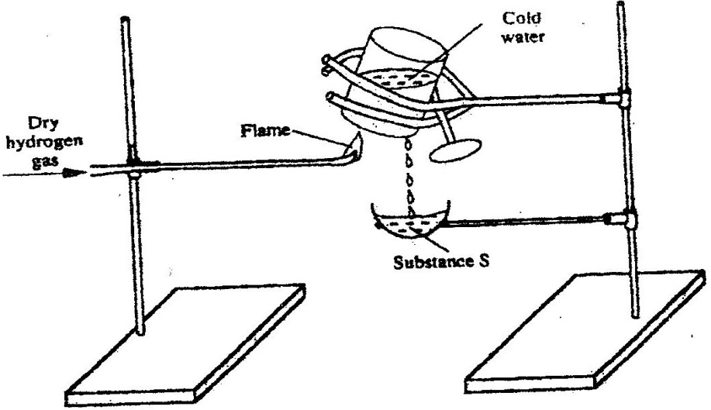

Describe one chemical test that can be carried out to identify substance s. (2 marks)

15. 2006 Q 19
a) Starting from solid magnesium hydroxide, describe how a solid sample
of magnesium hydroxide can be prepared (2 marks)
b) Give one use of magnesium hydroxide. (1 mark)

16. 2007 Q 25a
The diagram below shows a student’s set-up for the preparation and
collection of hydrogen gas.

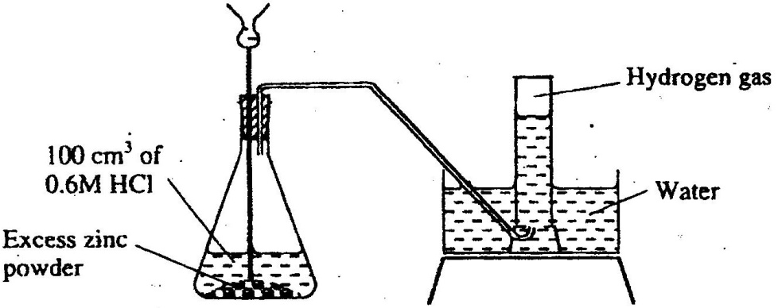

(a) How would the final volume of hydrogen gas produced be affected if
80cm³ of 0.75 M hydrochloric acid was used? (1 mark)

17. 2008 Q 13 P2
In a laboratory experiment hydrogen gas was passed over heated
copper (II) oxide as shown the diagram below.
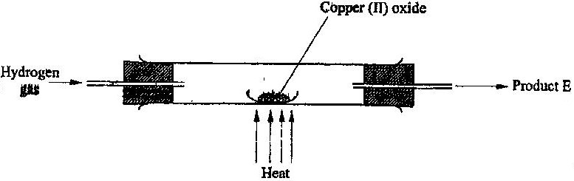

Describe a chemical test that can be used to identify the product e. (2marks)

18. 2009 Q 4 P1
An experiment was set up shown in the diagram below.

(a) Identify substance D. ……………………………….. (1 mark)

(b) Describe how the other product of the burning candle could be
prevented from getting into the environment (2 marks)

19. 2009 Q 15 P1
A student used the set up shown in the diagram below in order to study
the reactions of some metals with steam. The experiment was carried out
for ten minutes.
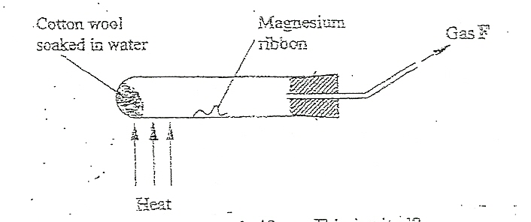

(a) What observation would be made if gas F is ignited?
(b) When the experiment was repeated using iron powder instead of
magnesium ribbon, very little gas F was obtained.
(i) Give a reason for this observation (1 mark)
(ii) What change in the conditions of the experiment should the student
have made in order to increase the volume of gas F produces. (1 mark)

20. 2009 Q 5c P2
Coal, oil and natural gas are major sources of energy. They are known as
fossil Hydrogen is also a source of energy.
(i) State and explain two reasons why hydrogen is a very attractive fuel
compared to fossil fuels (3 marks)
(ii) State one disadvantage of using hydrogen fuel instead of fossil fuel.
(1 mark)
21. 2011 Q 9
State two reasons why hydrogen is not commonly used as a fuel. (2 marks)

22. 2011 Q 12
Sodium hydroxide can be prepared by the following methods;I and II.
- Sodium metal cold water Sodium hydroxide + Hydrogen

- Concentrated process A Sodium hydroxide+chlorine+hydrogen
Sodium chloride

        - Name one precaution that needs to be taken in method 1. (1 mark)
        - Give the name of process A. (1 mark)
        - Give one use of sodium hydroxide. (1 mark)

23. 2012 Q3 P1
In an experiment, dry hydrogen gas was passed over heated Lead (II) Oxide
as shown in the diagram below.

State and explain the observations made in the combustion tube (3 marks)

24. 2012 Q19 P1
The set up shown below was used to investigate a property of hydrogen gas.

State and explain the observation that would be made in the glass tube
if beaker A was filled with hydrogen gas. (3 marks)

25. 2013 Q18 P1
The set-up below was used to investigate the products of burning biogas
(methane). Study it and answer the questions that follow.

- What product will be formed in test- tube Y? (1 mark)
- State and explain the observations which would be made in Z? (2 marks)
26. 2015 Q9 P1
The set up below was used to investigate the reaction between dry
hydrogen gas and copper (II) oxide
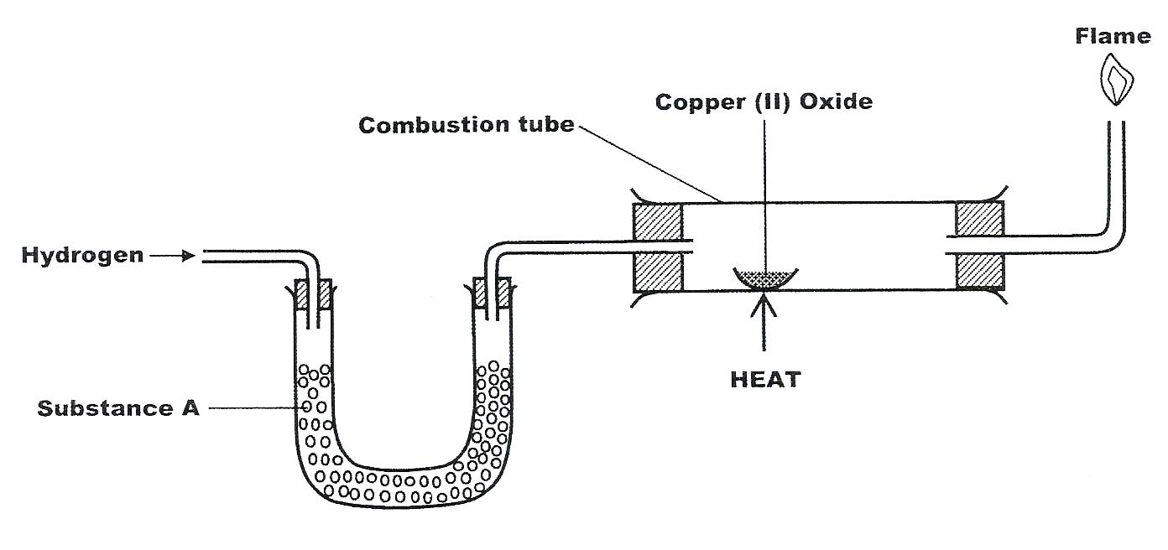
- Name substance A (1 mark)
- state the observation made in the combustion tube (1 mark)
- Explain the observation stated in (b) above. (1 mark)

27. 2015 Q24 P1
The graph below is a cooling curve for water. Study it and answer the
questions that follow
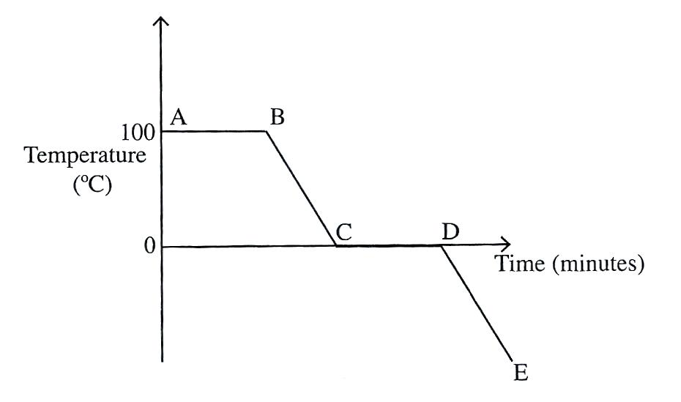
- Explain what happens to the molecules of water in the region BC in
terms of kinetic theory. (2 marks)
- In what state is the water in the region DE?
INTRODUCTION TO CHEMISTRY
MARKING SCHEME

1. 2000 Q 15
Luminous Non – Luminous
- Its sooty or Smokey - Not sooty or Smokey
- Not very hot - Steady
- Not steady - Noisy
- Quit
Any two in order / No other differences.

2. 2007 Q4 P1
C- unburnt gas D- Luminous yellow flame

3. 2014 Q1 P1
By opening the air hole / by letting in more air (1)

SIMPLE CLASSIFICATION OF SUBSTANCE
MARKING SCHEME

1. 1995 Q7 P1
II Because pure substances have sharp MP and BP as shown by the flat regions of
curve II. (accept systematic)

2. 1995 Q15 P1
Cool the mixture to a temperature below – 196ºC to form a liquid then start warming,
Nitrogen distils off a gas at – 196O (cool first) (2 marks)

3. 1995 Q6 P2
(a) (i) Bitumen, it has highest B.P (2 marks)
(ii) Fractional distillation. During the distillation petrol would distil off at 175⁰
and diesel could distil at 350⁰C (2 marks)
(iii) Each component is mixture of hydrocarbons which have different boiling
Points
(iv) Methane CH₄(g)
Ethane C₂H₆
Propane C₃H₈
Butane C₄H₁₀

(b) Burning it in limited amount of air will produce carbon monoxide which is
poisonous (2 marks)
(c) Manufacture of tar used in tarmac/ sealing of roofs (1 mark)

4. 1997 Q22 P1
(a) - Thermometer should not be dipped in the mixture thermometer be
at outlet point of condenser
  - The direction of water flow is wrong/ condenser wrongly fixed
  - Named flask used/ No water bath is used
(b) - Boiling point/ Freezing point
- Density / refractive index

5. 1998 Q17 P1
6. 1998 Q25 P1
R- Melting/ fusion
V- Boiling/ vaporization
W – Condensation/ liquefaction
U- Freezing/ solidification

7. 2000 Q1 P1
a) Mass increases because oxygen combine with copper metal
b) Mass decreases it decomposes into gases that escape.

8. 2001 Q4a P2
(a) (i) KOH or NaOH or chemical names or common nodes
(any contradiction = 0 mark)
(ii) ( Boiling points Nitrogen = -196⁰ C, Oxygen = -183⁰C)

    - Heat/ boil the liquid air/warm/ raise the temp of liquid air
    - Nitrogen comes out first because it has a lower boiling point than oxygen
(if word heating/ boiling/ raising the temp or warming not mentioned
the candidate score 0mark)
9. 2003 Q9 P1
a) A condenser/ lie big condenser
b) To show when vapour fractions are distilling off.
c) C

10. 2004 Q27 P1
(a) 4 and 5 blue and Green (full ) H₂SO₄ _{(aq)} is on electrolyte
(b) 2 and 3 (1) yellow and red
(c) Yellow and red (1)
4 – Blue
5 – Green
2 – Yellow
3 – Red award if the colour is tied to the number (3 marks)

11. 2004 Q6a P2
(a) (i) Fractional distillation
(ii) Molecular mass/ density
Boiling point
12. 2005 Q1 P2
a) (i)
(ii) A and C

b) Since NH₄CL₄ sublimes but CaCl₂ does not ; sublimation process would do .Heat the mixture. Ammonium chloride sublimates into vapour and condenses on the cooler part of the heating tube. Calcium chloride will remain on the bottom of the heating tube.

c) i) Fractional distillation
ii) Separating funnel method
Since the tow liquids are immiscible, pour both the liquids in a separating funnel and allow to settle, the denser liquid will settle down and the less dense will form a second layer on top. Open the tape and run out the liquid in the bottom layer leaving the liquid in the second layer in the funnel.
13. 2006 Q10a P1
a) sublimation (1 mark)

14. 2006 Q25 P1
a) V₁ and V₃
b) Add petrol to the mixture. Filter. V₂ is the residue. Filtrate is V₄ (2marks)
Distill the filtrate.

15. 2006 Q26 P1
a) They gain energy and move faster. The intermolecular distance increases.
b) XY
c) The energy supplied changes molecules of water from liquid to Gaseous state.

16. 2008 Q14 P1
(a) A (I)
(b) A₁ (l) using baseline

17. 2008 Q25 P1
(a) Cooling
(b) Latent heat of fusion

18. 2008 Q1a P1
(a) (i) Contain methane which is a fuel/ methane can burn/ flammable
(ii) Pass a weigh a known volume of biogas (VI) through dissolved NaOH or

KOH/ Ca (OH)₂ CO₂ will be observed
Or CH₄ will not be absorbed – measure volume (v₂)
CH₄ Volume methane x 100
Volume of biogas
19. 2009 Q20 P1
(a) Chemical change
(b) Physical change
(c) Chemical change

20. 2009 Q5a-b P2
(a) (i) I. Condensation
II. Melting
(ii) Iodine, Benzoic acid, Camphos, Dry Ice. Solid CO₂ Naphthalene
H₂O(g) →H₂O(g)
(b) (i) Van des waals and hydrogen bonding
II Van des waals forces
21. 2011 Q3 P1
- Heat the mixture to sublime the NH₄Cl
- Add water to dissolve the NaCl or Copper (II) oxide does not dissolve.
Filter and evaporate the filtrate to obtain sodium chloride
- Add water to the mixture to dissolve NaCl or/ Copper (II) Oxide does not
dissolve. Filter and evaporate to dryness.
- Heat to sublime NH₄Cl. NaCl remains behind.

22. 2012 Q2 P1
– add water√ to dissolve CuSO₄, Fe₂O₃ doesn’t dissolve
- Filter out Fe₂O₃ √
- Wash the residue √with plenty of distilled water to remove traces of the filtrate
Dry the residue√ between filter papers

23. 2012 Q5 P1
Water contained impurities
Or presence of impurities raises bpt.
Or water contains ions or hard water

24. 2013 Q3 P1
Using mortar and pestle crush the nuts and add appropriate solvent such as acetone. Filter the mixture to obtain a solution of oil in acetone as the filtrate. Put the filtrate in the sun for acetone to evaporate leaving oil in the dish.

25. 2013 Q15 P1
(a) RandT (b) T

26. 2014 Q 19 P1

27. 2014 Q 22 P1
- to increase surface area for condensation of the liquid with higher boiling point

- methanol
- has lower b.p due to its smaller molecular mass

28. 2015 Q3 P2
(a) Reversible chemical change,
(b) Hydrated copper (II) sulphate.

29. 2015 Q21 P1
Put the mixture in a beaker and place a flask with cold water on the beaker. Heat the mixture. Ammonium chloride sublimes and is deposited on the flask. To the residue add water and stir. Sodium chloride dissolves while lead (II) sulphate does not. Filter to obtain lead (II) sulphate as the residue. Evaporate the filtrate to obtain sodium chloride.

ACIDS BASES AND INDICATORS
MARKING SCHEME

- 1990 Q21 P1A
Dilute H₂SO₄ is more ionized than concentrated H₂SO₄
- 1992 Q6 P1
B = Strongly acid, C = Weakly acid D = Strongly basic / Alkaline
- 1994 Q9 P1
NH₄ it is a proton donor or H in the reaction / because it donates a proton to the
H₂O _{(I)} give a proton to ammonia.

- 1995 Q18 P1
a) 2HCl (aq) + Zn(s) ZnCl₂(aq) + H₂ (g) (⁻¹/₂) states)
b) 2H₂ (g) + O₂ (g) 2H₂O (g) (Not L) (⁻¹/₂ state)

- 1997 Q17 P1
H₂O(l) – It accepts a proton (H⁺) forward r x n

6. 1998 Q12 P1
Strong acid – one which is fully dissociated when in water eg. HCL, HBr
Weak acid - one which is partially dissociated when in water eg.CH₃COOH

7. 1998 Q24 P1
Sting from a bee contains an acid which causes irritation NaHCO₃ being alkaline
neutralizes the acid

8. 1999 Q3 P1
The blue crystals turn into a white powder (I) Concentrated H₂SO₄ (I) removes
water of crystallization (I) or is a dehydrating agent

9. 1999 Q1 P2
Mg_{(s)} + 2HCL (aq) MgCl₂ + H_{2(g)} -¹/₂ mark if states are missing

10. 2000 Q27 P1
It reacts with NaHCO₃ to form CO₂ which causes the dough to rise.

11. 2001 Q8 P1
(a) Effervescence due to production of carbon dioxide ║Hissing ║fizzing ║bubble
(b) No change observable. Copper is below hydrogen in the activity series therefore
cannot displace hydrogen

12. 2001 Q26 P1
To neutralize soil audity/ increase soil PH
To be used as fertilizer / Add Ca²⁺ to the soil

13. 2003 Q7 P1
HCl is a strong acid hence fully ionizes. Ethanoic acid is a weak acid
hence partially ionized.

14. 2003 Q18 P1
a) SO₄²⁻ , Sulphate ion
b) Ba²⁺ (aq) + SO₄²⁺ BaSO₄(s)
c) Zn (NH₃)₄²⁺

15. 2003 Q1d P2
Both must be present and correct, do not accept one
Al(OH)₃(s) + OH⁻ (aq) ALO₂ (aq) + 2H₂O (l)

16. 2004 Q8 P1
a) (i) KOH _{(l)}
b) Plants need potassium on a large-scale macro scale therefore the ash
contains mainly K₂O or potassium compound.

17. 2004 Q2a P2
(a) (i) hydrogen gas / H₂
(ii) Ca (OH)₂ is slightly soluble in water // only a few OH⁻ are produced in solution
(iii) It is used for testing presence of CO₂ used in prep. Of ammonia //
calcium Oxide

18. 2006 Q19 P1
Anti-acid (treatment of acid indigestion)

19. 2006 Q24 P1
a) Acidic Basic
Orange Pink
b) The PH of 0.1 M KOH is higher than that 0.1 M aqueous ammonia.
KOH is strongly dissociated in solution

20. 2007 Q5 P1
The product from nettle plant is acidic aqueous ammonia solution being basic
neutralize the acidic product.

21. 2007 Q19 P1
(a) O²⁻
(b) [Zn(OH)₄] ⁽²⁻⁾

22. 2008 Q3 P1

No | Gas | Test | Observation
I | Chlorine |  | The red litmus pare turns white/ the litmus paper is bleached
II | Acidified must be there | Put a filter paper dipped in acidified potassium dichromate (VI) into the gas
III |  |  | The bromine water is decolorized

23. 2008 Q10 P1
Magnesium burns in air to form Mgo and Mg₃N₂, Mg₂N₂ reacts with water to
Liberate ammonia gas
Mg₃N₂(s) + 6 H₂O (I) → 2NH₃ (g) + Mg (OH)₂(ag)

24. 2009 Q22 P1
Tests 2(½) and 3(½) for test 2 iron is above hydrogen in the reactivity series hence
it displaces hydrogen (l).For rest 3, dilute sulphuric acid is not an oxidizing agent (1)

25. 2009 Q30 P1
(a) Crush the roses with a suitable solvent (½) filter /decant /scape wilt, droper to
obtain pigment /e.g. ethanol – methanol – propanus – Aocome.

(b) Add pigment to an acid or base
It shows different colours in each.

26. 2011 Q20 P1
Dissolve actal in water and to the solution add universal indicator. Match the
colour on the Ph chart to determine the PH.

27. 2014 Q27 P1
- Propanone or acetone
- Being a non polar solvent) it dissolves organic matter in the flower.

AIR AND COMBUSTION
MARKING SCHEME

- 1989 Q11 P1
Mg is above copper in reactivity series
- 1992 Q18 P1
- (i) Mgo
(ii) Cl₂O / CLO₂/ CL₂O₆ / CLO₂O₇
- CL₂O(g) + H₂O(i) 2HClO_{3(aq)}
CLO₂ + H₂O HClO_{3(aq)}
CL₂O₆ (g) + H₂O HClO_{3 (aq)}
CL₂O₇ (g) + H₂O 2HClO_{4 (aq)}
- 1995 Q8 P1
a) 2H₂sO₄
b) Insoluble in water/slightly soluble in water
To ensure that the air that occupied the apparatus initially is expected
(reject impurities)

- 1995 Q15 P1
Cool the mixture to a temperature below – 196ºC to form a liquid then start warming,
Nitrogen distils off a gas at – 196⁰ (cool first)

- 1996 Q12 P1
2mg_{(s)} + O_{2 (g)} MgO _{(s)}
3Mg_{(s)} + N₂ _{(g )} Mg₃ N_{2(s)}

- 1997 Q1 P1
- Iron wool turns or rusts due to formation of hydrated iron (III) oxide
  - Level of water inside the tube rises to occupy the space left by oxygen
  - Level of water in the beaker will fall

- 1999 Q17 P1
The volume change was greatest when magnesium is used. This is because zinc
only reacts with the oxygen part of air while magnesium reacts with both oxygen and nitrogen.

- 2000 Q21 P1
Acet5ylene (ethyne) or Hydrogen

- 2001 Q16 P1
Magnesium is above iron in the activity series. It supplies electrons to the iron bar
Hence prevent it from rusting

10. 2001 Q19 P1
The burning magnesium produces more heat energy that the burning splint.
The heat energy from magnesium is enough to break the sulphur oxygen bond
setting free oxygen magnesium uses freed oxygen to continue burning.

11. 2002 Q3 P1
A sulphur, carbon, nitrogen
B Sodium potassium, lithium

12. 2002 Q22 P1
a) Manganese (IV) oxide (1)
b) -Welding (l)
- Fuel in rockets
- Breathing aid / hospitals
- Steel making
Accept any other correct ans

13. 2003 Q16 P1
a) 3Mg (S) + N₂ (g) Mg₃N₂(S)
b) Argon / Neon (name of a rare gas)
Because they are inert and not likely to have reacted with any of the reagents.

14. 2003 Q16 P1
a) (i) KOH (l)
b) Plants need potassium on a large-scale macro scale therefore the ash contains
mainly K₂O or potassium compound.

15. 2005 Q23 P1
C_{(s)} + O_{2(g)} → 2CO_{(g)}
Fe₂O₃ + 3CO(g) → 2Fe_{(s)} + 3CO_{2(g)}

16. 2005 Q2 P2
a) To remove any oxide film on it i.e. layer of magnesium oxide.
b) A white solid formed which is magnesium oxide
c) The increase in mass was due to the oxygen which combines with magnesium.
d) 2Mg_{(s)} + O_{2 (g)} heat 2MgO_{(s)}
e) The filtrate is magnesium hydroxide which is an alkaline.
There was no change in blue litmus paper but red litmus paper turned blue.
f)
From equation in (d)
1 Mole of Magnesium atom combines with a mole of oxygen atom.
OR
Mg Oxygen
Mass 2.4 1.6
Molar mass 24 16
No. of moles 2.4 = 0.1 1.6 = 0.1 moles
24 16
Mole ratio 1 : 1
No. of moles of oxygen used = 1.6 = 0.1 moles
16

1 mole = 24,000cm³
0.1 mole = 24,000 x 0.1
Volume of oxygen used = 2,400cm³

17. 2006 Q2 P1
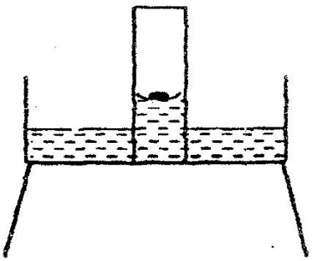
a)

b) Calibrate the gas jar before the start of experiment (1 mark)

18. 2007 Q1a P1
- Cost
- Availability

- Effects to the environment
- Heating value
- Ease of storage

19. 2009 Q4 P1
(a) Water (l)
(b) The second / other product of burning candle is carbon (IV) oxide (l). It can
be prevented from getting into the environment by passing it though a
hydroxide solution/ alkaline solution e.g. K.O.H NaOH or aqueous ammonia (l). (2 marks)
To form K₂CO₃
20. 2009 Q21 P1
Magnesium phosphate (reject formula)

21. 2010 Q21 P1

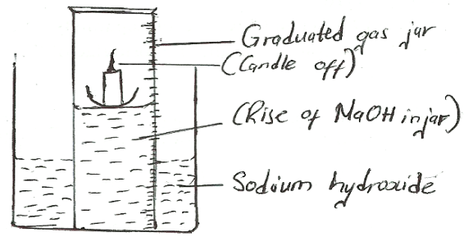

22. 2012 Q1 P1
(a) -carbon (iv) oxide OR - carbon(ii) oxide
Or Carbon dioxide or carbon monoxide
Or CO₂ or CO

(b) CO₂ – Refrigeration CO - extraction of metals
- Fire extinguisher - manufacture of ethanol
- Fizzy drinks - manufacture of fuels (water gas)
- Food preservative
- Photosynthesis
- Solvay process
- Cloud seedlings
23. 2012 Q3 P1
Grey solid is deposited Pbo has been reduced to lead metal
- A vapour condenses on the cooler sides of the tube – the hydrogen has been oxidised to water
Or
H₂ _{(g)} + Pbo_{(s)} Pb_{(s)} + H₂O_{(l)}

24. 2012 Q3 P1
(a) there is no air due to boiling
no O₂
(b) 1. All forms a protective Al₂O₃ layer.
2. All being more reactive then iron rusts fast / sacrificial or cathodic protection
25. 2013 Q1 P1
      - Water
      - Oxygen is only slightly soluble in water
      - Used in welding and cutting of metals(oxyacetylene flame)
      - Used in hospitals to aid patients with respiratory problems

26. 2014 Q16 P1
i) Moist steel wool after four days 1mark
Turned brown
Had formed hydrated iron (III) oxide / rust

ii) Water level in the measuring cylinder after four days 1mark
Had risen
To occupy the vacuum left by the oxygen that was used during rusting

b) What would be the effect of using steel wool moistened with salty water? (1mark)
Would have turned brown faster
Would have rusted faster

WATER AND HYDROGEN
MARKING SCHEME

1. 1990 Q25 P1
(i) If ignited immediately explosion would occur because it would still be mixed
with air (explosion and air tied)

2. 1991 Q3 P1
Colourless droplets/droplets of water on cooler parts of the tube solid melts to
orange/a grey residue/silvery beads or bells are formed

3. 1991 Q11 P1
HCL in water dissolves H⁺ ions in solution reacts with zinc to evolve H₂.
No ions are formed when HCL is in menthyl/benzene/HCL remains in
molecular form

4. 1995 Q10P1
a) To remove oxide coating which could inhibit reaction
b) ORP

5. 1995 Q18 P1
a) 2HCl (aq) + Zncl₂ □ (aq) + H₂ (g) (⁻¹/₂) states)
b) 2H₂ (g) + O₂ (g) 2H₂O (g) (Not L) (⁻¹/₂ state)

6. 1996 Q22 P1
a) Li(s) + 2H₂O (g) Li₂O(s) + H₂ (aq)
b) Potassium is very reactive; and so the reaction is likely to be very violent

7. 1997 Q21 P1
(a) To generate stream which pushes out air
(b) The air would oxidize zinc oxide no gas would be obtained
(c) It is less than air

8. 2000 Q17 P1
a) Mg(s) + H₂O(g) MgO(s) + H₂(g)
Mg(s) + 2H₂O(l) Mg(OH)₂(s) + H₂(g)
b) Insoluble in water / slight soluble
Mention of water is not necessary since the liquid is not labeled.

9. 2002 Q22 P1
(a) (i) Hydrogen // H
(ii) carbon //C
(b) (i) Extinguishes // put off // goes off // want out // Die; CO₂ and
Water vapour, which do not support combustion, accumulates around the
supply of oxygen
(ii) Mass increases; water vapour reacts with CaO and forms Ca (OH)
Ca (OH)₂ reacts with Co₂ to produce CaCO₃
CaO(s) + H₂O(l) →Ca (OH)₂(s) → CaO reacts with moist CO₂
Ca (OH)₂ + CO₂(g) →CaCO₃(s) + H₂O
(iii) Oxygen and Nitrogen Helium, Neon argon; Accept a name of inert gas
(iv) To absorb excess water vapour // moisture
(v) Sodalime // NaOH⁻ and CaO // KOOH // Caustic potash // caustic soda

10. 2002 Q22 P1
a) Manganese (IV) oxide (1)
b) -Welding (l)
- Fuel in rockets
- Breathing aid / hospitals
- Steel making (3 marks)
11. 2003 Q6 P2
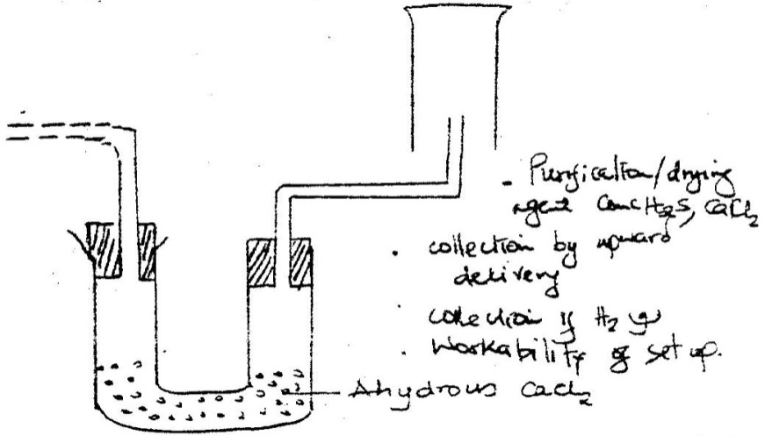
a)

b) 2H₂ (g) + O₂ (g) 2H₂O(g)
(c) (i) Zn(s) + H₂SO₄(aq) ZnsO₄(aq) + H₂(g)
1.2 = 0.05
24
Moles of Zn = 0.05
0.05 moles of zn = 0.05 moles
R.A. M 3.27 = 65.4 (N0 units)
0.05
d) - Manufacture of ammonia
- Extraction of tungstein
- Synthesis of HCL (acid) or HCL (gas)
- Filling weather balloons
- Making oxy-hydrogen flame for welding
- Hardening of oil/manufacture of margarine.

12. 2004 Q1 P1
Burning involves use of oxygen (1) the products include the mass of candle and oxygen
Oxidation increase in mass
Combined with oxygen

13. 2005 Q3 P1
(a) Carbon dioxide gas
(b) Temporary hard water dissolves hydrogen carbon salts which decomposes
on heating to produce carbon dioxide

Ca(HCO₃)₂ (aq) Heat CaCO₃(s) + H₂O(l) + CO₂(g)

14. 2006 Q18 P1
add anhydrous copper(II) Sulphate to substance S. It changes from white to blye
OR
Dip cobalt chloride paper into Substance s. It changes from blue to pink. (2marks)

15. 2006 Q19 P1
a) To MgO and excess HCl or H₂SO₄. Add NaOH or KOH to the mixture.
Filter and dry the residue.
b) Anti-acid (treatment of acid indigestion)

16. 2007 Q25a P1
(a) No change in volume since the number of moles of acid is equal in both cases.

17. 2008 Q13 P1
Pass product ever anhydrous copper (II) sulphate (I) which turns from white to
blue (I) turns to blue or anhydrous copper (II) sulphate or use Cobalt Chloride
(anhydrous which turns from blue to pink.

18. 2009 Q1 P1
(a) Water (1)

(b) The second /other product of burning candle is carbon (IV) oxide(1).It can be
prevented from getting into the environment by passing it through a hydroxide
solution /alkaline solution e.g. KOH NaOH or aqueous ammonia.(1) to form K₂CO₃

19. 2009 Q1 P1
(a) The gas burns with a blue flame (1)
(b) (i) The iron is less reactive than magnesium (1)
(iii)Heat the iron powder (1) 3 marks

20. 2009 5c P2
(i) Hydrogen burns to produce steam which is a non pollutant/ does not cause
pollution to the environment
- Hydrogen has a high energy content hence very small amount produce a lot
of heat energy
- Hydrogen is renewable hence cannot be exhausted/ used completed.
(ii) It can easily explore when burning/ highly flammable unlike fossils
fuels expensive.
- 2011 Q9 P1
- It is expensive
- It is explosive (deny not dangerous/ harmful/ not easily available.
- It is difficult to store

- 2011 Q12 P1
- Small piece of sodium metal (pea size) with a lot of water
- perform the experiment wearing goggles
- Electrolysis
- Manufacture of papers (soften)
- Manufacture of soaps and detergents
- Fractional distillation of liquid air
- Extraction of Aluminium metal
- Manufacture of bleaching agents e.g NaOCl
- Making herbicides on weed killers
- It is boiled with textile industry to soften

- 2012 Q3, 19 P1
- Grey solid is deposited PbO has been reduced to lead metal
- A vapour condenses on the cooler sides of the tube – the hydrogen has been oxidised to water
Or
H₂ _{(g)} + PbO_{(s)} Pb_{(s)} + H₂O _{(l)}

- 2012 Q19 P1
Level of water glass tube goes down / bubbles in the beaker
H_{2(g)} gas being less dense than air diffusing than air into the porous pot

- 2013 Q18 P1
- Water

- White precipitates are formed which eventually dissolve to form a colourless solution. Carbon (IV) oxide formed reacts with calcium hydroxide forming insoluble calcium carbornate which then reacts with more carbon(IV) oxide forming soluble
calcium hydrogen carbonate.

29. 2015 Q24 P1
(a) As the temperature reduces, the kinetic energy of the water molecules
reduces making them vibrate less vigorously,
(b) Solid

